Sinclair Inlet Chapter No. 80 National Sojourners, Inc

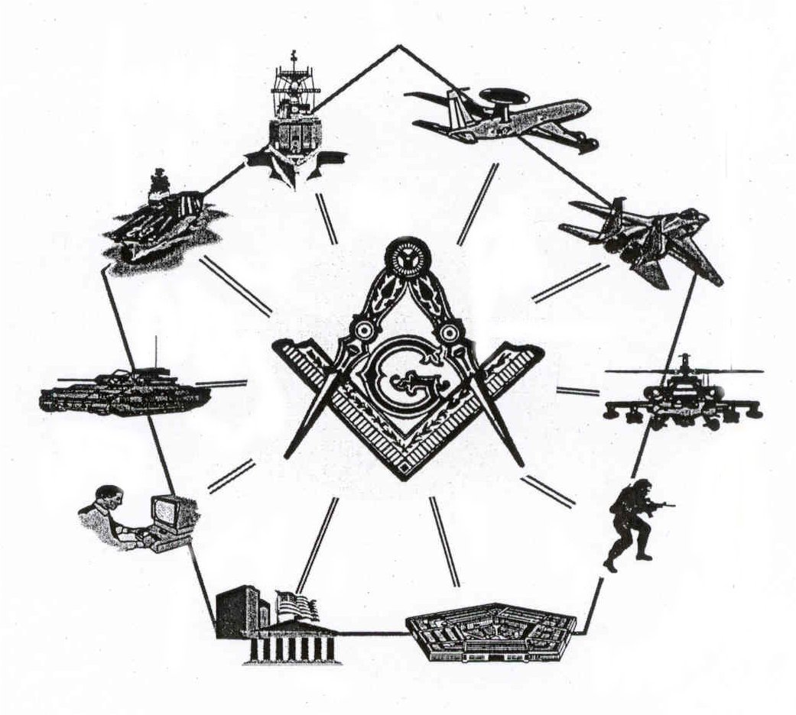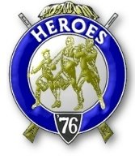

Bremerton, Washington
Our website address is: www.telebyte.com/masons/sojourn/80/sinclair_inlet_chapter.htm

September 2004 Newsletter

Chapter Officers 2004-2005
President | S/SGT Michael Pursey | 360-692-2421 | kpursey@silverlink.net
1st Vice President | Col William M. Biscomb
2nd Vice President
Secretary/Treasurer | WTCS John Gray | 360-895-3188 | wtcs_sw@wavecable.com
Marshal | CWO4 Richard Patterson
Chaplain | 1LT Harold E. Richardson | 360-692-4023 | haroldr@telebyte.net
Color Bearer

Hero Camp Officers 2004-2005
Commander | CAPT Harry R. Houston | 360-692-8478 | hbhouston@telebyte.com
Chief of Staff | 1Lt Harold R. Richardson | 360-692-4023 | haroldr@telebyte.net
Adjutant | WTCS John Gray | 360-895-3188 | wtcs_sw@wavecable.com

Meeting Notice!
We will meet at Elk’s Lodge #1181, Pine Road, Bremerton on 10 SEP. Social hour and dinner begins at 1800, Meeting at 1900 hours. Ladies and guests are always welcome at the meeting and are urged to attend.

The associated Lewis and Clark Camp of the Hero's of '76 meets immediately following the Sojourner meeting and is open to all Hero's.
Don’t forget to wear your Medal!
President’s Message
Too Arms! Too Arms! Too Arms! My Brethren,

When threatened aforetime, the militia of old would go from house to house, recruiting and activating its members to action. A rag-tag army indeed, rough and untrained, it would emerge to join in the common cause of defense of our country.
Well, fellow Sojourners, this is my call to you now. Time to dust off your Masonic arms, don your old Patriotic uniform and re-awaken the Fellowship within your heart. In other words--LETS GET SOME NEW MEMBERS INTO OUR RANKS! Let’s apply these watchwords: Masonic, Patriotic and Fellowship!
Let's look at what’s required of our members. To be a Mason in good standing. Yep, I know some of those. To be an Officer, Warrant Officer or Senior Enlisted. H-m-m-m I know some of those too. To have love of country and flag. Brethren, who doesn't know of someone like this! Regular Enlisted...Lets make him an honorary member. That's what I am, my brothers.
I want to congratulate our newest Sojourner, Br. Chuck Compton. He received his initiation at the capable hands of our friends and fellows at Olympic Chapter No. 539, Sequim WA. I salute the brethren for their fine work and enthusiasm. Well done, my friends, well done.
No speaker for our first meeting of the year. Just a friendly time to get re-acquainted. Remember, bring your lady. We all enjoy the love of friends and our love of this mighty country. Let us meet and sup together. Let us reflect on the situation of the world, and the vital role of our troops in the continuing war against terrorism and tyranny.
God Bless America!
SSgt Mike Pursey
From the Desk of the Secretary
Brethren,

Due to several of the officers having to work, the chapter has scheduled monthly meetings to take place in the evenings. Meetings will be held at Elks Lodge #1181, Pine Road Bremerton, beginning with dinner at 6 pm and the meeting called to order at 7pm. Our next meeting will be on 10 September.

At the 84th Annual Convention of National Sojourners, Inc on 18 June 2004 a resolution was passed to increase the National Per Capita Tax by $5.00 effective 2005. This was done to address a budget deficit. Accordingly, our Chapter Dues will now be set at $21.00 annually. A good way to avoid dues increases is to invest in a Life Membership

Life Membership in National Sojourners is obtained through Membership-In-Perpetuity (MIP). An MIP cost only $200.00. Comparing MIP to yearly dues paying Membership, MIP is the best deal in town. At the current rate of $21.00 annual dues, an MIP will pay for itself in about 8 years.

Lastly I want to thank the members for electing me to the office of Secretary. I know there will be some growing pains as I assume the duties but hopefully the transition will be smooth. Please let me know if there is anything I can do for you or that I may have missed. I can be contacted by telephone at 360-895-3188 or email at wtcs_sw@wavecable.com. I hope I fulfill your expectations. Thanks to Harold Richardson for the many years of service to our organization.

Fraternally,
John
Highlights of Last Meeting
Installation of Officers was conducted at the Des Moines Masonic Center on 5 June. The festivities started at 1200 hours with a social hour and lunch, then at 1300 with the joint installation of officers.

