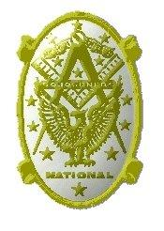
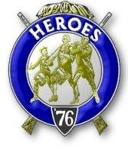
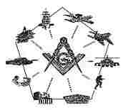
Sinclair Inlet Chapter No. 80 National Sojourners, Inc

Bremerton, Washington
Our website address is: www.telebyte.com/masons/sojourn/index.htm

Sep 2016 Newsletter

Chapter Officers 2016-2017
President | Mr. Peter Dawson | 360-779-8219 | etypebubba@aol.com
1st Vice President | MSG Robert Monroe | 360-801-2237 | robertmonroe@hotmail.com
2nd Vice President | CSCS Todd Mears | 360-286-0358 | navy.pride1987@yahoo.com
Secretary/Treasurer | Mr. Charles Yankosky | 206-780-0563 | cyankosky@yahoo.com
Marshal | MCPO Henry Carman | 360-698-4776 | hankcarman@wavecable.com
Chaplain | LTC Wendell Dutt | 253-565-5264 | wadutt@comcast.net
Color Bearer | HMC Christian Vardeleon | 360-475-4588 | cnvardeleon@yahoo.com

Hero Camp Officers 2016-2017
Commander | MSG Robert Monroe | 360-801-2237 | robertmonroe@hotmail.com
Chief of Staff | HMCM Joseph MacIntyre | 360-275-0589 | haggis@wavecable.com
Adjutant | Mr. Charles Yankosky | 206-780-0563 | cyankosky@yahoo.com

Meeting Notice!
We will meet at VFW Post #239, 190 Dora Ave, Bremerton on Friday, 9 Sep. Social hour and dinner begin at 1800, meeting at 1900 hours. Ladies and guests are always welcome at the meeting and are urged to attend.
The associated Lewis and Clark Camp of the Heroes of ’76 meets immediately following the Sojourner meeting and is open to all Heroes.
Don’t forget to wear your Medals!

Highlights of the 17 Jun. Meeting
This was installation night for our Chapter. A 4 Jun installation at Des Moines lodge didn’t work out because the host Chapter hadn’t rented the lodge in time, so the chapters went their own ways. We had 4 people present this evening, so Bro. Joe MacIntyre acted as Installing Officer and installed Bro. Peter Dawson as President and Bro. Charles Yankosky as Secretary. Bros. Joe MacIntyre and Charles Yankosky were also installed into Heroes Camp. Past Pres. Richard Dexter offered some remarks. He challenged us to pick something every month for a presentation, to make our meetings more interesting. Do something if you have it.
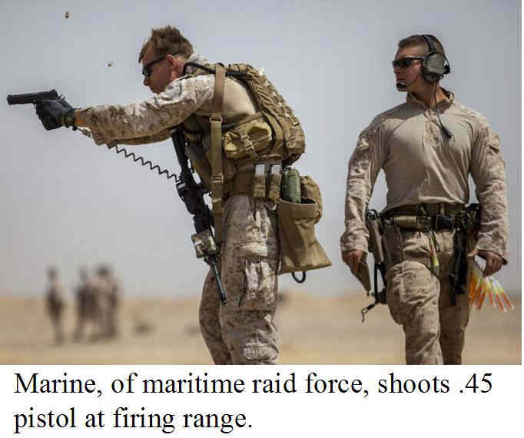
Bro. Dexter attended the Bremerton JROTC award ceremony. He offered to do “Old Glory Speaks,” but not enough time had been allotted in the program to do this. The Honor Guard was practicing. The kids did a great job. Bro. Richard told how the flag was important to him. He had a son who served in Iraq. It gave him a great deal of pleasure to present this award. The winner of the award, Cadet/Chief Adriana Fowler, was also leader of the Honor Guard. Incoming President, Peter, thanked Bro. Richard for doing this service. This way kids learn respect for the Country and for the Flag. Bro. Richard will contact the JROTC Commander and offer to do a “Build the Flag” ceremony. Our Chapter members can do it in 45 minutes.
Pres. Peter closed Chapter at 19:30. Bro. Joe MacIntyre reminded us that Pac Beach is coming up at the end of September.
P.S. A Heroes Camp was held at the Bremerton Masonic Temple on 28 Aug. Prior to opening Camp, Pres. Peter Dawson installed MSG Robert Monroe as Camp Commander. Bros. Todd Mears and Christian Verdeleon were therein made Heroes.

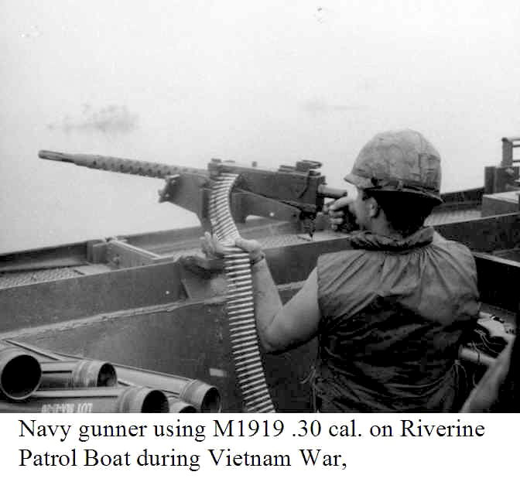
A List of 10 of the Longest Serving Weapons in the U.S. Military
By Shelby Elphick, We Are The Mighty Aug. 18, 2016

1. M1903 Springfield .30 Caliber Rifle.
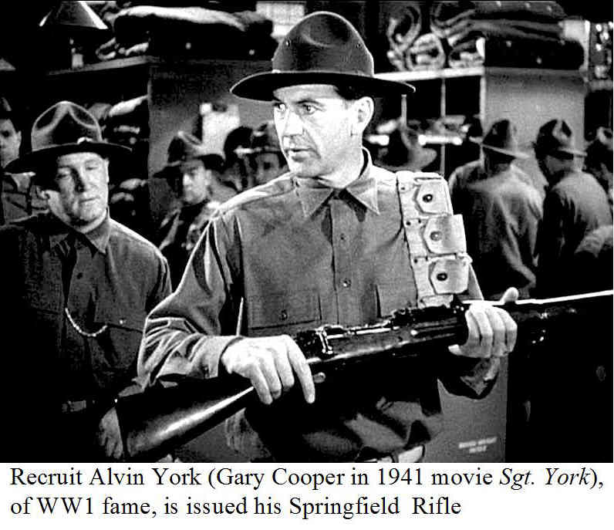
. This was the standard U.S. service rifle in WW1. It was replaced by the M1 Garand in 1937. But it was still in use when there weren’t enough M1’s to go around. The rifle was in service for 60 years, being used as a sniper rifle in Korea and Vietnam.
2. M1911 .45 caliber pistol.
Created by gunmaker John Browning, the M1911 was used for over 100 years. It was replaced by the Baretta M9 9mm pistol in the 1980’s, but still used by Special Operations units as the M45.

3. M1919 .30 caliber Machine Gun
This was an air-cooled version of John Browning’s M1917 used by U.S. troops in WW1, WW2 and Korea. It was replaced by the M60 in the 1950’s. The Navy converted surplus M1919’s to 7.62mm for use on river patrol boats in the Vietnam war.

4. M2 .50 Caliber Machine Gun.
Also designed by John Browning for use in
World War1, it went into service in 1921. Although replacements have been proposed, nothing has been found to take its place.

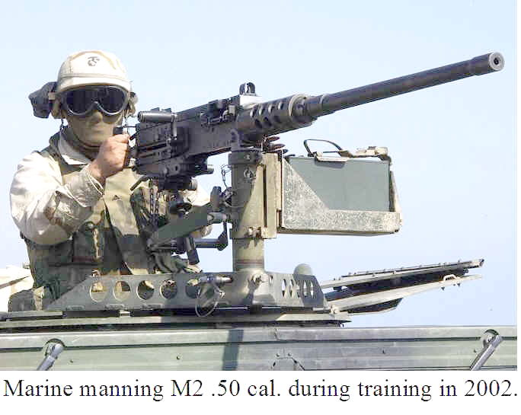
5. Boeing B-52 Stratofortress Bomber.
Designed to deliver nuclear warheads during the Cold War, it has never performed that function. Instead it has been used for conventional bombing for 60
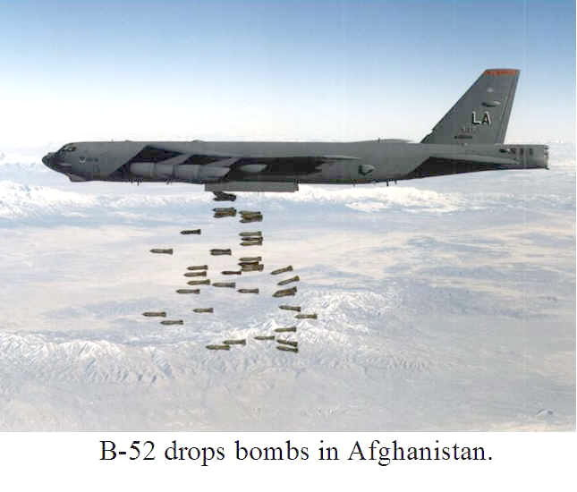
years. The Air Force plans to keep it until 2040.

6. M60 .30 Caliber Machine Gun.
Entering service in 1957, in time for the Vietnam War, it was superseded by the M240 in the 1990’s. It is still used as helicopter armament.
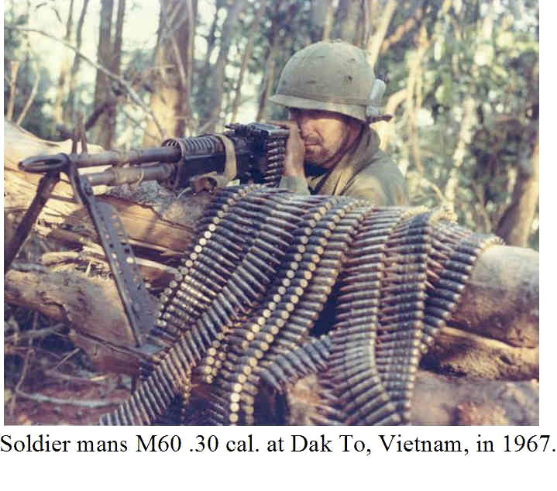
7. M14 .30 Caliber Rifle.
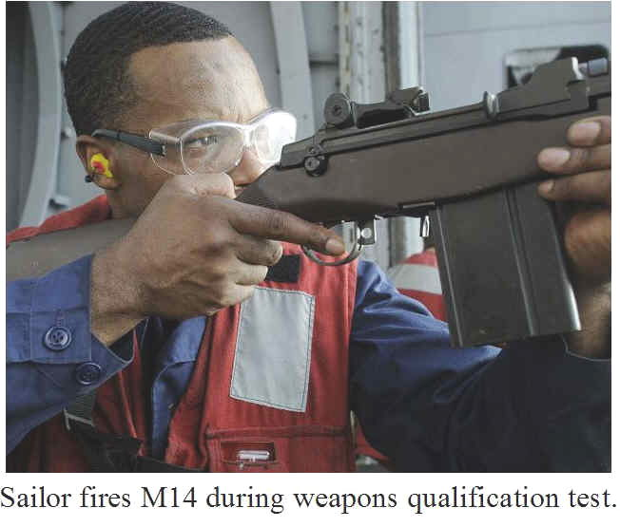
A replacement for the M1 Garand in 1959, it was itself replaced by the M16 in 1964. Used as a basis for sniper rifles, it was brought back as the M14 Enhanced Battle Rifle for the Global War on Terror.

8. M16 5.56mm Rifle/M4 Carbine.
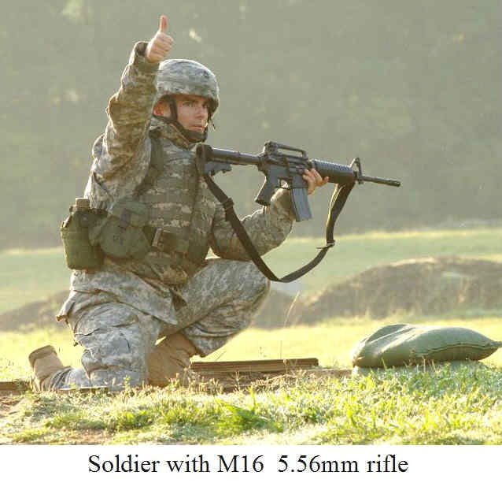
It is now the longest serving rifle for the U.S. military. Despite early reliability problems, it has gained a reputation as an effective and reliable rifle.

9. LGM-30 Minuteman Ballistic Missile.
Part of the U.S. Nuclear Triad of ballistic missile submarines, manned bombers, and intercontinental ballistic missiles, the Boeing Minuteman ICBM has been in service since 1962. It was the first missile to be able to launch multiple warheads for a greater chance
of target destruction. 450 are still operational, down from 1,000 in the 1970’s.
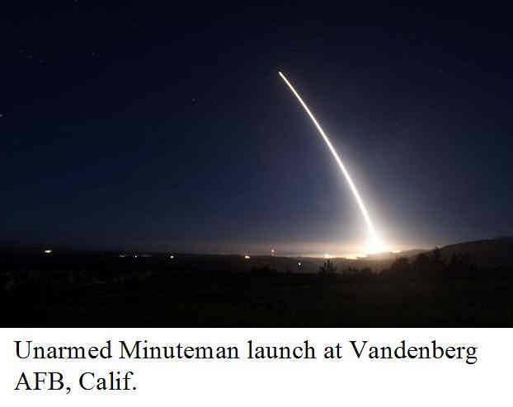
10. M61 Vulcan 20mm Cannon.
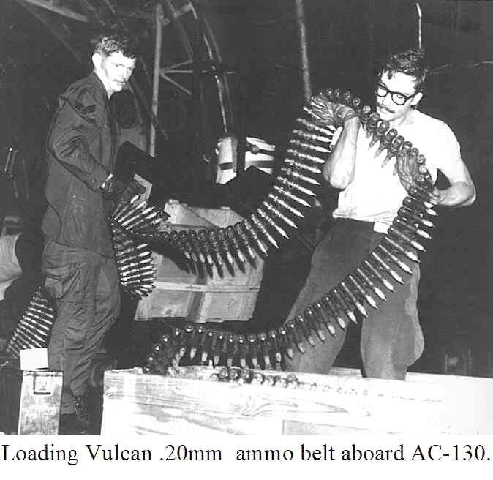
The M61 has been standard armament for fixed-wing aircraft since 1959. Used heavily during the Vietnam War, it was credited with shooting down 39 MIGs. It is still used on American fighters and by the Navy as the Phalanx CIWS.
SINCLAIR INLET No. 80 SOJOURNER MEETINGS:
2ND Friday, 7 p.m. (1900)
at VFW #239

09 Sep. 2016
14 Oct. 2016
11 Nov. 2016
09 Dec. 2016
13 Jan. 2017
10 Feb. 2017
10 Mar. 2017
14 Apr. 2017
12 May 2017
03 Jun. 2017 Installation at
Des Moines Lodge, WA.
Dark during Jul. & Aug.

