Sinclair Inlet Chapter No. 80 National Sojourners, Inc

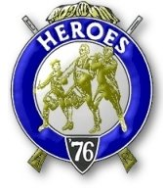

Bremerton, Washington
Our website address is: www.telebyte.com/masons/sojourn/index.htm

September 2014 Newsletter

Chapter Officers 2014-2015
President | CPO Stephen B.J. Quance | 360-731-5552 | sdquance@yahoo.com
1st Vice President | Mr. Richard Dexter | 360-692-6876 | rdexter@tscnet.com
2nd Vice President | Mr. Peter Dawson | 360-779-8219 | etypebubba@aol.com
Secretary/Treasurer | Mr. Charles Yankosky | 206-780-0563 | cyankosky@yahoo.com
Marshal | None
Chaplain | LTC Wendell Dutt | 253-565-5264 | wadutt@comsast.net
Color Bearer | None

Hero Camp Officers 2013-2014
Commander | Mr. Alex Jordan |  | jordan3614@hotmail.com
Chief of Staff | Col. William Biscomb | 206-842-6417 | hankcarman@wavecable.com
Adjutant | Mr. Charles Yankosky | 206-780-0563 | cyankosky@yahoo.com

Meeting Notice!
We will meet at VFW Post #239, 190 Dora Ave, Bremerton on Friday, 9 May. Social hour and dinner begins at 1800, meeting at 1900 hours. Ladies and guests are always welcome at the meeting and are urged to attend.
The associated Lewis and Clark Camp of the Heroes of ’76 meets immediately following the Sojourner meeting and is open to all Heroes.
Don’t forget to wear your Medals!
Highlights of the 9 May Meeting
Pres. Joe MacIntyre opened Chapter at 19:00. To night Joe brought some raffle tickets to help raise money to send a NJROTC candidate to the PLU leadership conference run by Col. Gibson this summer. Six tickets could be bought for $5. The raffle raised $40. Admission to the conference for one student is $375. We thought the conference was in August, but this year it will be held 22-26 June. So by now arrangements should already have been made. When Pres. Joe called CDR Gary Brooks of Bremerton, CDR Brooks didn’t seem to know anything about it. Pres. Joe will see about setting something up for next year. Joe said he will call Tom Dangelo about doing the South Kitsap JROTC presentation on May 19, but Bill Biscomb volunteered to do it.Last year the Sojourners were listed at #7 in the program in order of appearance, so it shouldn’t be a long evening.
No membership applications have been returned. Someone asked if we would be interested in finding another place for meetings with a variety of meals. Here the menu is always steak, baked potato, vege-tables and salad. Wendell Dutt’s travelling buddy doesn’t eat steak. He usually orders fish and chips and hasn’t come here once.
Those who said they will be going to the 7 June joint installation in Des Moines were: Dick Dexter, Alex Jordan, B.J. Quance, Joe MacIntyre, Bryan Remley, Bill Biscomb, Peter Dawson, Charles Yankosky and Hank Carman. People will have to pay their Chapter for their lunch, or else pay $20 a head at the door. Most people pay at the door. Pres. Joe also has a York Rite Grand Session that he has to attend.
Area Rep. Wendell Dutt reported that the flyer for the Pacific Beach Heroes Camp is now on the web. New rules & Responsibilities for running the Pac Beach event wil be handed out at the Installation by Jerry Earl. The late Bob Colton, who ran Pac Beach for years, had everything in his head. But when he passed a protocol needed to be written down so his successors could run it too.
MEMORIAL DAY Pres.Joe gave a talk on the up-coming holiday. On 26 May 1966 President Lyndon B. Johnson signed a presidential proclamation marking Waterloo, New York, as the birthplace of Memorial Day. This is a day for honoring the dead who died while serving in the armed forces during our country’s wars. In 1868 Gen. John A Logan, commander of the Grand Army of the Republic, a Union war veterans organization, proclaimed that Decoration Day be observed yearly and nationwide to honor those who gave their all for the Union in the great Civil War just ended.
Decorating soldiers graves with flowers is an ancient custom, observed in the U.S. before and dur-ing the Civil War. The end of May is when most flowers are in bloom. In 1915 a Lt. Col. John McCrae, of the Canadian army, wrote a poem about the poppies that grew among the soldiers graves after the Second Battle of Ypres during World War 1. A YWCA worker, Moina Michael, being inspired by the poem, wore a silk poppy pinned to her coat during a YWCA conference in 1918. By 1920 the American Legion
had adopted the poppy as their symbol of remem-brance. Madame Guerin, from France, visited the U.S., saw this custom, and made poppies to raise money for war orphans. In 1922 the VFW was the first organization to sell poppies. In 1948 the U.S. Post Office issued a 3 cent red poppy stamp.
Today many have forgotten the meaning of Memorial Day. Most people don’t know flag etiquette.
The National flag is raised to the top of the staff, then lowered to half staff until noon. After 12 noon it is raised to full staff for the rest of the day. Many have not observed Memorial Day in decades. 1,200 soldiers of the 3RD Infantry Division place flags on the graves at Arlington National Cemetery before Memorial Day. The Boy Scouts put flags on graves in 1951. Today Boy Scouts and Girl Scouts place candles on graves at the Civil War battlefield of Fredricksburg, Virginia. On Memorial Day we should observe a moment of remembrance and respect and listen to TAPS. Senator Daniel Inouye of Hawaii, a WW2 vet, introduced a bill to return Memorial Day to its original date of May 30, and kept re-introducing it until his death in 2012.
Dick Dexter recalled how just before one Memor-ial Day he and the wife were taking a body to Tahoma National Cemetery. High School kids were out there placing flags on the graves and there was a news story about it. Dick had vision problems so he never got to serve in the armed forces. Bill Biscomb noted how on Bainbridge he American Legion, assisted by the Boy Scouts, puts flags on veteran’s graves at all the island cemeteries. Bill cautioned that before you put a flag in the ground, first punch a hole with a screw driver or sharper the end of the wooden stick with a pencil sharpener. Otherwise the stick will probably break in the hard ground. Wendell reported how the Chapter 89 color guard goes out to the cemetery a 1 p.m. on Sunday and does a ceremony. All the different military organizations bring their flags. It is very impressive.
Alex Jordan picked the night’s lottery winners. Bill Biscomb got an electric knife. Wendell got a MWB John McNab watch (Joe has one too). Joe will bring more raffle tickets.
We got a combination lock for the Chapter box and Alex had it installed. $15 was received from Peter Dawson for medals.
HEROES MEETING. How many people are going to Pac Beach this October? Host camp, Chapter 40, needs to know who’s going and two candidates are required. Let #40 know if you want to bring any candidates. The National President will be there. Bill
Biscomb put out a call for four Heroes to help
“Build The Flag” at Franklin #5’s next stated meeting.

JROTC: Col. Bill Biscomb traveled to South Kit-
sap High School in Port Orchard on May 19 to present the Chapter #80 JROTC award. What was unusual is that Col. Biscomb is Army and he was giving an
award to a Navy cadet.
The Bremerton High School awards ceremony was on May 28 in Bremerton. Bro. Orville Stoner and Bro. Robert Monroe made the presentation for Chapter 80
to Cadet Jessica Froggatt. They also took some photos shown here.
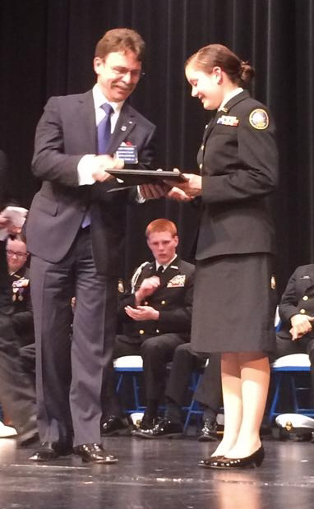
Bro. Stoner gives award to Cadet Froggatt.
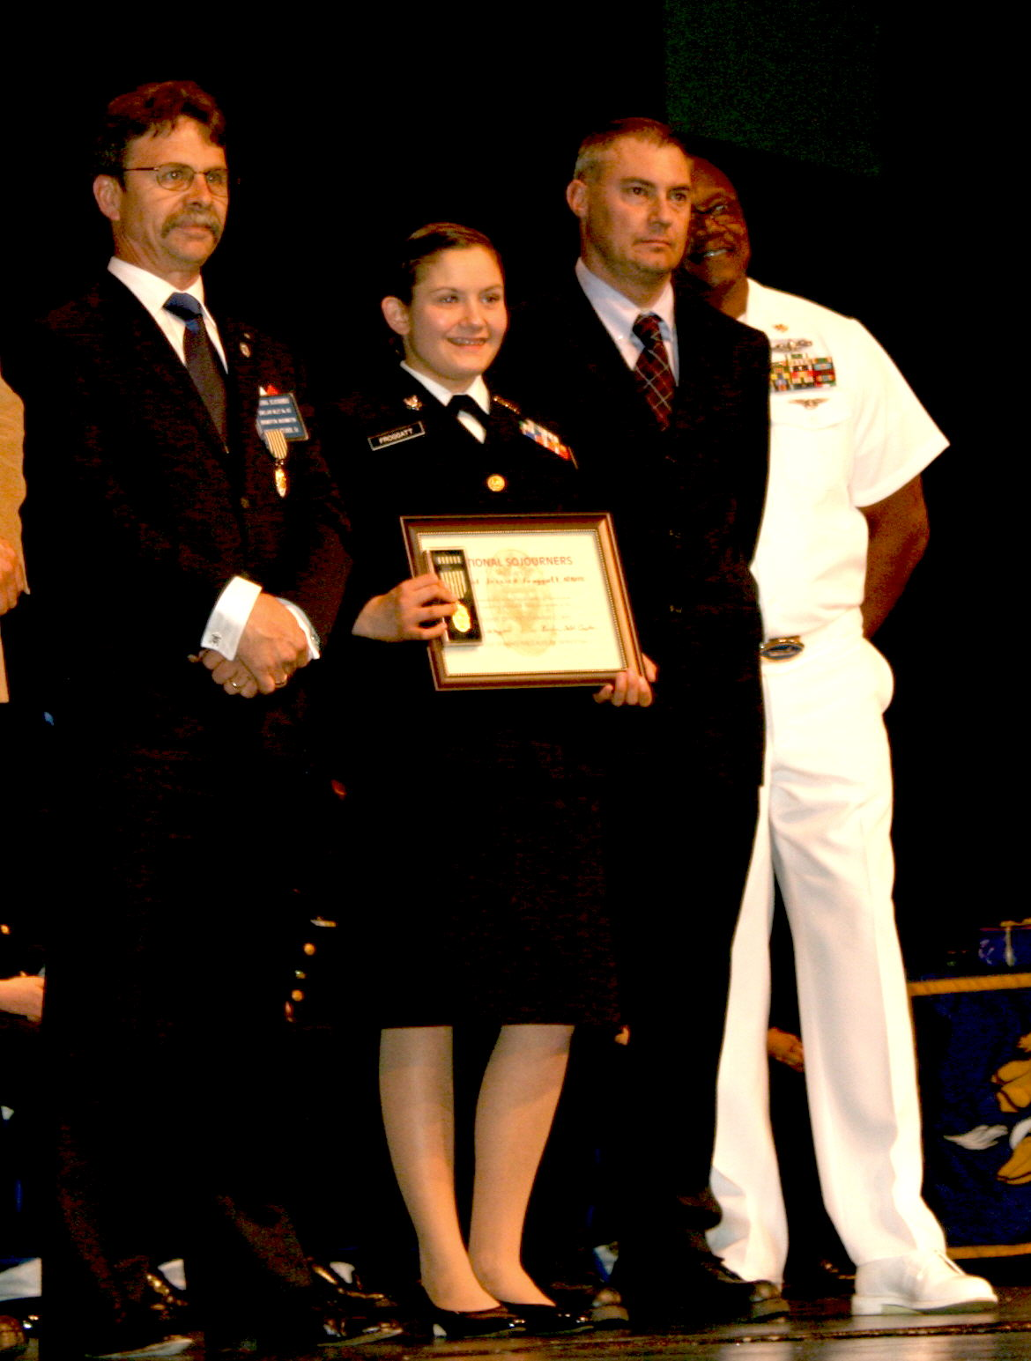
Bro. Stoner, Cadet Froggatt holding medal and
plaque, Bro. Monroe and CDR Gary Brooks
7 June Joint Installation at Des Moines
Fort Lewis Chapter #89 hosted the Joint Installation at Des Moines Lodge. This year’s Long Horn Bar BQ featured ribs and whole pieces of chicken. The Presiding Officer for Ft. Lewis #89 was Bruce Johnson. Don Patrick did “A Toast To The Flag.”
The elected and appointed officers for the ensuing year are:
V/Adm. Homer Wallin Chap. #40 Pres. James Erickson; 1ST VP Steven Dazey; 2ND VP John Kraft: 3RD VP Steven Dvirg Prodigalidad; Chap. Saturo Tashiro; Sec/Treas.Donald Beck; Marshall Travis Dean; Asst. Sec/Treas. William Harker Capt. Wm F. Gordon Heroes Com. E.W. McKinney; C.of S. James Erickson; Asst. C. of S. Gerald Earl; Chap. SatTashiro; Adj. Don Beck; OOD Virg Prodigalidad.
Sinclair Inlet Chap. #80 Pres. B.J. Quance; 1ST VP Dick Dexter; 2ND VP Peter Dawson; Chap. Wendell Dutt; Sec/Treas. Charles Yankosky. Lewis &
Clark Heroes Com. Alex Jordon; C.of S. Bill Biscomb; Adj. Charles Yankosky.
Fort Lewis Chap. #89 Pres. Frank Smith; 1ST VP
Ed Tebbutt; 2ND VP Arland Buchanan; 3RD VP James Parker; Chap. Al Luberts; Sec/Treas. Wendell Dutt; Marshall Donald Campbell; Asst. Sec/Treas. Donald Campbell. Meriwether Lewis Heroes Com. James Parker; C.of S. Don Patrick; Asst. C.of S. Ed Tebbutt; Adj. Herman Strickland III.
Spokane Chap. #102 Pres. Thomas Upchurch; 1ST VP
Joseph Baird; 2ND VP Clem Crowston; Sec/Treas.
Merle Iverson. William Clark Heroes Com. Merle
Iverson; C.of S. Thomas Upchurch; Asst. C.of S. Jo-seph Baird; Adj. Merle Iverson (protem). (Spokane Chapter not being present, the officers were installed
in abstentia.)
Pacific NW Chap. #534 Pres. Paul Steinsiek; 1ST VP Dale Thayer; 2ND VP Jerry Lounsberry; 3RD VP Mike Dilley; Sec/Treas. Doug Jerome. Thomas Casey Heroes Com. Ken Cage; C.of S. Harvey Lail; Asst. C.of S. Michael Coustance; Adj. Doug Jerome.
Olympic Chap. #539 Pres. Robert Caruthers; 1ST VP Kirk Rose; 2ND VP Thomas Dangelo; Chap. Paul Carmean; Sec/Treas. Edwin Marion; Asst. Sec/Treas. Darel Maxfield. Marvin Shields Heroes Com. Donald Williams; C.of S. Robert Caruthers; Asst. C.of S. Kirk Rose; Chap. Paul Carmean; Adj. Edwin Marion; Asst. Adj. Darel Maxfield.
The guest speaker was a representative of Wounded Warriors, a group that helps disabled vets.

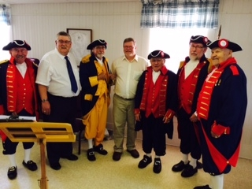
18 Jun 2014. Sinclair Inlet #80 Heroes “Build The Flag” at Franklin Lodge #5 in Port Gamble.
(L to R) Bro. Joe MacIntyre, VWB Mike Pursey (also #80 member) Dist. Deputy of the G.M. for Dist. # 12,

Bro.William Biscomb, WB Jim Shiver – Master of Franklin #5, Bro. Henry Carman, Bro. Peter Dawson, Bro. Richard Dexter.

