Sinclair Inlet Chapter No. 80 National Sojourners, Inc

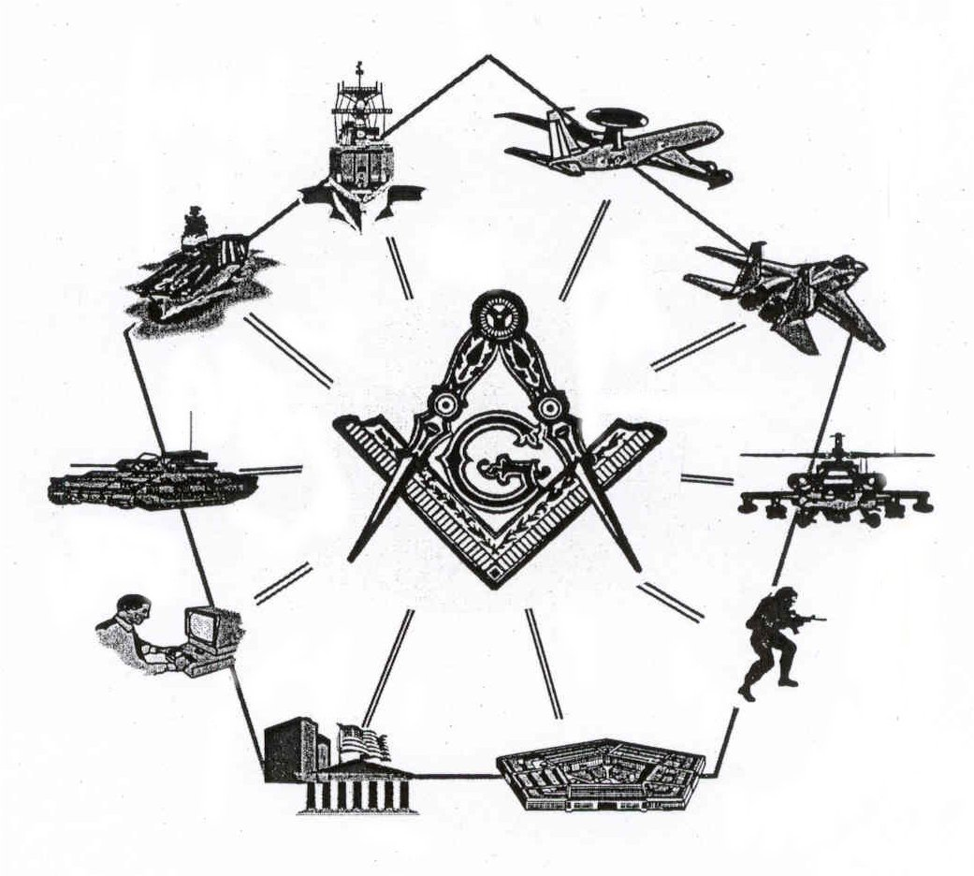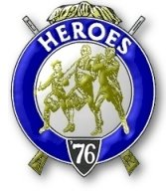

Bremerton, Washington
Our website address is: www.telebyte.com/masons/sojourn/80/sinclair_inlet_chapter.htm

September 2005 Newsletter

Chapter Officers 2005-2006
President | Col William M. Biscomb | 206-842-6417 | biscombpi@hotmail.com
1st Vice President | HMCM Joseph MacIntyre | 360-275-0589 | haggis@hctc.com
2nd Vice President | MMCM Henry T. Carman | 360-698-4776 | hankcarman@wavecable.com
Secretary/Treasurer | WTCS John M. Gray | 360-895-3188 | wtcs_sw@wavecable.com
Marshal | CWO4 Richard Patterson | 360-769-8246 | rlpatt@ix.netcom.com
Chaplain | 1LT Harold E. Richardson | 360-692-4023 | harolder46@comcast.net
Color Bearer

Hero Camp Officers 2005-2006
Commander | 1Lt Harold E. Richardson | 360-692-4023 | harolder46@comcast.net
Chief of Staff | HMCM Joseph MacIntyre | 360-692-4023 | haggis@hctc.com
Adjutant | WTCS John Gray | 360-895-3188 | wtcs_sw@wavecable.com

Meeting Notice!
We will meet at Elk’s Lodge #1181, Pine Road, Bremerton on 9 SEP. Social hour and dinner begins at 1800, Meeting at 1900 hours. Ladies and guests are always welcome at the meeting and are urged to attend.

The associated Lewis and Clark Camp of the Hero's of '76 meets immediately following the Sojourner meeting and is open to all Hero's.
Don’t forget to wear your Medals!
President’s Message
Brothers:
It is official! I and the other officers of your chapter were duly and truly installed at a joint installation on 4 June 2005. I must confide that I hoped our junior past president, Mike Pursey, was going to be "president for life". He was just getting comfortable in the position when he received a higher calling in Masonry. The honored purple of our fraternity has been draped on his shoulders and we are indeed proud that he is a member of our chapter. I won't steal his thunder, but will let him tell you all about his new office in York Rite at a future meeting.

In case you were not present at the meeting that elected your officers, let me tell you that the 1st Vice President is Master Chief Joe MacIntyre. His job is programs, and he has promised to find some interesting and informative speakers. I can't wait to see what he comes up with. The 2d Vice President is Master Chief Hank Carman (membership). He promises to beat the bushes in the lodges throughout our area to seek out eligible and valuable brothers who don't mind a social evening out with their spouses and like minded Masonic brothers. Lt Harold Richardson is our ever faithful Chaplain, Chief Warrant Officer Dick Patterson is our Marshall and last but not least, our hard working and dependable Secretary/Treasurer is Senior Chief John Gray.

I am looking forward to an enjoyable year and with your attendance and enthusiasm, a productive year in this corner of our craft.

Fraternally,
Bill Biscomb COL AUS (Ret.)

From the Desk of the Secretary
Brethren,
During Mike Pursey’s year as president, Chapter 80 made great strides in membership increases and attendance. Now we regularly have 10-15 members, wives and guests at our meetings. I want to thank him for tirelessly promoting our organization and making it fun to attend the meetings. Hey Mike, there are some openings on committees if you want to stay active! Required committees include Americanism, Bridge of Light and Membership. If anyone desires to serve on one, I can provide information on what is required. The effort required on any one of them is small. It’s only when all the work of running the chapter is attempted to be accomplished by a few individuals that the task becomes daunting. Please consider assisting your Chapter by serving on a committee.

Brothers, you should be receiving dues notices from the national office soon. Please try to pay them as soon so as to save the organization postage. Both our chapter and the national office send out second notices, which incurs more costs.

Sadly Brother William Denend passed away just prior to our May meeting so we will conduct a memorial service at the September meeting.
Fraternally,
John
Highlights of Last Meeting
The meeting opened at 1230, 4 June 05 at the Des Moines Masonic Temple for the joint installation of Chapters 40, 80, 89, 102, 534 and 539 with numerous members, ladies and guests present. Preceding the meeting, social hour began at 1100, and lunch was served at 1200. The following members of Sinclair Inlet Chapter 80 were installed in office for the year 2005-06:

William Biscomb: President, Joseph McIntyre: 1st Vice, Henry Carman; 2nd Vice, John Gray: Secretary, Richard Patterson: Marshal, Harold Richardson: Chaplin.

Lewis and Clark Camp of Heroes: Harold Richardson: Commander, Chief of Staff: Joseph McIntyre, John Gray, Adjutant. Brother MacIntyre was installed in absentia.

Sadly the passing of Brother William Denend was noted, we will conduct a memorial service at the September meeting. Joe McIntyre discussed the new Masonic License plates available, the Royal Order of Scotland by the Scottish Rite, and the 50th annual Scottish Rite Scholarship Awards being held on 27 May in Bremerton. John Gray reminded everyone of the Pancake Breakfast by William H. Upton Naval & Military Lodge #206 on the morning of the Bremerton Armed Forces Day Parade and Bethel 43, Jobs Daughter Installation at Hood Canal Lodge on 14 May. The President commented on the good year we had as a Chapter, particularly in the areas of membership growth and attendance. There being no further business, the meeting ended at 1945, peace and harmony prevailing.

Lewis & Clark Camp of the Hero's of '76 News

Minutes of the 13 May 05 Lewis and Clark Heroes Camp Meeting:
Opened at 1946, Commander Harry Houston reviewed the Bivouac held on 9 April at the Bremerton’s Elks Lodge. Meeting closed at 1950.

