Sinclair Inlet Chapter No. 80 National Sojourners, Inc

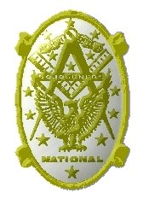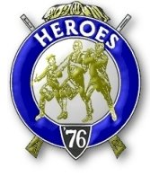

Bremerton, Washington
Our website address is: www.telebyte.com/masons/sojourn/index.htm

October 2013 Newsletter

Chapter Officers 2013-2014
President | HMCM Joseph MacIntyre | 360-275-0589 | haggis@wavecable.com
1st Vice President | CPO Stephen Quance | 360-731-5552 | sdquance@yahoo.com
2nd Vice President | Mr. Richard Dexter | 360-692-6876 | rdexter@tscnet.com
Secretary/Treasurer | Mr. Charles Yankosky | 206-780-0563 | cyankosky@yahoo.com
Marshal | None
Chaplain | LTC Wendell Dutt | 253-565-5264 | wadutt@comsast.net
Color Bearer | None

Hero Camp Officers 2013-2014
Commander | Mr. Peter Dawson | 360-779-8219 | etypebubba@aol.com
Chief of Staff | MMCM Henry Carman | 360-698-4776 | hankcarman@wavecable.com
Adjutant | Mr. Charles Yankosky | 206-780-0563 | cyankosky@yahoo.com

Meeting Notice!
We will meet at VFW Post #239, 190 Dora Ave, Bremerton on Friday, 11 Oct. Social hour and dinner begins at 1800, meeting at 1900 hours. Ladies and guests are always welcome at the meeting and are urged to attend.
The associated Lewis and Clark Camp of the Heroes of ’76 meets immediately following the Sojourner meeting and is open to all Heroes.
Don’t forget to wear your Medals!
Highlights of the 13 Sep Meeting
Pres. Joe MacIntyre opened the meeting at 19:00.
A petition was read from a prospective member
who was due to check in with his unit at Fort Lewis
that week. The petitioner is a member of Mystic Tie #1032 in Germany. This reference was checked against the book of regular lodges for verification. The peti-tioner plans to retire from the Army in two years and is glad to be moving here, rather than to Tacoma. He has a 16 year old son who will be talked to about Demolay. After the service he plans to go to college in hopes of getting a leg up in getting a job. He is interested in going into law enforcement. Dick Dexter made a motion to admit him, seconded by Bill Biscomb. The Motion was approved. Pres. Joe will be in Portland at the next meeting. The candidate will be invited bto the next meeting. At the last meeting blank petitions were
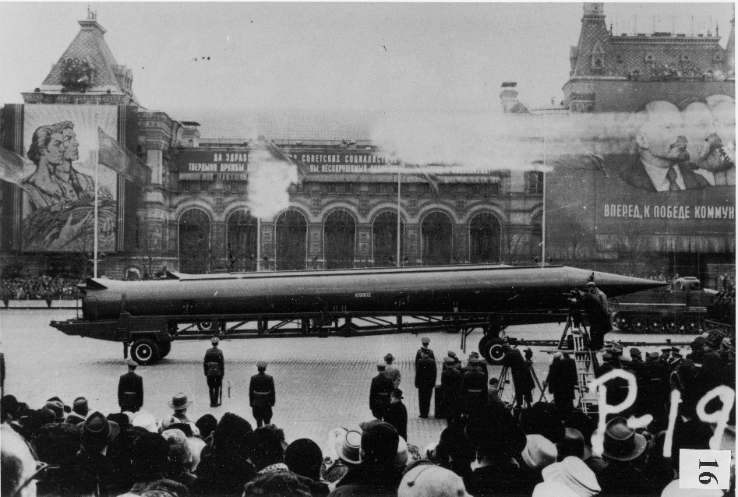
given to everyone. But many members were too busy working on Scottish Rite, since fall is when the degree work is done.
Pres. Joe MacIntyre did a good job as Master of Ceremonies at the Des Moines Installation. It was
Joe’s idea to charge a flat $20. 40+ people attended.
Joe will be charging $45 for a banquet coming up,
which includes an open bar.
The deadline for making reservations for the
Pacific Beach Heroes camp is today. Joe MacIntyre and Peter & Mrs. Dawson will be there. Changing the date
to October cuts costs by 1/3. Jerry Earl said at least 31 people plan to come. The National Sojourners
National Commander was invited, but it is not known
if he will attend. Please get worn out flags for Peter or Joe to take to Pac Beach for retirement.
Area Rep Wendell Dutt reported that at the National Convention there weren’t enough votes so
both the Resolutions failed. The resolutions were to
open membership up all Master Masons and change NCO requirements to include grade E-5 and above.
The hotel was across the street from the Alamo. Ron Hale gave a presentation of William Travis’s “Victory
or Death” Alamo speech in 100 degree heat.
Please support the Masonic Concert to be held in Bremerton on Nov. 16.
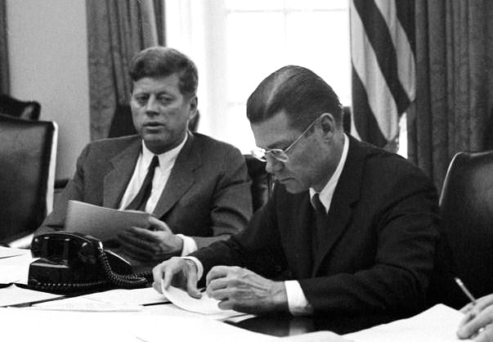
Chapter was closed at 19:45. Immediately fol- lowing a Heroes Camp meeting was held to discuss arrangements for Pacific Beach on Oct. 4, 5 & 6.

Missiles of October – The Cuban Missile Crisis, October 14 – 28, 1962
For 13 days in October 1962 the U.S. and Soviet Union came the closest to a nuclear conflict during the entire Cold War era. The term “Mutual assured destruction” (MAD) was first used .
Fidel Castro, being afraid of a U.S. invasion of
Cuba, asked Soviet Premier Khrushchev to do what
ever was needed to convince the U.S. that any attack
on Cuba was the same as an attack on the Soviet
Union. Khrushchev suggested placing Soviet nuclear missiles in Cuba to deter U.S. invasion. After a secret agreement in July,work began on several missile sites.

Soviet R-12 (NATO SS-4) intermediate range
nuclear ballistic missile in Red Square.

On Oct. 14, reconnaissance flights by Air Force U-2 spy planes got photographic evidence of medium and intermediate range ballistic missiles in Cuba. The U.S. considered an air/sea invasion but decided on a
blockade instead. Since a “blockade” is an act of war, the term “quarantine of offensive weapons” was used. . The U.S. would not permit offensive weapons to be
sent to Cuba and demanded that those already there be taken apart and sent back to Russia.
Premier Khrushchev sent a letter to President Kennedy on Oct. 24 charging that the U.S. blockade of international waters was “an act of aggression propel-ling human kind into the abyss of a world nuclear war.”
However, at the same time, the Premier and the Pres-ident were holding secret back door negotiations to try
to resolve the crisis.
President Kennedy and Secretary of Defense Robert McNamara at an EXCOMM meeting. On Oct. 22, Kennedy convened 9 members of the National Security Council and 5 other advisors as a group called the Executive Committee of the National Security Council (EXCOMM).

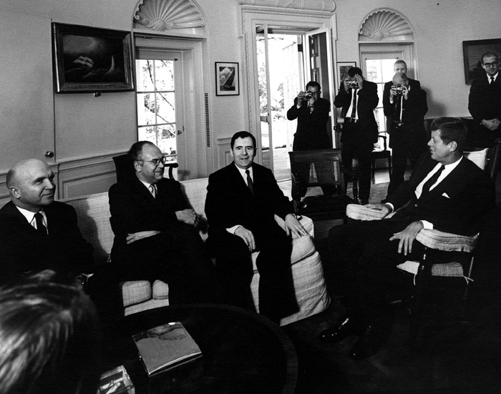
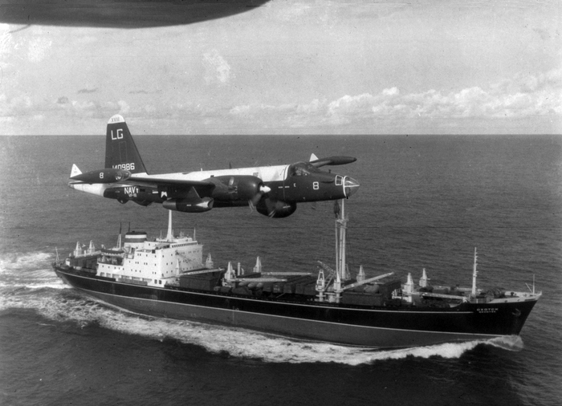
President Kennedy meets with Soviet Foreign Minister
. Andrei Gromyko in the Oval Office, Oct. 18, 1962.
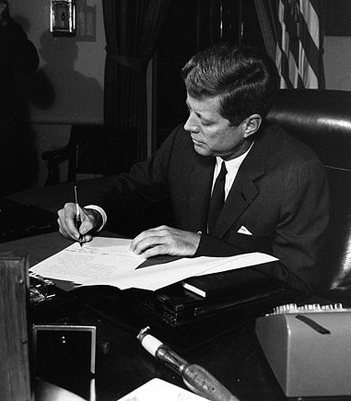
On Oct. 22 at 7 pm EDT, President Kennedy gave a nationally televised address announcing the discovery of missiles in Cuba.
The President signs the Quarantine Proclamation in the Oval
Office at 3 pm EDT Oct. 23.
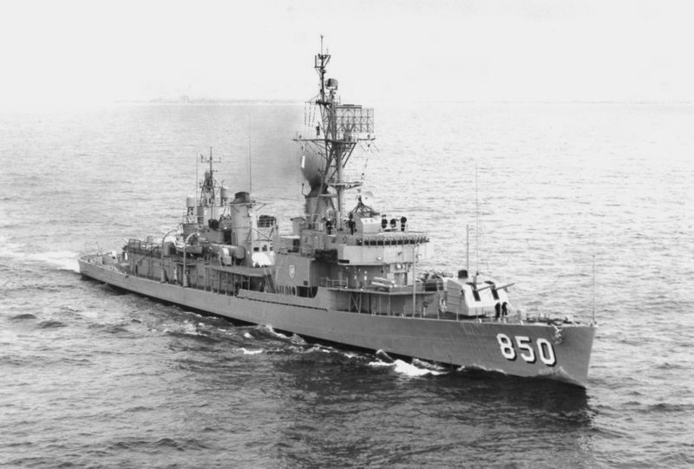
Gearing class destroyer Joseph P. Kennedy, Jr. , named
for the President’s brother, boarded Lebanese freighter Marucla
on Oct. 26. No weapons were found & ship allowed to proceed.
U.S. Navy P-2H Neptune of VP-18 flying over Soviet
freighter with crated IL-28’s on board during crisis.

While talks were going on several Russian ships
tried to run the blockade. Orders were given to U.S. Navy ships to fire warning shots, then open fire. On
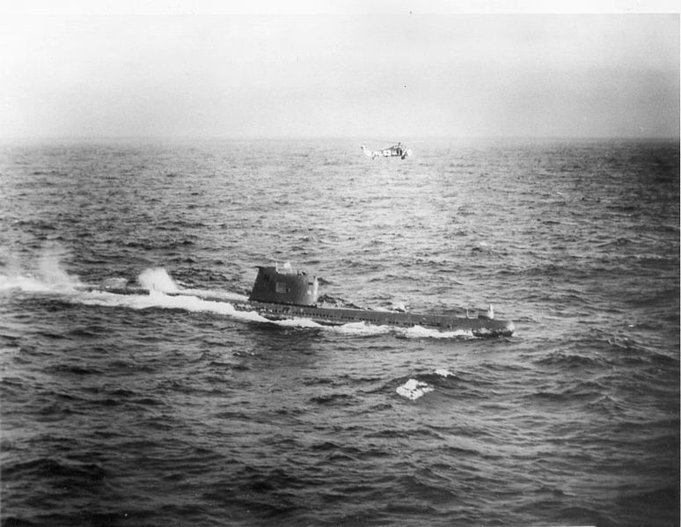
Oct. 27 a U.S. U-2 plane was shot down and the pilot killed by a Soviet SAM missile. Rather than retaliate, President Kennedy held back and let the negotiations continue.
U.S. Navy HSS-1 Seabat helicopter hovers over Russian
sub B-59, forced to surface by U.S. Naval forces near Cuba
Oct. 27, 1962.

The crisis was resolved on Oct. 28 when Kennedy and U.N. Secretary-General U. Thant came to an agreement with Khrushchev. The Russians agreed to dismantle their offensive weapons in Cuba and take them back to the Soviet Union. U.N. observers would verify that this was done. In exchange the U.S. was to agree never to invade Cuba. Secretly the U.S. also agreed to remove Jupiter ICBM’s from Turkey and Italy that were aimed at the Soviet Union. The blockade was lifted on Nov. 20, 1962 after the Soviet missiles and bombers left Cuba.
The tense negotiations showed the need for quick and direct communication between Washington and Moscow, so a Hot Line telephone link between the
two capitols was put in place.

The first batch of R-12 missiles had arrived in
Cuba on the night of Sep 12, then another on Sep. 16.
The R-12 was an intermediate range ballistic missile capable of carrying a megaton-class nuclear warhead 2,000 miles. The Soviets were building 6 sites for the
R-12 and 3 for the R-14 (with a 2,800 mile range).
The plan was to target the entire continental U.S.
with 40 launchers.
When this information was brought to the Presi-dent’s EXCOMM committee, several responses were
proposed.
- Do nothing. Soviet missiles in Cuba made little difference to the military balance of power.
- Diplomacy. Put diplomatic pressure on the Russians to remove the missiles.
- Warning. Warn Castro of the danger he and . Cuba were in.
- Blockade. Use the Navy to stop more missiles from arriving.
- Air Strike. Have the Air Force bomb all known missile sites.
- Invasion. Invade Cuba to overthrow Castro.
The Joint Chiefs of Staff felt invading Cuba was
the only solution. Kennedy felt that attacking Cuba
would make the Soviets seize Berlin.
Called to the Oval Office on Oct. 18, Soviet
Foreign Minister Andrei Gromyko claimed the
weapons were for defensive purposes only.
By Oct. 19 the U.S. military was put on high
alert to enforce the blockade and be ready to invade Cuba at a moments notice.
On Oct. 22 the President went on national TV to announce the discovery of the missiles and the next
day signed the Quarantine order. Khrushchev’s letter
stating that the U.S. blockade constituted an act of aggression and piracy came on Oct. 24.
Adlai Stevenson showed aerial photos of the
missiles in Cuba to the United Nations on Oct. 25.
The next day the readiness level of the Stategic
Air Command was raised to DEFCON 2 with 1/8 of
SAC’s 1,436 bombers airborne and 145 ICBM
missiles on ready alert. Twenty three B-52’s, armed
with nuclear bombs, orbited within striking distance of the U.S.S.R.
Fourteen Soviet ships, presumably carrying weapons, turned back from the blockade that day.
With the President still leaning toward a military option to get rid of the Cuban missiles, the Pentagon planned an Operation Mongoose. Cuban sabotage units would attack the missile sites and install a new govern-ment after an invasion.
A U-2, piloted by USAF Maj. Rudolf Anderson, was shot down over Cuba by a surface to air missile on Oct. 27. The pilot was killed. Rather than attack, Kennedy decided not to act unless another attack was made.
Also on this Black Saturday, Oct. 27, the destroyer U.S.S.Beal dropped signaling depth charges (the size of hand grenades) on Soviet submarine B-59, forcing it to surface. The Americans were unaware that the sub was armed with a nuclear-tipped torpedo, with orders to use it if a hole was punched in the sub’s hull by depth charges or gun fire. But firing the torpedo required the agreement of the 3 officers on board. Even though the captain wanted to fire, the third officer wouldn’t give his consent. Firing a nuclear-tipped torpedo at U.S. Navy ships, alone, could have started a nuclear war.
Robert Kennedy recalled the mood in Washington that weekend. All hope had not been abandoned, but what hope there was rested with Khrushchev reversing his course within the next few hours. A military con-frontation was expected by Tuesday, maybe tomorrow.
Finally, on Oct. 28, Khrushchev backed down and issued orders to cease work at the missile sites, and dismantle and return the weapons to the Soviet Union. Forty two missiles were loaded onto 8 Soviet ships and left Cuba between Nov. 5-9. The U.S. government called off the blockade at 6:45 pm EST on Nov. 20, 1962.
It is now known that the Soviets had deployed 100 tactical nuclear weapons in Cuba, to be launched at the discretion of the local Soviet commander. A U.S. air strike and invasion probably would have resulted in a nuclear response against American ships and troops
and possibly even Miami. Moscow didn’t trust
Castro with 100 Hiroshima-sized atomic bombs.
Anastas Mikoyan negotiated with Castro for the
return of the weapons, arguing that it was against
Soviet law (actually there is no such law) to per-manently hand the weapons over to the Cubans. The tactical nuclear weapons were returned to the Soviet Union in Dec. 1962.

