Sinclair Inlet Chapter No. 80 National Sojourners, Inc

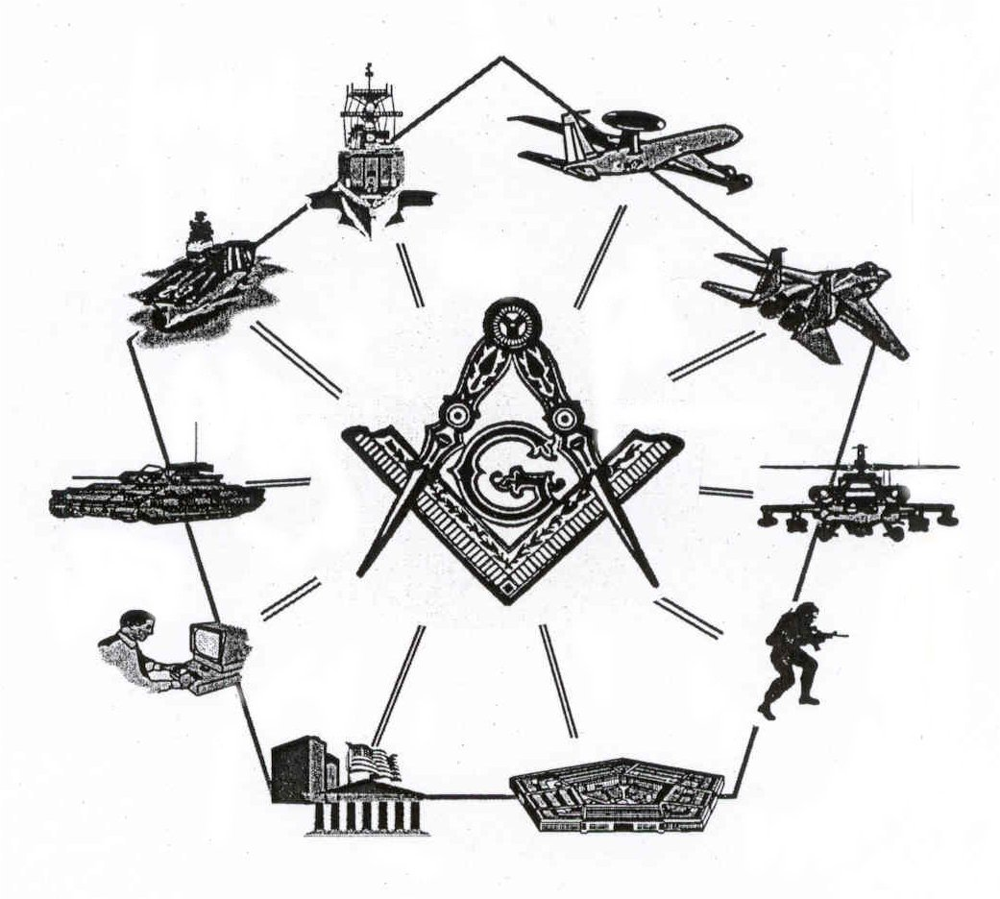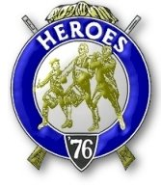

Bremerton, Washington
Our website address is: www.telebyte.com/masons/sojourn/80/sinclair_inlet_chapter.htm

October 2005 Newsletter

Chapter Officers 2005-2006
President | Col William M. Biscomb | 206-842-6417 | biscombpi@hotmail.com
1st Vice President | HMCM Joseph MacIntyre | 360-275-0589 | haggis@hctc.com
2nd Vice President | MMCM Henry T. Carman | 360-698-4776 | hankcarman@wavecable.com
Secretary/Treasurer | WTCS John M. Gray | 360-895-3188 | wtcs_sw@wavecable.com
Marshal | CWO4 Richard Patterson | 360-769-8246 | rlpatt@ix.netcom.com
Chaplain | 1LT Harold E. Richardson | 360-692-4023 | harolder46@comcast.net
Color Bearer

Hero Camp Officers 2005-2006
Commander | 1Lt Harold E. Richardson | 360-692-4023 | harolder46@comcast.net
Chief of Staff | HMCM Joseph MacIntyre | 360-692-4023 | haggis@hctc.com
Adjutant | WTCS John Gray | 360-895-3188 | wtcs_sw@wavecable.com

Meeting Notice!
We will meet at Elk’s Lodge #1181, Pine Road, Bremerton on 14 OCT. Social hour and dinner begins at 1800, Meeting at 1900 hours. Ladies and guests are always welcome at the meeting and are urged to attend.

The associated Lewis and Clark Camp of the Hero's of '76 meets immediately following the Sojourner meeting and is open to all Hero's.
Don’t forget to wear your Medals!
President’s Message
Fellow Sojourners:
I was talking with a past master the other day. He incidentally retired from the Navy many years ago. Guess what? He had never heard of National Sojourners. Not really surprising, I guess, because rarely do our members talk about the organization. That prompted me to obtain some pamphlets from our secretary and bring them to the next meeting of my Blue Lodge. At the "for the good of Masonry" time, I read the purposes of National Sojourners as printed in the pamphlet. After the meeting, I handed out one pamphlet to a former officer. Another officer, on active duty, approached me and said he was a member of Sojourners while stationed on Guam. So you see, "IT DOES PAY TO ADVERTISE".
Talk it up in your own lodge. Have some pamphlets at the ready. Mention that our opening ritual is minimal, there is no obligation to memorize, the dues are also minimal and the fellowship is maximum. Bear in mind that if nothing else, our meeting is a good excuse to take the bride out to dinner. In our "area of operations" we fortunately have a number of military installations, large and small: Bremerton and Bangor and Keyport and don't forget the Naval Hospital also at Bremerton. I am certain Sojourner-eligible Masons are members of one of the Masonic bodies you belong to. So bring a brother Mason as your guest to the next meeting. Can't think of anyone this minute? Then come yourself. We want to see your smiling face.
See you at our October meeting.
Fraternally,
Bill Biscomb COL AUS (Ret.)
From the Desk of the Secretary
Brethren,
I encourage all members who are not members in perpetuity to take note of the $50 price increase effective 1 JAN 2006. If you want to purchase a MIP on the payment plan, you need to send a monthly check, minimum payment $25.00, to the National Headquarters with a note telling them you are purchasing a MIP by payments. The address is:

NATIONAL SOJOURNERS, INC.
8301 East Boulevard Drive
Alexandria, Virginia 22308-1399

Make the check out to: National Sojourners Trust Fund. They will keep a running total of what you have paid and send me a copy of your total. Once you reach $200, you’re done!
If you have any more questions let me know.
Highlights of Last Meeting
The meeting opened at 1900, 9 SEP 05 by President Bill Biscomb. Read the minutes of the 4 JUN 05 meeting. Treasurers balance: $1853.97. A memorial service was conducted for Brother William Denend who passed away on 9 MAR 2005. Correspondence was read. Unfinished Business: The secretary was reminded that nametags were needed for Leonard Altig and Tom Lou. New Business: Steve Seteroff discussed the WA State sojourners list provided to the chapters by Wayne Smith. He also discussed the Freedoms Foundation at Valley Forge and Youth Leadership Conference programs, with emphasis on the Bremerton Scottish Rites funding of youth groups, particularly the DeMolay. Brother Dutt expounded on the local PLU program. The president presented Mike Pursey with a Past President certificate. Wendell Dutt gave a report on the National Meeting and on the various resolutions addressed. Of particular importance was the passing of the new MIP cost of $250 effective 1 JAN 2006. Dual MIP’s remain at $150. He also reported that Brother Joseph W. Illes was awarded the prestigious Houghton Memorial Award. Announcements: Brother Seteroff reminded everyone of the Pacific Northwest Encampment on 30 SEP -2 OCT. There being no further business, the meeting ended at 1950, peace and harmony prevailing.
Lewis & Clark Camp of the Hero's of '76 News

No meeting conducted.

