Sinclair Inlet Chapter No. 80 National Sojourners, Inc

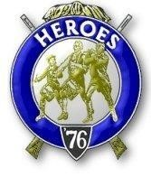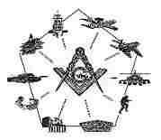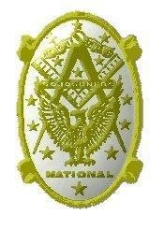
Bremerton, Washington
Our website address is: www.telebyte.com/masons/sojourn/index.htm

Nov 2016 Newsletter

Chapter Officers 2016-2017
President | Mr. Peter Dawson | 360-779-8219 | etypebubba@aol.com
1st Vice President | MSG Robert Monroe | 360-801-2237 | robertmonroe@hotmail.com
2nd Vice President | CSCS Todd Mears | 360-286-0358 | navy.pride1987@yahoo.com
Secretary/Treasurer | Mr. Charles Yankosky | 206-780-0563 | cyankosky@yahoo.com
Marshal | MCPO Henry Carman | 360-698-4776 | hankcarman@wavecable.com
Chaplain | LTC Wendell Dutt | 253-565-5264 | wadutt@comcast.net
Color Bearer | HMC Christian Vardeleon | 360-475-4588 | cnvardeleon@yahoo.com
Hero Camp Officers 2016-2017
Commander | MSG Robert Monroe | 360-801-2237 | robertmonroe@hotmail.com
Chief of Staff | HMCM Joseph MacIntyre | 360-275-0589 | haggis@wavecable.com
Adjutant | Mr. Charles Yankosky | 206-780-0563 | cyankosky@yahoo.com

Meeting Notice!
We will meet at VFW Post #239, 190 Dora Ave, Bremerton on Friday, 11 Nov. Social hour and dinner begin at 1800, meeting at 1900 hours. Ladies and guests are always welcome at the meeting and are urged to attend.
The associated Lewis and Clark Camp of the Heroes of ’76 meets immediately following the Sojourner meeting and is open to all Heroes.
Don’t forget to wear your Medals!

Highlights of the 14 Oct. Meeting President Peter Dawson opened Chapter at 1900, who thanked those members who attended for coming out on such a rainy night. Previous minutes were accepted as published. A Motion was made by Bro. Wendell Dutt to pay the $80.30 to get our 3-6-5 Club Streamer. Motion was seconded by Bro. Hank Carman and approved.
Per Area Rep. Wendell Dutt, we need to drop all the stuff in our ritual referring to Officers and Warrant Officers. At the National Convention it was decided to open membership up to Master Masons of all ranks in the Armed Forces. Look out for possible candidates for membership and just approach them, since all vets are now eligible.
Bro. Wendell Dutt gave his observations on Pac Beach. Chapter #534 ran a good program. The recruit was provided by #534. The National Heroes Commander and National President were there. 35 to 38 Sojourners attended. The Hospitality Room served soft drinks to comply with regulations. Next year the location of the conference is up for grabs. Storms damaged the big room and we don’t know if the remodeling will be done in time for us to use it. There will be no catering. The kitchen will be turned into a restaurant. Harvey Lail and Marion Windell will let us now if we can go to Pac Beach or have to go somewhere else.
Planning is under way for the 2019 Grand Lodge
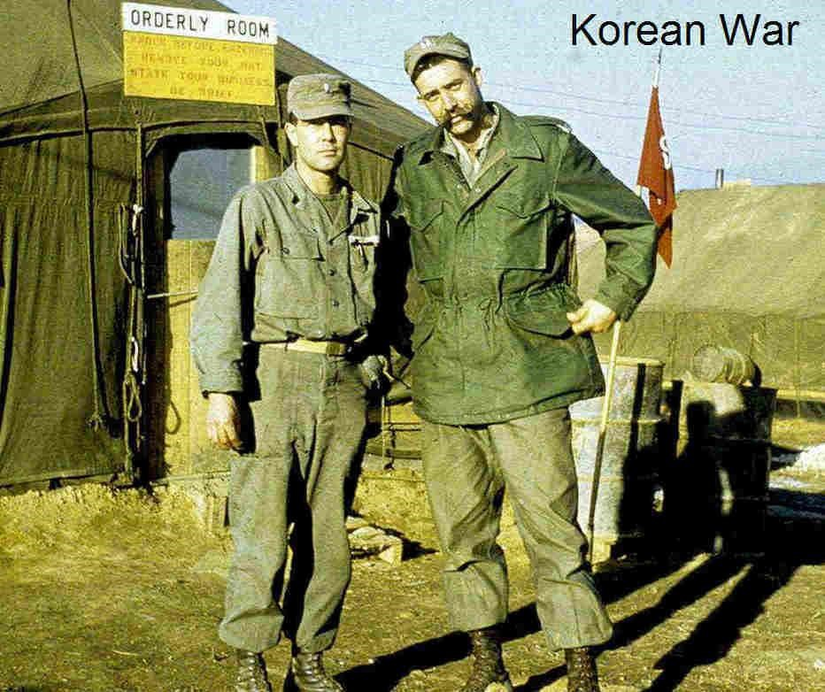
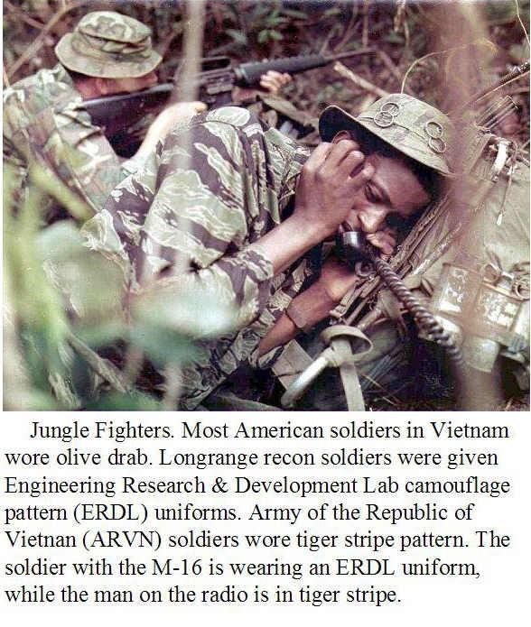
Annual Communication to be held in Bremerton. Bro, Hank Carman proposed that our President or Rep. pitch to RWB Jim Kendell that Chapter #80 participate to some degree in the convention. Since Bremerton is a seaport it will have a nautical theme. Perhaps we should offer to do colors for the Grand Lodge opening ceremony. The Honor Guard will be from Chapter #40. RWB Jim Kendall came up through the ranks as a mustang to retire as a Lt. Commander. Chapter closed at 1930 so we could get home before the big storm (not that big really).

Years of Army Uniforms (Part 2) 1950 to Present

In 1952 an Olive green shade uniform was adopted by the U.S. Army. During the Korean War solders in some units were ordered to sew white name tape and/or “U.S. Army” onto their uniforms. The Sec- retary of the Army made “U.S. Army” mandatory on uniforms in 1953.
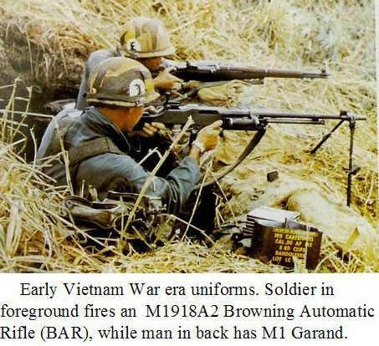

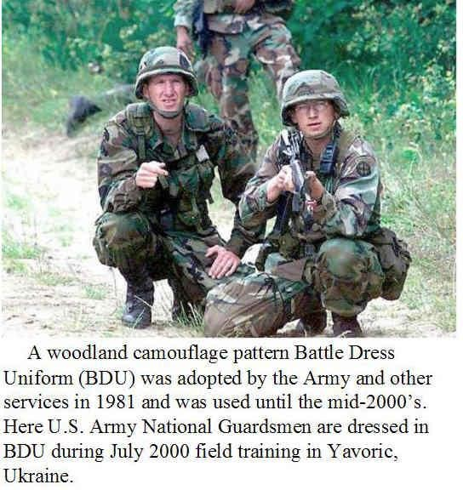
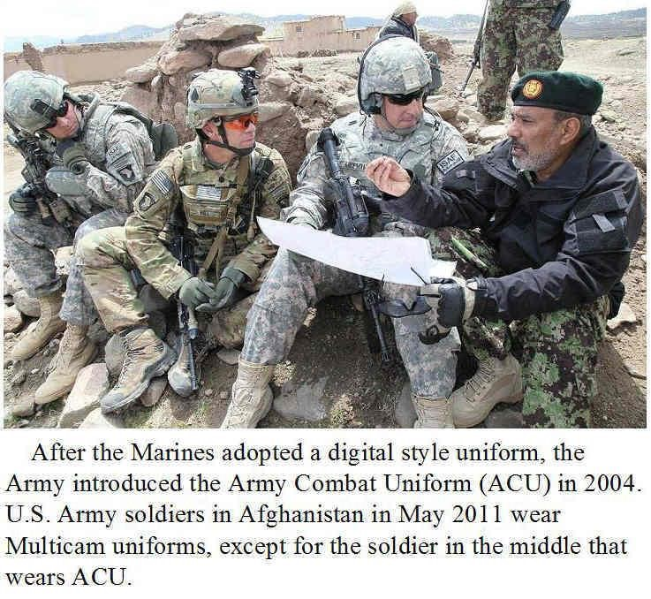
The transition to Operational Camouflage Pattern

Army Combat Uniform (ACU) from all the other styles
is a long process. But the Sgt. Major of the Army
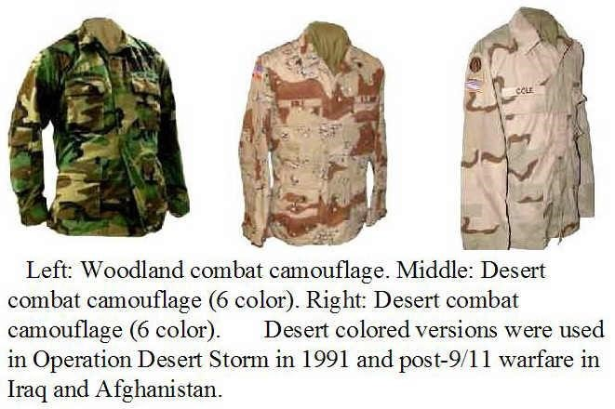
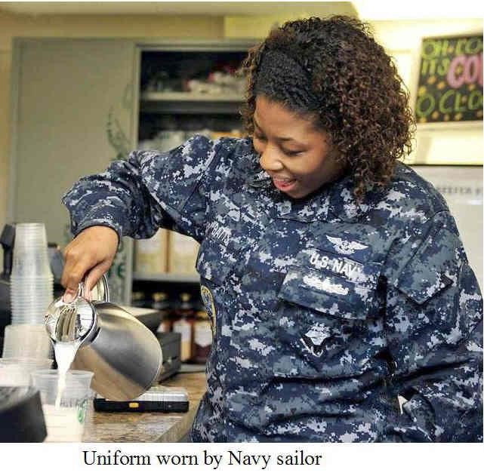
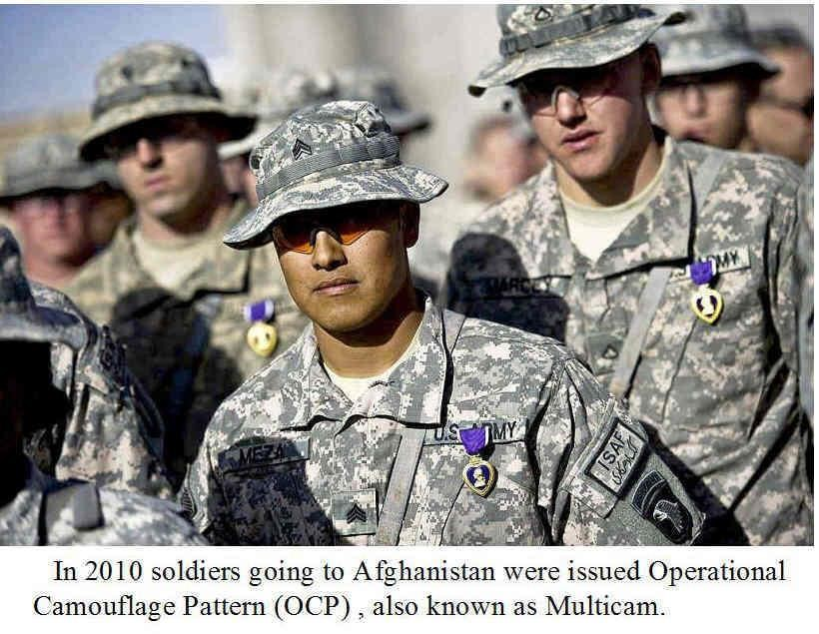
stressed that we still have the most lethal fighting force in the world, even though our belts won’t match for a few years.

