Sinclair Inlet Chapter No. 80 National Sojourners, Inc

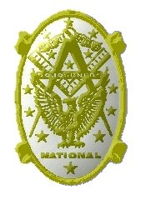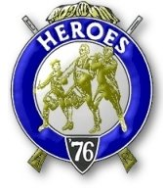

Bremerton, Washington
Our website address is: www.telebyte.com/masons/sojourn/index.htm

November 2015 Newsletter

Chapter Officers 2015-2016
President | Mr. Richard Dexter | 360-692-6876 | rdexter@tscnet.com
1st Vice President | Mr. Peter Dawson | 360-779-8219 | etypebubba@aol.com
2nd Vice President | MM1 Orville Stoner | 360-782-2385 | ovstoner@comcast.net
Secretary/Treasurer | Mr. Charles Yankosky | 206-780-0563 | cyankosky@yahoo.com
Marshal | CSCS Todd Mears | 360-286-0358 | navy.pride1987@yahoo.com
Chaplain | LTC Wendell Dutt | 253-565-5264 | wadutt@comsast.net
Color Bearer | None

Hero Camp Officers 2013-2014
Commander | Col. William Biscomb | 206-842-6417 | milfordbiscomb@comcast.net
Chief of Staff | HMCM Joseph MacIntyre | 360-275-0589 | haggis@wavecable.com
Adjutant | Mr. Charles Yankosky | 206-780-0563 | cyankosky@yahoo.com

Meeting Notice!
We will meet at VFW Post #239, 190 Dora Ave, Bremerton on Friday, 13 Nov. Social hour and dinner begin at 1800, meeting at 1900 hours. Ladies and guests are always welcome at the meeting and are urged to attend.
The associated Lewis and Clark Camp of the Heroes of ’76 meets immediately following the Sojourner meeting and is open to all Heroes.
Don’t forget to wear your Medals!
Highlights of the 9 Oct. Meeting
President Richard Dexter opened the meeting at 1900. Area Rep Wendell Dutt reported that the new staff directories and Sojourner Items Price List are in the mail. Wendell commented that it is a lot harder to get a Chapter Excellence award now. Per National Regulations, a chapter has to hold a family activity, initiate 4 new members, have a Bridge of Light event, hold a Lodge of Military Tribute, conduct a veterans’ event (such as on Memorial Day or Veterans’ Day), and present ROTC medals. A past first place winner in the Essay contest was from Fort Lewis #89.
Marshall Hank Carman presented Bro. Scott Coykendall for induction. Bro. Wendell Dutt gave the purposes of National Sojourners. The Sojourner Medal Lecture was presented by Bro. Hank Carman. Pres. Dick Dexter congratulated Bro. Scott on joining.
We talked Bro. Orville Stoner, Sr. received his Heroes’ degree. He had a great time. Two new Heroes were made and there were 35 brothers there, 7 from Sinclair chapter. Any Sojourner can attend the dinner and functions, except the degree if for Heroes only. Unfortunately the Hospitality Room closed at noon on Saturday. It used to be open all the time. We provided the refreshments.
Area Rep. Wendell announced that the Mid Winter convention is coming up in Austin, TX on
14-16 Jan. 2016. The meeting will be at the Crown Plaza Hotel in North Austin. The location had been changed from Oklahoma City. Wendell said that the national convention in June is still up for grabs. The resolutions will be set by the Committee of 33, of which Wendell is a member.

THE NIKE MISSILE

The U.S. Army’s Nike Ajax was the world’s first operational Surface to Air missile. It was designed to defend against planes flying 500 mph at 50,000 feet. Nike missiles (named after the Greek goddess of Victory) were seen as a last line of defense should enemy bombers break through the Strategic Air Command’ s long range fighter interceptor shield. The Nike system formed a protective ring around major military and population centers in the U.S. and over- seas bases. It was also used by U.S. allies in Europe and Asia.
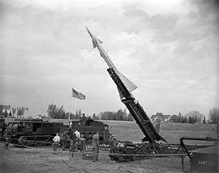
The introduction of jet aircraft toward the end of World War 2 made antiaircraft guns ineffective. Anti aircraft gunnery requires that each gun fire as many shells as possible to increase the chances of getting a hit. In January 1941 British gunners fired an average of 4,100 shells to destroy one German bomber. By 1944, German flak batteries, using radar directed guns, fired an average of 2,800 shells to shoot down one B-17. But jet aircraft, flying at twice the speed and altitude of propeller driven planes, are in firing range so briefly that it is almost impossible to get a hit.
In January 1945 the U.S. Army asked Bell Labs, then a world leader in radar and automated aiming systems, to make a proposal for an anti aircraft guided missile. Bell Labs reported that the idea was feasible. A supersonic missile could be launched vertically and powered initially

Fort Lawton Nike Ajax, Seattle WA 1955.

by a solid fuel booster rocket, which was then dropped, and then by a liquid fuel motor. Both target and missile could be tracked by radar and radio signals from a ground based computer could guide the missile to intercept the target and explode the missile by remote control.
Bell Telephone Laboratories and its manufacturing arm, Western Electric, were selected as prime contractor. Other members of the team were Douglas Aircraft, who designed the missile fuselage; government arsenals which produced warheads; Aerojet, who supplied the first stage rocket booster; and Bell Aircraft, who designed a liquid fuel rocket motor to propel the upper stage. Existing conical scanning radar systems were not adequate for tracking a high speed missile so new improved radar systems had a be developed. Ultimately a transponder had to be added to the missile so it could be tracked at higher altitudes. The Douglas-built missile had a range of 25 miles, a speed of 1,000 mph and could reach a height of 70,000 feet. Fragmentation charges were placed at 3 points down the length of the fuselage to be sure of a lethal hit.
Early tests at the White Sands Proving ground in New Mexico, using 8 JATO rocket boosters, powered the rocket to 140,000 feet. But unequal firing among the 8 boosters threw the rocket off course so a single, larger Navy rocket booster was used instead. The Navy booster was for the RIM-2 Terrier.
For the first several years development of the missile project was not a high priority until international events gave it a new sense of urgency. In 1949 the Russians exploded their first atomic bomb, Mainland China went communist and the Soviets blockaded West Berlin. The Korean War started in June 1950. Secretary of Defense Charles Wilson appointed Kaufman Keller as Director of Guided Weapons. Keller decided that Nike Ajax was the best developed and ordered that 60 launch stations and 1,000 missiles be completed by the end of 1952.
Testing continued at White Sands. A QB-17 drone was successfully intercepted on 27 Nov. 1951 and a another was shot down in a live fire test in April 1952. Service deliveries of the Nike Ajax system began in 1953 and a total of 350 launch systems and 13,714 missiles were made over the production run. In 1957 Army National Guard units started taking over manning the batteries from the Regular Army.
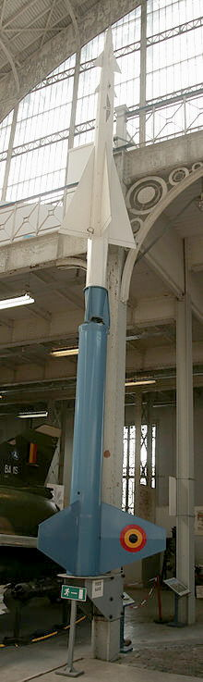
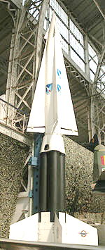
Nike bases were clustered around major cities and military installations. Fort George Meade, Maryland, defending Washington, D.C., had its 120 mm anti aircraft guns replaced by missiles and was at full combat readiness by 30 May 1954. This is the date the Army claims is the birthdate of the Nike system. Within 4 years 265 batteries had been built around most major cities in the continental U.S., replacing 896 radar controlled anti aircraft guns. The last 75mm Skysweeper AA guns were retired in 1960.
Even as the Nike Ajax was being put into production, a new improved version, the Nike-B, later Nike Hercules, was being developed to address the short comings of the Nike Ajax. One criticism of the Ajax was it’s short range of 25 miles. But it was the only thing available at the time, was the counter. The new Hercules would have a range of 75 miles, a speed of 3,000 mph and could fly to an altitude of 100,000 feet. Both booster and sustainer would use solid fuel, eliminating the hazards of liquid fuel. Four Ajax boosters strapped together lifted off the Hercules. The vacuum tubes of the Ajax were replaced by solid state, improving reliability of the electronics. New long range radar were developed, HIPAR (High Powered Acquisition Radar) and ABAR (Alternate Battery Acquisition Radar). Making the Hercules more potent, nuclear warheads were added in 3 kiloton, 20 kiloton and 30 kiloton yields. 15 kilotons was the size of the Hiroshima bomb. Nuclear warheads were intended to destroy formations of enemy bombers and knock out whatever nuclear weapons they might be carrying. But to bring down a Russian U-2 spy plane, a conventional warhead would be adequate. The mode of the Hercules could even be changed from surface-to-air to surface-to-surface by changing a “safe plug” on the warhead. In Surface-to-surface mode the Army could use the Hercules as a tactical nuclear weapon to destroy enemy armor and troop concentrations up to 100 miles away. The fuse could be set to explode as the missile hit the ground or in mid-air. Going into operation in 1958, 393 Hercules ground systems were built and used to replace Nike Ajax. Because of the improved performance of the Hercules, fewer missiles and bases were needed. By 1960 the Army Air Defense Command had 88 Hercules and 174 Ajax batteries defending 23 defense zones in 30 states A high of 134 Hercules batteries were in service by 1963, not counting those overseas.
The Nike Community. Nike bases were built on existing military bases or on land that had to be purchased

\

Nike Ajax Nike Hercules

by the government. A typical Nike base occupied 2 parcels of land – an Integrated Fire Contol (IFC) site (about 6 acres) in concrete block buildings for tracking radars and guidance computers, and a Launcher Area (about 40 acres) where missiles were stored, fueled and launched. The IFC was usually on high ground and separated from the Launcher Area by one half to three and a half miles. Because of limitations of the guidance system, the two areas had to be at least 3,000 feet apart and in line-of-sight with each other, so the tracking radar could “see” the missiles to “lock-on” as they took off. Housing and administration for the 109 officers and men who manned the base was usually in the IFC area unless another plot was available. This might contain barracks, mess hall, motor pool and recreational facilities. The IFC used 3 types of radar. An Acquisition radar searched for a target to hand off to a Tracking radar. Target Tracking Radar (TTR) tracked the target and remained locked on no matter what maneuvers the target pilot might try to elude it. Missile Tracking Radar (MTR) directed the missile in flight, by means of a transponder. An analog computer would analyze data from both radars and compute an intercept point to explode he missile.
During the Cold War Washington State had many valuable military and strategic sites that needed to be protected. Puget Sound contained Seattle and Tacoma, the Puget Sound Naval Shipyard, Fort Lewis, McChord Air Force Base, the Boeing Airplane Company and other military facilities. Eastern Washington was home to the Hanford Nuclear Reservation, the Fairchild Air Force Base and Spokane. These were guarded by anti aircraft guns and jet fighters and from 1954 to 1974 by Nike missiles. Eleven Nike sites were built surrounding Seattle, 4 around Hanford, and 4 around Fairchild AFB/Spokane. Nike batteries in a defense zone were numbered from 01 to 100 and arranged in quadrants running clockwise from nominal North: NE quadrant was 01-25, SE quadrant 26-50, SW quadrant 51-75, NW quadrant 76-100.. They varied in number from 2 for Barksdale AFB to 22 for the Chicago area. A one or two letter prefix designated the defense area: C-XX was Chicago, NY-XX was New York and S-XX was Seattle. Starting in October 1954 eleven missile batteries were built around Seattle with the area missile control center at Fort Lawton in Seattle. When the Nike Hercules replaced the Ajax, fewer sites were needed.
The Seattle Defense Area Nike bases were: S-03 Kenmore/Bothell (1956-Mar. 1964); S-13 & S-14 Redmond (Sep. 1954-Mar. 1974), a double launch site with twice the number of missiles, it became a Nike Hercules site in June 1958; S-20 Cougar Mountain/ Issaquah (1957-Mar. 1964); S-32 Lake Youngs (1956-Dec. 1961); S-33 Lake Youngs/Renton (1956-Dec. 1961); S-43 & S-45 Kent/Midway (1955-Feb. 1963) a dual launch site; S-61 Vashon Island (1956-Mar. 1974) converted to Nike Hercules in June 1960; S-62 Ollala (1956-Mar. 1963): S-81 Poulsbo (1955-Nov. 1960) the control area was at Frank Raab Park and the launch area on Finn Hill Road; S-82 Winslow/ Bainbridge Island (1956-Nov. 1960) the control area was in Eagledale and the launch area became Straw-berry Hill Park: S-92 Kingston (1956-Mar. 1974) converted to Nike Hercules in June 1958.
The Washington National Guard took over control of Kent, Kenmore, Cougar Mountain and Ollala from regular Army personnel on July 1, 1959. Other sites were taken over by the Guard later. Like the Army, the Guard operated on a 24 hour basis. Army and National Guard missilemen won many awards at the Fort Bliss, Texas, firing practices. The Army had the highest scores at the 1956, 1957 & 1958 firing practices winning the Commander’s Trophy. In April 1973 the Redmond Nike Hercules National Guard Battery was named best in the Army.
Used only for 4 or 5 years, many Washington sites were vacant for years after they were closed, vandalized and dilapidated. In time other uses were found for the land, such as turning it into parks. One Nike base that was preserved as a museum is in San Francisco Golden Gate National Recreation area.
By the late 1950’s the Russians were concentrating on intercontinental ballistic missiles (ICBMs), rather than manned bombers. There was no defense against missiles. An anti missile ballistic missile, the Nike Zeus, was under development in the early 1960’s but never went into production. Defense dollars in the 1960’s were needed to pay for America’s own ICBMs, as well as the rapidly growing Vietnam War. All Nike Ajax sites were gone by 1964 and Nike Hercules sites began closing in the mid 60’s. By 1966 there were 112 left, then 87 in 1968 and 82 in 1969.
The Strategic Arms Limitation Treaty (SALT I) with the Russians, signed in 1972, defined the Nike Hercules as a nuclear ABM and subject to limitation. That, plus further budget reductions, helped deactivate almost all Nike sites in the continental U.S. by April 1974.
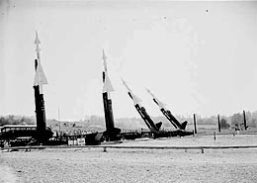
Redmond WA Nike Ajax Missiles – 30 July 1955
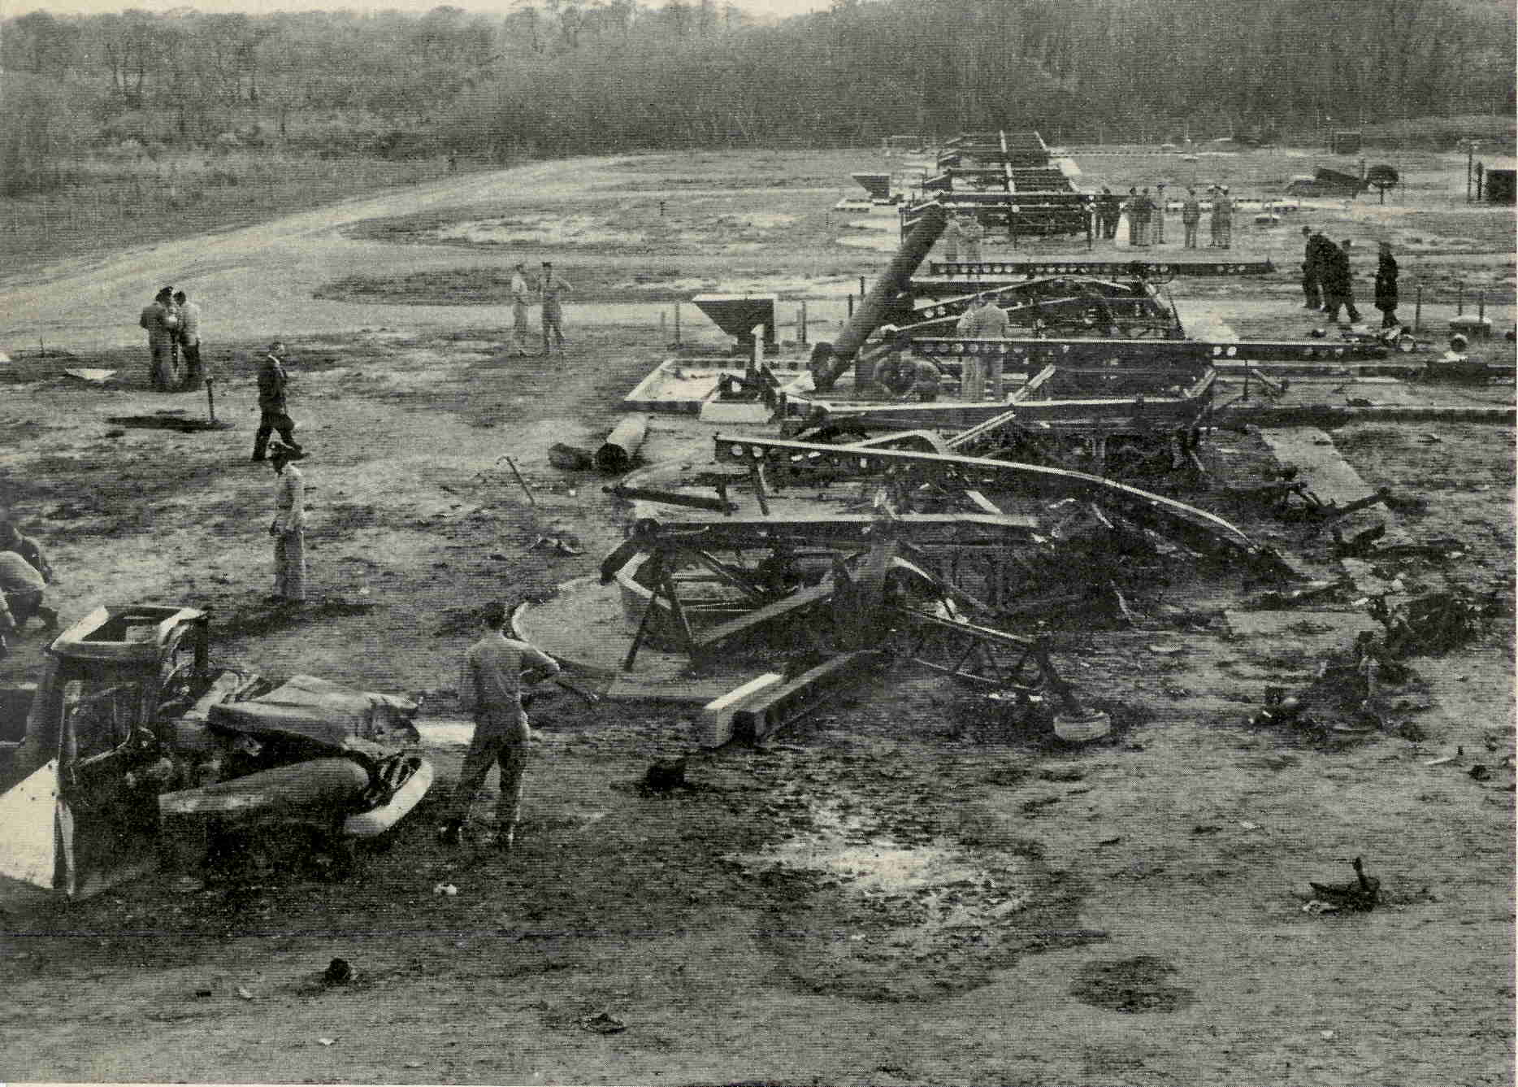
22 May 1958, Nike Ajax explosion at Leonardo NJ killed 6 soldiers and 4 civilians. One missile blew up and detonated the other 7. (LIFE Magazine)

Nike Missiles from Wikepedia.

the National Soj ourner newsletter(1956- will be e-mailed to all members who are on the e-mail list. This will save National mailing costs. A girl who won a $3,000 scholarship for first place in the Essay contest, found out about National Sojourners by going to our website.
A petition was received and read to the chapter. Bro. Orville reported that the petitioner is a retired submariner, a Shriner and member of Warren G. Harding No. 260. The petitioner was voted on and unanimously approved..
This past week the Mid-Winter Convention,, Jan. 14-16, 2016, was moved from Oklahoma City to

Austin, Texas per Wendell. People who want to attend will have to coordinate their airfares to get there.
Bro. Hank Carman reported that now he is leaving the real estate business, he has a Windows 7 computer that he can donate to the secretary. Let’s send our newsletter to VFW 239. Do we want to have a 5 to 10 minute program for or meetings?
Bro. Bill Biscomb gave the schedule for the Heroes retreat at Pacific Beach 2-4 Oct. 2 Oct: 0800-1200 Registation, 1400-1530 Officers training, 1930-2000 Patriotic presentation, open to the public. 3 Oct: 0815 Coffee and donuts, 0900 Degree work,
one candidate from #80, 1 from #89. 1100 Camp Followers degree. 1200 Retirement of old flags. 1800 Two bell ceremony and dinner banquet. 5 Oct: 0730 Breakfast and departure of guests. Bro. Bill asked who will be going? Bill Biscomb, B.J. Quance, Peter Dawson, Joe MacIntyre and Dick Dexter responded in the affirmative. Hank Carman will have to see if Silverdale #311 is having their installation on 3 Oct. Jim Parker will be the Commander for Fort Lewis #89

With the retirement of the last modern frigate, there is only one commissioned ship in the 272 ship U.S. Navy that has sunk an enemy ship in battle
On Tuesday, 29 Sep 2015 the frigate U.S.S. Simpson (FFG-56) was decommissioned. After 30
years in service, the Oliver Hazzard Perry class frigate represented 50 year old technology and was obsolete. She made her name in history by being the only U.S. Navy ship to sink an enemy vessel since the end of World War 2. In 1988 she sank a 270 ton Iranian missile boat in a Persian Gulf engagement. A sister ship, U.S.S. Samuel Roberts (FFG-58), struck an Iranian mine. In retaliation, the U.S. Navy sent a 3
ship squadron (Cruiser Wainright & frigates Bagley & Simpson) to destroy an Iranian oil platform. The oil platform was sunk on the morning of 18 Apr 1988. At noon an approaching Iranian ship was detected on radar. The enemy vessel was identified as the Joshan, known to be armed with U.S. made Harpoon missiles, a weapon with a 500 pound warhead and 600 mph speed that could sink any of the American ships. After the fourth warning the Wainright’s skipper, Capt. James Chandler, radioed, “If you don’t stop I will sink you.” The Joshan replied by firing its Harpoon missile at the cruiser and missing. Her view obstructed by the other ships in her squadron, the Wainright couldn’t fire back. But the Simpson had a clear shot and launched a 1,900 mph Standard missile, which hit the Joshan 15 seconds later. The Joshan sank after being hit by 2 more of the Simpson’s missiles and one from the Wainright. This, to date, has been the only ship versus ship missile battle in U.S. Navy history in which the combatants couldn’t see each other except by radar.
Today the only commissioned ship in the U.S. Navy which has sunk enemy ships in battle is the frigate U.S.S. Constitution ,which sank British frigates 200 years ago in the War of 1812. By 1830 the Constitution had reached the end of it’s service life. Oliver Wendell Holmes, Sr., read of the Navy’s plans to scrap the ship in a Boston newspaper. That night he wrote a poem and sent it to the paper. The poem, Old Ironsides, was reprinted in other East Coast papers and started a movement to save the ship. In May 2015 the Constitution was moved to the Charlestown Navy Yard to begin its latest 2 year restoration.

Old Ironsides
Oliver Wendell Holmes, 1830

