Sinclair Inlet Chapter No. 80 National Sojourners, Inc

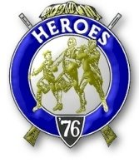

Bremerton, Washington
Our website address is: www.telebyte.com/masons/sojourn/index.htm

November 2014 Newsletter

Chapter Officers 2014-2015
President | CPO Stephen B.J. Quance | 360-731-5552 | sdquance@yahoo.com
1st Vice President | Mr. Richard Dexter | 360-692-6876 | rdexter@tscnet.com
2nd Vice President | Mr. Peter Dawson | 360-779-8219 | etypebubba@aol.com
Secretary/Treasurer | Mr. Charles Yankosky | 206-780-0563 | cyankosky@yahoo.com
Marshal | None
Chaplain | LTC Wendell Dutt | 253-565-5264 | wadutt@comsast.net
Color Bearer | None

Hero Camp Officers 2013-2014
Commander | Mr. Alex Jordan |  | jordan3614@hotmail.com
Chief of Staff | Col. William Biscomb | 206-842-6417 | hankcarman@wavecable.com
Adjutant | Mr. Charles Yankosky | 206-780-0563 | cyankosky@yahoo.com

Meeting Notice!
We will meet at All Star Lanes in Silverdale on Friday, 14 Nov. Social hour and dinner begins at 1800, meeting at 1900 hours. Ladies and guests are always welcome at the meeting and are urged to attend.
The associated Lewis and Clark Camp of the Heroes of ’76 meets immediately following the Sojourner meeting and is open to all Heroes.
Don’t forget to wear your Medals!
Highlights of the 10 Oct Meeting
1ST VPres. Richard Dexter opened Chapter at 19:00. Minutes of the previous meeting were accepted as mailed.
Bro. Wendell Dutt gave a report on last week’s Pacific Beach Bivouac. The traveling bar has been discontinued. An open bar will be provided whenever, wherever someone offers to furnish it. It’s BYOB. Next year Pac Beach will again be on the first weekend of October. The Pac Beach meeting needs to be improved. The National President and National Commander attended. But they were probably disappointed by the turn out. Chapter #80 and #89 wll co-host next year.
Bro. Hank Carman proposed that we start a re-cruiting effort. Get a program started. Even a short 15 minute program would make the evening interesting.
Get the ladies here. Restart the raffle thing.
Bro. Lance Otis reported that he was getting updates from Chapters across the U.S. In many cases the chapter officers were six months out of date. The goal is to list annual meetings and encampments.
A local organization supports Retsil by driving veterans to events. Chapter #80 should go out there and do something. Tie “Build the Flag” into a pro-gram. On Memorial Day Retsil has a church service. Tom Dangelo was there. There are vets in the area
that are homeless. Do something for them at the plate level. “Stand Down for Vets” is an organization that helps vets readjust to civilian life. Show your support.
Meeting was closed at 19:30.

U.S. Navy Has Only 4 types of Major
Warships Left by Rich Smith, Motley Fool.
Cost-cutting time for the Navy has caused a
debate between the Pentagon and Congress over the future of the Navy’s 22 Ticonderoga class cruisers. Built primarily to protect America’s 11 aircraft
carriers, these cruisers, built in the 1980’s and 1990’s, are expected to all be retired by 2028.
At present there is nothing to replace them. A CG(X) class was canceled in 2010 over cost concerns. An on-going program, the DDG(X), now called the DDG-1000 program, is building 3 stealth warships for $3.5 billion apiece. The U.S.S. Zumwalt (DDG-1000)
is a sleek ship, but can 3 of them replace 22 cruisers?
To solve the problem, the Navy plans to take 11 cruisers out of service, beginning in 2019, and
upgrade them for $8.8 billion. This would extend the ships’ service lives for 15 years, giving us cruisers through 2045. The New/Old cruisers would be 36 years old by then.
The Navy was giving Congress the choice of either operating on half of today’s cruiser fleet or going without cruisers altogether after 2028. Some Congressmen worry that the Navy intends to take 11 cruisers out of service and not upgrade them at all, but spend the money on some other program.
The Navy has come upon some lean times. The planned 32 ship DDG-1000 program is stuck at just 3 ships due to cost. Coming up for retirement are the
last of the Oliver Hazard Perry class frigates. That leaves a fleet of 18 ballistic missile submarines, a few dozen attack subs, 10 of 11 mandated aircraft carriers, a handful of Littoral Combat ships, and some support ships. Only the Arleigh Burke class of destroyers, of which 77 are planned, are being produced in numbers at $1.5 billion apiece.
Restarting the CG(X) program is needed to replace the cruiser fleet, but it won’t be cheap. If a DDG-1000 destroyer costs $3.5 billion, then replacing the Ticon-geroga class would come to about $77 billion. Ship-builders General Dynamics and Huntington Ingalls would get 9 times as much for building new ships as they would for re-modeling 11 aging cruisers. But the mission of cruisers is to help defend investments like the new $13 billion Gerald R. Ford class of nuclear powered aircraft carriers. 20 July 2014

(Note: A Carrier Strike Group is not really defined. It is a collection of ships formed on an as-needed basis to suit a particular mission.
A Strike Group typically consists of a Nimitz class aircraft carrier, a Ticonderoga class Tomahawk-armed guided missile cruiser, two guided missile destroyers for anti-air warfare, a Los Angeles class attack sub to combat enemy ships and subs, and a supply ship to provide oil, ammunition and supplies.
The mission of the group is to protect economic and/or military shipping, to provide protection for Marine amphibious forces, and to show the flag in support of national interest.)
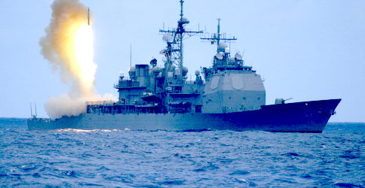
Ticonderoga Class Guided Missile Cruiser

U.S.S. Zumwalt (DDG-1000)

CNO Warns of Advanced Russian Submarine Development
Kris Osborn, Military.com 23 Oct 2014
U.S. Navy Chief of Naval Operations, Adm Jon Greenert, said that U.S. officials are concerned about the pace and intensity of Russian submarine devel-opment. The Russians have been working on a sea-based strategy and an attack submarine.
Although the U.S. spends more than both the Russians and Chinese combined, the Russians and Chinese are increasing their spending year by year.
Russia plans to sell a version of its new Amur 1650 attack sub to the Chinese. The Amur 1650 is an upgraded Kilo class Russian sub with improved acoustic stealth, new combat systems and air-independent propulsion. Defense website Inquisitr reported that the Russian nuclear sub Vladimir Monomakh successfully launched a Bulava inter-continental ballistic missile. China’s newest nuclear submarine, the Jin SSBN would be China’s first credible second strike nuclear capability.
Adm. Greenert said the U.S. Navy plans to
advance it’s own submarine fleet with the Ohio Replacement Program or ORP. A class of 12 new
next generation quiet and stealthy nuclear armed subs are being planned to provide a strategic nuclear deterance. This means that in the event of a cata-strophic nuclear first strike against the U.S., submarines stationed at sea would guarantee a nuclear response against an aggressor.
Greenert said the ORP program is top priority and Electric Boat Co, in Rhode Island is building the first boat to be completed in 2021. Research and develop-ment funding will put tremendous pressure on the Navy’s annual shipbuilding budget.
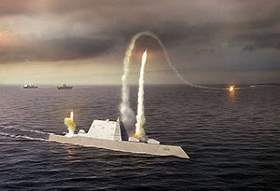
A recently released 30 year shipbuilding plan states that there isn’t enough money to fund the ORP project as well as pay for more destroyers, carriers, amphibs and cruiser upgrades. The plan is divided into 10 year blocks and says the Navy will need $19.7 billion per year from 2025 through 2034 due to the Ohio Replacement Program, a cost not covered by present resources.
The first ship of the ORP program is expected to cost $12.4 billion - $4.8 billion in non-recurring engineering and development costs and $7.6 billion
for construction. Design work should be finished by 2017and some construction is already being done. The new subs should be in service through the 2080’s.
If the Navy can’t get $19.7 billion per year through the middle of the planning period, the battle force will fall short of its requirements. The Navy needs to make more progress if its goal of building the ORP subs for $4.9 billion each is to be met. Working with Electric Boat, a General Dynamics subsidiary, specifications have been finished and some cost-cutting initiatives have been made.

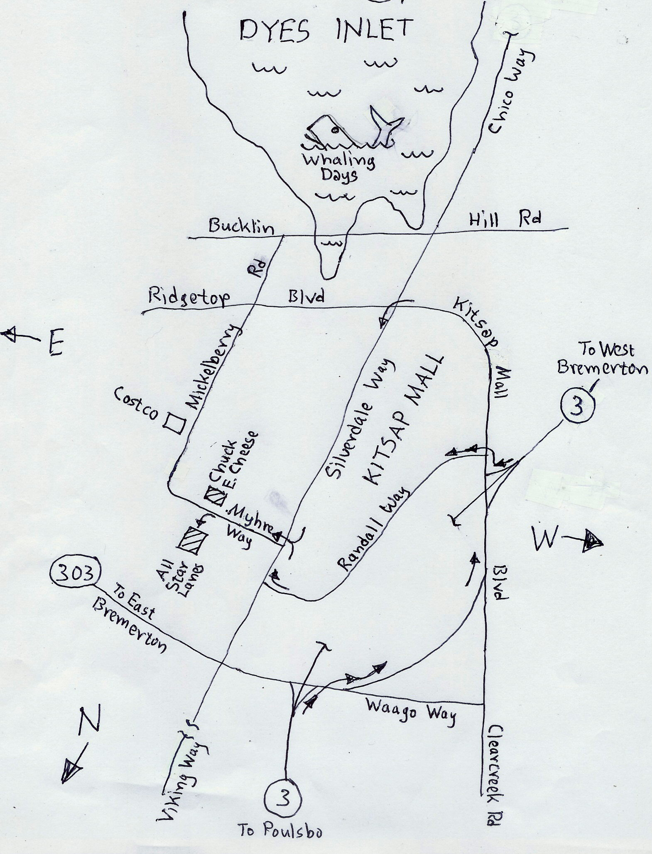
To All Star Lanes in Silverdale

