Sinclair Inlet Chapter No. 80 National Sojourners, Inc

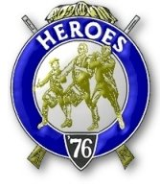

Bremerton, Washington
Our website address is: www.telebyte.com/masons/sojourn/index.htm

November 2013 Newsletter

Chapter Officers 2013-2014
President | HMCM Joseph MacIntyre | 360-275-0589 | haggis@wavecable.com
1st Vice President | CPO Stephen Quance | 360-731-5552 | sdquance@yahoo.com
2nd Vice President | Mr. Richard Dexter | 360-692-6876 | rdexter@tscnet.com
Secretary/Treasurer | Mr. Charles Yankosky | 206-780-0563 | cyankosky@yahoo.com
Marshal | None
Chaplain | LTC Wendell Dutt | 253-565-5264 | wadutt@comsast.net
Color Bearer | None

Hero Camp Officers 2013-2014
Commander | Mr. Peter Dawson | 360-779-8219 | etypebubba@aol.com
Chief of Staff | MMCM Henry Carman | 360-698-4776 | hankcarman@wavecable.com
Adjutant | Mr. Charles Yankosky | 206-780-0563 | cyankosky@yahoo.com

Meeting Notice!
We will meet at VFW Post #239, 190 Dora Ave, Bremerton on Friday, 8 Nov. Social hour and dinner begins at 1800, meeting at 1900 hours. Ladies and guests are always welcome at the meeting and are urged to attend.
The associated Lewis and Clark Camp of the Heroes of ’76 meets immediately following the Sojourner meeting and is open to all Heroes.
Don’t forget to wear your Medals!
Highlights of the 13 Sep Meeting
1ST VP B.J. Quance opened the meeting at 19:00.
Area Rep. Wendell Dutt asked how many MIP’s were in our chapter. I need to follow up with National about re-issuance of the $240 MIP fund amount that was returned to their account because the check went un-cashed. A motion was made and approved to pay $76.60 to the 3-6-5 club. A number of National circulars came in the mail.
Chapter #80 MIP member Karl Forch, 71, died on Oct. 4. Doc Forch was a 31 year Navy man who retired as a master chief. He served in Vietnam, Cambodia, Laos, Thailand and lastly in Desert Storm, earning a Purple Heart for his service. He was a Mason, Shriner and York Rite Mason.
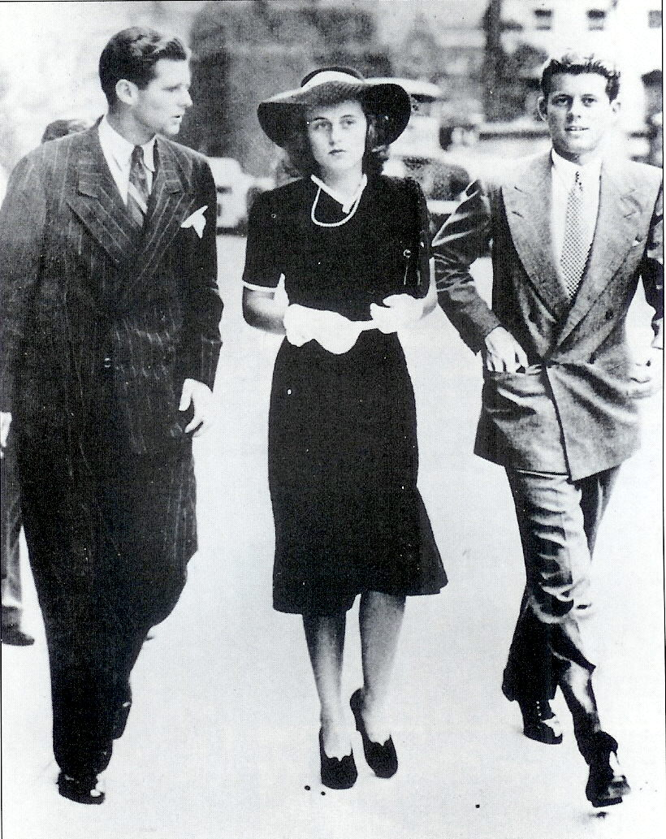
Wendell gave a report on Pac Beach. Himself,
Peter Dawson and Joe MacIntyre attended. Bob
Colton organized this event for years until he died last year. The new organizer, Gerry Earl, was unaware of a ladies program, so the ladies were on their own. #539 was the host chapter this year. In the future it is expect-ed that the host chapter will run the hospitality room. #539 shouldn’t have to do it year after year. Next year
#40 will host. Two years from now #80 do it. It was suggested that we charge $3 for a drink and $2 for a coke. Chap. 89 will host the joint installation in Des Moines next year.
Presiding Officer B.J. said business at Pac Beach
is so good you have to make reservations a year in advance. They have 3 good banquet rooms. All infor-mation regarding Pac Beach and how to apply is on
the Sojourner NW website. Wendell will update it shortly for next year’s Oct. 3, 4 & 5 Pac Beach week-end. B.J. remarked that he doesn’t drive and didn’t
know about it this year. Joe MacIntyre goes out on Wednesday, rents a house, and lets some other people share it. There were about 30 people total at Pac
Beach this year. But there were no National officers. They try to attend regional gatherings, but no one made
it this year.
Dick Dexter has a flag presentation scheduled for William H. Upton #206’s next stated meeting 11/19.
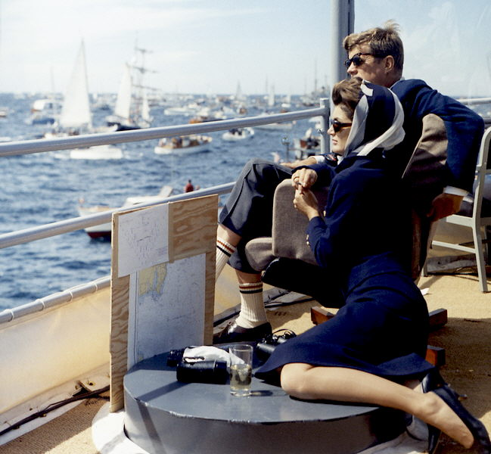
Meeting closed at 19:30.
At a Heroes Camp meeting afterwards, Wendell reported some more on Pac Beach. Briefly, about 30 people were there. The weather was good. A number
of worn out flags were retired. No national officers.

John, We Hardly Knew Ye
. American Veterans, those who served in the armed forces in peace and war, will be commemorated on
Nov. 11. The 11TH hour of the 11TH day of the 11TH month marked the Armistice in 1918 that ended the Great War, the war to end all wars. Armistice Day
was expanded after WW2 to include all veterans.
Eleven days after Nov. 11 marks the 50TH anniver-sary of the death of a veteran who won a Navy and Marine Corps medal for gallantry in naval action in
the Solomon Islands during WW2. This veteran, John
F. Kennedy, was also the 35TH President of the United States. He died on Nov. 22, 1963, the 4TH president
to be assassinated after Lincoln.

Sep. 3, 1939. Joe Kennedy, Jr., Kick (Kathleen) Kennedy and 22-yr-old John F. Kennedy walk to Parliament to hear Prime Minister Neville Chamberlain declare war on Germany. Their dad, Joe Kennedy, Sr, was American Ambassador to Britain from 1937-1940. Joe Jr and Jack (John F.) graduated from Harvard. Joe Jr. became a Navy pilot and was killed when the B-24 he was piloting exploded on Aug. 12, 1944. Kick married a British army officer on May 6, 1944 and was widowed when he was killed by a German sniper on Sep. 9, 1944. She, herself. was killed in a plane crash in 1948. She was buried with her husband in England and a stone on her grave recounts a visit made there by President John F. Kennedy in June 1963. John is buried in Arlington National Cemetery.
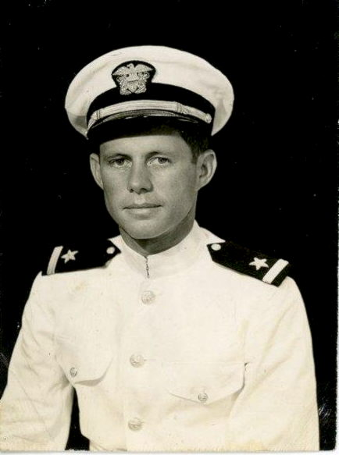
(Insert) Newly minted Ensign John F. Kennedy, commissioned in the U.S. Naval Reserve on 25 Sep 1941.
20 years later as Commander-In-Chief. President and Mrs. Kennedy watch the Americas Cup Race in Sep. 1962 from the deck of the destroyer U.S.S. Joseph P. Kennedy, Jr., named for the President’s older brother who was killed in WW2.

