Sinclair Inlet Chapter No. 80 National Sojourners, Inc

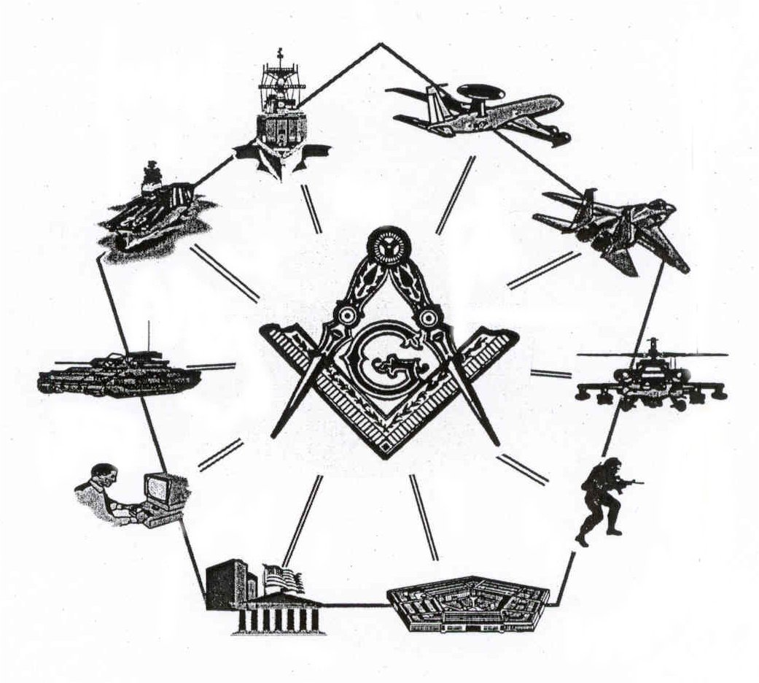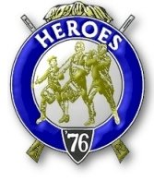

Bremerton, Washington
Our website address is: www.telebyte.com/masons/sojourn/80/sinclair_inlet_chapter.htm

May 2004 Newsletter

Chapter Officers 2003-2004
President | LTC Graham Kent | 360-692-5781 | kentgg@tcsnet.com
1st Vice President | Michael Pursey
2nd Vice President | Bill Biscombe
Secretary/Treasurer | 1LT Harold E. Richardson | 360-692-4023 | haroldr@telebyte.net
Marshal
Chaplain
Color Bearer

Hero Camp Officers 2003-2004
Commander | LTC Graham Kent | 360-692-5781 | kentgg@tcsnet.com
Chief of Staff | CAPT Harry R. Houston
Adjutant | 1LT Harold E. Richardson | 360-692-4023 | haroldr@telebyte.net

Meeting Notice!
We will meet at Elk’s Lodge #1181, Pine Road, Bremerton on 21 MAY. Social hour with soup and sandwiches at 1200, Meeting at 1300 hours. Ladies and guests are always welcome at the meeting and are urged to attend.

The associated Lewis and Clark Camp of the Hero's of '76 meets immediately following the Sojourner meeting and is open to all Hero's.
Don’t forget to wear your Medal!
President’s Message
Fellow Sojourners,

I am delighted to announce the election of the new officers for the Chapter and Camp and want to be the first in wishing them good luck and support for a successful year.
An item of interest- Harold and I "Built the Flag" for the Shrine Club on 20 April. I have received nothing but laudatory comments regarding our performance. We need to encourage our members to encourage the schools to request that we perform. The fact that reference to God recurs in the performance has become a barrier in certain schools and this is something which may be overcome through attrition of certain teachers either transfer or retirement. Again, all the best for the new officers in the upcoming year.
Graham

From the Desk of the Secretary
Our next meeting will an afternoon meeting on 21 May at the Elks Lodge #1181, Pine Road Bremerton with soup/san at 1200 hours and the meeting to start at 1300 hours. It is assumed that all officers to be installed will attend the installation in Des Moines on 5 June. It starts with a social hour at 1200 hours with installation to be at 1300 hours. If you are taking a spouse, make a dinner reservation for her as well and let me know for sure 24 May. Also to all members: if you plan to attend the installation of officers in Des Moines on 5 June and are not an officer to be installed, please let Harold Richardson know the number of reservations you need no later than 24 May. That will help the planners. Phone 360-692-4023 or email at haroldr@telebyte.net
Fraternally, Harold
Highlights of Last Meeting
At the April meeting elections of officers was held with the following results:
Chapter
President S/SGT Michael R. Pursey 1st Vice President Col William M. Biscomb Secretary/Treasurer WTCS John M. Gray Marshall CWO4 Richard Patterson Chaplain 1Lt Harold R. Richardson
Lewis & Clark Camp
Commander CAPT Harry R. Houston Chief Staff 1Lt Harold R. Richardson Adjutant WTCS John M. Gray
After elections the meeting was closed and the social hour resumed.

