Sinclair Inlet Chapter No. 80 National Sojourners, Inc

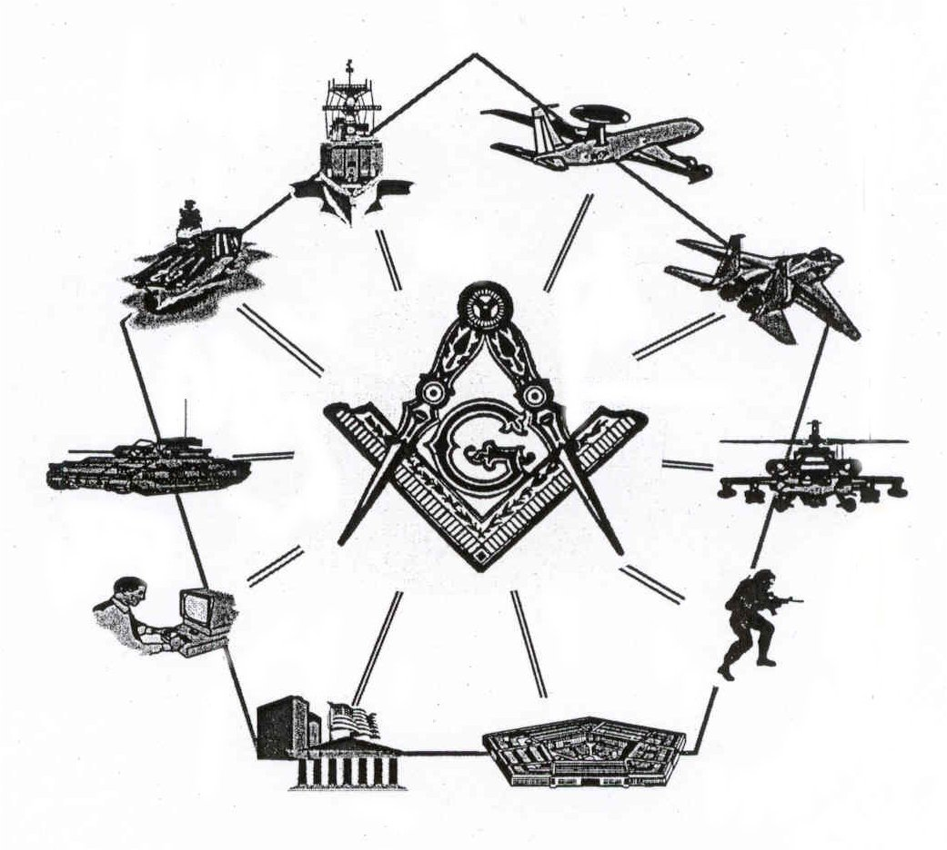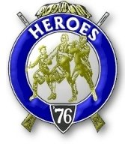

Bremerton, Washington
Our website address is: www.telebyte.com/masons/sojourn/80/sinclair_inlet_chapter.htm

March 2004 Newsletter

Chapter Officers 2003-2004
President | LTC Graham Kent | 360-692-5781 | kentgg@tcsnet.com
1st Vice President | Michael Pursey
2nd Vice President | Bill Biscombe
Secretary/Treasurer | 1LT Harold E. Richardson | 360-692-4023 | haroldr@telebyte.net
Marshal
Chaplain
Color Bearer

Hero Camp Officers 2003-2004
Commander | LTC Graham Kent | 360-692-5781 | kentgg@tcsnet.com
Chief of Staff | CAPT Harry R. Houston
Adjutant | 1LT Harold E. Richardson | 360-692-4023 | haroldr@telebyte.net

Meeting Notice!
We will meet at Elk’s Lodge #1181, Pine Road, Bremerton on 19 MAR. Social hour begins at 1200, Dinner and Meeting at 1300 hours. Ladies and guests are always welcome at the meeting and are urged to attend.

The associated Lewis and Clark Camp of the Hero's of '76 meets immediately following the Sojourner meeting and is open to all Hero's.
Don’t forget to wear your Medal!

Presidents Message
The flag building team performed at Tracyton and Jackson Park Elementary schools in February and had approximately 70 students attending each session. The students were very responsive and their attention span remained acute during the session. Our next engagement will be at 11am on 9 March at West Hill Elementary. The children will write essays on the subject matter presented. Their essays will be evaluated for their accuracy and patriotic content and special recognition will be awarded to the outstanding authors.
Our Flag Building Program is a most valuable public service particularly in the schools. This year however, we have not been performing as regularly as in the past ten years. We need your help in soliciting the schools in Silverdale and Poulsbo. If in your travels, you have the opportunity to solicit our services to schools, please give us the boost.
Membership is becoming a definite problem. The falling leaves are not being replaced. It was not until we lost Dick Miller that I began to worry but now we must start to look seriously for new members. A factor that has discouraged aggressive solicitation stems from experience gained from my years serving in service organizations, VFW and American Legion. Granted we are all Masons but Masons are human too. But the condition has been reached where we must be less exclusive and actively solicit.
Remember the Pacific Beach Sojourner meeting will take place in October. Make your reservations
From the Desk of the Secretary
Our next meeting will at 1300 hours at Elks Lodge #1181, March 19, 2004. Soup and Sandwiches are available starting at 1200 hours. Business to be taken care of includes nomination of a slate of officers for the ensuing year. Br. Richard Patterson is on the nominating committee. If he asks you to serve, and it is at all possible, please say yes. We hope to see you there.

Highlights of Last Meeting
John Gray reported on the progress of establishing a Chapter newsletter. A preliminary design was presented for review. It is hoped one can be ready in time for the March mailing. He also reported that a link to the Pacific Northwest National Sojourners website was placed on the Freemasons of Washington District 12 website. It is located at:
http://www.telebyte.com/d12/wa12.html
Our meetings are being schedule on the district calendar.
Additionally William H. Upton Naval & Military Lodge # 206 began announcing our events in their Trestleboard and on their website. It is located at:
http://www.telebyte.com/d12/L206.html

A Nominating Committee was appointed for the purpose of selecting potential chapter officers for the upcoming year.

Brother Steve Seteroff, Secretary of Olympic Chapter 539 invited all chapter members to attend their 28 April 2004 Anniversary Dinner Meeting. They will honor charter members and sponsorship by Sinclair Inlet Chapter No. 80. Location is Paradise Restaurant in Sequim. There will be an election of officers. Guest speakers are MW James N. Reid, Jr. Past Grand Master of F&AM of Washington and Stanley Miller, National Chief of Staff of the Heroes of '76. Musical entertainment will be provided. Reservations are required to Franklin Benson at f.benson@worldnet.att.net

A lively discussion on shipbuilding in WWII, national security and foreign threats ensued prior to closing the meeting.

2004 Committee Appointments

Americanism Committee
Chair:
Members:

Membership and Attendance Committee
Chair:
Members:

Bridge of Light Committee
Chair:
Members:
Education and Training Committee
Chair:
Members:

Fraternal Liaison Committee
Chair:
Members:

Program and Arrangements Committee
Chair:
Members:
Change of Address
Remember, it is your responsibility to notify the Chapter Secretary if your address or telephone number changes. The Chapter address is:

Sinclair Inlet Chapter #80
8297 State Hwy 303 NE
Bremerton, WA 98311-8764

Membership-In-Perpetuity

Life membership in National Sojourners is obtained through Membership-In-Perpetuity (MIP). An MIP cost only $200.00. Comparing MIP to yearly dues paying Membership, MIP is the best deal in town. At the current rate of $20.00 annual dues, an MIP will pay for itself in about 8 years.

Lewis and Clark Camp of the Hero's of '76 News



Lewis and Clark Camp of the Hero's of '76

An active team presents a 23 minute program "Building the Flag of the United States of America". All organizations public and private may request this program. The program has been performed continuously since 1991 and audiences have ranged from kindergarten through high school students, fraternal and service organizations, churches, and retirement centers.
Contact the Adjutant Harold Richardson or any Camp Officer for further information and scheduling.

A presentation is scheduled for 9 MAR at West Hills Elementary.

Lewis and Clark Camp, of Sinclair Inlet Chapter #80 will host an encampment along with Marvin Shields Camp, of Olympic Chapter #539, on March 13, 2004. The encampment will convene at the home of Steve Seteroff in Quilcene, WA at 1300 hours. Two candidates will be initiated into the Heroes. Our candidate is Br. John Gray. We will be leaning heavily upon Marvin Shields camp for support and appreciate their help. It will be close to 1600 hours before we are through. Please try to eat lunch before you arrive as facilities in Quilcene are scarce.

Xx

Attending meetings of the Chapter, I find a dearth of members present. We are always looking for ways to improve attendance. One way would be to increase our participation in Regional and National activities. As one example, the Chapter is doing well in the ROTC sponsor program.

On the other hand, I find that there is little Chapter participation in the annual conventions and mid-winter meetings. These are meeting that bring together brothers from around the country. The fellowship is great! But, more importantly, they provide a means to have a voice in the management of the national organization.

At the Regional level, we have an annual joint installation the first Saturday of June, and an annual encampment at Pac Beach each October. A real “fun” one-day excursion is the Annual Oregon Encampment held each July. These are all open to all, and all are encouraged to attend.

On the local level, the best way to find out what is going on in your Chapter is to attend the monthly meetings. There is much information on local Masonic activities being dispensed. Planning, history, administration, trivia, and National Resolutions are among the items normally aired and discussed.

While it sometimes appears that the National organization is far away, and has no impact on local Chapters, such is not the case. We are fortunate in having members on several National committees, to include the Resolutions, the Committee of 33, and Education & Training

The Resolutions Committee sets the agenda for matters come before the membership for a vote. Included, among other things, are membership standards.

The Committee of 33 meets to recommend to the membership solutions to far-reaching questions such as the benefits of Proxy Voting.

The Education and Training Committee meets to develop standard materials to be used by local Chapters.

