Sinclair Inlet Chapter No. 80 National Sojourners, Inc

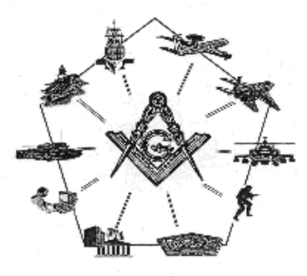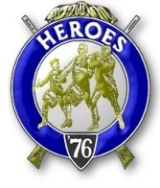

Bremerton, Washington
Our website address is: www.telebyte.com/masons/sojourn/index.htm

May 2013 Newsletter

Chapter Officers 2013-2014
President | HMCM Joseph MacIntyre | 360-275-0589 | haggis@wavecable.com
1st Vice President | CPO Stephen Quance | 360-731-5552 | sdquance@yahoo.com
2nd Vice President | Mr. Richard Dexter | 360-692-6876 | rdexter@tscnet.com
Secretary/Treasurer | Mr. Charles Yankosky | 206-780-0563 | cyankosky@yahoo.com
Marshal | None
Chaplain | LTC Wendell Dutt | 253-565-5264 | wadutt@comsast.net
Color Bearer | None

Hero Camp Officers 2013-2014
Commander | Mr. Peter Dawson | 360-779-8219 | etypebubba@aol.com
Chief of Staff | MMCM Henry Carman | 360-698-4776 | hankcarman@wavecable.com
Adjutant | Mr. Charles Yankosky | 206-780-0563 | cyankosky@yahoo.com

Meeting Notice!
We will meet at Des Moines Masonic Center , 2208 So. 223RD, Des Moines on Saturday, 1 June 2013 for our Joint Installation. Also attending are V. Adm. Homer Wallin #40, Seattle; Fort Lewis #89, Tacoma; Pacific NW #534, Bellingham; and Olympic #539, Port Angeles. Social hour begins at 1100, lunch at 1200, meeing at 1300 hours. Dinner tickets are $18. Guests and ladies welcome.
Don’t forget to wear your Medals!
Highlights of the 10 May Meeting
Pres. Joe MacIntyre opened the meeting at 19:00.
Area Rep Wendell Dutt reported that National had made a decision that if annual dues were not paid on time, an immediate NPD notice will be sent to the Brothers who are delinquent. (As was reported in the Nov. 2012 newsletter, the Chapter voted to raise it’s
dues to $25 per year for those who do not have Life Memberships (MIPs). Of this amount, National’s dues are $20 per member, payable by Dec. 31 of the previous year. This amount MUST be paid by then or National will send out NPD notices within a couple of weeks.)
Bro. Wendell also reported that the Secretary’s Chapter “Vitality Assessment & Metrics” report is
due next week.
Old Business: JROTC awards will soon be presented. Bro. B.J. Quance will find out who the recipients are so that Certificates can be written. We will ask Bro. Lance
Otis if he can print the names. Bro. B.J. found that LCDR Dan Myer’s candidate for South Kitsap is Canyon Wayment, and LCDR Gary Brooks candidate for Bremerton is Timothy Riders. Bremerton will
be having their awards ceremony on May 30. We will ask Bro. John Gray if he can present the South Kitsap award. Bro. .B.J. offered to present the Bremerton award but will probably need transportation.

New Business: The Brethren approved the nomina-tions of Chapter Officers for the coming year with modifications. They are: HMCM Joseph MacIntyre to continue as President; 1ST Vice President: CPO
Stephen B.J. Quance; 2ND V.P.: Bro. Richard Dexter; Secretary: Bro. Charles Yankosky; Chaplain: LTC Wendell Dutt. Elected as Hero Camp officers were: Commander: Bro. Peter Dawson; Chief of Staff: MMCM Hank Carman; Adjutant: Bro. C. Yankosky.
Pres. Joe discussed the arrangements for the Sojourner Joint Installation at the Des Moines Ma-
sonic Center on 1 Jun 2013. He will make arrange-
ments for the food and act as Master of Ceremonies.
He will ask the Grand Secretary, RWB David Owen
to be guest speaker. He asked Bro. Dawson to collect money at the door for the meal. Bro. Wendell said
that he would take care of the programs and Chapter #539 would provide the alcoholic beverages.
Bro. Wendell informed the Brethren that a couple
of resolutions are going to be proposed at the National Convention. (1) That Membership be opened up to all Master Masons and (2) Change the NCO requirement
to include pay grade E-5 and above.
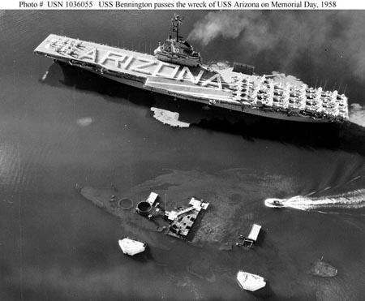
Pres. Joe announced that the Bremerton Valley Scottish Rite will host a School Scholarship Presen-tation Ceremony at the Bremerton Masonic Temple
on May 24th.
Sickness & Distress. Bro. Dick Dexter reported that Bro. B.J. Quance was not feeling well.
The Chapter was closed at 19:40, Peace and Harmony prevailing.
(Taken by Sec. Pro Tem Hank Carman)

U.S.S. Bennington, Memorial Day 1958

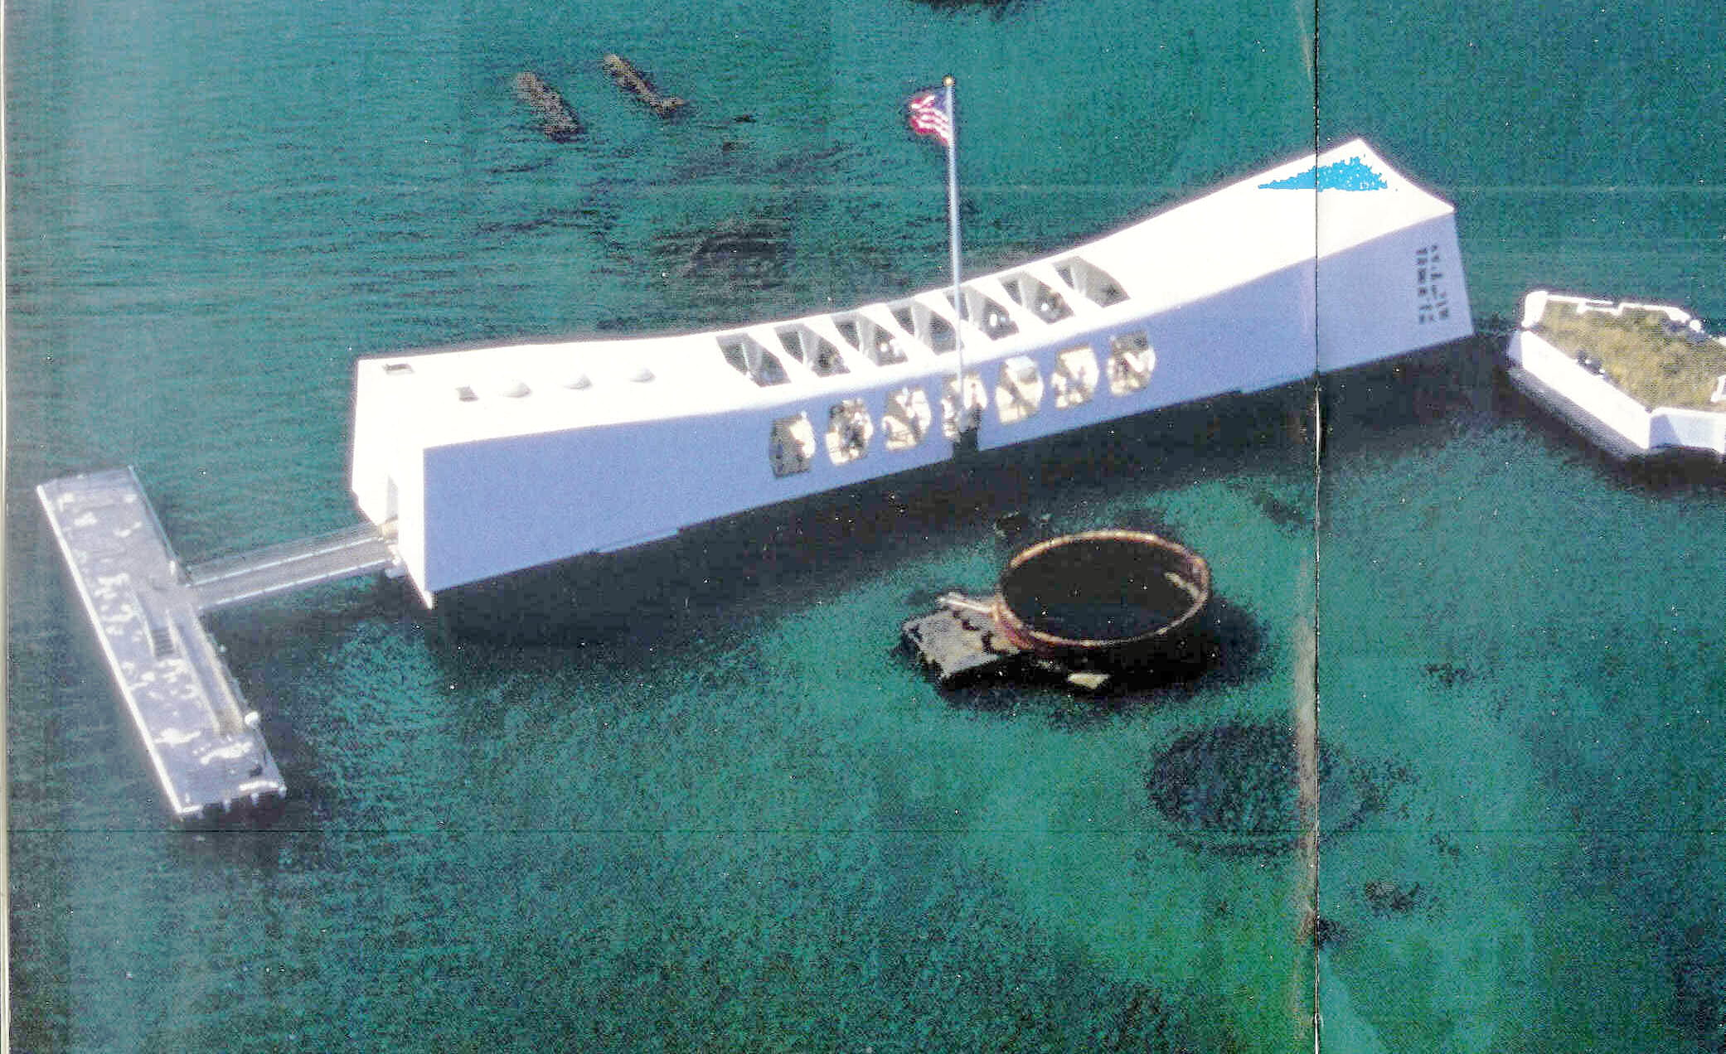
Arizona Memorial, Pearl Harbor, dedicated 1962
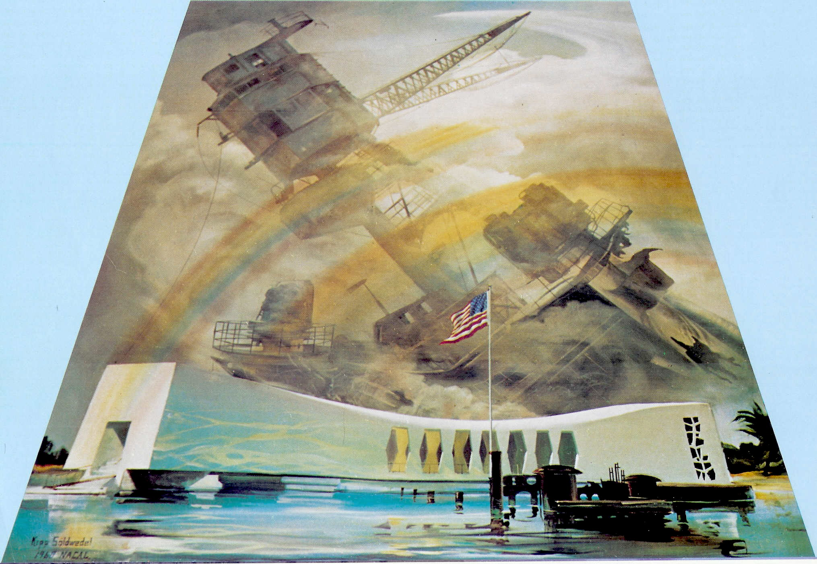
Painting of Memorial

