Sinclair Inlet Chapter No. 80 National Sojourners, Inc



Bremerton, Washington
Our website address is: www.telebyte.com/masons/sojourn/index.htm

March 2014 Newsletter

Chapter Officers 2013-2014
President | HMCM Joseph MacIntyre | 360-275-0589 | haggis@wavecable.com
1st Vice President | CPO Stephen Quance | 360-731-5552 | sdquance@yahoo.com
2nd Vice President | Mr. Richard Dexter | 360-692-6876 | rdexter@tscnet.com
Secretary/Treasurer | Mr. Charles Yankosky | 206-780-0563 | cyankosky@yahoo.com
Marshal | None
Chaplain | LTC Wendell Dutt | 253-565-5264 | wadutt@comsast.net
Color Bearer | None

Hero Camp Officers 2013-2014
Commander | Mr. Peter Dawson | 360-779-8219 | etypebubba@aol.com
Chief of Staff | MMCM Henry Carman | 360-698-4776 | hankcarman@wavecable.com
Adjutant | Mr. Charles Yankosky | 206-780-0563 | cyankosky@yahoo.com

Meeting Notice!
We will meet at VFW Post #239, 190 Dora Ave, Bremerton on Friday, 14 Mar. Social hour and dinner begins at 1800, meeting at 1900 hours. Ladies and guests are always welcome at the meeting and are urged to attend.
The associated Lewis and Clark Camp of the Heroes of ’76 meets immediately following the Sojourner meeting and is open to all Heroes.
Don’t forget to wear your Medals!
Highlights of the 14 Feb Meeting
1ST Vice Pres. B.J. Quance opened the meeting at 19:00. We thought we would be doing an induction tonight, but tonight was also Valentine’s Day so other members had prior commitments. Also, because of the holiday, the VFW club was serving a prime rib dinner tonight, instead of the usual steak dinner. If we had known this ahead of time we could have invited the other members to share in a prime rib dinner for $15. Normally, it’s $11 for a steak dinner with onion topping, baked potato and veggies. Area Rep. Wendell Dutt suggested that notification be given about special events at the VFW. Bro. Hank Carman, a VFW 239 member, was made Assistant Secretary for Special Events and will e-mail members about upcoming special events.
Wendell made a motion that was seconded and approved to donate $100 to VFW #239 for being such
a generous host.
There being a few typos, the minutes from the previous meeting needed some corrections.
Bro. Hank Carman noted that we’ve always had
to borrow someone else’s Bible to open chapter. Hank made a motion that we buy our own Bible. Wendell offered to bring a Bible that came from a Sojourner chapter in Germany. It’s in English.
Bro. Dick Dexter talked to the Commander of the VFW Chapter about doing a “Building The Flag” pro-gram. The Commander thought it would be nice. Dick did 2 “Old Glory” speeches at funerals in January.
There being no further business 1ST V.P. B.J.
closed chapter at 19:15.

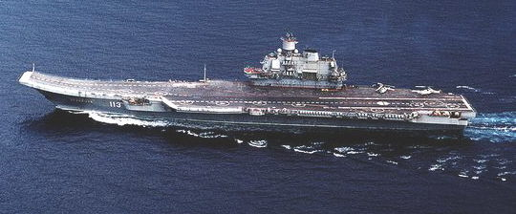
Russia Plans to Build a New Navy to Dominate the Arctic Ocean
Jan. 19, 2014 article by Rich Smith, The Motley Fool.

(Before Ukraine became news this article came out)
The United States Navy still leads its former arch rival the Russian navy by 283 ships to 208, but Russia has plans to expand.
In an interview with RIA Novosti, Russian Navy Deputy Commander Adm. Viktor Bursuk revealed
that 40 new ships will be added to the Russian fleet
this year. Most are surface ships but they include a Borey class nuclear powered ballistic missile sub and a Varshavyanka class diesel-electric sub. A submarine rescue ship, the Igor Belousov, is also planned.
Bursuk also said that the Kirov class nuclear pow-ered missile cruiser Admiral Nakhimov will be taken
out of “mothballs” and 3 nuclear powered attack subs will be upgraded. Russia’s first nuclear powered air-
craft carrier might also be built.
Last December Russian President Vladimir Putin
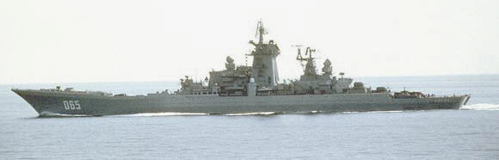
Told the Russian Defense Ministry that one of Rus-
Russian Kirov class nuclear powered missile cruiser
sia’s top priorities is to increase Russian influence at
the North Pole.
Global warming has opened up 1 million square miles of navigable water in the Arctic Ocean to com-mercial shipping. The shrinking ice cap is making rich mineral deposits easier to get to. 95% of Russia’s pro-bable natural gas and 60% of her oil reserves are in the Arctic. Oil and gas giants Rosneft and Gazprom want to defend these deposits and search for new ones.
Earlier this month Russia announced plans to increase air patrols “significantly” using Tu-142 and
IL-38 recon and anti-submarine aircraft. Also half a dozen Arctic airfields and ports, closed down since the end of the Cold War, are to be re-opened,
Many of Russia’s new ships may be sent to Arctic duty to defend Russian interests. And if Russia does build a nuclear aircraft carrier, former Russian Northern Fleet Commander Adm. Vladimir Vysolsky thinks it too should be sent to the Arctic to support Russian subs.
Russia’s only operational carrier, the Adm. Kuznetsov

A new U.S. Navy report advocates “hardening” U.S. warships to help them perform in the Arctic – at a cost of up to $8.4 billion. Building 10 new Arctic ice breakers, at a cost of $7.8 billion, was also proposed.

Reader’s Comment: This is not 1985. You can’t com-pare a Russian PT boat to the carrier U.S.S. Nimitz. The U.S. Navy has 70% of the tonnage of all the world’s navies combined. The U.S.Navy has 10 times the annual budget of the Russian navy. In the 1990’s and early 2000’s the Russian navy was a rust bucket wreck. They
decommissioned most of their warships and sold any ships that other countries were willing to buy. China and India bought aircraft carriers and other ships. Even with 40 new ships, they still have a long way to go.

