Sinclair Inlet Chapter No. 80 National Sojourners, Inc

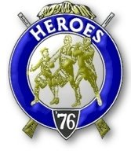

Bremerton, Washington
Our website address is: www.telebyte.com/masons/sojourn/index.htm

March 2012 Newsletter

Chapter Officers 2011-2012
President | Mr. Peter Dawson | 360-779-8219 | etypebubba@aol.com
1st Vice President | HMCM Joseph MacIntyre | 360-275-0589 | haggis@wavecable.com
2nd Vice President | None
Secretary/Treasurer | Mr. Charles Yankosky | 206-780-0563 | cyankosky@yahoo.com
Marshal | CPO Stephen Quance | 360-731-5552 | sdquance@yahoo.com
Chaplain | Mr. Richard Dexter | 360-692-6876 | rdexter@tscnet.com
Color Bearer

Hero Camp Officers 2011-2012
Commander | Col William Biscomb | 206-842-6417 | milfordbiscomb@comcast.net
Chief of Staff | Mr. Alex Jordan |  | jordan3614@hotmail.com
Adjutant | MMCM Henry Carman | 360-698-4776 | hankcarman@wavecable.com

Meeting Notice!
We will meet at VFW Post #239, 190 Dora Ave, Bremerton (see directions) on Friday 9 Mar. Social hour and dinner begins at 1800, meeting at 1900 hours. Ladies and guests are always welcome at the meeting and are urged to attend.
The associated Lewis and Clark Camp of the Hero's of '76 meets immediately following the Sojourner meeting and is open to all Hero's.
Don’t forget to wear your Medals!
Highlights of the Last Meeting
President Peter Dawson opened the meeting at 19:00. Lance Otis read the purposes of National Soj-ourners. Pres. Peter thanked everyone for turning out. The Feb. minutes were approved as printed. Wendell Dutt said that National wants us to send in per capita dues as soon as they come in, not wait until you have them all. Even if just one come in, send it. Also National wants to know how many members are Honorary. If the number is over 15%, no more Honoraries will be allowed until more vets are recruited. Area Rep. Wendell had some information on the National Convention to be held 18 – 23 June in Burlington, VT. Hank Carman suggested we start thinking about the JROTC awards for this May’s school graduations. Wendell noted that National wants a head count to be done as soon as possible. We’ve always awarded one at South Kitsap High and one at Bremerton H.S. Chapter 89 presents 17 medals at all the Tacoma area high schools. Order the medals about 3 years ahead. Lance Otis can print out the award certificates. John Gray has done a lot of presen-tations, but he is very busy working on his doctorate. Tom Dangelo, Joe MacIntyre, Lance Otis and Dick Dexter can also be presenters. South Kitsap has a new JROTC contact.
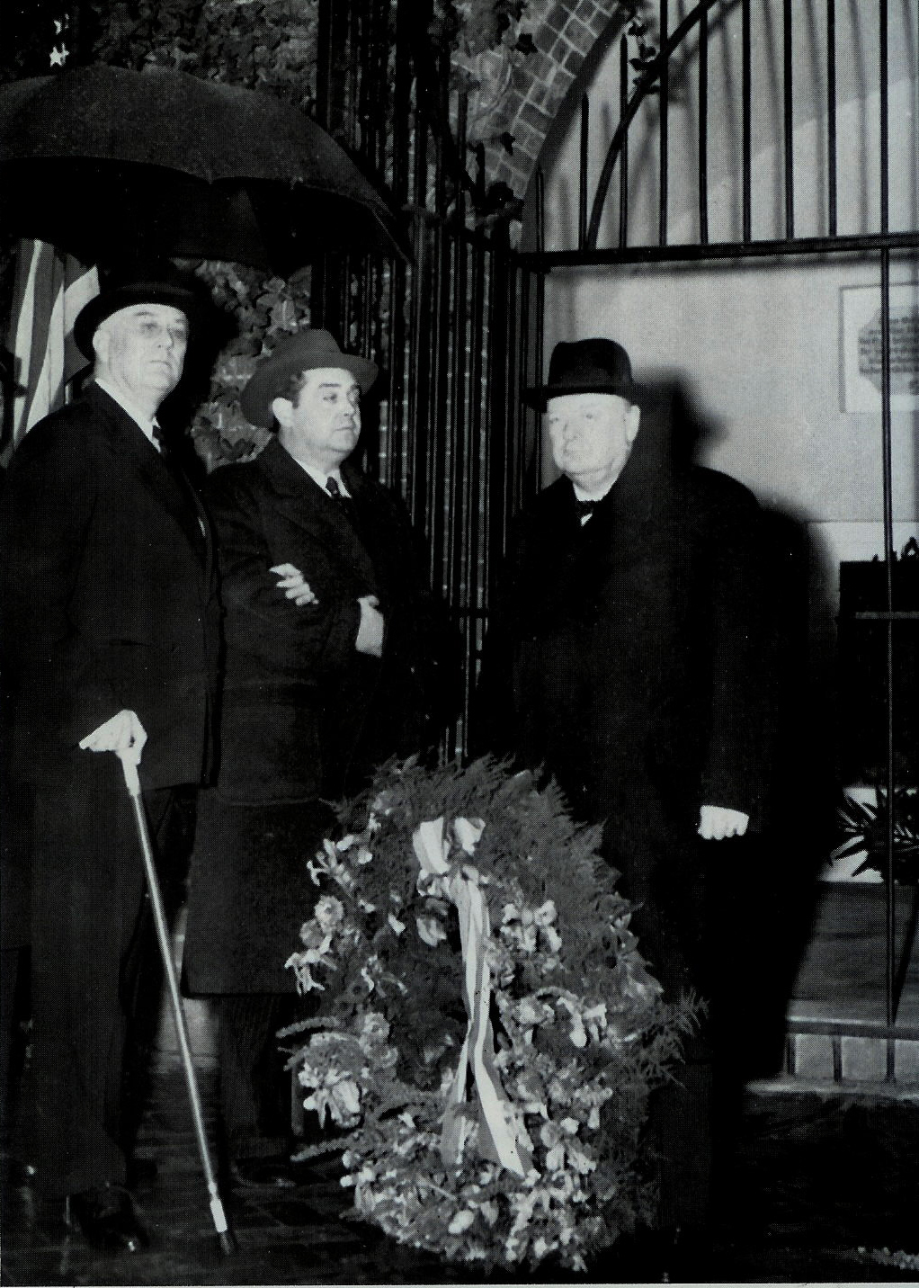
We received a request from Franklin Lodge #5 for a Flag Building ceremony for their Military Apprecia-tion Night on 9 May. Port Gamble has tent pavilion that seats 175 people. That night the lodge intends to invite local members of the military and their families. The Sojourners will have about 30 minutes to build the American flag. The flannel board is at Dick’s place. Peter has the flags in his garage. Income from the night will go to Fisher House at Madigan Hospital.
Be sure to turn in the Bi-Annual report to Bob Col-ton He was supposed to present them at the Mid-Win-ter conference in Arizona. But because of sickness they weren’t all collected. Natl Sojourners has 168 chapters. Of these only 119 responded. National was looking for specific answers: who attended; did you have a program. This feed back will go to a planning committee who will deduce what’s working and what isn’t. To be healthy, a chapter should have a score of over 10 on the report. It’s not too early to look ahead to the Pacific Beach Heroes’ encampment in Septem-ber. Bob Colton is again in charge but he’s not in the best of health.
If the National Sojourner newsletter were were on the internet a lot of money would be saved due to rising postal rates. With the passing of Bro. Joe Illes we lost a lot at the national level. Each chapter needs to contribute $16.89 to Bob Colton for ads in the June convention souvenir program. The Burlington Conven-tion wasn’t fully financed. $10,000 in donations have to be raised to cover the cost. Wendell also informed us that a new format has been devised for the Nat’l Sojourner school essay program. It’s now in a generic form, downloaded from the National website. Essay subject will be posted on the national website. Costs have to be controlled because it’s expensive to send kids to Valley Forge.
Bill Biscomb reported that Dick Dexter, Hank Carman and himself presented the flag at a meeting of the Northwest Chapter of the Naval Criminal Assn. (NCISSA). Bill is the secretary of that organization.
Lance Otis attended a briefing on Iran. A retired general provided information to broadcasters on the challenges posed by Iranian missile boats to U.S. aircraft carriers. Would you think that a little missile boat could be a threat to an aircraft carrier? It seems they can do significant damage. Over the next three months expect to see posturing by the U.S. and Iran over the Straits of Hormuz. Keep your ear to the wall. It’s possible we may see some action before the elections.
Sickness & Health: Earl Whittaker, a past master from Poulsbo, was in the hospital with pneumonia. Earl Riggs of Olympic Chapter is in Belmont Terrace recovering from a stroke. He is talking now. B.J. Quance is still mending from his heart surgery. Meeting closed at 19:45.
An Interesting Picture
New Year’s Day 1942. British Prime Minister Winston
Churchill lays a wreath at the tomb of George Washington. Looking on are President Franklin D. Roosevelt, escorted by F.D.R.’s military advisor, Gen. Edwin “Pa” Watson. The P.M. and members of his War Cabinet crossed the U-boat infested Atlantic aboard British battleship .H.M.S. Duke of York before Christmas 1941 to confer with Pres. Roosevelt and the American war chiefs on how to conduct the war against Hitler and the Axis. (One Christmas In Washington – The Secret Meeting Between Roosevelt & Churcill That Changed The
World – by David Bercuson & Holger Herwig, Overlook Press, 2005)

