Sinclair Inlet Chapter No. 80 National Sojourners, Inc

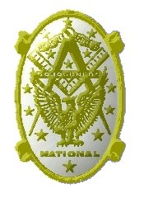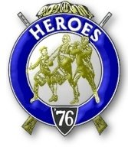

Bremerton, Washington
Our website address is: www.telebyte.com/masons/sojourn/80/sinclair_inlet_chapter.htm

June 2006 Newsletter

Chapter Officers 2005-2006
President | Col William M. Biscomb | 206-842-6417 | biscombpi@hotmail.com
1st Vice President | HMCM Joseph MacIntyre | 360-275-0589 | haggis@hctc.com
2nd Vice President | MMCM Henry T. Carman | 360-698-4776 | hankcarman@wavecable.com
Secretary/Treasurer | WTCS John M. Gray | 360-895-3188 | wtcs_sw@wavecable.com
Marshal | CWO4 Richard Patterson | 360-769-8246 | rlpatt@ix.netcom.com
Chaplain | 1LT Harold E. Richardson | 360-692-4023 | harolder46@comcast.net
Color Bearer

Hero Camp Officers 2005-2006
Commander | 1Lt Harold E. Richardson | 360-692-4023 | harolder46@comcast.net
Chief of Staff | HMCM Joseph MacIntyre | 360-275-0589 | haggis@hctc.com
Adjutant | WTCS John Gray | 360-895-3188 | wtcs_sw@wavecable.com

Meeting Notice!
We will meet at the Masonic Temple in Des Moines Lodge #245, 2208 S 223rd St, Des Moines, WA 98198-7935 on 3 JUN. Social hour begins at 1100, lunch at 1200 and installation at 1300 hours.

Ladies and guests are always welcome at the meeting and are urged to attend.
Don’t forget to wear your Medals!

President’s Message
Brother Sojourners:
This is expected to be my last "official" remark in writing as your President...soon to be Past, after handing over the gavel to the one and only Bro. Joe McIntyre. Our last meeting was again a big success, in my opinion. We once more had a full house, a guest speaker and a newly initiated member. As promised, here are the details regarding our first try at a family outing at a place other than our usual meeting spot (Bremerton Elks).
On Sat. 8 July 2006, members, spouses and guests are invited to 625 Ripley Creek Road, Quilcene. Arrive late morning. Walk around the 20 acres, play horseshoes, or just enjoy nature, before partaking of a Mongolian BBQ. Directions are as follows:

1. From the Hood Canal Bridge, go West for 14 miles, to the intersection of US Hwy. 101.
2. Go South on 101, heading for Quilcene (if you get to Olympia you have gone too far), for about 7 miles until you see a sign saying "Lords Lake Loop".
3. Go right (West) for exactly 1.5 miles. The entrance gates are on the right and a sign saying Ripley Creek - Private road, No hunting.
4. Go 15 mph for exactly one half mile and you will see the sign marker 625. You have arrived! The telephone number there is (360) 765-0438.

This is a must...you must let either myself (206) 842-6905 or the Secretary know if you plan to attend and how many will be in your party. NOT LATER THAN 30 June, please. Otherwise we will run out of food. Second, please bring a salad or dessert and your own beverages. This is a "semi-pot luck" social to see if the membership enjoys such extra get togethers. Hope to see you there.

Bill Biscomb COL AUS (Ret.)
President
From the Desk of the Secretary
Brethren,
I want to extend a warm welcome to our four newest members, Tom Dangelo, Don Lauer, Francis Worthington and Charles Yankosky. We look forward to seeing you at our meetings!
We have 41 active members in our Chapter, and in the process of maintaining all the records, sometimes things fall through the cracks. If there is anything that I have missed regarding you membership, please let me know and I will try to correct it as soon as possible.
NJROTC awards were prepared for the Bremerton and South Kitsap nominees and were awarded on 30 May and 17 May respectively. Sojourners presented the awards in person which was greatly appreciated by the units.
After the June meeting in Des Moines, the next meeting of our Chapter will be on Friday 8 SEP 2006 at the Elks Club. The next newsletter will be the September edition.
Brothers, if you desire to receive your newsletter strictly by email, please let me know so the Chapter can save money on postage and printing.
I know I can speak for the President when I say this past year has been a learning and rewarding experience. I look forward to serving you in the upcoming year.
Fraternally,
John
Highlights of Last Meeting
The meeting opened at 1900 12 May 06 by President Bill Biscomb with the members, ladies and guests as listed on the Muster Report. It was moved by Joe Illes and passed to forego the reading of the minutes of the APR meeting. Treasurers Report was read, balance on hand: $1661.84. Correspondence was read, consisting of chapter newsletters from Chapter 89 and a packet on the National meeting in June in Austin, TX. Committee Reports: Membership committee reported that chapter membership stood at 61, (17 Active, 24 MIP’s, 20 Inactive MIP’s). The following candidates were initiated: Charles Yankosky and Francis Worthington. The Medal Lecture was given by Joe Illes. Unfinished Business: None. New Business: The president and his wife will host a BBQ at their property in Quilcene on 8 JUL starting at 1100. Members are requested to bring dessert and their drink of choice. They would like an RSVP by 1 July. Directions will be included in the next newsletter. Guest Speaker: The 1st VP introduced CAPT Bruce W. Woolnough, CO of the Bremerton High School NJROTC. Among other things, CAPT Woolnough explained how the NJROTC high school program works, that theirs was the largest Navy program in the NW (over 200 students) and that they had been a distinguished unit (in the top 10% of units in the nation) for the last 12 years. Joe MacIntyre then presented the CAPT with 4 Northwest Youth Leadership Conference scholarships at PLU. The selectees were Justin Smith, Sean Phillips, Brianne O’Neil and Miles Hicks. Announcements: The Secretary reminded everyone of the Pancake Breakfast by William H. Upton Naval & Military Lodge #206 on the morning of the Bremerton Armed Forces Day Parade and of our Joint Installation of Chapters 40, 80, 89, 102, 534 and 539 at the Des Moines Masonic Temple, 2208 S 223rd in Des Moines on 3 June. Social hour will start at 1100, dinner at 1200 and the installation will commence at 1300. Cost of dinner is $10.00. The president’s wife explained the Seattle Opera Audience Development Program and provided the Secretary with ticket request information. He will contact the Seattle Opera to explore the possibility of obtaining some free tickets for our Chapter. Steve Seteroff reminded everyone of Olympic Chapter’s 24 May noon meeting. There being no further business, the meeting ended at 2000, peace and harmony prevailing.

Directions to Des Moines Masonic Temple

Brothers, the Joint installation of officers for Chapters 40, 80, 89, 102, 534 and 539 at the Des Moines Masonic Temple is on 3 June. Please let me know ASAP if you plan on attending so I can call ahead and reserve a lunch for you. The cost is $10.00. Unless told otherwise, I assume all our incoming officers will be attending. Directions:

1. Merge onto WA-16 E toward TACOMA. 24.5 miles

2. Merge onto I-5 N via the exit on the LEFT toward SEATTLE. 17.0 miles

3. Merge onto S KENT DES MOINES RD/WA- 516 W via EXIT 149B toward DES MOINES.
4. Turn RIGHT onto 24TH AVE S.

5. Turn LEFT onto S 223RD ST.

6. End at 2208 S 223rd St, Des Moines, WA

NW Leadership Conference Awards

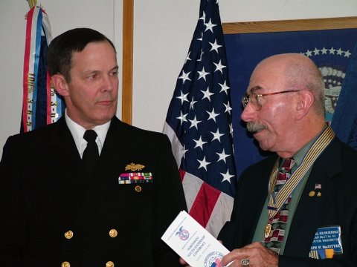

1st VP Joe MacIntyre announces the Bremerton High School award recipients to CAPT Bruce Woolnough, NJROTC, the unit Commanding Officer.

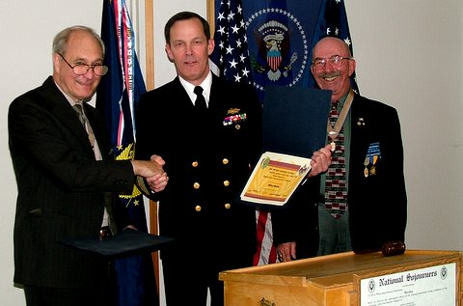

President Bill Biscomb presents award certificates to CAPT Woolnough for each scholarship selectee.

Lewis & Clark Camp of the Hero's of '76 News

Congratulations to Tom Lou, our newest Hero of ’76.

The Bennington Flag, the flag used by the Hero’s of ’76 was used in the Battle of Bennington, August 16, 1777, by Vermont militia. This flag is the first to lead American armed forces on land. The original is preserved in the museum at Bennington, Vermont although there is some dispute whether it is the original flag or an early 19th century copy made for French General Lafayette’s visit to America.

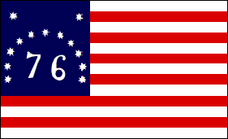

Navy Terms and Sayings

The English language is well-known for its tendency to borrow words and phrases from other languages and adopt them for its own. Quite a few of these come from the sea-faring portion of our history, and have distinctly nautical overtones which are still recognized. Many nautical phrases and terms have their origins from the days of sailing ships. Since both Great Britain and the United States have shared a long maritime heritage as well as a common language, it is only natural that many of these have survived to the present day. Germany, Holland and France, for example, are other European nations with a long sea faring tradition of their own, and they have also contributed a few. Indeed, some of these terms are still in use in everyday conversation, although the speakers themselves may not know just where and when they came from. Here's a few of them:

Ahoy - This was once the dreaded war-cry of the Vikings.

Chit - Hindu in origin. "Chittee", meaning a small, hand- written note used as a voucher for food or a small debt. It is now used as a personal request form.

Binnacle List - The binnacle list gets its name from the old nautical practice of placing the sick list on the binnacle (This was a covered stand on the ship's deck which contained the ship's compass and a lamp to enable the officer of the deck to check his course at night and in foul weather) each morning, so that it would be readily available for the captain. The modern binnacle list contains the names of crewmen suffering from minor complaints which would preclude employment on strenuous duty. Today, the Sick List is for hospitalized personnel.

Cumshaw - Something procured without official payment. Free, A lift. Unauthorized work done or equipment given to a ship or unit without official payment. It comes from the beggars of Amoy, China who said, "Kam Sia!", meaning, "Grateful Thanks!"

Gee-Dunk - World War II in origin. It was the slang nick-name given by sailors for the pre-mixed concentrate (Often labeled as 'General Dairy' products on the containers) that was loaded aboard American warships to be made into ice cream while at sea. Some scholars argue it was originally intended to be a substitute for the rum ration privilege given to British sailors, while others point out that ice cream was a popular American treat anyway, and could be easily made aboard ship. In either case, American warships since WW II have had sea-going ice cream soda shops or fountains, where this commodity could be regularly sold to members of the crew for a small sum. Gradually, other snack foods such as candy bars, chips, cookies, etc. were added to the stocks. The term is now generally applied to all "junk" food that is not on the ship's regular menu.

COLLINGWOOD LIBRARY AND MUSEUM ON AMERICANISM (CLMA)

It is dedicated to providing information about our national heritage to the American Public, available to anyone who cares to learn of the heroic efforts made by American Patriots, particularly members of the Masonic Fraternity, in founding and developing the United States of America, the greatest nation on earth. There are many rooms in Collingwood which are dedicated to specific purposes. One of these is called the Heroes Room, dedicated to Masonic Heroes who sacrificed their lives, their honor, and their fortunes to establish this Republic. This great organization is not only the home of a great museum for patriotism and Americanism but also where the National Sojourners are on constant display. They need our continued support. Your Tax Deductible Donation will go a long way towards preserving some very special history. Please send your donation to the Collingwood Library on Americanism, 8301 East Boulevard Drive, Alexandria, VA 22308-1399.

