Mjn ny7Sinclair Inlet Chapter No. 80 National Sojourners, Inc

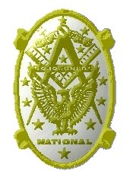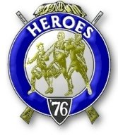

Bremerton, Washington
Our website address is: www.telebyte.com/masons/sojourn/index.htm

January 2016 Newsletter

Chapter Officers 2015-2016
President | Mr. Richard Dexter | 360-692-6876 | rdexter@tscnet.com
1st Vice President | Mr. Peter Dawson | 360-779-8219 | etypebubba@aol.com
2nd Vice President | MM1 Orville Stoner | 360-782-2385 | ovstoner@comcast.net
Secretary/Treasurer | Mr. Charles Yankosky | 206-780-0563 | cyankosky@yahoo.com
Marshal | CSCS Todd Mears | 360-286-0358 | navy.pride1987@yahoo.com
Chaplain | LTC Wendell Dutt | 253-565-5264 | wadutt@comsast.net
Color Bearer | None

Hero Camp Officers 2015-2016
Commander | Col. William Biscomb | 206-842-6417 | milfordbiscomb@comcast.net
Chief of Staff | HMCM Joseph MacIntyre | 360-275-0589 | haggis@wavecable.com
Adjutant | Mr. Charles Yankosky | 206-780-0563 | cyankosky@yahoo.com

Meeting Notice!
We will meet at VFW Post #239, 190 Dora Ave, Bremerton on Friday, 8 Jan. Social hour and dinner begin at 1800, meeting at 1900 hours. Ladies and guests are always welcome at the meeting and are urged to attend.
The associated Lewis and Clark Camp of the Heroes of ’76 meets immediately following the Sojourner meeting and is open to all Heroes.
Don’t forget to wear your Medals!
Highlights of the 11 Dec. 2015 Meeting
President Richard Dexter called the meeting to order at 1900 and thanked everyone for being here tonight. A visiting Sojourner was introduced. James Walker, of Lewis & Clark #89, was here to visit our Scottish Rite. The question was asked, Did we do a Candle Light Ceremony? No. We usually do that at the last meeting in May. How about membership? Guys are starting to attend more regularly.
Building the Flag at William H. Upton Naval & Military #206’s stated meeting on 17 Nov. went really well. Upton’s new Master had flag stands made by Romy Labonete. The flags of the armed services were presented, including MIA and POW, and were posted by members of each service. “Old Glory Speaks” was presented by Bro. Dick Dexter. The Flag was built at dinner. Area Rep. Wendell Dutt commented that it would be nice to have a write-up sent to the National Sojourner Magazine, if it could be sent to the National Secretary by the 21ST. At our last meeting Bro. Bill Biscomb did a version of “Old Glory Speaks,” that he is learning. Bro. Richard Dexter will do
his version, which is different. When Bro. Dick Dexter was a new Mason he heard Bro. Steve Seteroff present “Old Glory” in lodge. At the time Bro. Dick had a son in Iraq for the first of 3 tours of duty. After hearing Steve Seteroff, Bro. Dick thought, “I have to learn this.” And learn it he did.
Bro. Joe MacIntyre shared some interesting items that happened on this date in history. In 1620 103 Pilgrims landed at Plymouth Rock. In 1866 a yacht crossed the Atlantic. In 1909 motion pictures were shown at Madison Square Garden. In 1941 Germany and Italy declared war
on the U.S. In 1946 Spain was suspended from the U.N. In 1961 JFK gave helicopters to South Vietnam.
For “good of the order” Secretary Charles read the poem “Old Ironsides,” about the 38-gun frigate U.S.S. Constitution. Commissioned in 1798, the Navy was going to scrap her at the end of her service life in 1830. The same day he read of this plan in the newspaper, Oliver Wendell Holmes, Sr., of Boston, wrote this poem and sent it in to the local paper. Other East coast newspapers reprinted the poem and a successful movement to save the ship was begun. Today the ship is the oldest commissioned ship in the U.S. Navy (IX-22) and is undergoing a 2 year restoration project.
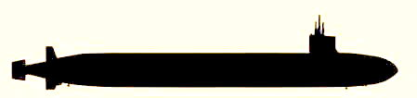
Bro. Hank Carman shared with us that another historic sailing ship, the Constellation, a sister ship of the Constitution and also commissioned in 1798, is moored in Baltimore as a museum ship. Bro. Hank pulled up the website on his I-phone with information about tours. The frigate Constellation was laid-up in 1845, and due to the state of deterioration of the wooden ship, she was completely rebuilt by the Norfolk Navy Yard in 1854 as a 22-gun sloop of war. Thus the refurbished Constellation saw service from the War Between The States until she served as a shore-based flagship for the Atlantic Fleet in World War 2. She was decommissioned and stricken from the Navy list in 1955 and given to a patriotic citizens group in Baltimore as a naval relic. (Dictionary of American Naval Fighting Ships, Vol. II (C thru F) 1963)
Area Rep. Wendell suggested adding a link to the National website: www.nationalsojourners.org and checking out the Resale Catalog on the National website. Bro. Robert Monroe volunteered to distribute the monthly newsletter via e-mail.

Secretary Charles saw an interesting Info-Graphic wall map on the internet, listing all the vessels of the U.S. Navy as of April 2015. It shows the fleet in to-scale ship outlines. Since there are 62 Arleigh Burke destroyers, a destroyer silhouette is repeated 62 times, and so on. I thought it would be interesting to add the ship’s commissioning date, since a ship’s service life is usually 25 years. All of the cruisers are over 20 years old. Bremerton’s own nuclear attack sub, USS Bremerton (SSN-698) is over 30 years old so it might be coming up for retirement. I believe all the guided missile frigates are retired now. The Page Number refers to the ship’s specification table printed in “Naval Institute Guide to Ships & Aircraft of the U.S. Fleet, 17TH Edition, Norman Polmar, 2001,” which I used as a guide.

This is the U.S. Navy April 2015
from naval.graphics@gmail.com

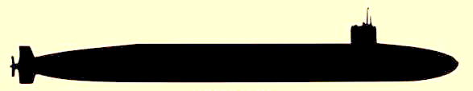
GUIDED MISSILE SUBMARINES:
OHIO Class (18,750 tons displacement) (pg 64)
SSGN-726 USS Ohio (commissioned 1981)
-727 USS Michigan (1982)
-728 USS Florida (1983)
-729 USS Georgia (1984)

BALLISTIC MISSILE SUBMARINES:
OHIO Class (pg 64)
SSBN-730 USS Henry M. Jackson (1984)
-731 USS Alabama (1985)
-732 USS Alaska (1986)
-733 USS Nevada (1986)
-734 USS Tennesse (1988)
-735 USS Pennsylvania (1989)
-736 USS West Virginia (1990)
-737 USS Kentucky (1991)
-738 USS Maryland (1992)
-739 USS Nebraska (1993)
-740 USS Rhode Island (1994)
-741 USS Maine (1995)
-742 USS Wyoming (1996)
-743 USS Louisiana (1997)

NUCLEAR POWERED ATTACK SUBS:
SEAWOLF Class (9,137 tons displ.) (pg 75.76)
SSN-21 USS Seawolf (1997)
-22 USS Connecticut (1998)
-23 USS Jimmy Carter (2003)

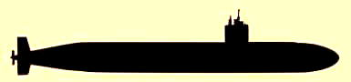
LOS ANGELES Class (7,147 tons displ.) (pg 80,82)
(40 boats)
SSN-698 USS Bremerton (1981)
-699 USS Jacksonville (1981)
-700 USS Dallas (1981)
-701 USS La Jolla (1981)
-705 USS City of Corpus Christi (1983)
-706 USS Albuquerque (1983)
-711 USS San Francisco (1981)
-713 USS Houston (1982)
-715 USS Buffalo (1983)
-717 USS Olympia (1984)
-719 USS Providence (1985)
-720 USS Pittsburgh (1985)
-721 USS Chicago (1986)
-722 USS Key West (1987)
-723 USS Oklahoma City (1988)
-724 USS Louisville (1988)
-725 USS Helena (1987)
-750 USS Newport News (1989)
-751 USS San Juan (1988)
-752 USS Pasadena (1989)
-753 USS Albany (1990)
-754 USS Topeka (1989)
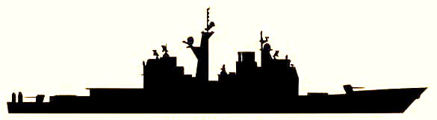
-756 USS Scranton (1991)
-757 USS Alexandria (1991)
-758 USS Asheville (1991)
-759 USS Jefferson City (1992)
-760 USS Annapolis (1992)
-761 USS Springfield (1993)
-762 USS Columbus ( 1993)
-763 USS Santa Fe (1994)
-764 USS Boise (1992)
-765 USS Montpelier (1993)
-766 USS Charlotte (1994)
-767 USS Hampton (1993)
-768 USS Hartford (1994)
-769 USS Toledo (1995)
-770 USS Tucson (1995)
-771 USS Columbia (1995)
-772 USS Greenville (1996)
-773 USS Cheyenne (1996)

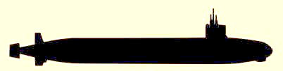
VIRGINIA Class (7,800 tons displ.) (pg 73)
SSN-774 USS Virginia (2004)
-775 USS Texas (2005)
-776 USS Hawaii (2006)
-777 USS North Carolina (2007)
-778 USS New Hampshire
-779 USS New Mexico
-780 USS Missouri
-781 USS California
-782 USS Mississippi
-783 USS Minnesota
-784 USS North Dakota

AIRCRAFT CARRIERS: (pg 111)
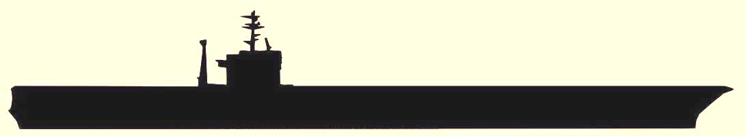
NIMITZ Class (100,000+ tons displacement)
CVN-68 USS Nimitz (commissioned 1975)
-69 USS Dwight D. Eisenhower (1977)
-70 USS Carl Vinson (1982)
-71 USS Theodore Roosevelt (1986)
-72 USS Abraham Lincoln (1989)
-73 USS George Washington (1992)
-74 USS John C. Stennis (1995)
-75 USS Harry S. Truman (1998)
-76 USS Ronald Reagan (2003)
-77 USS George H.W. Bush (2007)

GUIDED MISSILE CRUISERS: (pg 136)
TICONDEROGA Class (9,466 tons displ.)
(22 ships)
CG-52 USS Bunker Hill (1986)
-53 USS Mobile Bay (1987)
-54 USS Antietam (1987)
-55 USS Leyte Gulf (1987)
-56 USS San Jacinto (1988)
-57 USS Lake Champlain (1988)
-58 USS Philippine Sea (1989)
-59 USS Princeton (1989)
-60 USS Normandy (1989)
-61 USS Monterey (1990)
-62 USS Chancellorsville (1989)
-63 USS Cowpens (1991)
-64 USS Gettysburg (1991)
-65 USS Chosin (1991)
-66 USS Hue City (1991)
-67 USS Shiloh (1992)
-68 USS Anzio (1992)
-69 USS Vicksburg (1992)
-70 USS Lake Erie (1993)
-71 USS Cape St. George (1993)
-72 USS Vella Gulf (1993)
-73 USS Port Royal (1994)

GUIDED MISSILE DESTROYERS: (pg 143,145)
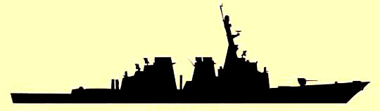
ARLEIGH BURKE Class (9,217 tons displ.)
(62 ships)
DDG-51 USS Arleigh Burke (1991)
-52 USS Barry (1992)
-53 USS John Paul Jones (1993)
-54 USS Curtis Wilur (1994)
-55 USS Stout (1994)
-56 USS John S. McCain (1994)
-57 USS Mitscher (1994)
-58 USS Laboon (1995)
-59 USS Russell (1995)
-60 USS Paul Hamilton (1995)
-61 USS Ramage (1995)
-62 USS Fitzgerald (1995)
-63 USS Stethem (1995)
-64 USS Carney (1996)
-65 USS Benfold (1996)
-66 USS Gonzales (1996)
-67 USS Cole (1996)
-68 USS The Sullivans (1997)
-69 USS Milius (1996)
-70 USS Hopper (1997)
-71 USS Ross (1997)
-72 USS Mahan (1998)
-73 USS Decatur (1998)
-74 USS McFaul (1998)
-75 USS Donald Cook (1998)
-76 USS Higgins (1999)
-77 USS O’Kane (1999
-78 USS Porter (1999)
-79 USS Oscar Austin (2000)
-80 USS Roosevelt (2000)
-81 USS Winston S. Churchill (2001)
-82 USS Lassen (2001)
-83 USS Howard (2001)
-84 USS Bulkeley (2001)
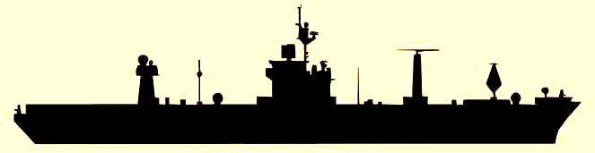
-85 USS McCampbell (2002)
-86 USS Shoup (2002)
-87 USS Mason (2002)
-88 USS Preble (2002)
-89 USS Mustin (2003)
-90 USS Chafee (2003)
-91 USS Pinckney (2003)
-92 USS Momsen (2004)
-93 USS Chung-Hoon (2004)
-94 USS Nitze (2004)
-95 USS James W. Williams (2005)
-96 USS Bainbridge (2005)
-97 USS Halsey (2005)
-98 USS Forrest Sherman (2006)
-99 USS Farragut (2006)
-100 USS Kidd (2006)
-101 USS Gridley (2007)
-102 USS Sampson (2007)
-103 USS Truxton (2008)
-104 USS Sterret (2008)
-105 USS Dewey (2009)
-106 USS Stockdale (2009)
-107 USS Gravely (2010)
-108 USS Wayne E. Meyer
-109 USS Jason Dunham
-110 USS William P Lawrence
-111 USS Spruance
-112 USS Michael Murphy

GUIDED MISSILE FRIGATES: (pg 158)
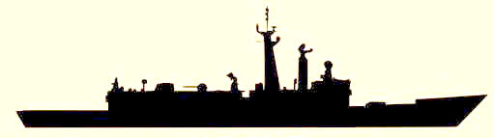OLIVER HAZARD PERRY Class (3,658T displ.)
FFG-50 USS Taylor (1984)
-51 USS Gary (1984)
-56 USS Simpson (1985)
-58 USS Samuel B. Roberts (1986)
-59 USS Kauffman (1987)

AMPHIBIOUS SHIPS:

AFLOAT FORWARD STAGING BASE:
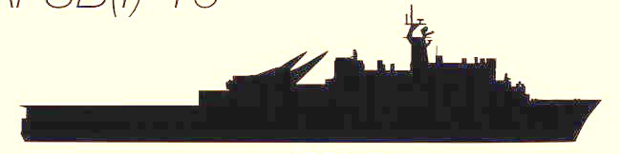
AUSTIN Class (17,000T displ.) (pg 181)
AFSB-15 USS Ponce (1971)

AMPHIBIOUS COMMAND SHIPS:
BLUE RIDGE Class (18,686T displ.) (pg 166)
LCC-19 USS Blue Ridge (1970)
-20 USS Mount Whitney (1971)

LITTORAL COMBAT SHIPS:

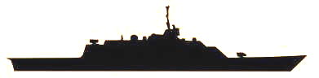
FREEDOM Class
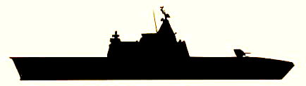
LCS-1 USS Freedom
-3 USS Fort Worth

INDEPENDENCE Class
LCS-2 USS Independence
-4 USS Coronado

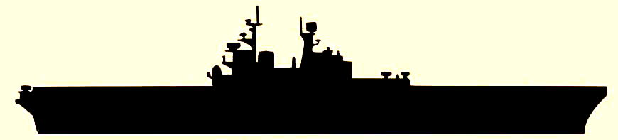
AMPHIBIOUS ASSAULT SHIPS (Carrier):
AMERICA Class
LHA-6 USS America

AMPHIBIOUS ASSAULT SHIPS (Carrier):
WASP Class (40,535T displ.) (pg 173)
LHD-1 USS Wasp (1989)
-2 USS Essex (1992)
-3 USS Kearsarge (1993)
-4 USS Boxer (1995)
-5 USS Bataan (1997)
-6 USS Bonhomme Richard (1998)
-7 USS Iwo Jima (2001)
-8 USS Makin Island

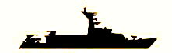
AMPHIBIOUS TRANSPORT DOCK SHIPS:
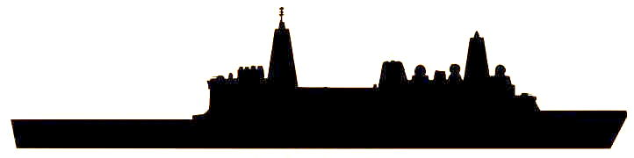
SAN ANTONIO Class (25,000T displ.) (pg 179)
LPD-17 USS San Antonio (2003)
-18 USS New Orleans (2004)
-19 USS Mesa Verde (2005)
-20 USS New York
-21 USS San Diego
-22 USS Anchorage

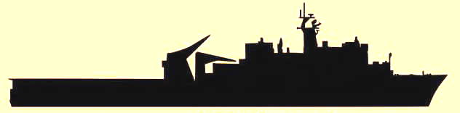
DOCK LANDING SHIPS:
WHIDBEY ISLAND Class (15,745T displ.) (pg 185)
LSD-41 USS Whidbey Island (1985)
-42 USS Germantown (1986)
-43 USS Fort McHenry (1987)
-44 USS Gunstan Hall (1989)
-45 USS Comstock (1990)
-46 USS Tortuga (1990)
-47 USS Rushmore (1991)
-48 USS Ashland (1992)

HARPERS FERRY Class (16,695T displ.) (pg 183)
LSD-49 USS Harpers Ferry (1995)
-50 USS Carter Hall (1995)
-51 USS Oak Hill (1996)
-52 USS Pearl Harbor (1998)

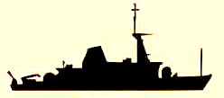
MINE COUNTERMEASURES SHIPS:
AVERGER Class (1,312T Displ.) (pg 221)
MCM-3 USS Sentry (1990)
-4 USS Champion (1991)
-5 USS Guardian (1989)
-6 USS Devastator (1990)
-7 USS Patriot (1991)
-8 USS Scout (1990)
-9 USS Pioneer (1992)
-10 USS Warrior (1992)
-11 USS Gladiator (1993)
-12 USS Ardent (1993)
-13 USS Dexterous (1994)
-14 USS Chief (1994)

COASTAL PATROL SHIPS:
CYCLONE Class (331T Displ.) (pg 208)
PC-2 USS Tempest (1993)
-3 USS Hurricane (1993)
-4 USS Monsoon (1994)
-5 USS Typhoon (1994)
-6 USS Sirocco (1994)
-7 USS Squall (1994)
-8 USS Zephyr (1994)
-9 USS Chinook (1995)
-10 USS Firebolt (1995)
-11 USS Whirlwind (1995)
-12 USS Thunderbolt (1995)
-13 USS Shamal (1996)
-14 USS Tornado (2000)

AUXILIARY SHIPS :

SUBMARINE TENDERS:
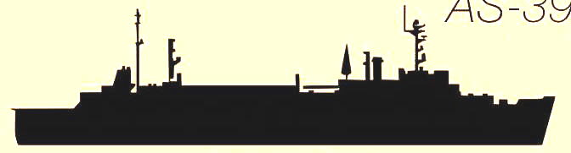
EMORY S. LAND Class (22,650T displ.) (pg 269)
AS-39 USNS Emory S. Land (1979)
-40 USNS Frank Cable (1980)

MISSILE RANGE INSTURMENTATION SHIP:
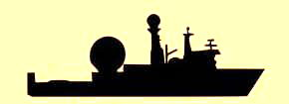
STALWART Class (16,076T displ.) (pg 243)
T-AGM-24 USNS Invincible (1987)

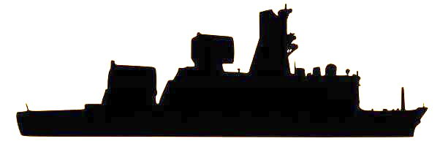
HOWARD O. LORENZEN Class
T-AGM-25 USNS Howard O. Lorenzen

OCEAN SURVEILLANCE SHIPS:
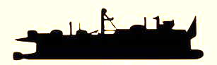
VICTORIOUS Class (3,438T displ.) (pg 250)
T-AGOS-19 USNS Victorious (1991)
-20 USNS Able (1992)
-21 USNS Effective (1993)
-22 USNS Loyal (1993)
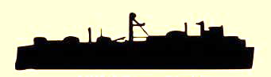
]
IMPECCABLE Class (pg 253)
T-AGOS-23 USNS Impeccable

INTELLIGENCE COLLECTION SHIP:
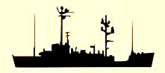
T-AGR-2 USS Pueblo (pg 243)

NAVIGATION TEST SUPPORT SHIP:
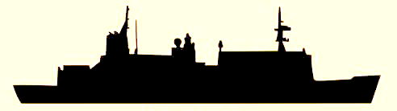
WATERS Class (12,208T displ.) (pg 253)
T-AGS-45 USNS Waters (1993)

OCEANOGRAPHIC SURVEY SHIPS:
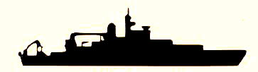
PATHFINDER Class (5,100T displ.) (pg 253)
T-AGS-60 USNS Pathfinder (1994)
-62 USNS Bowditch (1995)
-63 USNS Matthew Henson (1998)
-64 USNS Bruce C. Heezen (2000)
-65 USNS Mary Sears (2002)

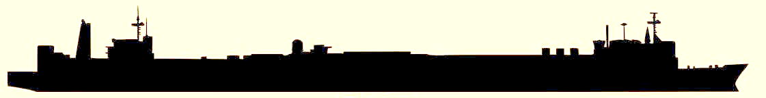
HOSPITAL SHIPS:
MERCY Class (69,360T displ.) (pg 258)
T-AH-19 USNS Mercy (1986)
-20 USNS Comfort (1987)

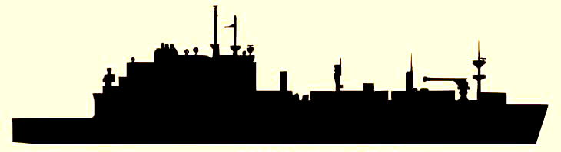
UNDERWAY REPLENISHMENT/CARGO SHIPS:
LEWIS & CLARK Class (35,400T displ.) (pg 233)
T-AKE-1 USNS Lewis & Clark
-2 USNS Sacagewea
-3 USNS Alan Shepard
-4 USNS Richard E. Byrd
-5 USNS Robert E. Peary
-6 USNS Amelia Earhart
-7 USNS Carl Brashear
-8 USNS Wally Schirra
-9 USNS Mathew Perry
-10 USNS Charles Drew
-11 USNS Washington Chambers
-12 USNS William McLean
-13 USNS Medgar Evers
-14 USNS Cesar Chavez

FLEET OILERS:
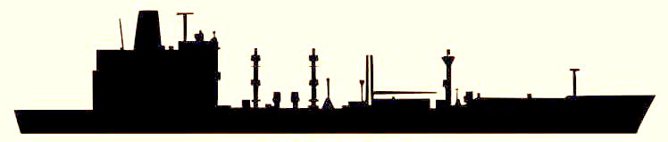
HENRY J. KAISER Class (26,500T displ.) (pg 260)
T-AO-187 USNS Henry J. Kaiser (1986)
-188 USNS Joshua Humphreys (1987)
-189 USNS John Lenthall (1987)
-193 USNS Walter S. Diehl (1988)
-194 USNS John Ericsson (1991)
-195 USNS Leroy Grumman (1989)
-196 USNS Kanawha (1991)
-197 USNS Pecos (1990)
-198 USNS Big Horn (1992)
-199 USNS Tippecanoe (1993)
-200 USNS Guadalupe (1992)
-201 USNS Patuxent (1995)
-202 USNS Yukon (1994)
-203 USNS Laramie (1996)
-204 USNS Rappahannock (1995)

FAST COMBAT SUPPORT SHIPS:
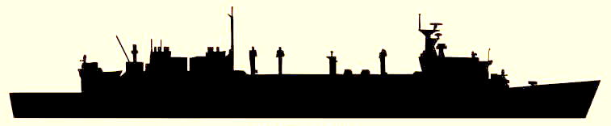
SUPPLY Class (48,800T displ.) (pg 262)
T-AOE-6 USNS Supply (1994)
-7 USNS Ranier (1994)
-8 USNS Arctic (1995)
-10 USNS Bridge (1998)

FLEET OCEAN TUGS:
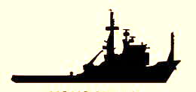
POWHATAN Class (2,260T displ.) (pg 272)
T-ATF-168 USNS Catawba (1980)
-169 USNS Navajo (1980)
-171 USNS Sioux (1981)
-172 USNS Apache (1981)

SAILING FRIGATE: (2,200T) (pg 328)
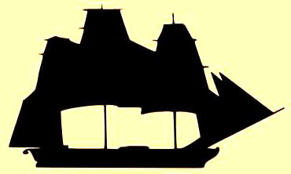
IX-22 USS Constitution (1798)

