Sinclair Inlet Chapter No. 80 National Sojourners, Inc

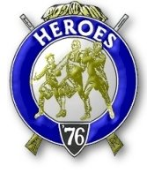

Bremerton, Washington
Our website address is: www.telebyte.com/masons/sojourn/index.htm

January 2014 Newsletter

Chapter Officers 2013-2014
President | HMCM Joseph MacIntyre | 360-275-0589 | haggis@wavecable.com
1st Vice President | CPO Stephen Quance | 360-731-5552 | sdquance@yahoo.com
2nd Vice President | Mr. Richard Dexter | 360-692-6876 | rdexter@tscnet.com
Secretary/Treasurer | Mr. Charles Yankosky | 206-780-0563 | cyankosky@yahoo.com
Marshal | None
Chaplain | LTC Wendell Dutt | 253-565-5264 | wadutt@comsast.net
Color Bearer | None

Hero Camp Officers 2013-2014
Commander | Mr. Peter Dawson | 360-779-8219 | etypebubba@aol.com
Chief of Staff | MMCM Henry Carman | 360-698-4776 | hankcarman@wavecable.com
Adjutant | Mr. Charles Yankosky | 206-780-0563 | cyankosky@yahoo.com

Meeting Notice!
We will meet at VFW Post #239, 190 Dora Ave, Bremerton on Friday, 10 Jan. Social hour and dinner begins at 1800, meeting at 1900 hours. Ladies and guests are always welcome at the meeting and are urged to attend.
The associated Lewis and Clark Camp of the Heroes of ’76 meets immediately following the Sojourner meeting and is open to all Heroes.
Don’t forget to wear your Medals!
Highlights of the 13 Dec Meeting
Pres. Joe MacIntyre opened the meeting at 19:00.
The minutes from the previous meeting were approved as mailed. National wants to see a copy of all the Chapters newsletters to see if they are informative, since many members don’t often get to go to meetings – all they see is the newsletter.
Some supplies were requested: four Past Presidents pins and a Heroes Commander pin; also a red ’76 cocade for a Heroes tri-corn hat.
Area Rep. Wendell Dutt will be the only member going to the Mid-Winter meeting on 15-18 January in Orlando, FL.
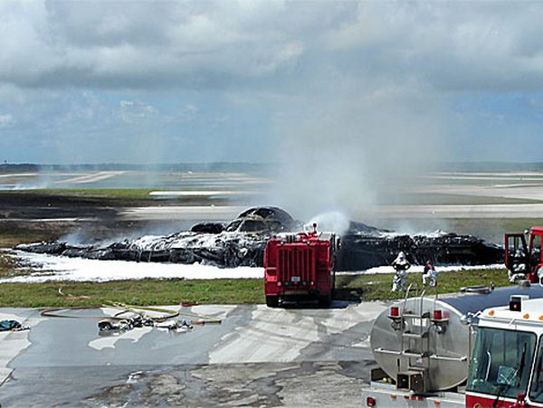
In keeping with the Christmas-time season, Pres. Joe held a present raffle. The members chose a ticket and got the bag whose number matched the ticket. The presents were mostly Scottish Rite items.
Any leads on any other candidates? Our newest member, Bro. Monroe, won’t be eligible for Heroes
until October. Bro. Houston is very busy working full time, besides being a lodge secretary and being invol-
ved in Royal Arch Masons.
Hank wants our MIP check, which got lost in
April and the funds were returned to the National Sojourners treasury. Why, we could pay for some
body’s life membership with that.
Richard Dexter reported that 1ST V.P. B.J. Quance was having a difficult time and wanted us to keep him in our prayers. Bill Biscomb wanted to thank the Master of of William Upton #206 for inviting our Heroes to do
the flag ceremony. Bill & Hank Carman participated. Bill was concerned about VWB Bernie Korst, who
had missed the last couple of Renton #29 meetings for
health reasons, and doesn’t was to be treasurer again. Wendell Dutt told about Pacific NW Chapter #534 secretary, Doug Jerome, who has birthday list and
sends out cards to members on their birthday.
Our Chapter received a 3-6-5 Club streamer for
our flag. Pres. Joe wished us a joyous holiday season
and a prosperous New Year and closed Chapter.
The next week Secretary Charles phoned new National Secretary William Sanner about our check.
The last e-mail sent about the subject had been in November, but the National office was unsettled with previous National Secretary Nelson Newcombe retir-
ing. Sec. Sanner agreed to re-issue the check and it
was sent after Christmas, this time to a locked post office box.


What Do You Do When You’ve Only Got 20 B-2 Bombers and
One of Them Catches Fire?
Jan. 2, 2014 article by Mark Thompson, CNN News

‘ Back in February 2010 the B-2 Stealth bomber “Spirit of Washington (State),” AV-10, built 1994,
had one of its four engines catch fire on the ground during a routine engine start at Andersen AFB on
Guam. Ground crews quickly put out the engine bay
fire and the Air Force called the damage “minor.” But the $2 billion aircraft only returned to service this
Dec. 16 – nearly 4 years later. The bomber wing’s
AV-12 “Spirit of Kansas” (Built 1995) crashed on Guam
shortly after take-off in 2008. Both crewmen safely ejected.

maintenance chief called it a very cool experience when an aircraft that many thought would never fly again is put back into the air.
Older metal planes can be repaired and put back in service much more quickly.
This was one of three fires the Air Force studied to establish new procedures to enable fire fighters to more readily cut into, penetrate and put out composite material fires. Aircraft composite fires are harder to extinguish because they can smolder and re-ignite. Also a com-posite body can’t be cut open with a fire ax, and with difficulty by a fire fighting saw. There aren’t dozens of retired Stealth bombers sitting out in the desert from which one can get spare parts. Some parts came from parts depots. Other parts had to be made from scratch.
The manufacturer, Northrup-Grumman helped repair the plane. One challenge was how to remove charcoal left over from the fire from the plane’s sensitive radar absorbing skin. The answer was spray dry ice on it and remove the residue as it melts. The cost of the refurb-ishmet wasn’t disclosed.
B-2 in Plan View

