Sinclair Inlet Chapter No. 80 National Sojourners, Inc

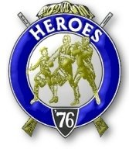

Bremerton, Washington
Our website address is: www.telebyte.com/masons/sojourn/index.htm

January 2013 Newsletter

Chapter Officers 2012-2013
President | HMCM Joseph MacIntyre | 360-275-0589 | haggis@wavecable.com
1st Vice President | Mr. Peter Dawson | 360-779-8219 | etypebubba@aol.com
2nd Vice President | CPO Stephen Quance | 360-731-5552 | sdquance@yahoo.com
Secretary/Treasurer | Mr. Charles Yankosky | 206-780-0563 | cyankosky@yahoo.com
Marshal | None
Chaplain | Mr. Richard Dexter | 360-692-6876 | rdexter@tscnet.com
Color Bearer | None

Hero Camp Officers 2012-2013
Commander | Col William Biscomb | 206-842-6417 | milfordbiscomb@comcast.net
Chief of Staff | Mr. Peter Dawson | 360-779-8219 | etypebubba@aol.com
Adjutant | MMCM Henry Carman | 360-698-4776 | hankcarman@wavecable.com

Meeting Notice!
We will meet at VFW Post #239, 190 Dora Ave, Bremerton on Friday, 11 Jan. Social hour and dinner begins at 1800, meeting at 1900 hours. Ladies and guests are always welcome at the meeting and are urged to attend.
The associated Lewis and Clark Camp of the Hero's of '76 meets immediately following the Sojourner meeting and is open to all Hero's.
Don’t forget to wear your Medals!
Highlights of the 14 Dec Meeting
Pres. Joe MacIntyre opened the meeting with Wendell Dutt as Chaplain. There was not a quorum present to be able to hold a business meeting. A moment of silence was observed in honor of Bob Colton who died on Tuesday, Dec. 11, 2012. Burial will be at Tahoma National Cemetery in Kent at 2
p.m. on Monday, Dec. 17. Petitions for membership were distributed at the last meeting but so far none have been returned. Pres. Joe intends to show a video at the January meeting. He will provide a computer and projector. Rep. Wendell Dutt proposed that a give a $100 donation to VFW Post #239 every January to thank them for letting us use their meeting hall.
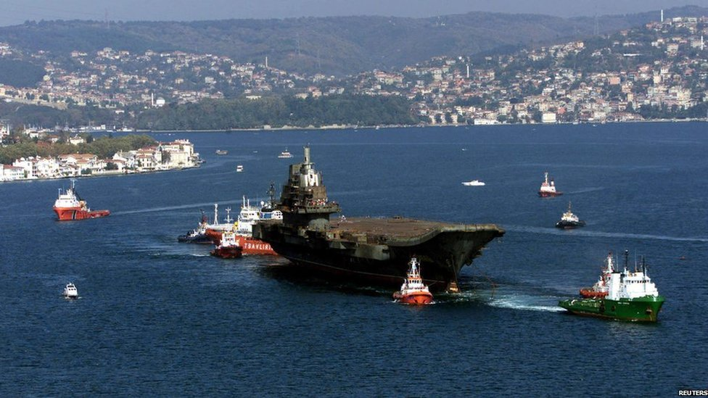
New Business: Pres. Joe MacIntyre got an e-mail from our new NW Area Rep., Marion Windell, that
next Heroes encampment at Pacific Beach will be held on Oct. 4, 5 & 6, 2013, rather than in September. Chapter 539 will be the host and they hope to have a candidate from Chapter 80.
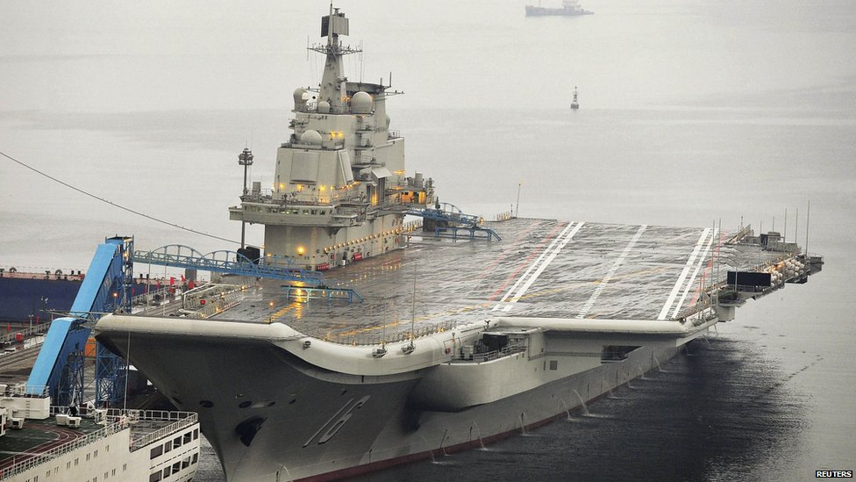
Education: Pres. Joe gave a talk on the Flag Pledge. The “Pledge of Allegiance” was written in 1892 by Francis Bellamy (1855-1931), a Baptist minister and Christian socialist. Since then it has gone through five changes. The 1892 version said, “I pledge allegiance to my Flag and the Republic for which it stands, one nation indivisible, with liberty and justice for all.” In 1923 the word “to” was added to the phrase “and to the Republic.” In 1924 a new phrase was added to Flag: “to the Flag of the United States of America.” In 1954 the words “under God” were officially added to the Pledge. The words were taken from Lincoln’s Gettysberg Address, “that the nation shall, under God, have a new birth of freedom.” This was a way of setting the United States apart from
other countries. So, in it’s final version, the Pledge reads: “I pledge allegiance to the Flag of the United States of America, and to the Republic for which it stands, one Nation under God, indivisible, with liberty and justice for all.”
District Rep Wendell urged us to use the new cata-log on the National Sojourners website.
In closing, Pres. Joe MacIntyre wished us a Merry Christmas and a happy and prosperous New Year.
Afterwards the Heroes gathered to have a meeting to discuss the change of date for Pac Beach.

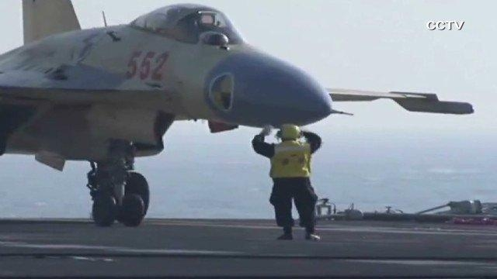
CHINA’S 1ST AIRCRAFT CARRIER
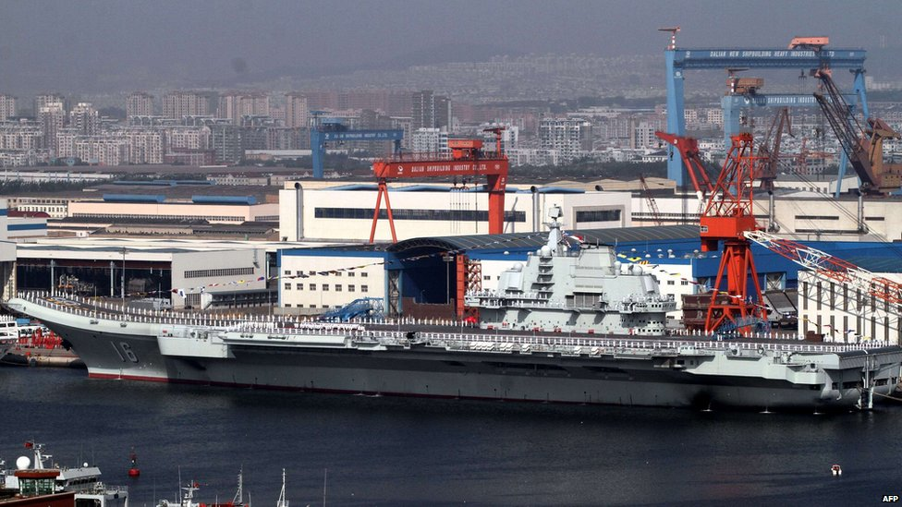
The Liaoning, China’s first aircraft carrier, entered service with the navy on Tues., 25 Sep 2012.
The Liaoning was originally a Soviet ship called Varyag. A company with links to the Chinese military
bought the ship from Ukraine and towed it out of the Black Sea in 2001. The new owners claimed they wanted to turn the ship into a floating gambling casino in Macau, but it was then refitted as an aircraft carrier for China at the Port of Dalian.
China landed its first jet on the Liaoning on 28 Nov 2012. The Chinese J-15 is comparable to the Russian Su-33. The ship can carry 30 J-15’s and will have a crew of 2,000.

