Sinclair Inlet Chapter No. 80 National Sojourners, Inc

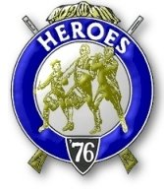

Bremerton, Washington
Our website address is: www.telebyte.com/masons/sojourn/index.htm

January 2012 Newsletter

Chapter Officers 2011-2012
President | Mr. Peter Dawson | 360-779-8219 | etypebubba@aol.com
1st Vice President | HMCM Joseph MacIntyre | 360-275-0589 | haggis@wavecable.com
2nd Vice President | None
Secretary/Treasurer | Mr. Charles Yankosky | 206-780-0563 | cyankosky@yahoo.com
Marshal | CPO Stephen Quance | 360-731-5552 | sdquance@yahoo.com
Chaplain | Mr. Richard Dexter | 360-692-6876 | rdexter@tscnet.com
Color Bearer

Hero Camp Officers 2011-2012
Commander | Col William Biscomb | 206-842-6417 | milfordbiscomb@comcast.net
Chief of Staff | Mr. Alex Jordan |  | jordan3614@hotmail.com
Adjutant | MMCM Henry Carman | 360-698-4776 | hankcarman@wavecable.com

Meeting Notice!
We will meet at VFW Post #239, 190 Dora Ave, Bremerton (see directions) on Friday 13 Jan. Social hour and dinner begins at 1800, meeting at 1900 hours. Ladies and guests are always welcome at the meeting and are urged to attend.
The associated Lewis and Clark Camp of the Hero's of '76 meets immediately following the Sojourner meeting and is open to all Hero's.
Don’t forget to wear your Medals!
Highlights of the Last Meeting
President Peter Dawson opened the meeting at 19:00. Wendell Dutt read the Aims of National Soj-ourners. The Dec. minutes were approved as distributed in the newsletter. Wendell suggested investigating a credit union to get a better return on
our bank account. Hank Carman noted that he needed a Past President’s bar for himself and Dick Dexter. Hank was tired of having to haul the flags around. Wendell was looking at storing the flags here at the VFW hall, since the Post Commander said we could leave them here. We will have the 3 Candle Service at the end of our Chapter year, in May, to honor our
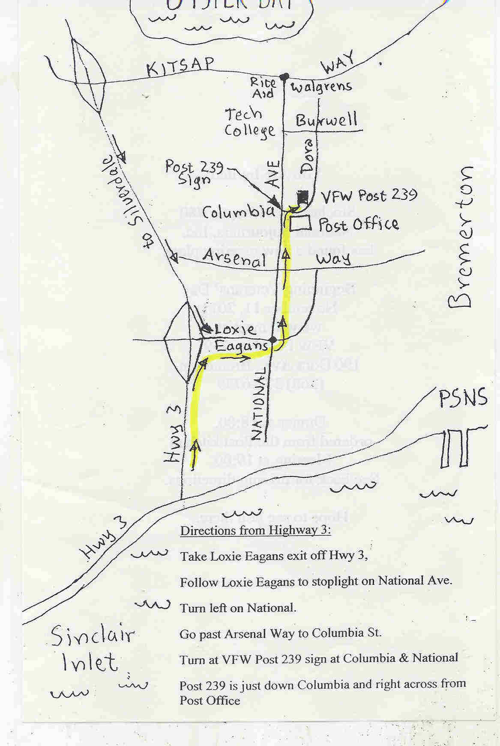
Directions to VFW Post #239

departed members. A Motion was made to donate $100 to the SEM (Sojourner Endowment Memorial) Fund. It was seconded by Joe MacIntyre and approved. $100 will be sent to the SEM Fund in honor of Jerry Lingle, Joe Illes and Harry Houston. Hank wants to recruit some new members. He will go out and get some prospects. We will start getting speakers if we can get a large enough audience. Area Rep Wendell Dutt had some information about the Mid-Winter meeting to be held in Tucson, AZ from 18-21 Jan. 2012. At this meeting plans will be laid for the Annual Convention to be held 18-23 June 2012 in Burlington, VT. The Jan. 2013 Mid-Winter meeting will prepare for the 93RD National Convention in June 2013 in San Antonio, TX. In 2016 the National Convention will be held in the Seattle area.
President Peter Dawson asked Joe MacIntyre to give us a little talk. Joe felt that this was an appropriate place to put on his VFW peaked cap and talk about the history of the Veterans of Foreign Wars. The VFW is the oldest veterans organization in the U.S. This was the group that was insturmental in making the “Star Spangled Banner” our national anthem. On Sep 29, 1899 thirteen men gathered together in a shop in Ohio. All were veterans of the Spanish American War. They met to remember comrades who died in the war and recall shared events. A man named Putnam then tracked down other vets to form a club. Born in Iowa, Putnam headed west to fight Indians, was wounded as a scout and left the service. Putnam was a descendant of Israel Putnam who served on George Washington’s staff during the Revolutionary War. Putnam also wrote the charter of the group that would become the VFW. The VFW name was created in 1914 by the merger of two veterans groups at a conference at the Schenley Hotel in Pittsburgh, PA. The American Veterans of Foreign Service, vets who served in Cuba, and the National Society of the Army of the Philip-pines, vets who served in the Philippines, both formed in 1899, merged to form the VFW.
Other organizations have come and gone. A club formed after the Revolutionary War admitted only officers. The Grand Army of the Republic faded away as American Civil War veterans died off. But the VFW welcomes any serviceman who has served outside the U.S. Since World War 2 this includes vets who served in Korea, Vietnam, Kosovo, the Persian Gulf and now Irag and Afghanistan. It’s mission is to boost the morale of the troops. Support from back home sees the service people through. Public backing for later wars has been lacking. In spite of public apathy the VFW has not forgotten. And present benefits – the G.I. bill for education and the home loan program, have been the result of VFW action.
Dick Dexter talked to the current commander and he would love to see the Sojourners “Build the
Flag Program” in May when the Canadians visit.
Sickness and Health. Dick Dexter reported that B.J. Quance had his heart surgery and it went really well. Before he was completely winded just going from the house to the car, but now he has energy and is feeling a lot better. Meeting closed at 19:30.

