Sinclair Inlet Chapter No. 80 National Sojourners, Inc

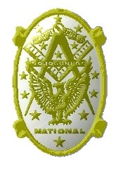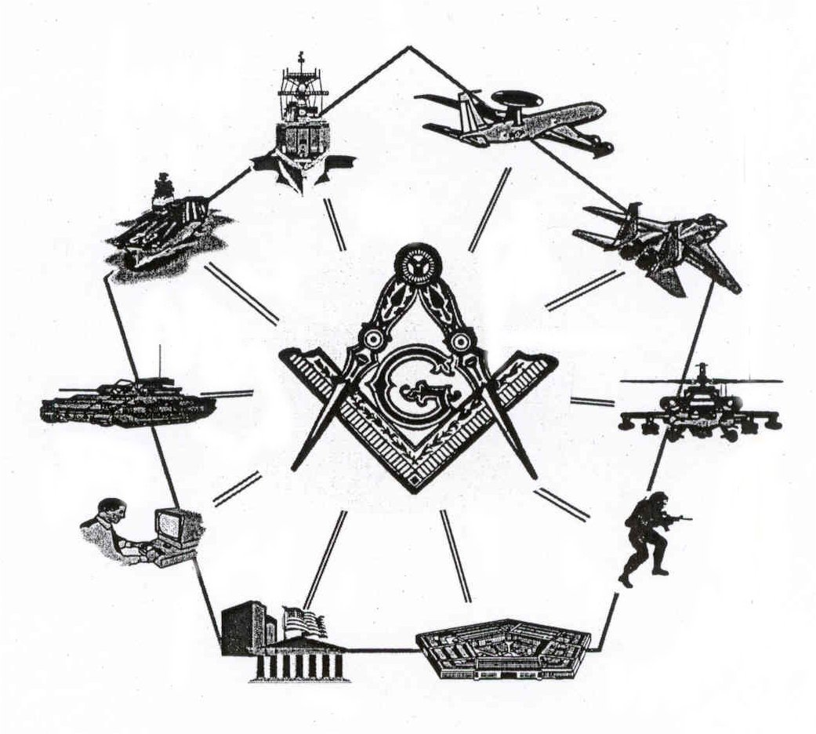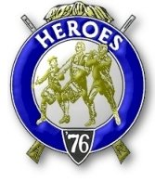

Bremerton, Washington
Our website address is: www.telebyte.com/masons/sojourn/80/sinclair_inlet_chapter.htm

January 2005 Newsletter

Chapter Officers 2004-2005
President | S/SGT Michael Pursey | 360-692-2421 | kpursey@silverlink.net
1st Vice President | Col William M. Biscomb | 206-842-6417
2nd Vice President
Secretary/Treasurer | WTCS John Gray | 360-895-3188 | wtcs_sw@wavecable.com
Marshal | CWO4 Richard Patterson | 360-769-8246
Chaplain | 1LT Harold E. Richardson | 360-692-4023 | harolder@comcast.net
Color Bearer

Hero Camp Officers 2004-2005
Commander | CAPT Harry R. Houston | 360-692-8478 | hbhouston@telebyte.com
Chief of Staff | 1Lt Harold R. Richardson | 360-692-4023 | harolder@comcast.net
Adjutant | WTCS John Gray | 360-895-3188 | wtcs_sw@wavecable.com

Meeting Notice!
We will meet at Elk’s Lodge #1181, Pine Road, Bremerton on 14 JAN. Social hour and dinner begins at 1800, Meeting at 1900 hours. Ladies and guests are always welcome at the meeting and are urged to attend.

The associated Lewis and Clark Camp of the Hero's of '76 meets immediately following the Sojourner meeting and is open to all Hero's.
Don’t forget to wear your Medals!
President’s Message
No article submitted this month.

From the Desk of the Secretary
Brethren,

I want to remind members who pay annual dues that they are now due. I was required to send them to the National office by 31 December. If you have not paid your dues yet please take time out to do it now. Annual Dues are $21. If your dues are a hardship, please contact me and we will see if we can work something out.

The Sojourner Endowment Memorial (SEM) is the primary means of support for National Sojourners. The 3-6-5 Club is a major contributor to the SEM. It is totally voluntary. Annual contributions for members are $3.65 or members may purchase a Life Membership for $36.50. All contributions to the SEM Fund are TAX DEDUCTIBLE. Sinclair Inlet Chapter receives credit each time a member contributes to the 3-6-5 Club. Chapters that have 100% annual participation receive a streamer to attach to their chapter flag. I am pleased to report that the chapter qualified for a streamer for 2004. The chapter has six 3-6-5 Club Life Members.

This month we will vote on the application of RM1 Leonard Altig for membership. Please try to attend, cast your ballot and enjoy some fellowship with your brothers in arms.
Fraternally,
John
Highlights of Last Meeting
The meeting opened at 1900, 10 DEC 04 by President Michael Pursey with the members, ladies and guests as listed on the Muster Report.
Read the minutes of the 12 NOV 2004 meeting, they were approved as read. Treasurers Report was read, balance on hand, $2427.28. Correspondence was read, consisting of chapter newsletters from Chapters 40 and 89. No Committee Reports were given. Membership application received for RM1 Leonard Altig. The following candidates were initiated: HMCM Karl Forch and MMCM Henry T. Carmen. Unfinished Business: The president displayed the new Chapter flag and the MMIP for LCDR Tompkins. New Business: The President read a request for Phone Cards for wounded troops. Brother Steve Seteroff suggested we contact the Veterans Home at Retsil and the Naval Hospital to see what we can do. Brother Forch took this for action. The Secretary gave a report on the status of the Chapter 3-6-5 Club, concluding that the chapter needed to contribute $76.00 to qualify for a streamer. Brother Seteroff moved and it was passed that we make this contribution. The guest speaker was Brother Gordon Sumner, a Pearl Harbor survivor, gave a presentation on his naval service as a Corpsman, with a focus on 7 DEC 1941 aboard USS Utah. He supplemented it with many pictures and memorabilia. He related how he had to abandon ship, swim to Ford Island and survived a 500 lb bomb dropped by a Japanese plane on the Naval Dispensary. Announcements: Information about the 2005 National Essay Contest and 2005 Youth Leadership Conferences were read and packets made available to the membership. The President commented that he was pleased to see the increase in members attending, new membership applications and interest in our activities. George Mitchell requested his MIP from Chapter #58 be transferred to Sinclair Inlet. Joe MacIntyre announced the annual Robert Burns Dinner at the Seattle Scottish Rite on 21 JAN 05 and made tickets available. The Secretary gave a report on the health of CWO Patterson, the membership requested a Get Well card be sent. There being no further business, the meeting ended at 2030, peace and harmony prevailing.

Lewis & Clark Camp of the Hero's of '76 News

The Commander requested that the Adjutant determine if Brothers Biscomb and Patterson had any interest in becoming Heroes.
The rest is not part of the newsletter, just a template



Lewis and Clark Camp of the Hero's of '76

Commander Harry Houston requests that Heroes consider a taking a part in the ceremony and that he can provide a list of uniform suppliers for those who need to purchase uniforms.
Masonry in the Civil War
L.J. Williams of Harvard, New York, enlisted in the 114th New York Volunteers at the beginning of the Civil War. He received the Entered Apprentice and Fellowcraft Degrees in Downsville Lodge No. 464 prior to his leaving home.

Later during the war he was captured and imprisoned near Savannah, Georgia. While in the prison, he communicated with his friends in the North. His lodge in New York through the proper officials got in touch with Zerubbabel Lodge in Savannah and stated that they would consider it a favor if the lodge in Savannah would confer the Third Degree on the Fellowcraft Brother Williams.

One night Brother Williams was taken from the prison and conducted to the lodge room in Savannah. He only had his blue tattered uniform to wear, a token of his sympathy with the cause he believed in. The officers of the lodge were all in Confederate gray. Although on opposite sides in the struggle going on on the battlefields of the South, they were all Brethren. He was then and there raised to the sublime degree of Master Mason and acclaimed a full Brother and friend to those who wore the gray.

Later that night Brother Williams escaped. When asked about his escape he would "smile peculiarly. You might put it down as an escape, but it wasn't an escape strictly speaking. They put me in a boat and carried me off some distance. Then they deposited me on neutral soil between the lines." From there Williams was able to find his friends. Williams never knew who exactly helped him escape. He considered it as their secret and it was never disclosed. Williams stated: "I know exactly to whom I may attribute my escape, His name is Hiram."

Binnacle List
Brothers,
Please pray for CWO4 Patterson’s quick recovery from surgery.

