Sinclair Inlet Chapter No. 80 National Sojourners, Inc

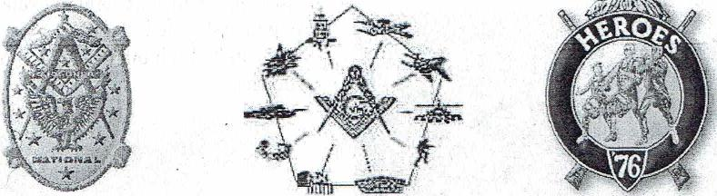

Bremerton, Washington
Our website address is: www.telebyte.com/masons/sojourn/index.htm
February 2016 Newsletter
Chapter Officers 2015-2016
President | Mr. Richard Dexter | 360-692-6876 | rdexter@tscnet.com
1st Vice President | Mr. Peter Dawson | 360-779-8219 | etypebubba@aol.corn
2nd Vice President | MM1 Orville Stoner | 360-782-2385 | ovstoner@comcast.net
Secretary/Treasurer | Mr. Charles Yankosky | 206-780-0563 | cyankosky@yahoo.com
Marshal | CSCS Todd Mears | 360-286-0358 | navy.pride1987@yahoo.com
Chaplain | LTC Wendell Dutt | 253-565-5264 | wadutt@comsast.net
Color Bearer | None
 | Hero Camp Officers 2013-2014
Commander | Col. William Biscomb | 206-842-6417 | milfordbiscomb@comcast.net
Chief of Staff | HMCM Joseph Maclntyre | 360-275-0589 | haggis@wavecable.com
Adjutant | Mr. Charles Yankosky | 206-780-0563 | cyankosky@yahoo.com

Highlights of the 8 Jan. Meeting
Meeting Notice!
We will meet at VFW Post #239, 190 Dora Ave, Bremerton on Friday, 12 Feb. Social hour and dinner begin at 1800, meeting at 1900 hours. Ladies and guests are always welcome at the meeting and are urged to attend.
The associated Lewis and Clark Camp of the Heroes of '76 meets immediately following the Sojourner meeting and is open to all Heroes.
Don't forget to wear your Medals!
1
Tonight our members were scattered. Since we didn't have a quorum of members present to hold an official meeting, we stayed out in the dining area of the VFW hall and continued our fellowship dinner through the meeting time. No ritual, but stories were swapped and the time was well spent. This didn't deter President Richard Dexter from doing his duties. He gave a impromtu "Old Glory Speaks" for those assembled in the VFW dining hall. Friday night is steak night so other VFW members and their guests were present. The VFW people asked President Richard if he would perform "Old Glory" at one of their meetings. No Hero business was discussed.

Continental soldiers wearing 1779 regulation uniforms issued during the Yorktown campaign. Coats were blue, lined with white. Breeches and waistcoats were also white. Epaulet on left shoulder of the man carrying the rod identifies him as a lieutenant.

250 Years of U.S. Army Uniforms
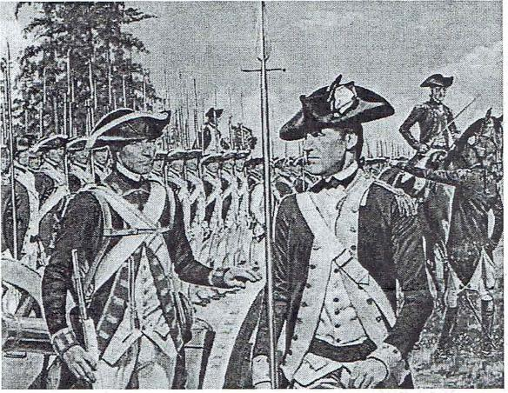
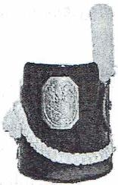
War of 1812 Regalia
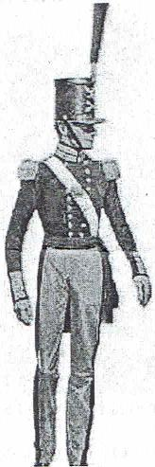
2
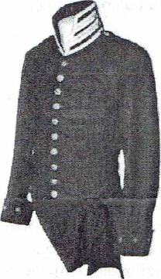
War of 1812. May 1813 regulation blue coatee and Belgic-type cap known as a "Tombstone" shako. Blue coats were issued from 1813 to 1820, but because of a shortage of blue wool, state militias and service academies wore gray. During the July 5, 1814 Battle of Chippewa, the British saw gray clad ranks of Americans, led by Gen. Winfield Scott, advancing toward them. They assumed this was militia that could
scattered with a few shots. But the way the Americans closed ranks to replace the fallen and kept on coming caused one British general to exclaim, "My God, those are regulars!" Gen. Scott's regulars won the battle. The American had run out of blue cloth and so wore gray uniforms.
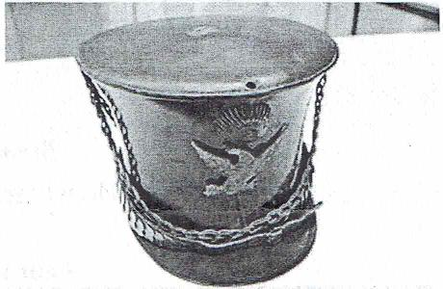
Bell Crown Cap. In 1821 the Army dropped the "tombstone shako" for the "bell crown cap." The hole in the top is for a pompon feather to distinguish the branch of the service, such as infantry or artillery. That year also saw the introduction of epaulets and shoulder wings to show a soldier's rank.
1833 buttons for Dragoons (cavalry) (L) and Infantry (R)
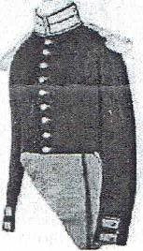
Private's coatee from 1840
1836 Artillery Sergeant
In 1847 non-commissioned officers could display chevrons on both arms above the elbows. Soldiers began wearing colored accents to indicate branches of service — blue for infantry, red for artillery.

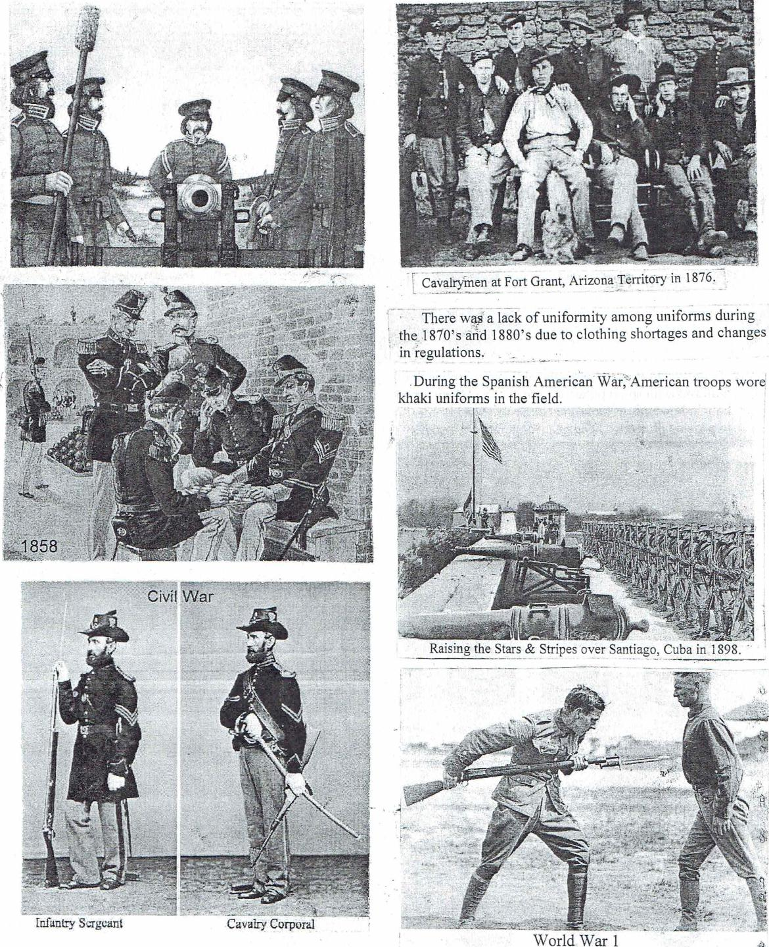
va Corporal
In_funtry Sergeant
- _
¹ Cavalrymen at Fort Grant, Arizona Territory in 1876.
L _
- there w# a lack of uniformity among uniforms during
, the,1870's arid 1880's due to clothing shortages and changes
in regulations. •
.During the Spanish American. War, American troops wore
khaki uniforms in the field.
. .
Clvit War
t)

I
Raising, the Stars & Stripes over Santiago, Cuba in 1898.
World War 1

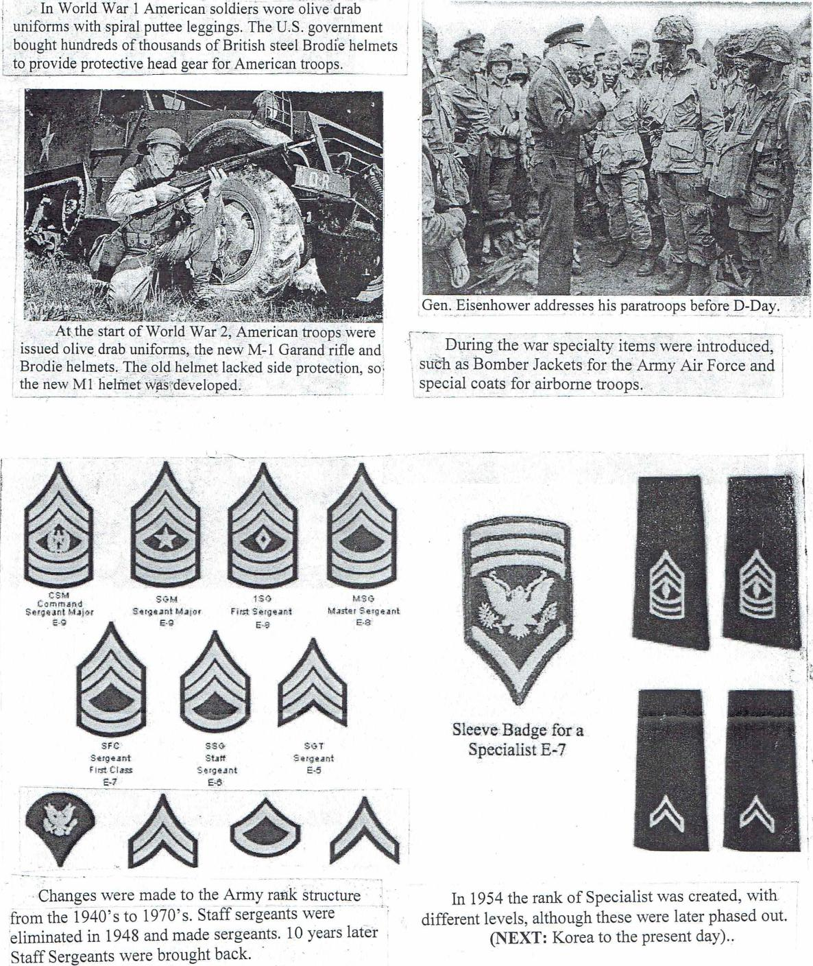
In World War 1 American soldiers⁻ wore olive drab
uniforms with spiral puttee leggings. The U.S. government
, bought hundreds of thousands of British steel Brodie helmets
to provide protective head gear for American troops.
At the start of World War 2, American troops were issued olive drab uniforms, the new M-1 Garand rifle and Brodie helmets. The old helmet lacked side protection, so, the new MI helmet was developed
Gen. Eisenhower addresses his paratroops before D-Day.
During the war specialty items were introduced, such as Bomber Jackets for the Army Air Force and special coats for airborne troops.
- Changes were made to the Army rank structure from the 1940's to 1970's. Staff sergeants were eliminated in 1948 and made sergeants. 10 years later Staff Sergeants were brought back.
In 1954 the rank of Specialist was created, with different levels, although these were later phased out. (NEXT: Korea to the present day)..
SSG' Staff Sergeant E-13
SG I
:Sergeant
E-5
SFC
Sergeant
First Class
_
Sleeve Badge for a Specialist E-7
CSM Command Sergeant
E-9
I >Cr
First Sergeant
MSG
A/taster Sergeant

