Sinclair Inlet Chapter No. 80 National Sojourners, Inc

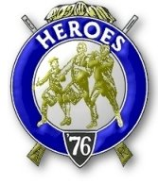

Bremerton, Washington
Our website address is: www.telebyte.com/masons/sojourn/index.htm

February 2015 Newsletter

Chapter Officers 2014-2015
President | CPO Stephen B.J. Quance | 360-731-5552 | sdquance@yahoo.com
1st Vice President | Mr. Richard Dexter | 360-692-6876 | rdexter@tscnet.com
2nd Vice President | Mr. Peter Dawson | 360-779-8219 | etypebubba@aol.com
Secretary/Treasurer | Mr. Charles Yankosky | 206-780-0563 | cyankosky@yahoo.com
Marshal | None
Chaplain | LTC Wendell Dutt | 253-565-5264 | wadutt@comsast.net
Color Bearer | None

Hero Camp Officers 2013-2014
Commander | Mr. Alex Jordan |  | jordan3614@hotmail.com
Chief of Staff | Col. William Biscomb | 206-842-6417 | hankcarman@wavecable.com
Adjutant | Mr. Charles Yankosky | 206-780-0563 | cyankosky@yahoo.com

Meeting Notice!
We will meet at All Star Lanes in Silverdale on Friday, 13 Feb. Social hour and dinner begins at 1800, meeting at 1900 hours. Ladies and guests are always welcome at the meeting and are urged to attend. Happy Valentine’s Day!
The associated Lewis and Clark Camp of the Heroes of ’76 meets immediately following the Sojourner meeting and is open to all Heroes.
Don’t forget to wear your Medals!
Highlights of the 9 Jan. Meeting
Pres. B.J. Quance opened the meeting at 19:00.
A full hour was taken for the dinner and refreshment session, but the meeting was rather short.
Area Rep. Wendell Dutt reminded us that if any-one wanted to participate in the Essay Contest, their submittal has to be in by Wednesday. A motion was made, seconded and approved to pay a $16 share for the annual Convention advertisement. Bro. Wendell will report on the mid winter convention at the next meeting.
Note: Bro. Yankosky plans to do a slide show on the Battleship Oregon at the next meeting.
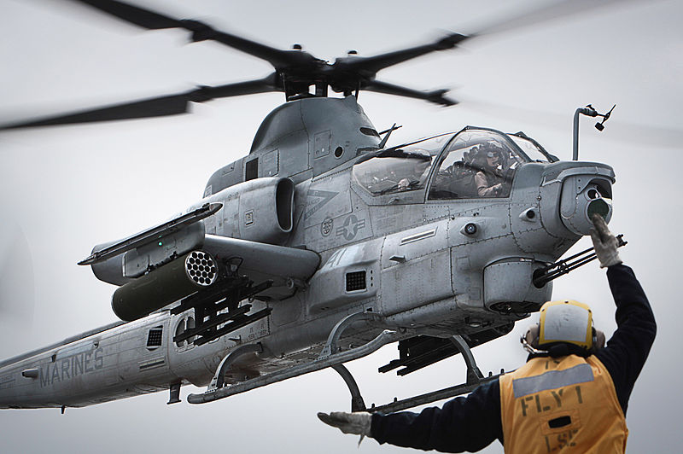
Marines 5 Most Lethal Weapons of War
Dave Majumdar of The National Interest 1/8/2015

The U.S. Marines are a fire brigade that the President can call on in any emergency. While part of the Navy and primarily a maritime force, they have been used as a de-facto army the past dozen years.

- Marine Riflemen. Every Marine, from the
lowest private to the Commandant, is trained to be an infantryman. Even Marine aviators have to go through 9 months of infantry training before they go to flight school. Even though they’re flying planes, this gives pilots the shared experience of fighting alongside Marines on the ground. The service will be down to 182,000 by 2017 after combat in Iraq and Afghanistan winds down. But this will still make them as large as the entire British military.

2. M1A1 Abrams Tank. Though primarily a medium mobile force, when the Marines need armor support they have it with the General Dynamics M1A1 Abrams tank.
The Abrams has a 120 mm cannon and is protected by depleted uranium armor. It’s 1,500 hp Honeywell gas turbine engine can move it along at 45 mph. The Marines have about 400 tanks in 3 tank battalions stored in pre-positioned stocks.
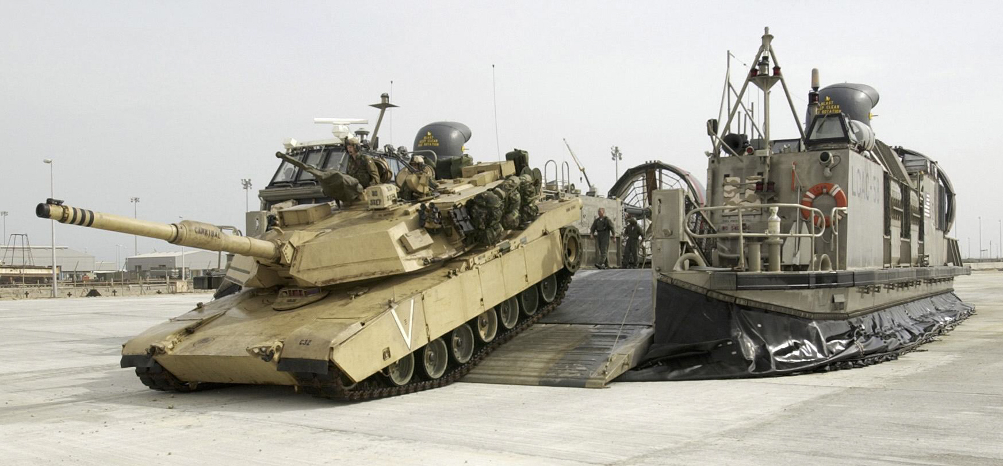
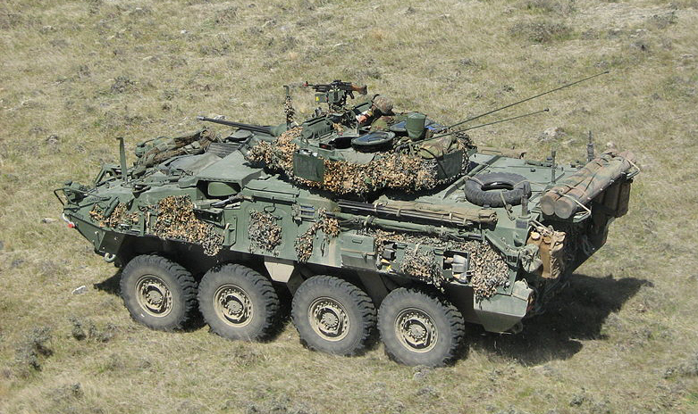
M1A1 debarking from hover craft.

3. AH-1Z Viper The Bell AH-1Z Viper is the latest version of the Vietnam era Cobra attack helicopter. Powered by two 1,800 hp GE T700 turbo shaft engines,
the Viper’s 4-bladed composite rotors give it great maneuverability, It is equipped with advanced sensors and the Longbow radar system. The Viper carries 16 Hellfire missiles, like the Army’s AH-64 Apache, but it can also carry AIM-9 Sidewinder air-to-air missiles for antiaircraft capability. Many parts of the helicopter are common to the Marines’ Bell UH-1 Venom (a version of the UH-1 Huey), But the Marine versions are unique to the service and not built in large quantities like the Army’s Apache and
UH-60 Black-hawk helicopters. So keeping the Marines’ aircraft up-to-date and finding spare parts could be a problem.

4. AV-8B Harrier. The Harrier jump-jet offers mobile fire support to Marine expeditionary forces that don’t have ready access to heavy artillery or air support. Though not the best fighter or attack aircraft in the world, the AV-8’s STOL (short take off and landing) capabilities enable it to operate from amphibious assault ships. The AV-8 should be replaced by the Lockheed Martin F-35B joint strike fighter by 2025. The Marines plan to keep their Boeing F/A-18’s until the F-35B replaces these as well.
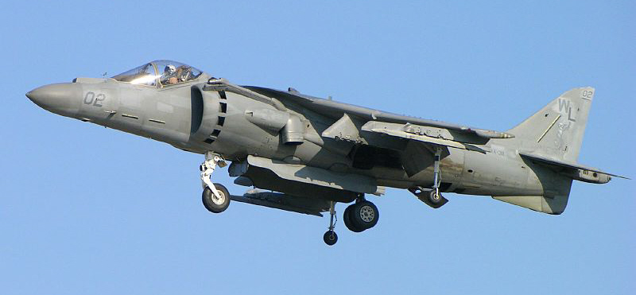
5. LAV General Dynamics Light Armored Vehicle series (LAV) offers high mobility to Marine light armored recon forces who don’t want to be weighed down with heavy armor. Marine battalions may have different versions of LAVs. They range from anti tank to anti aircraft to command and control. The common LAV carries a 25 mm automatic cannon, a pair of 7.62 mm machine guns and can travel faster than 63 mph.

