Sinclair Inlet Chapter No. 80 National Sojourners, Inc

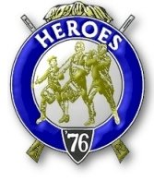

Bremerton, Washington
Our website address is: www.telebyte.com/masons/sojourn/index.htm

February 2014 Newsletter

Chapter Officers 2013-2014
President | HMCM Joseph MacIntyre | 360-275-0589 | haggis@wavecable.com
1st Vice President | CPO Stephen Quance | 360-731-5552 | sdquance@yahoo.com
2nd Vice President | Mr. Richard Dexter | 360-692-6876 | rdexter@tscnet.com
Secretary/Treasurer | Mr. Charles Yankosky | 206-780-0563 | cyankosky@yahoo.com
Marshal | None
Chaplain | LTC Wendell Dutt | 253-565-5264 | wadutt@comcast.net
Color Bearer | None

Hero Camp Officers 2013-2014
Commander | Mr. Peter Dawson | 360-779-8219 | etypebubba@aol.com
Chief of Staff | MMCM Henry Carman | 360-698-4776 | hankcarman@wavecable.com
Adjutant | Mr. Charles Yankosky | 206-780-0563 | cyankosky@yahoo.com

Meeting Notice!
We will meet at VFW Post #239, 190 Dora Ave, Bremerton on Friday, 14 Feb. Social hour and dinner begins at 1800, meeting at 1900 hours. Ladies and guests are always welcome at the meeting and are urged to attend.
The associated Lewis and Clark Camp of the Heroes of ’76 meets immediately following the Sojourner meeting and is open to all Heroes.
Don’t forget to wear your Medals!
Highlights of the 10 Jan. Meeting
Pres. Joe MacIntyre opened the meeting at 19:00.
Joe needs a dues card from Germany for Bro. Monroe. The minutes of the previous meeting were approved as mailed. (The secretary erroneously reported that the Christmas gifts handed out by Pres. Joe at the December meeting were Scottish Rite items. They were in fact a variety of personal items that I didn’t see be-cause they were in brown paper bags. I got chocolates).
Pres. Joe had an experience at a Naval medical facility. He got there after colors. Outside they did formation and all present inside the hospital stood and said the Pledge of Allegiance. They don’t do that in
the army, do they? Bro. Monroe confirmed that they
didn’t, but the rules are changing.
A petition from another candidate was read..
Marshall Dick Dexter presented Bro. Bryan Remley for induction into the Sojourners. The Lecture of the degree was presented by Bro. Bill Biscomb. Bro.Wendell Dutt gave the candidate the Sojourner Medal Lecture. Afterwards Bro. Bryan was welcomed as a
new Sojourner. The Heroes of ’76 was explained to
the new member.
Who’s heard of the Black Watch? They are a Scottish regiment of the British army who were
Known as the “ladies from hell” because they wore
kilts. Pres. Joe gave us a talk from an article in The Patriot, a Scottish –American military magazine. It wasn’t as long as the 250 year recap of the regiment given by Bro. Tim Cooke at the June 2013 installation (summarized in the Sep. 2013 newsletter) but hit the high points.

Defense budget cuts were discussed. There’s talk of disbanding the Marines. After all the Marines are sim-ply the Navy’s army. Some say we don’t need another army. Navy, Army and Air Force strength is going to
be reduced. The Navy Hospital is going to close it’s
ER, intensive care and one ward. Former Secretary of Defense, Bob Gates, has written a new book, Duty: Memoir of a Secretary at War. In it Gates finds fault with Pres. Obama’s handling of the Afghan War, a
war that Obama doesn’t believe in and wants to pull
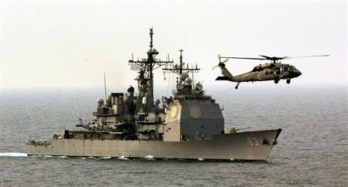
out of.
Bro. Bill Biscomb will be chairman of the nomin-ating committee for election of officers in May.
Area Rep. Wendell Dutt attended the Mid-Winter meeting in Orlando, FL. and got a notice of Chapter Revitalization. The 192 nationwide Sojourner chapters are judged on 20 items. Chapter #80 scored 14 out of
20. NW Rep. Marion Windell made the assessment.
He’s a member of #534. You lose points for things like having the same members in Chapter and Heroes Camp; not having ladies present; and if you’ve had the same secretary for longer than 5 years.
Wendell noted that one year we were Chapter
of the Year.
Sickness & Health: B.J. is doing OK but the doctors want to operate. B.J.’s son wants his dad to come down to San Diego to be with him. Dick tries to keep track of B.J. to be sure he’s alright.
Announcements: Bro. Dick Dexter reported that Bremerton Valley Scottish Rite’s Masonic Night dinner is next Wednesday. Sr.GW RW Don Munks will be the speaker.
There will be a lot of wind and rain tomorrow for the Seahawks game. A Russell Wilson football sign will be auctioned off for a local kids’ charity in Wenatchee.
Bro. Alex Jordan is Oriental Guide for Tacoma’s Afifi Shrine. In 3 years he should be Potentate.

Near Collision in South China Sea
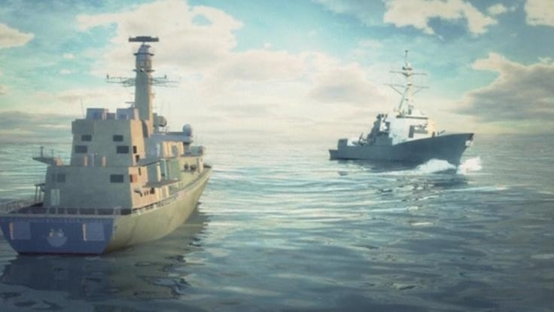
CNN News. On 5 Dec. 2013 the 10,000 ton cruiser U.S.S. Cowpens had to maneuver to avoid colliding with a ship from a Chinese navy squadron. The Chinese squadron was on a drill involving China’s first aircraft carrier, the Liaoning (PLAN CV-16) and her support ships, includ-ing an amphibious dock ship.
Chinese naval vessel tries to halt U.S. warship.
The Chinese claimed that the Cowpens, though she was in international waters, had intruded within 30 miles of their squadron’s inner defense layer.
Helo over U.S.S. Cowpens 12 Mar 2003
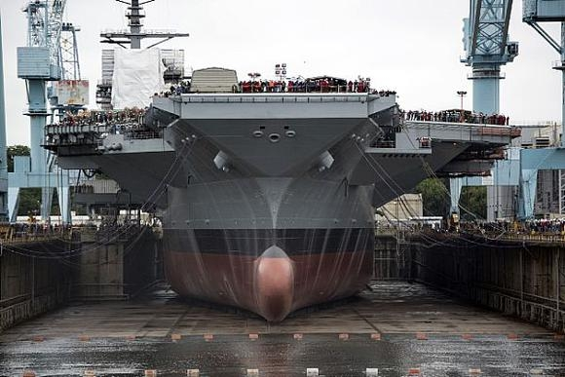
The incident was the most serious since Chinese ships and planes harassed the American ocean sur-veillance ship U.S.N.S. Impecable in 2009 in the South China Sea.
U.S. Secretary of Defense Chuck Hagel, on 12
Dec., called the action by the Chinese ship, cutting
100 yards in front of the Cowpens, an “irresponsible”
act. Hagel said the U.S. and China need to have pro-tocols to defuse these issues and avoid potential
clashes in the Pacific.
Gen. Martin Dempsey, Chairman of the Joint
Chiefs of Staff, said American and Chinese officers
have been meeting to draft rules for when the two militaries meet each other at sea, in the air, or in cyberspace. Some progress has been made.
The Chinese Defense Ministry said it’s naval
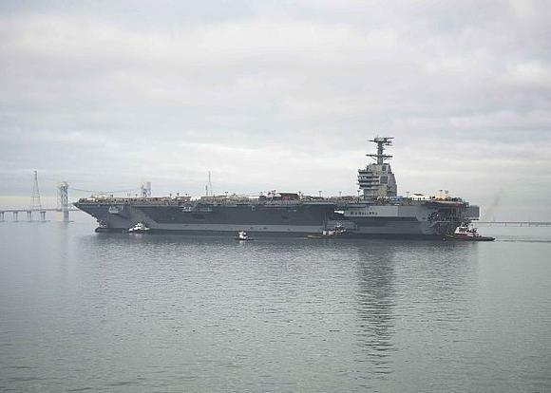
forces followed proper procedures and the two
defense departments “communicated effectively.” Yet they said the U.S. ship posed a “threat.”
Beijing recently declared a new air defense zone over parts of the South China Sea. Aircraft are re-
quired to submit flight plans, identify themselves, and take orders from the Chinese military. Japan and the U.S. have objected and others are refusing to comply.
The U.S. military has vowed to keep operating in international waters and airspace throughout Southeast Asia as a counter balance to Beijing’s assertiveness.

China Forges Ahead with Aircraft Carriers – U.S. Falls Back 2-3-2014
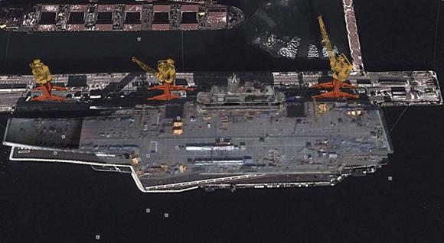
Spy in sky view of Chinese jump jet carrier Liaoning
By 2020 the People’s Liberation Army Navy could have 2, 3 even 4 aircraft carriers, while budget cuts are slowing the U.S. Navy down.
Budget cuts and delays have pushed back delivery
of the Navy’s newest super carrier U.S.S. Gerald R. Ford (CVN-78) to Feb. 2016. U.S. Navy Adm. Jon-athan Greenert warned that any further cuts could
delay delivery by another 2 years.
U.S.S. Gerald R. Ford in drydock.
U.S.S. Ford in the James River
Aircraft carrier task forces are terribly expensive to operate - $6.5 million a day and $2.5 billion per year. Building the actual carrier costs about $13 billion, then $3 billion to refuel at half her life span at 25 years. At the end of her 50 year service life it will cost $2 billion to have Huntington Ingalls take her apart.
To save money in today’s cost-cutting environment, Defense Secretary Chuck Hagel’s first instinct is to cut the present 11 carrier strike groups down to 8 or 9. U.S.S. George Washington will soon have her mid life $3 billion refueling coming up. Retiring her would save $1 billion and eliminating her strike group would save another $62.5 billion. Taking a second carrier strike group offline would save $125 billion or more.
But today’s Navy operates with just 10 flat tops, down from 26 in 1962 and from 15 in the 1980’s.The Navy is required by law to have 11 carrier groups to fullfill it’s mission.
Carrier groups also carry 6 dozen types of aircraft including Sikorsky Seahawks (United Technologies), F/A-18 fighters (Boeing), E-2 Hawkeyes (Northrup Grumman) and tomorrow probably F-35C Stealth fighters (Lockheed Martin). Cutting a carrier group eliminates 150 planes and billions for the contractors.
Also cutting a carrier would cost Huntington
Ingalls shipyard 2 years worth of revenue and if they were to go out of business America might not have the capacity to build anymore super carriers at all.
(Article by Rich Smith, the Motley Fool)

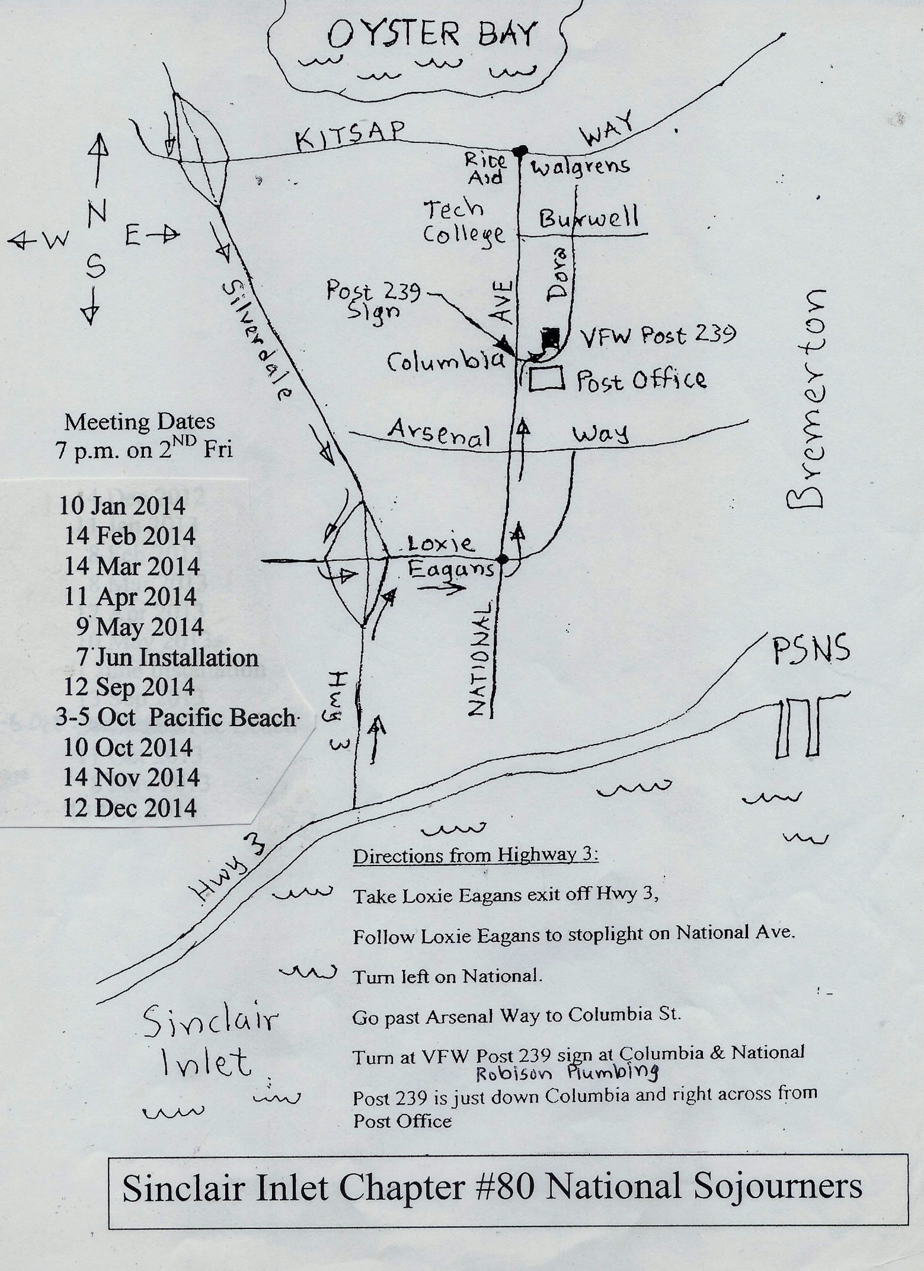
Kissinger Says Asia is like 19th Century Europe on use of Force
Former Secretary of State Henry Kissinger, 90, in regard to tensions between China and Japan, said,
“Asia is more in a position of 19TH century Europe, where military conflict is not ruled out. Between
Japan and China, the issue for the rest of us is that
neither side be tempted to rely on force to settle the issue.” Kissinger was addressing a global security conference in Munich.
Fu Ying, chairwoman of the Foreign Affairs Com-
mittee of China’s National People’s Party said China’s relations with Japan were at their worst over a ter-
ritorial dispute and that China would take action to maintain stability in the region.
China protested when Japan bought some disputed islands in the East China Sea from a private owner in 2012. They are known as Senkaku in Japanese and Diaoyu in Chinese.
In November 2012 China established an air defense identification zone in the area of the islands. Fu said
that Beijing would “respond effectively to any provo-
cation” that risked upsetting the tranquility of East
Asia. Fu also blamed Japan for it’s “history of denial” for crimes committed in the Second World War.
Japanese Foreign Minister Fumio Kishida respond-
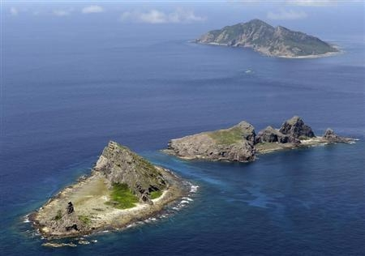
ed that Japan had reflected seriously about its wartime and colonial past and was now involved in peace keeping in the Middle East and Asia and contributing
to nuclear non-proliferation.
(Article by Jonathan Tirone of Bloomberg)

Disputed islands between China and Japan in East China Sea

