Sinclair Inlet Chapter No. 80 National Sojourners, Inc

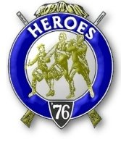

Bremerton, Washington
Our website address is: www.telebyte.com/masons/sojourn/index.htm

February 2013 Newsletter

Chapter Officers 2012-2013
President | HMCM Joseph MacIntyre | 360-275-0589 | haggis@wavecable.com
1st Vice President | Mr. Peter Dawson | 360-779-8219 | etypebubba@aol.com
2nd Vice President | CPO Stephen Quance | 360-731-5552 | sdquance@yahoo.com
Secretary/Treasurer | Mr. Charles Yankosky | 206-780-0563 | cyankosky@yahoo.com
Marshal | None
Chaplain | Mr. Richard Dexter | 360-692-6876 | rdexter@tscnet.com
Color Bearer | None

Hero Camp Officers 2012-2013
Commander | Col William Biscomb | 206-842-6417 | milfordbiscomb@comcast.net
Chief of Staff | Mr. Peter Dawson | 360-779-8219 | etypebubba@aol.com
Adjutant | MMCM Henry Carman | 360-698-4776 | hankcarman@wavecable.com

Meeting Notice!
We will meet at VFW Post #239, 190 Dora Ave, Bremerton on Friday, 8 Feb. Social hour and dinner begins at 1800, meeting at 1900 hours. Ladies and guests are always welcome at the meeting and are urged to attend.
The associated Lewis and Clark Camp of the Hero's of '76 meets immediately following the Sojourner meeting and is open to all Hero's.
Don’t forget to wear your Medals!
Highlights of the 11 Jan. Meeting
Vice Pres. Peter Dawson opened the chapter at
19:00. Dick Dexter was Chaplain and Col. Bill
Biscomb read the purposes of National Sojourners.
Area Rep. Wendell Dutt told us about the Mid-Winter conference held in Alexandria, Louisiana. There was
a special meeting for Secretaries. They want to keep
track of who are Honorary members on the chapter
rosters. An Honorary will have no Rank or Service
record. Send the Honorary list to National so we don’t
get too high a percentage. Also take note of
Widow Take-overs. That is when a member has died,
but theWidow continues to receive the Sojourner Magazine.
A new computer system has been put in place at National.

Almost all secretary forms are now down- loadable
from the website. If you know about the history of your chapter, send it to Woody Bently, the historian at National, and he will file and post it on
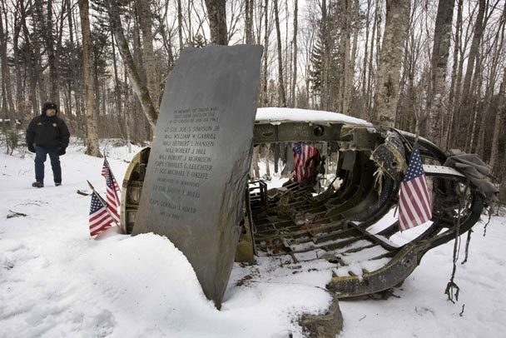

the National website. Each chapter, now, will be required to file their own 990-N tax form to take the burden off National. Use your own E.I.N. number. It only takes about 30 minutes to do it on line. If a chapter goes for three years without filing a tax return,
they lose their tax-exempt status, and it’s expensive
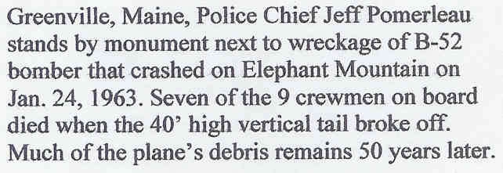
to get it back. Once you send your tax return in, get a confirmation from the I.R.S. and send it to National. There is a Tomb Guard website that you can contact if you want a guest speaker for Memorial Day. All chap-ters do a Flag Building ceremony, but now there is a script that National wants you to use so everybody’s Flag Building is done the same way. The deadline for the National Essay contest is in four days.
Wendell congratulated Peter Dawson for the write-up Peter got in the December 2012 Knights Templar Magazine.
Bill Biscomb informed us that Department of Defense policy has changed for stickers on vehicles going onto military bases. Per the D.O.D. all you need
to do is have a blue sticker and show the guard your driver’s license and insurance. Navy bases are in violation of D.O.D. policy in that they require a date. In the November newsletter, Bill mentioned how he was part of an effort to get the Navy in sync with the rest of the services. Now they seem to be going back
to their old ways. The McChord Base website even says D.O.D. policy has changed–you don’t need dates.
Sickness and Health: Memorials have been done for MWB Wayne Smith and Bob Colton, who recently passed. Bill Biscomb reported that Steve Seyl of Renton #29, a retired Lt. Commander, is on oxygen and not doing well. The V.A. is trying to cut back on B.J. Quance’s disability benefits. At tonight’s meet-ing, Dick Dexter took a nasty tumble down the stairs in a dark passage way and is feeling poorly. Don’t go down those passage ways without the lights being on.
Heroes: We may have a new Heroes officer. An e-mail was received from Alex Jordan expressing interest in filling the vacant Asst. Chief of Staff spot. Bill Biscomb has contacted the Cub Scout pack that Renton #29 is sponsoring, offering to have the Sojourners put
on a flag presentation for them.
V.P. Peter Dawson closed Chapter at 19:30.

The Boeing B52 Stratofortress weighed 350,000 pounds, it’s 8 jet engines powering it to a top speed of around 650 mph to a height of over 50,000 feet. It was designed to be a high altitude carrier of nuclear bombs. But advances in Soviet radar detection were to force the plane, with a 185 foot wingspan, to fly at tree top level to escape detection while making a nuclear strike. This caused structural fatigue that wasn’t foreseen in the original design. The plane has now been in use for half a century and, with upgrades, will have many more service years ahead, since there is nothing to replace it. But 50 years ago several training flights uncovered a design flaw that might have grounded the big jet.
On Jan. 24, 1963 a B-52 took off from West-over Air Force Base in Massachusetts. This was a training flight to help the crew learn how to use terrain avoidance radar so they could fly at tree top level. The 9-man crew was commanded by Lt. Col. Dan Bulli, an experienced pilot with 9,000 flight hours and whose job it was to see that B-52 pilots and crews were proficient. The crew had a choice of two routes, one over Maine and the other over North Carolina. Maine was chosen because it looked like better weather.
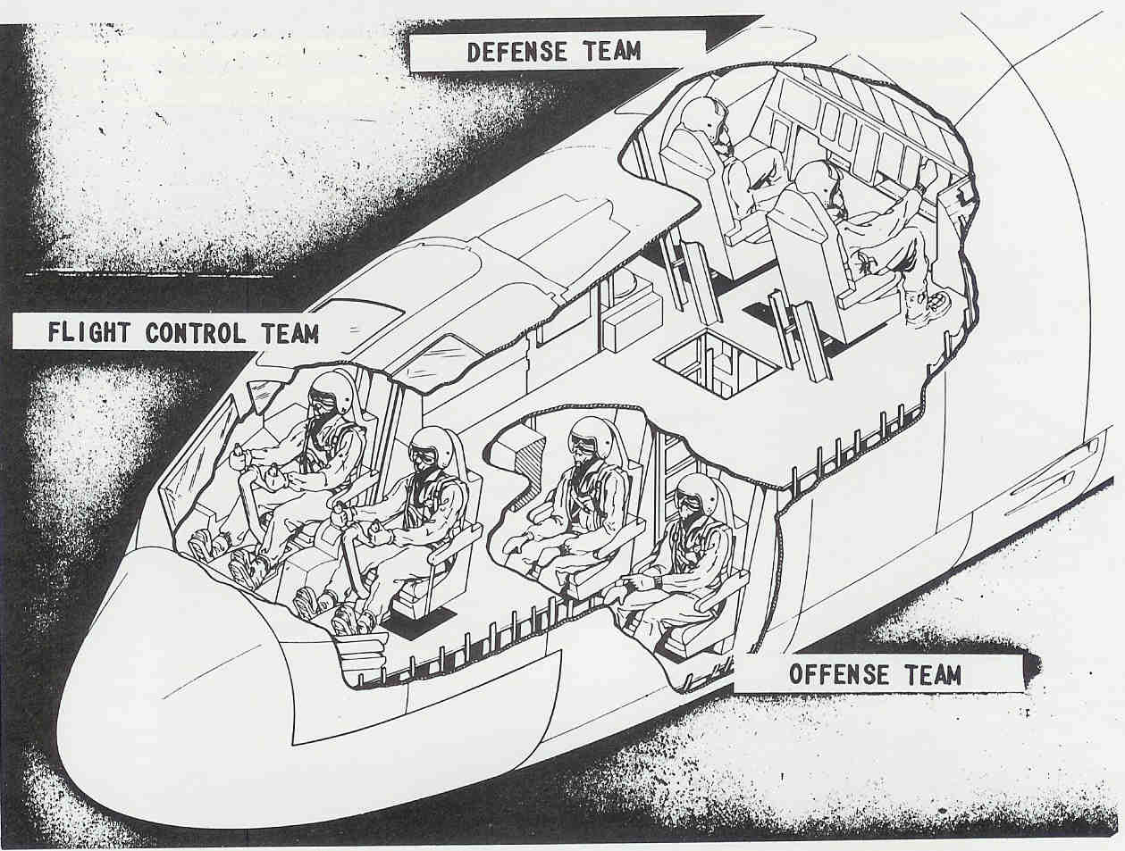
As the B-52 approached Greenville, 150 miles from Portland, Maine, wind gusts coming off 3 to 4,000 foot Elephant Mountain shook the plane. The vib-rating became so bad that Bulli couldn’t read the dials or radar on the insturment panel. Then he heard a loud bang. He learned later that it was the 40 foot high vertical stabilizer breaking off.. Traveling at 325 mph the plane nosed down toward the snowy ground. Unable to control the plane, Bulli ordered the crew to bail out. The cockpit seats for the pilot, copilot and navigator eject upwards. The remaining crew have to eject downward or bail out in an emergency. Six crew members were killed when the plane hit the mountain.
Bulli smashed his foot on the insturment panel while bursting through the escape hatch. His parachute caught in a tree and left him hanging 30 feet above the ground. The copilot also ejected but was killed when he hit a tree. Navigator Gerald Adler’s para-chute didn’t open, and still strapped in his seat he tumbled head over heels through trees and shoulder-deep snow. Adler’s landing broke his ribs and fractured his skull but the soft snow saved his life. Unfortunately Adler’s survival kit was destroyed so he had to wrap himself in his parachute to keep from freezing as best as he could. Bulli lowered himself to the ground, dug a hole in the snow and climbed into his sleeping bag. When darkness came the tempera-ture plunged to 20 below. Neither survivor knew the fate of the others.
The area where they crashed, Piscataquis County, Maine, is in the North Woods, the last frontier and least populated region East of the Mississippi. It took rescuers using helicopters, snowshoes and primitive snowmobiles 20 hours to reach Bulli and Adler. Adler suffered severe frostbite, was unconscious for five days and had to have a leg cut off because of gangrene. He spent 14 months in the hospital. Bulli recovered and continued to fly B-52’s.
About a week later another B-52 crashed in New Mexico. In a plane not designed for low level flying, the vertical stabilizer can break off under certain conditions.

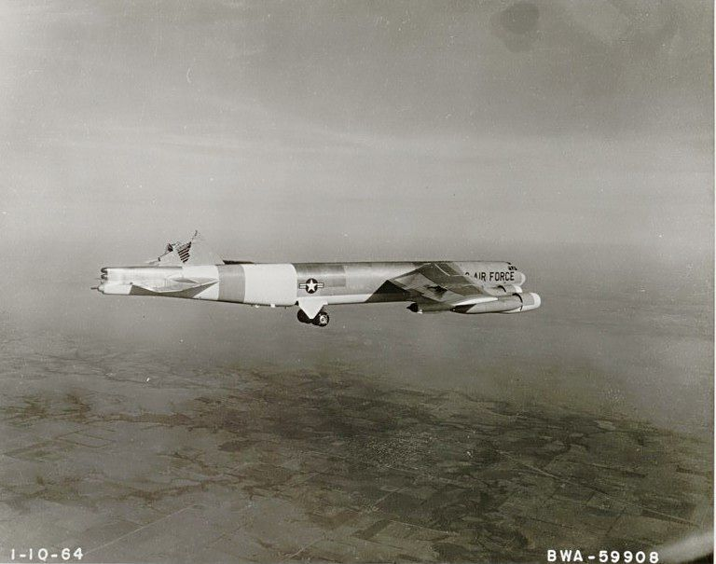
Flying Along
On Jan. 10. 1964 a B-52H took off from Boeing’s Wichita plant with a 3 man Boeing flight crew for a test flight. Pilot Chuck Fisher encoun-tered extreme air turbulence over Colorado. It was like being in a high speed elevator, being shoved up and down. Finally there was a heavy blow on the right side.
Fisher prepared to abandon the plane, dropping to a lower altitude so they could bail out. But he regained some control and informed Wichita he believed he could bring the plane back.
An emergency control center was set up in Wichita. The FAA cleared the airspace around the troubled plane. An F-100 fighter was sent up to inspected the damage and reported that the plane’s vertical tail was gone.
Engineers calculated the best way to get the plane down safely. An airborne Air Force B-52 was used to test various flight configurations before Fisher tried them. Six hours after the incident began Fisher and his crew brought the plane down for a safe landing at Blytheville AFB in Arkansas.

