Sinclair Inlet Chapter No. 80 National Sojourners, Inc

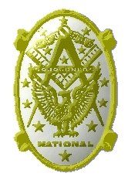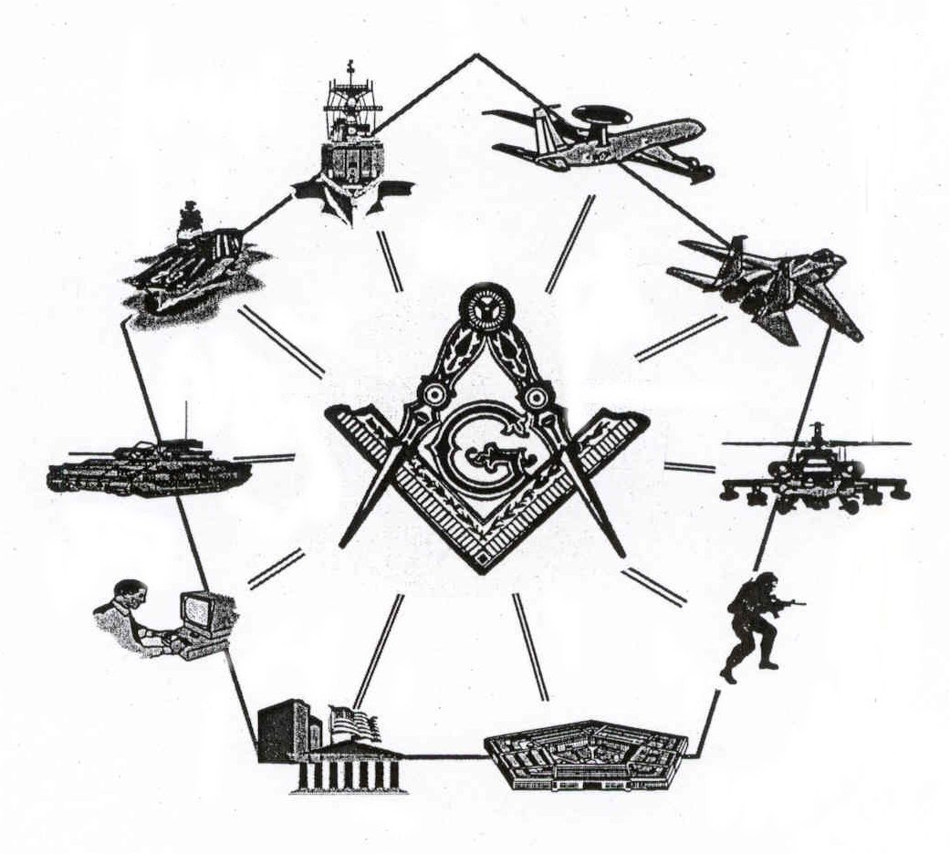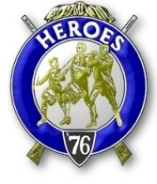

Bremerton, Washington
Our website address is: www.telebyte.com/masons/sojourn/80/sinclair_inlet_chapter.htm

February 2005 Newsletter

Chapter Officers 2004-2005
President | S/SGT Michael Pursey | 360-692-2421 | kpursey@silverlink.net
1st Vice President | Col William M. Biscomb | 206-842-6417
2nd Vice President
Secretary/Treasurer | WTCS John Gray | 360-895-3188 | wtcs_sw@wavecable.com
Marshal | CWO4 Richard Patterson | 360-769-8246
Chaplain | 1LT Harold E. Richardson | 360-692-4023 | harolder@comcast.net
Color Bearer

Hero Camp Officers 2004-2005
Commander | CAPT Harry R. Houston | 360-692-8478 | hbhouston@telebyte.com
Chief of Staff | 1Lt Harold R. Richardson | 360-692-4023 | harolder@comcast.net
Adjutant | WTCS John Gray | 360-895-3188 | wtcs_sw@wavecable.com

Meeting Notice!
We will meet at Elk’s Lodge #1181, Pine Road, Bremerton on 11 FEB. Social hour and dinner begins at 1800, Meeting at 1900 hours. Ladies and guests are always welcome at the meeting and are urged to attend.

The associated Lewis and Clark Camp of the Hero's of '76 meets immediately following the Sojourner meeting and is open to all Hero's.
Don’t forget to wear your Medals!
From the Desk of the Secretary
Brethren,

At the February meeting the President will appoint a committee to nominate successors to chapter offices for the upcoming year. Potential candidates will be presented at the March meeting and officers elected at the April meeting. I encourage all members to attend. The chapter is also looking for volunteers to serve on the following committees required by national regulations: Americanism, Bridge of Light and Membership. If you can find the time to assist it the chapter would be grateful, many hands make the workload light.
This month we will vote on the application of Chief Thomas Lou, U.S. Navy retired for membership. Please try to attend, cast your ballot and enjoy some fellowship with your brothers in arms.
Fraternally,
John
Highlights of Last Meeting
The meeting opened at 1900, 14 JAN 05 by President Michael Pursey with the members, ladies and guests as listed on the Muster Report. The minutes of the 10 DEC 2004 meeting were approved as read. Treasurers Report was read, balance on hand, $2330.36. Correspondence was read, consisting of chapter newsletters from Chapter 89 and a letter from Bro Jim Gillen with his new address and stating how much he enjoyed the chapter newsletter. No Committee Reports were given. Membership applications: none.
The following candidates were initiated: none.
Unfinished Business: The secretary stated that he had received the new flag stand but hadn’t had time to assemble it. Brother Seteroff moved to purchase a Bennington Flag and 2 addition wooden poles not to exceed $150, motion passed. Membership packets, contents and new chapter initiation dues were discussed. It was moved by Brother Seteroff that initiation fees be set at $45, for future memberships, not including outstanding petitions, motion passed. The secretary announced that the chapter had received the 3-6-5 Club membership streamer for the chapter flag and that HMCM MacIntyre and WTCS Gray became 3-6-5 Club Life Members. New Business: The Secretary read information on a Coin available to support the Collingwood Foundation. It was announced that Brothers Harold Richardson and Joseph MacIntyre became Chapter MIP's. Brother Illes gave a report on the Midwinter Meeting in Honolulu, including information on new resolutions, annual convention location and new fee structures. LTC Dutt, Regional Representative, presented a report on regional news. There was no guest speaker. It was announced that CAPT James A. Root requested to demit. HMCM MacIntyre invited members to the all Masonic Night on 19 JAN and Robert Burns night at the Seattle Scottish Rite on 21 JAN. There being no further business, the meeting ended at 1949, peace and harmony prevailing.

Lewis & Clark Camp of the Hero's of '76 News

Meeting opened at 1950, Commander Harry Houston presiding. The Commander requested that Brother Seteroff determine the location and possible date our upcoming initiation. Meeting closed at 1953.
LEWIS AND CLARK
Both Lewis and Clark were Freemasons. Membership was widespread among the officer corps of the U.S. Army and was practically a prerequisite for anyone holding public office between 1780 and 1820. Lewis was the more committed Mason; he joined the Door of Virtue Lodge in Albemarle County in 1797 and received the Royal Arch degree in Staunton, Virginia, two years later. After the expedition, he founded a lodge in Missouri and persuaded Clark to join. When he died, he was still carrying his Masonic apron, which was found "soiled only by the life-blood of its owner."
(Source: Lewis and Clark Across the Divide, published by Smithsonian Institution - 2004)

Like the Kit Fox, the Freemasons performed rites and rituals using ceremonial regalia such as painted aprons and certificates of initiation. Masonry inculcated spiritual values and high ideals. A Masonic text from the 1770s listed the central tenets as brotherly love, relief of the distressed, and truth. Their cardinal virtues were temperance ("to govern our passions and to check our unruly desires"), fortitude ("to resist temptations and to encounter dangers with spirit and resolution"), prudence ("to regulate our conduct by the dictates of reason"), and justice ("the principles of equity").
(Source: Lewis and Clark Across the Divide, published by Smithsonian Institution - 2004)

Masonry in the Civil War
L.J. Williams of Harvard, New York, enlisted in the 114th New York Volunteers at the beginning of the Civil War. He received the Entered Apprentice and Fellowcraft Degrees in Downsville Lodge No. 464 prior to his leaving home.

Later during the war he was captured and imprisoned near Savannah, Georgia. While in the prison, he communicated with his friends in the North. His lodge in New York through the proper officials got in touch with Zerubbabel Lodge in Savannah and stated that they would consider it a favor if the lodge in Savannah would confer the Third Degree on the Fellowcraft Brother Williams.

One night Brother Williams was taken from the prison and conducted to the lodge room in Savannah. He only had his blue tattered uniform to wear, a token of his sympathy with the cause he believed in. The officers of the lodge were all in Confederate gray. Although on opposite sides in the struggle going on on the battlefields of the South, they were all Brethren. He was then and there raised to the sublime degree of Master Mason and acclaimed a full Brother and friend to those who wore the gray.

Later that night Brother Williams escaped. When asked about his escape he would "smile peculiarly. You might put it down as an escape, but it wasn't an escape strictly speaking. They put me in a boat and carried me off some distance. Then they deposited me on neutral soil between the lines." From there Williams was able to find his friends. Williams never knew who exactly helped him escape. He considered it as their secret and it was never disclosed. Williams stated: "I know exactly to whom I may attribute my escape, His name is Hiram."
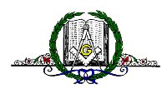
Binnacle List
Brothers,
Please pray for CWO4 Patterson’s quick recovery from surgery.

