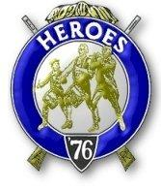
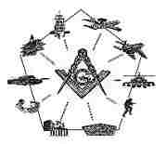

Sinclair Inlet Chapter No. 80 National Sojourners, Inc

Bremerton, Washington
Our website address is: www.telebyte.com/masons/sojourn/index.htm

Dec 2016 Newsletter

Chapter Officers 2016-2017
President | Mr. Peter Dawson | 360-779-8219 | etypebubba@aol.com
1st Vice President | MSG Robert Monroe | 360-801-2237 | robertmonroe@hotmail.com
2nd Vice President | CSCS Todd Mears | 360-286-0358 | navy.pride1987@yahoo.com
Secretary/Treasurer | Mr. Charles Yankosky | 206-780-0563 | cyankosky@yahoo.com
Marshal | MCPO Henry Carman | 360-698-4776 | hankcarman@wavecable.com
Chaplain | LTC Wendell Dutt | 253-565-5264 | wadutt@comcast.net
Color Bearer | HMC Christian Vardeleon | 360-475-4588 | cnvardeleon@yahoo.com

Hero Camp Officers 2016-2017
Commander | MSG Robert Monroe | 360-801-2237 | robertmonroe@hotmail.com
Chief of Staff | HMCM Joseph MacIntyre | 360-275-0589 | haggis@wavecable.com
Adjutant | Mr. Charles Yankosky | 206-780-0563 | cyankosky@yahoo.com

Meeting Notice!
We will meet at VFW Post #239, 190 Dora Ave, Bremerton on Friday, 9 Dec.. Social hour and dinner begin at 1800, meeting at 1900 hours. Ladies and guests are always welcome at the meeting and are urged to attend.
The associated Lewis and Clark Camp of the Heroes of ’76 meets immediately following the Sojourner meeting and is open to all Heroes.
Don’t forget to wear your Medals!

Highlights of the 11 Nov. Meeting
President Peter Dawson opened Chapter at 1900, and thanked those who attended for coming out tonight. Bro. Dick Dexter noted that at Pacific Beach they had new books updated to the latest National Sojourner changes as of June. We now welcome not just officers, chiefs and warrant officers, but Master Masons of all ranks who served honorably in the armed forces. We need to get new books too.
We need to approach Senior Grand Warden RWB Jim Kendall about what part Chapter 80 might have in the 2019 Grand Lodge Annual Communication in Bremerton. Bro. Dick Dexter wanted to approach RWB Jim Kendall about doing “Old Glory.” Perhaps we could do a flag presentation. Pres. Peter noted that the Heroes should do this.
At our December (Christmas) Meeting, Pres. Peter wanted to have a raffle or auction. Everyone bring a $15 present to the next meeting that we can raffle off. Bro. Hank Carman suggested recycling one of last year’s gifts.
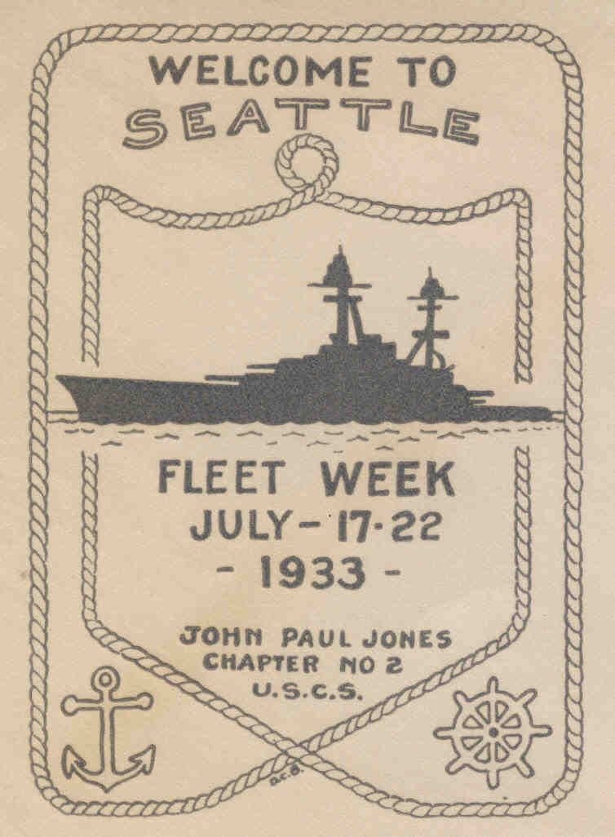
Secretary Charles saw an interesting picture show on the internet covering the building of the new aircraft carrier Gerald R. Ford. He will bring in a Power Point at the next meeting.
Bro. Dick Dexter noted that we have 6 people here tonight. Like lodge, we come here every month to keep the organization going. If we just quit, the chapter (and the lodge) would probably quit too. We have a lot of members, but where are they? At the last Lodge Officers Assn. Meeting a couple of guys asked Bro. Dick about the Sojourners. Come and sit in on a meeting. Get voted in.
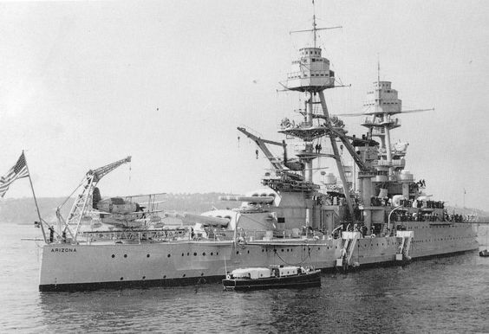
Bro. Hank Carman recalled how before a prospec-tive member had to be an E7 or above or an honorary Master Mason. Now any serviceman who is a Mason can join. Bro. Todd Mears said we should make it a goal for 2017 to get one new guy in. Bro. Hank said to get young people in with new ideas. Inherit what we leave behind. We used to meet at the Elks, until they insisted on a $10 cover charge per person for dinner for guests who weren’t members of the Elks.

Sickness & Health: Bro. Dick wanted to thank us for our concern. He was hospitalized for a bleeding ulcer. He didn’t realize how serious it was. Now you have to do certain things, think health and obey your doctor. Chapter closed at 1943.

Heroes Commander Robert Monroe called a Heroes meeting to order at 1950. He informed us that we needed to do 4 of these a year. Bro. Robert will watch for parades to march in. He’s talked with the Daughters of the American Revolution (DAR). Perhaps we could join in with them on something. Bro. Robert commented on how impressed the National President and Commander were with our Pacific Beach Heroes bivouac.
(Receipts: Monroe-$24 dues, $6 Hero book; Mears-$24 dues; Dexter-$6 Hero; Dawson-$6 Hero; ____-$6 Hero.)
(Attendees: Dawson, Dexter, Carman, Mears, Monroe, C.Y.)

USS Arizona in Seattle
During the 1930’s the battleship USS Arizona was a familiar sight in Puget Sound country. She was one of the Navy ships that came for Fleet Week in July and was in and out of the Bremerton Navy Yard. In 1934 she was one of the scenes for the filming of the Warner Bros. movie “Here Comes The Navy.” Other scenes were shot at Bremerton, San Diego and other bases. The last segment of the movie featured a Navy dirigible, the USS Macon. This film was the first of 9 that James Cagney and Pat O’Brien appeared in together.
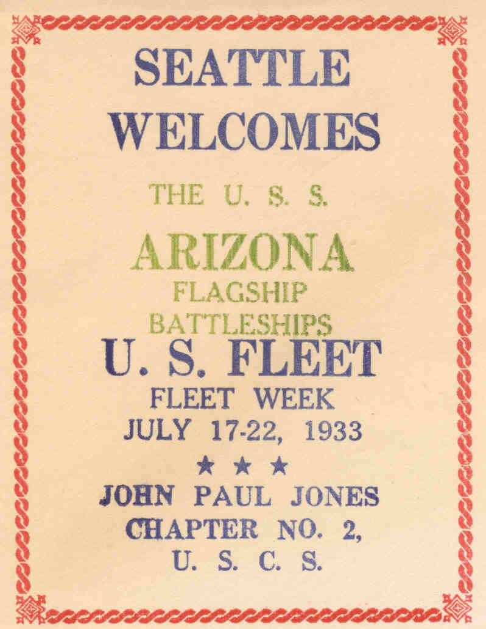
USS Arizona in Seattle’s Elliott Bay for Fleet Week in the 1930’s. Boats would carry guests from shore out to tour the battleships.
I once talked with a past master of the Warren G. Harding Lodge, Russ Hladik, who spent 6 of the happiest years of his life aboard the Arizona, from 1934-1940. He could recite the details of a 1930’s Pacific Fleet championship baseball game he was in inning by inning.

