Sinclair Inlet Chapter No. 80 National Sojourners, Inc

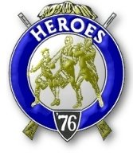

Bremerton, Washington
Our website address is: www.telebyte.com/masons/sojourn/index.htm

December 2015 Newsletter

Chapter Officers 2015-2016
President | Mr. Richard Dexter | 360-692-6876 | rdexter@tscnet.com
1st Vice President | Mr. Peter Dawson | 360-779-8219 | etypebubba@aol.com
2nd Vice President | MM1 Orville Stoner | 360-782-2385 | ovstoner@comcast.net
Secretary/Treasurer | Mr. Charles Yankosky | 206-780-0563 | cyankosky@yahoo.com
Marshal | CSCS Todd Mears | 360-286-0358 | navy.pride1987@yahoo.com
Chaplain | LTC Wendell Dutt | 253-565-5264 | wadutt@comsast.net
Color Bearer | None

Hero Camp Officers 2013-2014
Commander | Col. William Biscomb | 206-842-6417 | milfordbiscomb@comcast.net
Chief of Staff | HMCM Joseph MacIntyre | 360-275-0589 | haggis@wavecable.com
Adjutant | Mr. Charles Yankosky | 206-780-0563 | cyankosky@yahoo.com

Meeting Notice!
We will meet at VFW Post #239, 190 Dora Ave, Bremerton on Friday, 11 Dec. Social hour and dinner begin at 1800, meeting at 1900 hours. Ladies and guests are always welcome at the meeting and are urged to attend.
The associated Lewis and Clark Camp of the Heroes of ’76 meets immediately following the Sojourner meeting and is open to all Heroes.
Don’t forget to wear your Medals!
Highlights of the 13 Nov. Meeting
President Richard Dexter called the meeting to order at 1900. We received a streamer for the flag from a 3-6-5 Club contribution. New Heroes Manuals need to be ordered. Area Rep. Wendell Dutt suggested waiting until after the June convention, since the manuals are being re-written. Bro. Wendell asked that the previous meeting’s minutes be corrected to show that the National Convention in June will be at Greenville, SC. Members need name tags. Our local source, M & M Engravers, has gone out of business, but Romy Labonete has since taken over that operation.
Bro. Wendell announced that the Mid-Winter Convention will be held in Austin, TX. Cutoff date for reservations is 28 Dec. The National Convention will be in Greenville, SC on 14 June. This coming Tuesday night our Sojouners will “Build The Flag” at William H. Upton Naval & Military 206’s stated meeting. They hope to start by 6:50 to get through by 7:30. Flags of the different services will be presented and Bro. Bill Biscomb plans to recite “Old Glory” and Bro. Hank Carman will give “A Toast To The Flag.” At tonight’s meeting Bro. Bill Biscomb presented “Old Glory.” He did a good job. His was a different version than that given by Pres. Dick Dexter. But there are about half a dozen versions of “Old Glory” out there.
Sickness & Health. Bro. Bernie Curley is recovering from his ankle injury. Jim Ahlin passed out putting tables away at the Bremerton temple. They thought his pacemaker is off. Wish him well. Bro.
Paul Henry is recovering from a pretty good stroke.
He will be installed 28 Nov as master of Silverdale #311. A memorial service for WB Louis Peltier of William Renton #29 will be held on Saturday at 1 pm at Bethany Lutheran Church on Bainbridge.
Pres. Dick Dexter closed by commenting on the sad incident that happened today, Friday the 13TH, in Paris, France. Don’t think it can’t happen to us. It can.

“Whispering Death” The U.S. Army’s Abrams M1 Main Battle Tank
BOLD RIDE Bill Wilson, March 28, 2015.

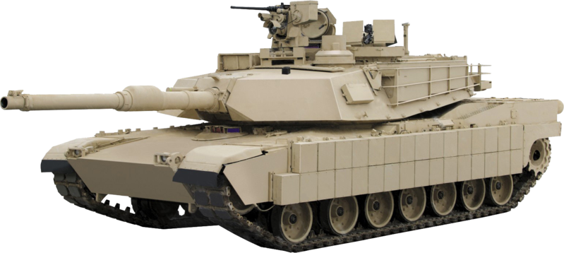
Developed in the 1970’s, the U.S. Army introduced a new tank in 1980. To it’s critics the Abrams M1 was technically complex, a gas guzzler and big. Yet 3273 tanks were delivered to the armed forces by 1985.
The M1 had many advantages. It had a highway speed of 60 miles per hour, 45 mph over long distances. Its original 105 mm rifled cannon was up-graded to a German 124 mm smoothbore gun in 1986. Armament also included 3 machine guns – a 50 cal. in front of the commander, a 7.62 mm in front of the loader, and a 7.62 mm to the right of the main gun. Armor consisted of overlappng layers of ceramics, steel, Kevlar and plastic to deflect most anti-tank rounds. In 1987 depleted uranium was incorporated into the turret and hull. Its gas turbine engine can run on gasoline, diesel or kerosene. At 1.67 miles to the gallon, it can burn 10 gallons of fuel per hour while idling. Its power plant is very quiet, compared to similar diesels, hence the name “Whispering Death.”
During the Persian Guld War of 1991, 1848 M1’s were deployed to Saudi Arabia for the liberation of Kuwait. For the first time the M1 would face Soviet-built T-55, T-62 and T-72 tanks on the battlefield. With the M1’s kill range of 2,500 meters, Iraqi tanks were destroyed before they could even get within shooting range. Opponents were wiped out with virtually no losses to the M1s. Only 9 M1s were destroyed by friendly fire or to prevent their falling into the hands of the enemy. One Abrams knocked out seven T-72’s 18 miles south of Baghdad.
Since then “Whispering Death,” the original M1 and its upgrades, are considered the best tanks in service today.

New Russian Tank Said to be Resistant to all NATO Weapons
Polina Tikhonova, June 25, 2015
Russia’s new 3RD generation battle tank, the T-14 Armata, shielded by advanced explosive reactive armor (ERA), will be impervious to all NATO anti tank missiles, says its builder. NII Stal. The ERA armor can resist 120 mm anti tank missiles and NATO’s DM53 and DM63 anti tank shells. Counter-mine defenses and HD video cameras giving the driver a 360 degree view are also included. Russian media claim the tank can even withstand attacks from Apache helicopters. The U.S. Army’s Foreign Military Studies Office countered that the Armata is protected only from “shape-charged gernades, anti-tank missiles and sub caliber bullets. China and India have shown interest in the new tank. Russian President Vladimir Putin has said that Russia will buy 2,300 Armatas by 2020 at a cost of $7 million each. Main armament is a 125 mm cannon in an unmanned turret fed by an automatic charging system that can fire 10 rounds a minute. The crew is protected by an armored capsule. Deliveries of the T-14 will start in 2017. NATO uses the Leopard 2A7 tank.

