Sinclair Inlet Chapter No. 80 National Sojourners, Inc

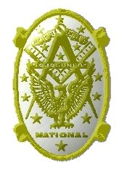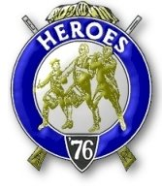

Bremerton, Washington
Our website address is: www.telebyte.com/masons/sojourn/index.htm

December 2013 Newsletter

Chapter Officers 2013-2014
President | HMCM Joseph MacIntyre | 360-275-0589 | haggis@wavecable.com
1st Vice President | CPO Stephen Quance | 360-731-5552 | sdquance@yahoo.com
2nd Vice President | Mr. Richard Dexter | 360-692-6876 | rdexter@tscnet.com
Secretary/Treasurer | Mr. Charles Yankosky | 206-780-0563 | cyankosky@yahoo.com
Marshal | None
Chaplain | LTC Wendell Dutt | 253-565-5264 | wadutt@comcast.net
Color Bearer | None

Hero Camp Officers 2013-2014
Commander | Mr. Peter Dawson | 360-779-8219 | etypebubba@aol.com
Chief of Staff | MMCM Henry Carman | 360-698-4776 | hankcarman@wavecable.com
Adjutant | Mr. Charles Yankosky | 206-780-0563 | cyankosky@yahoo.com

Meeting Notice!
We will meet at VFW Post #239, 190 Dora Ave, Bremerton on Friday, 13 Dec. Social hour and dinner begins at 1800, meeting at 1900 hours. Ladies and guests are always welcome at the meeting and are urged to attend.
The associated Lewis and Clark Camp of the Heroes of ’76 meets immediately following the Sojourner meeting and is open to all Heroes.
Don’t forget to wear your Medals!
Highlights of the 8 Nov Meeting
1ST VP B.J. Quance opened the meeting at 19:00.
A petition from Robert Monroe was read for the second time. The candidate had been voted on and accepted during the September meeting, so Area Rep. Wendell Dutt moved that we initiate him. Hank Carman, as Marshall, presented the candidate and B.J. Quance, as presiding officer, performed the ceremony. The Sojourner Medal Lecture was given by Wendell Dutt.
Wendell announced that Chapter 89’s next meeting will be this coming Tuesday because of Thanksgiving. Come on down to Patriot’s Landing at DuPont, next to Fort Lewis, for salmon fillet and prawns.
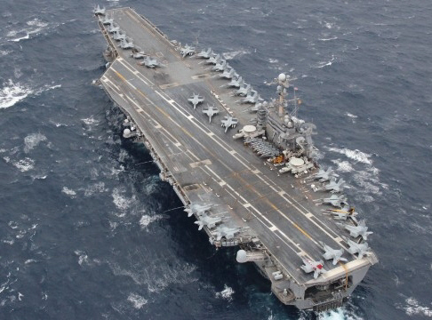
A second petition was read. Wendell made a motion to accept the petition. The motion was seconded and approved. There being no further business, 1ST V.P.
B.J. closed the meeting.
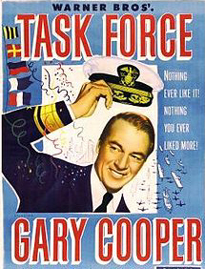
TASK FORCE the Movie.
From the dawn of Naval Aviation to present-day 1949.
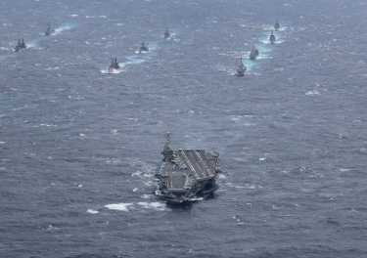
Super carrier U.S.S. George Washington leads
7TH Fleet in the Annual EX 2013 war games in the
East China Sea. The exercise brought together 23
ships and 20,000 service men and women from both
the U.S. and Japanese Self Defense navies to see how well they work together in a volatile region. Scenarios
acted out off Okinawa included defending Japan and
reacting to regional crises over areas which China
feels it should have.
China’s navy is becoming more professional and has deployed it’s own aircraft carrier, a refitted 1990’s surplus Soviet carrier bought from the Ukrainians.

U.S.S. George Washington facts: This Nimitz Class carrier with 5,000 crew and 80 aircraft is the only U.S. Navy carrier stationed permanently outside the U.S.
Displacement: 97,000 tons. Length of flight deck:
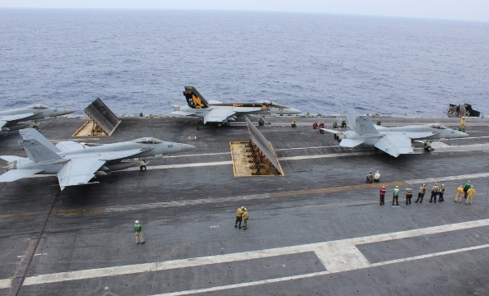
1,092 feet. Width of flight deck: 275 feet. Flight deck area: 4.5 acres. Height (keel to mast): 244 feet. Propul-sion: 2 nuclear reactors. Speed: more than 30 knots. Commissioned: July 4, 1992.
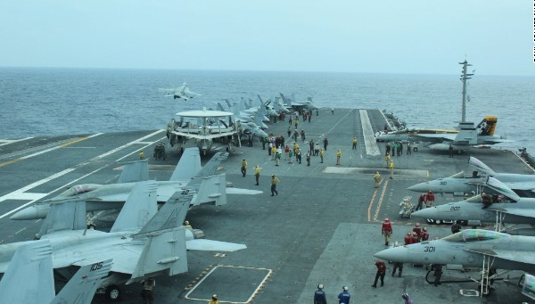
3 fighters prepare to catapult from carrier’s deck.
Busy flight deck
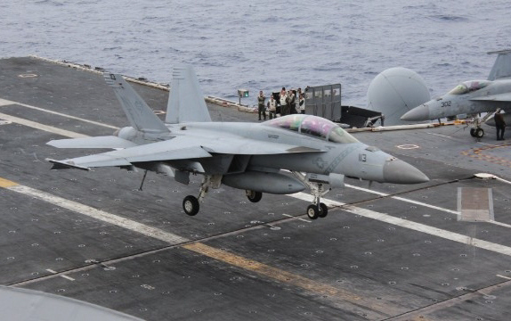
F-18 fighter comes in for landing
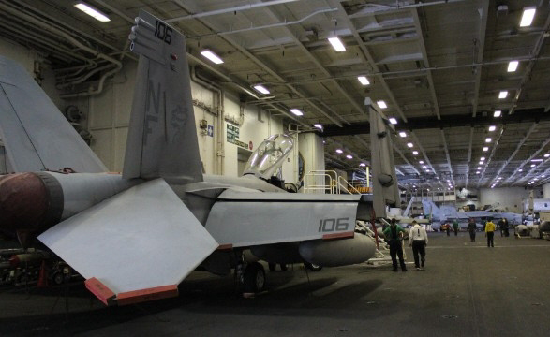
On the carrier’s hanger deck
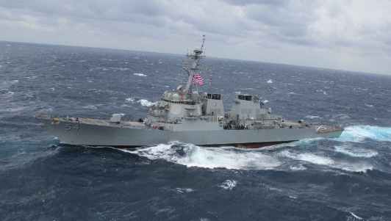
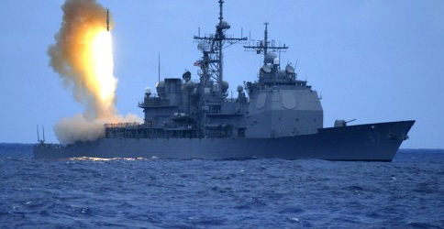
Escorting guided missile destroyer
Escorting guided missile heavy cruiser
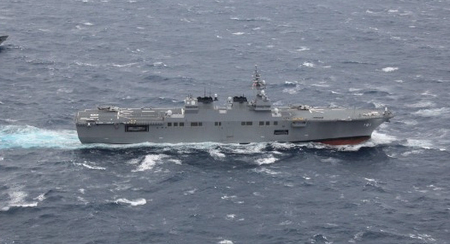
State of the art Japanese unit of the task force - a Hyuga class helicopter carrier
Source: CNN reporter Paul Armstrong interviews fleet commander Vice Admiral Robert C. Thomas aboard U.S.S. George Washington, Dec. 1, 2013.

EXERCISE 191
Admiral Husband Kimmel, commander of the Pacific Fleet, set aside the dates of November 23-25, 1941 for a fleet drill called Exercise 191. The object was to search for a Japanese carrier force believed to be north of Hawaii. Kimmel sent 46 warships into the North Pacific including 5 battleships, the carrier Lexington, and escorting cruisers, destroyers, subs and auxiliary ships. The Lexington’s 60 planes, plus 54 Marine Corps air-craft, were formed into a single air unit. Force Black (Japan) was to stage an air raid on Force White (U.S.). Force Black would launch its planes 200 miles north of Oahu over an inactive undersea volcano called the Prokofiev Seamount. The planes would take off early on a Sunday morning and target the Pearl Harbor naval base and Kaneohe Naval Air Station on Oahu. Force White (U.S.) was to search 600 miles seaward from Kaena Point, Oahu, along a 65 degree vector between Proko-fiev Seamount at 157 W. longitude and Chopin Sea-mount at 162 W. longitude. Long range air recon and radar were to be used in the search. Both Black and White forces were warned that hostile ships might be sighted at any moment and if they were the code phrase “Easy Cast Easy” was to be sent by signal flags or blinker light – not by radio so as not to tip off the Japanese. A strong North Pacific storm delayed the start of the war games. On Monday, Nov. 24, Lexington’s planes were about to attack Force White when Kimmel was ordered by the Assistant C.N.O. to call off the exercise. Negotiations with Japan were in a tense state and Kimmel wasn’t to make any provocations.
Two Sunday mornings later Japanese Admiral Nagumo arrived over the Prokofiev Seamount. His 30 ship fleet included 6 aircraft carriers and 2 battleships. He launched his First Air Fleet of 400 fighters and bombers 200 miles from Pearl Harbor, making Exercise 191 into the real thing.

