Sinclair Inlet Chapter No. 80 National Sojourners, Inc

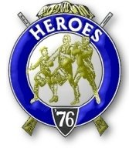

Bremerton, Washington
Our website address is: www.telebyte.com/masons/sojourn/index.htm

December 2012 Newsletter

Chapter Officers 2012-2013
President | HMCM Joseph MacIntyre | 360-275-0589 | haggis@wavecable.com
1st Vice President | Mr. Peter Dawson | 360-779-8219 | etypebubba@aol.com
2nd Vice President | CPO Stephen Quance | 360-731-5552 | sdquance@yahoo.com
Secretary/Treasurer | Mr. Charles Yankosky | 206-780-0563 | cyankosky@yahoo.com
Marshal | None
Chaplain | Mr. Richard Dexter | 360-692-6876 | rdexter@tscnet.com
Color Bearer | None

Hero Camp Officers 2012-2013
Commander | Col William Biscomb | 206-842-6417 | milfordbiscomb@comcast.net
Chief of Staff | Mr. Peter Dawson | 360-779-8219 | etypebubba@aol.com
Adjutant | MMCM Henry Carman | 360-698-4776 | hankcarman@wavecable.com

Meeting Notice!
We will meet at VFW Post #239, 190 Dora Ave, Bremerton on Friday, 14 Dec. Social hour and dinner begins at 1800, meeting at 1900 hours. Ladies and guests are always welcome at the meeting and are urged to attend.
The associated Lewis and Clark Camp of the Hero's of '76 meets immediately following the Sojourner meeting and is open to all Hero's.
Don’t forget to wear your Medals!
Highlights of the 9 Nov Meeting
Vice President Peter Dawson opened the meeting at 19:00. Mr. Dick Dexter officiated as chaplain. The minutes were approved as printed in the news letter. We asked the status of the Collingwood Library from District Rep. Wendell Dutt and he reported that they’re still in trouble. A comment was made that one thing that hurts us more than anything is the façade that this is strictly an officers’ organization. There are hundreds of retired NCO’s out there. About 95% of the member-ship of Silverdale #311 is retired Navy. William H. Upton Naval & Military #206 has it’s Uniform night. VP Peter Dawson would have gotten his Merchant Marine uniform out. We need to catch these NCO’s at lodge meetings to see if they want to join Sojourners. Hank Carman suggested putting a short synopsis of
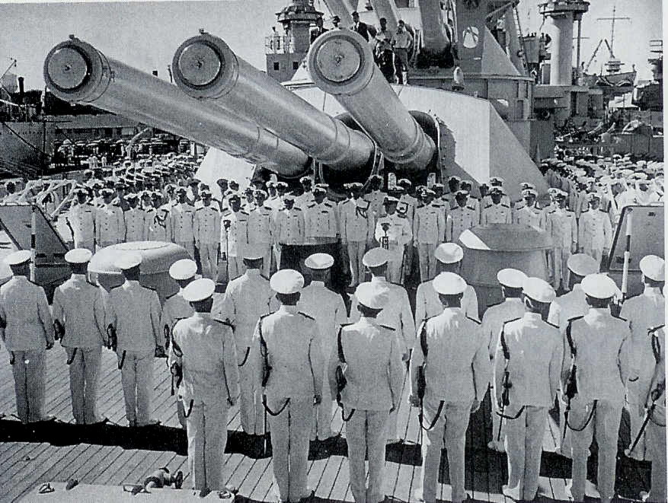
the Sojourners on the District 3 & 12 website. Tell them what this organizaton is about and carry around
a membership form. Bro. Dick Dexter, although not a veteran, joined when his son was in the army stationed in Iraq. Steve Seteroff did a recital of “Old Glory Speaks” and that’s what made Dick want to join.
Unfinished Business: The Past Presidents of the Chapter want their Past President pins.
Hank Carman advised the Chapter not to wait until May to think about putting on the Installation. This year is Chapter 80’s turn to host the installation of the combined chapters at Des Moines Lodge. One year,
on about May 15, the then President was going out of town and told Hank that Hank was going to host the installation. This means renting the lodge and getting
a caterer. Hank put out $300, got help from Wendell Dutt and with a week’s worth of work got it done. Wendell advised start getting ready for the installation
by the first of the year.
VP Peter Dawson thought the Secretary should be paid a stipend. This motion was made and passed (but issue is not covered in By-Laws).
Bill Biscomb was going to ask the Commander of the Bainbridge American Legion if he would want our Heroes to do a “Build The Flag” presentation. The Legion meets on the 1ST and 3RD Friday of the month. Possibly it could be done on 7 Dec, Pearl Harbor Day. Bill will find out.
Sickness & Health: Wendell reported that Bob Colton is still in the hospital after two and a half weeks. He was found unconscious in his house. He is now able to sit up and talk to people. He might be going to rehab. Marion Windell is now serving as our Area Rep. Meeting was closed at 19:30.

Kimmel/Richardson Change of Command Ceremony aboard battleship Pennsylvania 1 Feb 1941. Adm. Husband Kimmel (1882-1968) stands at microphone under right-most 14 inch gun. At his right is the man he replaced, Adm. James O. Richardson, who was fired as commander by Pres. Roosevelt. After the attack, Kimmel was demoted to 2 stars and replaced by Adm. Chester W. Nimitz on 16 Dec 1941. (Day of Deceit by Robt. Stinnett, Touchstone, 2000, Pg 36)

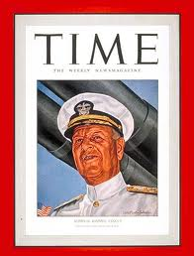
On the day of the 7 Dec Japanese attack, Edwin T. Layton recalled how “Kimmel stood by the window of his office at the submarine base, hia jaw set in stony anguish. As he watched the disaster across the harbor unfold with terrible fury, a spent .50 caliber machine gun bullet crashed through the glass. It brushed the admiral before it clanged to the floor. It cut his white jacket and raised a welt on is chest. “It would have been merciful had it killed me.” Kimmel murmured to his communications officer.” (And I Was There: Pearl Harbor and Midway, Edwin T. Layton, 1985, pg 315.
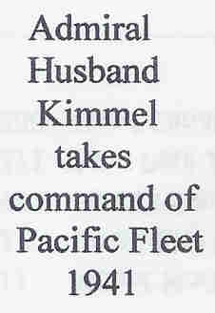
In the 1970 film “Tora, Tora, Tora” the scene was recreated by actor Martin Balsam, who played Kimmel)
Kimmel had been ordered to begin a “defensive deployment” on 27 Nov 1941. He took this to mean defense against sabotage, so the ships were kept in port and not on alert. Because of a lack of working PBY’s, long range air patrols were not sent out.
In a 1964 interview, Adm. Chester Nimitz recalled that “it was God’s mercy that our fleet was in Pearl Harbor on Dec. 7.” Had Adm. Kimmel had advance notice of what the Japanese were up to, he probably would have gathered his fleet and gone out to inter-cept them. But the remodeled World War 1 American dreadnoughts could never have come within shooting range of the fast Japanese carriers. All the while the enemy flat tops would be sending out swarms of torpedo and dive bombers. American ships would
have sunk into the ocean depths and thousand of more men would have been lost. As it was the ships were sunk in shallow water. Their crews were easily saved and 6 battleships were re-floated. Also, the American aircraft carriers and their task groups were off deliver-ing airplanes to far flung Marine bases: Lexington to Wake Island and Enterprise to Midway. Saratoga was docked in San Diego. Battleship Colorado was at the Bremerton Navy Yard.

(From Husband E. Kimmel on Wikpedia, internet)

Picking Up The Pieces. Battleship Pennsyvania was relatively undamaged. But destroyers Downes (DD-375) and the toppled over Cassin (DD-372) were smashed. Bombs ruptured fuel tanks and the oil ignited spreading fire throughout the ships. The ships were ordered abandoned after torpedoes and depth charges exploded turning them into infernos. Flooding the dry dock to control the fires caused Cassin to
come off her blocks and roll over. Though considered
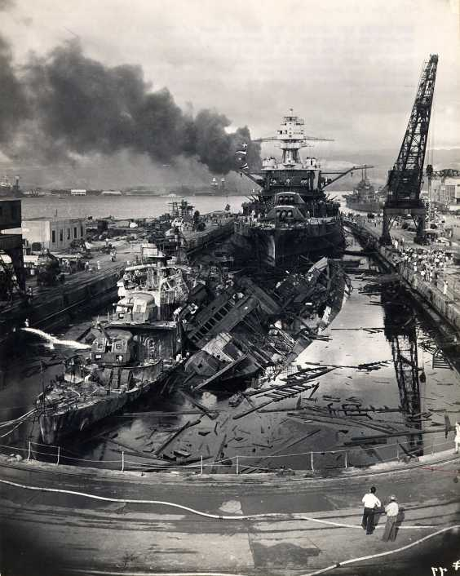
total losses, the wrecked ships had to be removed
from the dry dock. Turrets and superstructure were
removed to lighten them and the hulls patched for refloating. The hulls were warped beyond use, but
the machinery was still good so the Navy decided
to put it on new ships. 560 crates of parts weighing
more than a thousand tons were shipped to the Mare Island Navy Yard in San Francisco. By February
1944 the salvaged parts from both ships were back
in service.
