Sinclair Inlet Chapter No. 80 National Sojourners, Inc

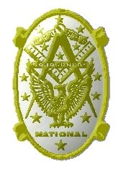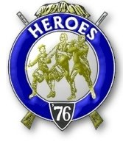

Bremerton, Washington
Our website address is: www.telebyte.com/masons/sojourn/index.htm

December 2011 Newsletter

Chapter Officers 2010-2011
President | Mr. Peter Dawson | 360-779-8219 | etypebubba@aol.com
1st Vice President | HMCM Joseph MacIntyre | 360-275-0589 | haggis@wavecable.com
2nd Vice President | None
Secretary/Treasurer | Mr. Charles Yankosky | 360-286-9385 | cyankosky@yahoo.com
Marshal | CPO Stephen Quance | 360-731-5552 | sdquance@yahoo.com
Chaplain | Mr. Richard Dexter | 360-692-6876 | rdexter@tscnet.com
Color Bearer

Hero Camp Officers 2010-2011
Commander | Col William Biscomb | 206-842-6417 | milfordbiscomb@comcast.net
Chief of Staff | Mr. Alex Jordan |  | jordan3614@hotmail.com
Adjutant | MMCM Henry Carman | 360-698-4776 | hankcarman@wavecable.com

Meeting Notice!
We will meet at VFW Post #239, 190 Dora Ave, Bremerton (see directions) on Friday 9 Dec. Social hour and dinner begins at 1800, meeting at 1900 hours. Ladies and guests are always welcome at the meeting and are urged to attend.
The associated Lewis and Clark Camp of the Hero's of '76 meets immediately following the Sojourner meeting and is open to all Hero's.
Don’t forget to wear your Medals!
Highlights of the Last Meeting
President Peter Dawson thanked Hank Carman for approaching VFW Post #239 for a meeting place. Our last meeting at the Elks was in May. Our instal-lation of officers, combined with that of the other chapters, was held at Des Moines Lodge #249 in Des Moines on 4 June. Many of our friends from the installation we saw again at the Heroes’s Bivouac at Pacific Beach over the 28 Sep weekend. The weather was rainy and windy outside, but a good time was had by all inside. We were even joined by National Presi-dent William G.L. Turner and his wife Patti, who flew up from Phoenix, AZ to attend our event. It was to be a
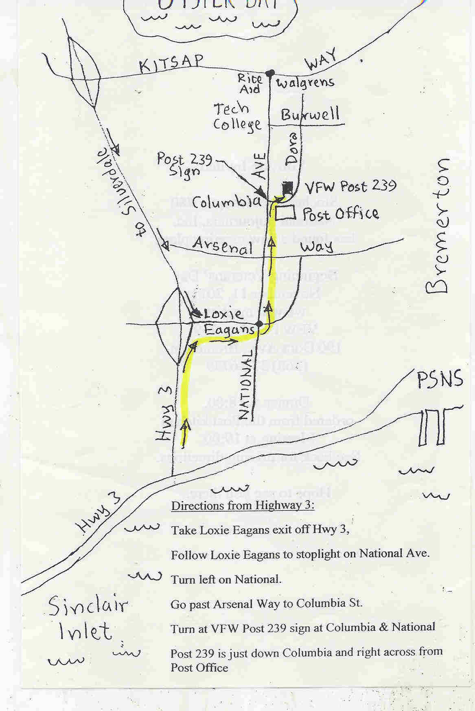
Directions to VFW Post #239

joint Heroes’ Degree between our Chapter’s Lewis & Clark Camp and Ft. Lewis #89’s Meriwether Lewis Camp. But since we lost our candidate, Sr. Grand Warden Jerry Lingle, one of the other chapters had to provide one. Bill Turner & Patti presented “A Toast to the Flag” in which he did half and she did half. Meri-wether Lewis Camp did a Flag Presentation in which they presented the variety of Colonial flags that were used at the beginning of the Revolution, prior to the development of the Bennington “76” flag and hence our National flag
At our Nov. 11 meeting, three of our members who had recently passed were remembered: RWB Jerald K. Lingle, Sr. Grand Warden, 19 Aug.; Harry R. Houston, Scottish Rite Past Grand Commander, 1 Oct.,
Joseph W. Illes, Past Sojourners NW Area Rep.,16 Oct.
The Mid-Winter meeting in Tucson, AZ from 18-21 Jan. 2012 was noted. This will be the planning conference for the National Convention in June.
A motion was made and passed to reimburse Hank Carman for the repairing the broken halberd at the end of our Chapter American flag. It was replaced with an Eagle. Hank has been taking care of the flags for 3 years. He would welcome anyone who would be willing to take over this duty.
This evening a dozen of us, including 3 wives, attended the meeting. We need to buy 10 meals to assist the Post cooks. If one is not a Post member they need to sign in on the sign-up sheet by the door. Tom Lou is a life member of the Post. The upstairs is a sports bar setting with TVs to watch the game. But most sports bars don’t have a scale model of the battle-ship Pennsylvania or WW1 and WW2 munitions and memorabilia. Music and joviality upstairs, but down-stairs are the silent meeting rooms where we conduct- ed our business.
Dick Dexter loves to do Old Glory. He plans to do it at the lodge on Tuesday and at the York Rite installation. He missed doing it for Veterans Day. Joe MacIntyre called our attention to the Veterans Coalition of Kitsap County. They do a Memorial Day ceremony at Ivy Green Cemetery in Bremerton, where Bremerton has its own unknown soldiers. They also do services at Lewis Funeral Home on Kitsap Way. Bryant Arnold is a member. He can answer questions about what all the Coalition does. Area Rep. Wendell Dutt presented a National Commander’s Patriot Award to Joseph MacIntyre from the National Secretary.
A revised Propeller Club form has come out. The purpose of the Propeller Club is to recruit two new members, one to replace yourself plus one more, plus donate to the Sem Fund or Youth Fund. Send the com-pleted form to the National Secretary, with a donation, and he wil send you a certificate.
SICKNESS & HEALTH: It was reported that Earl Riggs of Olympic #539 had a stroke and is in Room 22 of Belmont Terrace. He can understand you, lifts his right arm and tries to talk, but his left side is paralyzed. He would be happy to see some of us. B.J. Quance will be having heart surgery on 17 Nov. One heart chamber goes fast, the other slow. B.J. is Master of Wm. Upton #206 lodge. He walks from his house to the car and he’s out of breath. Dick Dexter is his driver. Harold Richardson will be installed in York Rite, but is not getting out much.
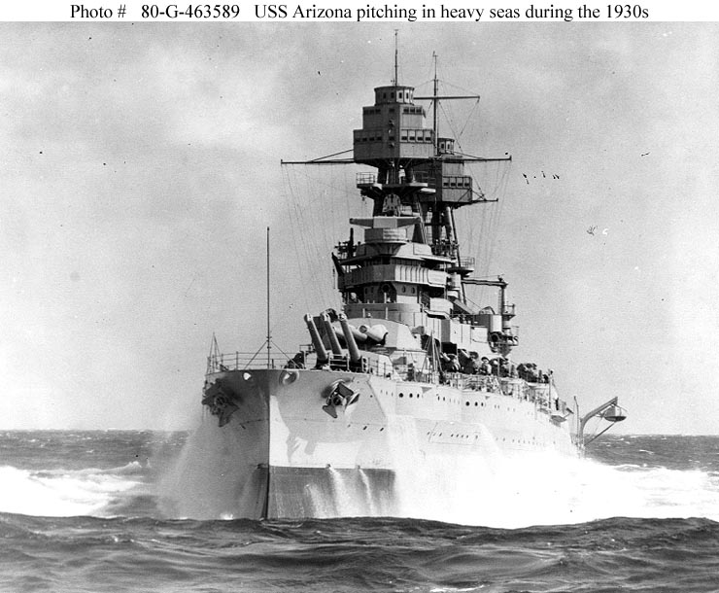
Bill Biscomb said a few words about the Heroes of ’76. The Heroes give programs to get people inter-ested in joining the Sojourners. There should be at least 4 people to do the programs. Hank and Dick
have done flag presentations with Bill as narrator. We should be asking lodges, church groups, American Legion posts, the Scouts if they would like us to do a presentation. The type of program would depend on how long we have to present it. Building the Flag
takes about 40 minutes. Historic Flags takes 30 min-utes. For the presentation of the 20 Historic flags, Jim Parker advised contacting Ron Hale, Asst. Chief of Staff of the Ft. Lewis #89 Heroes Camp. Reciting
“Old Glory” and “A Toast To the Flag” take 10 minutes. Bill told about the Pac Beach Heroes meeting.
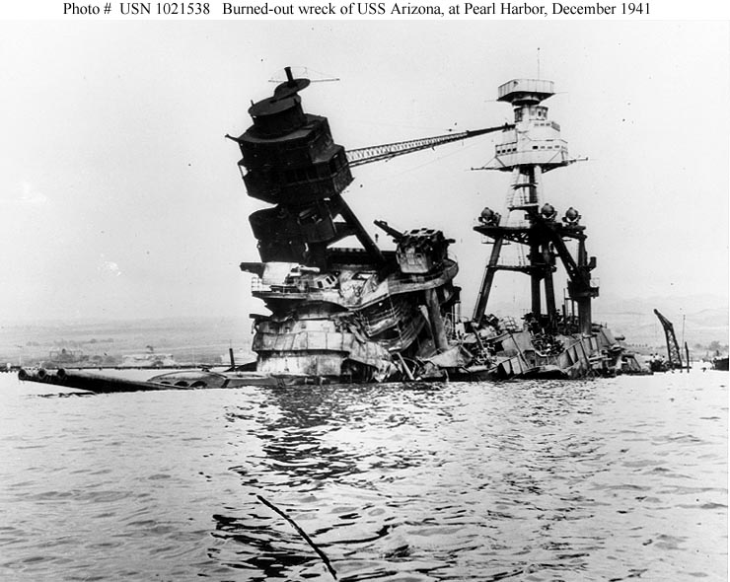
Chapter was closed at 19:30.
