Sinclair Inlet Chapter No. 80 National Sojourners, Inc

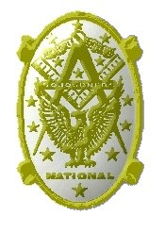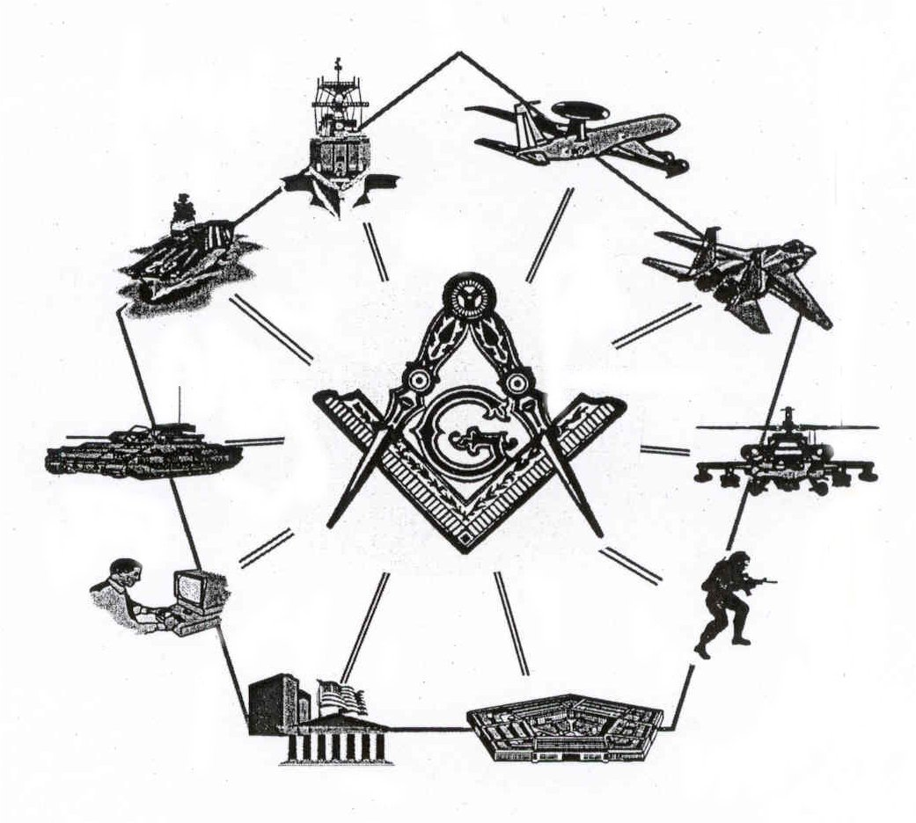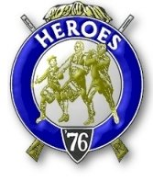

Bremerton, Washington
Our website address is: www.telebyte.com/masons/sojourn/80/sinclair_inlet_chapter.htm

December 2004 Newsletter

Chapter Officers 2004-2005
President | S/SGT Michael Pursey | 360-692-2421 | kpursey@silverlink.net
1st Vice President | Col William M. Biscomb | 206-842-6417
2nd Vice President
Secretary/Treasurer | WTCS John Gray | 360-895-3188 | wtcs_sw@wavecable.com
Marshal | CWO4 Richard Patterson | 360-769-8246
Chaplain | 1LT Harold E. Richardson | 360-692-4023 | haroldr@telebyte.net
Color Bearer

Hero Camp Officers 2004-2005
Commander | CAPT Harry R. Houston | 360-692-8478 | hbhouston@telebyte.com
Chief of Staff | 1Lt Harold R. Richardson | 360-692-4023 | haroldr@telebyte.net
Adjutant | WTCS John Gray | 360-895-3188 | wtcs_sw@wavecable.com

Meeting Notice!
We will meet at Elk’s Lodge #1181, Pine Road, Bremerton on 10 DEC. Social hour and dinner begins at 1800, Meeting at 1900 hours. Ladies and guests are always welcome at the meeting and are urged to attend.

The associated Lewis and Clark Camp of the Hero's of '76 meets immediately following the Sojourner meeting and is open to all Hero's.
Don’t forget to wear your Medals!
President’s Message
Season's Greetings Fellow Sojourners,

Our recruiting efforts are producing results, my brothers. Congratulations to MMCM Henry Carman and VWB John Watson (Honorary) on being accepted for membership in our Chapter.
I also am extremely pleased that HMCM Joe Macintyre has transferred his membership to our Chapter. When camp is closer to home, it is much easier to attend. Additionally, LT George Mitchell and his daughter Kelly have joined us and have shared in our comradery. If I can just figure out how to transfer his MIP up to Sinclair Inlet...

I'll just touch on my soap box a moment. ATTENDANCE!!! Oops...did I say that? Yes my brothers, we are taught through Freemasonry that you get out of an organization what you put into it. Since our ritual is brief, our fellowship lengthy and our patriotism extensive, all that is left is for you to come out and enjoy each other.

As Christmas approaches and the gala events of the holiday season occupy our time, please take time to reflect on the sacrifices made by our brave men and women who have served and continue to serve our beloved country. It's a great time to do something special for a service family. Perhaps invite a service man or woman to share your holiday activities. Every little deed helps, my brothers.

December 7th also brings a time for reflection. A time to remember the ultimate sacrifice and the heavy losses suffered during the surprise attack on Pearl Harbor. It was the twin towers of the day and every bit as devastating to our moral and costly in human life. We are indeed fortunate to have among us, a Pearl Harbor Survivor, Brother Gordon Sumner. I am pleased to announce that Brother Gordon will be our guest speaker at our DEC meeting, providing details and personal accounts of the events which unfolded during the heinous and tragic event. I urge you to invite friends and loved ones to this unique opportunity to learn about this most important day in the history of our country's struggle to preserve Democracy.

Merry Christmas to you and yours, my brothers
God Bless our service men and women and God Bless America.
SSgt Mike Pursey
President
From the Desk of the Secretary
Brethren,

I want to remind members who pay annual dues that they are now due. I am required to send them to the National office by 31 December. If you have not paid your dues yet please take time out to do it now. Annual Dues are $21. If your dues are a hardship, please contact me and we will see if we can work something out.

Two important youth programs are the National Essay Contest and the Youth Leadership Conferences. If you know of someone who might be interested in either of these outreach programs, let me know and I will get an information packet to them.

Fraternally,
John
Highlights of Last Meeting
The meeting opened at 1900, 12 NOV 04 by President Michael Pursey with the members, ladies and guests as listed on the Muster Report.
Treasurers Report was read, balance on hand, $2464.28. Correspondence was read, consisting of chapter newsletters from Chapters 40 and 89, and information on the SW and Southern California Areas Encampment on 6-8 FEB 2005.

Membership applications for VWB John Watson (Honorary) and MMCM Henry T. Carman were read. It was moved and unanimously passed that they be accepted for membership. There were no candidates to initiate. The president reported on the purchase of a Chapter flag, the MMIP for LCDR Tompkins and the membership packet that Chapter 539 provides to its new members. There was no new business. The President read a SECNAV message on “Honoring Veterans Day”. It was announced that Joseph MacIntyre transferred his membership from Chapter #40 to our chapter. Information about the 2005 National Essay Contest and 2005 Youth Leadership Conferences were read and packets made available to the membership.

There being no further business, the meeting ended at 2000, peace and harmony prevailing.

Lewis and Clark Camp of the Hero's of '76 News

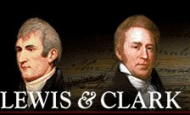

Lewis and Clark Camp of the Hero's of '76

Commander Harry Houston requests that Heroes consider a taking a part in the ceremony and that he can provide a list of uniform suppliers for those who need to purchase uniforms.
Masonry in the Civil War
L.J. Williams of Harvard, New York, enlisted in the 114th New York Volunteers at the beginning of the Civil War. He received the Entered Apprentice and Fellowcraft Degrees in Downsville Lodge No. 464 prior to his leaving home.

Later during the war he was captured and imprisoned near Savannah, Georgia. While in the prison, he communicated with his friends in the North. His lodge in New York through the proper officials got in touch with Zerubbabel Lodge in Savannah and stated that they would consider it a favor if the lodge in Savannah would confer the Third Degree on the Fellowcraft Brother Williams.

One night Brother Williams was taken from the prison and conducted to the lodge room in Savannah. He only had his blue tattered uniform to wear, a token of his sympathy with the cause he believed in. The officers of the lodge were all in Confederate gray. Although on opposite sides in the struggle going on on the battlefields of the South, they were all Brethren. He was then and there raised to the sublime degree of Master Mason and acclaimed a full Brother and friend to those who wore the gray.

Later that night Brother Williams escaped. When asked about his escape he would "smile peculiarly. You might put it down as an escape, but it wasn't an escape strictly speaking. They put me in a boat and carried me off some distance. Then they deposited me on neutral soil between the lines." From there Williams was able to find his friends. Williams never knew who exactly helped him escape. He considered it as their secret and it was never disclosed. Williams stated: "I know exactly to whom I may attribute my escape, His name is Hiram."

Binnacle List
Brothers,
Please pray for CWO4 Patterson’s quick recovery from surgery.

