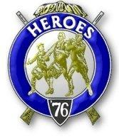
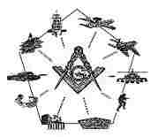
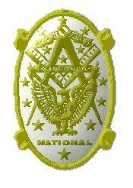
Sinclair Inlet Chapter No. 80 National Sojourners, Inc

Bremerton, Washington
Our website address is: www.telebyte.com/masons/sojourn/index.htm

Apr 2017 Newsletter

Chapter Officers 2016-2017
President | Mr. Peter Dawson | 360-779-8219 | etypebubba@aol.com
1st Vice President | MSG Robert Monroe | 360-801-2237 | robertmonroe@hotmail.com
2nd Vice President | CSCS Todd Mears | 360-286-0358 | navy.pride1987@yahoo.com
Secretary/Treasurer | Mr. Charles Yankosky | 206-780-0563 | cyankosky@yahoo.com
Marshal | MCPO Henry Carman | 360-698-4776 | hankcarman@wavecable.com
Chaplain | LTC Wendell Dutt | 253-565-5264 | wadutt@comcast.net
Color Bearer | HMC Christian Vardeleon | 360-475-4588 | cnvardeleon@yahoo.com

Hero Camp Officers 2016-2017
Commander | MSG Robert Monroe | 360-801-2237 | robertmonroe@hotmail.com
Chief of Staff | HMCM Joseph MacIntyre | 360-275-0589 | haggis@wavecable.com
Adjutant | Mr. Charles Yankosky | 206-780-0563 | cyankosky@yahoo.com

Meeting Notice!
We will meet at VFW Post #239, 190 Dora Ave, Bremerton on Friday, 14 Apr. Social hour and dinner begin at 1800, meeting at 1900 hours. Ladies and guests are always welcome at the meeting and are urged to attend.
The associated Lewis and Clark Camp of the Heroes of ’76 meets immediately following the Sojourner meeting and is open to all Heroes.
Don’t forget to wear your Medals!

Highlights of the 10 Mar. Meeting
Since we didn’t have enough members present to use the meeting room, we stayed in the dining room and had a longer fellowship hour.
Several issues did come up:
1. This year’s Pacific Beach conference will be held on 6 – 9 Oct. Deadline for reservations is 15 Sep. Encampment registration forms are available online.
2. JROTC award night for South Kitsap H.S. is scheduled for 31 May. We still need to hear from Bremerton H.S. We need members to present the awards.
3. Due to the fact that a minimum of 25 Sojourners are needed to conduct a joint installation of officers, there will be no joint installation this year. Chapters 40 & 534 will do theirs together, but the other chapters will hold theirs separately. Chapter #80 will hold our installation at VFW #239. We just need to pick a roster of officers and a date. The 2ND weekend in June is Grand Lodge. Friday, June 2 might be a logical choice.
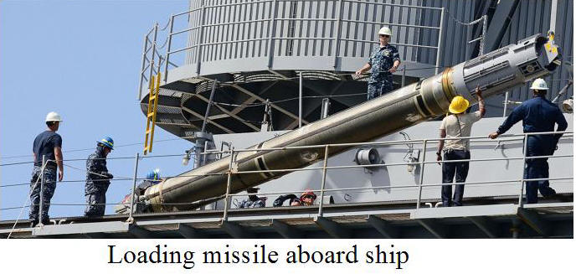
4. This year’s National Convention is 12 – 17 June in Austin, Texas. Registration deadline is 15 May.

Why U.S. Used Tomahawk Missiles on Syrian Airbase
Elizabeth McLaughlin, ABC News, Apr. 7, 2017

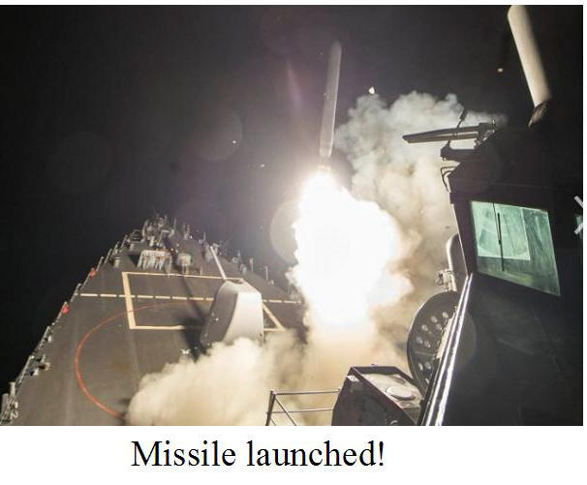
President Trump ordered missiles launched against a Syrian airbase in retaliation for a poison gas attack against Syrian civilians earlier this week. Syrian air force jets of Pres. Bashar al-Assad’s regime took off from the base carrying chemical weapons according to U.S. sources. U.S. Navy destroyers Ross (DDG-71) and Porter (DDG-78) fired 60 Tomahawk cruise missiles, which took 30 minutes to fly to their target. U.S. sources claimed that 59 missiles hit the base destroying 20 Syrian warplanes. The Russians countered that only 23 missiles hit the target.
The Raytheon Tomahawk is a medium range jet-powered missile that can be launched from vertical tubes on ships and submarines. It can fly 1,500 miles at 550 mph carrying a 1,000 conventional bomb or nuclear warhead. It can cruise 100 feet above the ground to avoid radar. Guided by GPS, it flies an eratic route to evade interception. They cost about $1 million apiece.
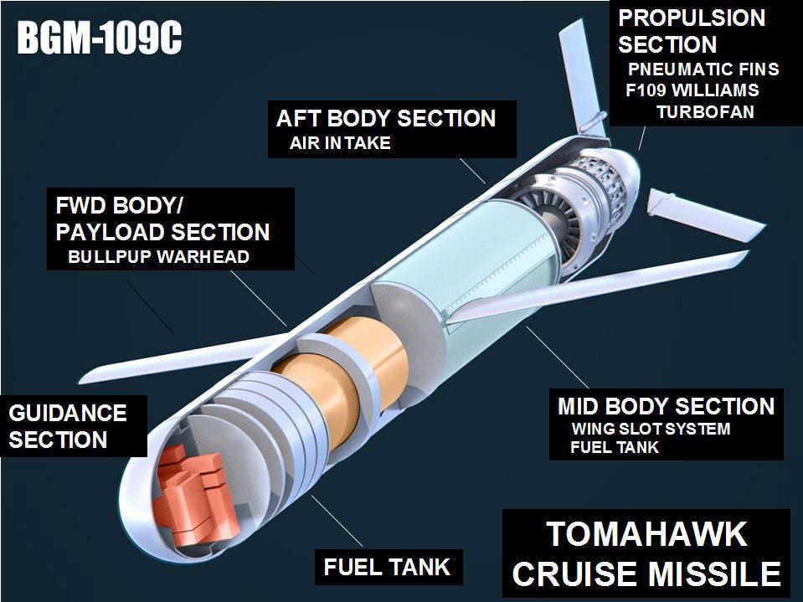
First used in the 1991 Gulf War against Iraq, the Tomahawk has been a missile of choice by the military ever since. They were used in Afghanistan and Sudan in 1998 to retaliate for Al-Qaeda bombings of embassies. Other Tomahawk strikes have been Bosnia (1995), Serbia (1999), Afghanistan (2001), Iraq again (2003), Somalia (2008), Yemen (2009), Libya (2011) and Syrian Isis targets (2014). In Oct. 2016 destroyer USS Nitze (DDG-94) fired Tomahawks against radar sites in Yemen in response to missiles fired at USS Mason (DDG-87).

U.S.N. Destroyer Commodore talks about Missile Strike.
David Martin, CBS News, Apr. 7, 2017.

The destroyer force that fired the missiles was commanded by Commodore Tate Westbrook. He was alerted on Tuesday, 4 Apr. when a Syrian jet took off from the field and dropped a nerve gas bomb on a road leaving a crater and a cloud of death. USS Ross and USS Porter were then 1,500 miles away. Westbrook ordered both ships to turn around and go at top speed across the Mediterranean to get in position. Pres. Trump approved the strike at 4:30 pm Thursday, 6 Apr. Ross and Porter were SW of Cyprus and within the 1,000 mile range of their missiles. Washington alerted the Russians that a missile strike was coming, but that it was not intended for them. At 7:36pm, Thurs. the 6TH the destroyers launched 5 dozen missiles, one falling in the water. The Russians had helicopters and crews at the airbase, but the missiles avoided them.

