Sinclair Inlet Chapter No. 80 National Sojourners, Inc

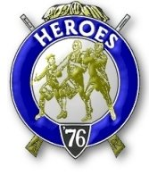

Bremerton, Washington
Our website address is: www.telebyte.com/masons/sojourn/index.htm

April 2015 Newsletter

Chapter Officers 2014-2015
President | CPO Stephen B.J. Quance | 360-731-5552 | sdquance@yahoo.com
1st Vice President | Mr. Richard Dexter | 360-692-6876 | rdexter@tscnet.com
2nd Vice President | Mr. Peter Dawson | 360-779-8219 | etypebubba@aol.com
Secretary/Treasurer | Mr. Charles Yankosky | 206-780-0563 | cyankosky@yahoo.com
Marshal | None
Chaplain | LTC Wendell Dutt | 253-565-5264 | wadutt@comsast.net
Color Bearer | None

Hero Camp Officers 2013-2014
Commander | Mr. Alex Jordan |  | jordan3614@hotmail.com
Chief of Staff | Col. William Biscomb | 206-842-6417 | hankcarman@wavecable.com
Adjutant | Mr. Charles Yankosky | 206-780-0563 | cyankosky@yahoo.com

Meeting Notice!
We will meet at All Star Lanes in Silverdale on Friday, 10 Apr. Social hour and dinner begins at 1800, meeting at 1900 hours. Ladies and guests are always welcome at the meeting and are urged to attend. Happy Valentine’s Day!
The associated Lewis and Clark Camp of the Heroes of ’76 meets immediately following the Sojourner meeting and is open to all Heroes.
Don’t forget to wear your Medals!
Highlights of the 13 Mar. Meeting
Pres. B.J. Quance called the meeting to order at 19:00. The major communication involved the clos-
Ing of Collingwood Library and the moving of the National Headquarters. If you’ve loaned anything to the Library be sure to ask for it back if you want it back. The National Office will be closed for a week for the move. Pres. B.J. read an e-mail sent from the National President about the relocation.
Bro. Bill Biscomb, an NCIS retiree, gave a talk about the year he spent in Vietnam with NCIS’s predecessor, the Naval Investigative Service. Bill was in Vietnam from Aug. 1969 to Aug. 1970, mostly at the Danang field office. He spoke about the people he worked with. Without going into all the details, he did say that one of his teammates wrote a book about their Vietnam experience. Doug Hubbard wrote “Special Agent Vietnam – A Naval Intelligence Memoir.” Chapter was closed at 19:30.
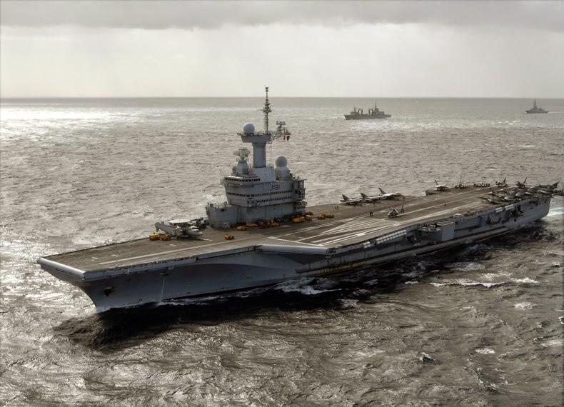
U.S.A. Aircraft Carrier definition means France has the only other Aircraft Carrier
Science & Technology, 20 Jan 2015
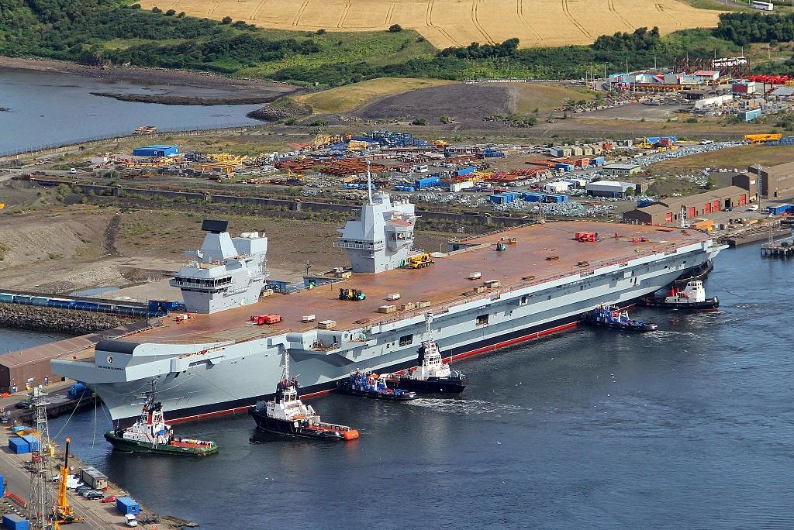
To be regarded as an aircraft carrier by the U.S. Navy,
a ship carrying aircraft must be 1) nuclear powered and 2) have aircraft-launching catapults. Futhermore, an aircraft carrier and its air wing needs to be thought of as a single combat system. It must be able to operate far from land-based support for limited periods of time in contested environments. And it must be able to defend against air, surface and submarine threats.
The U.S. Navy’s 11 amphibious assault ships aren’t considered aircraft carriers by this definition. Of the 16 other aircraft carrying ships operated by other navies, only the French have a nuclear-powered, catapult launching ship in service.
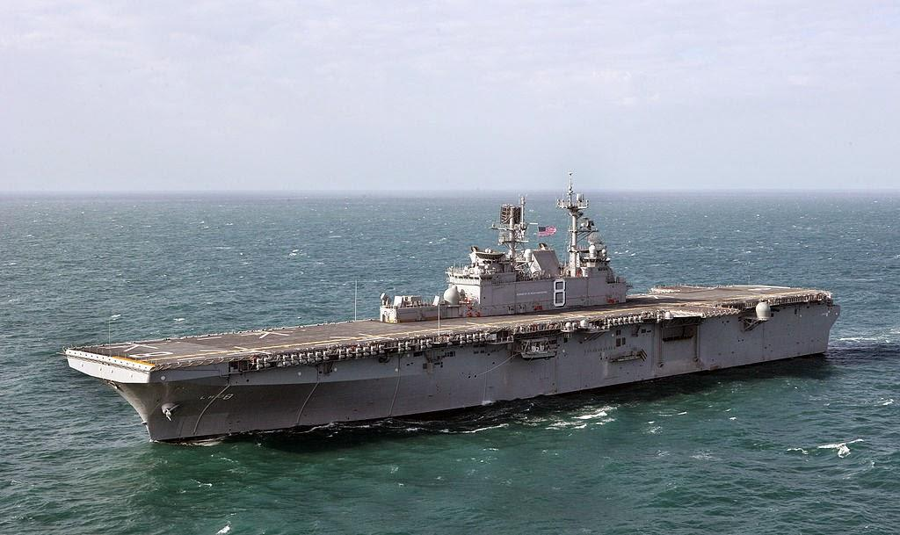
The U.S. Marine’s amphibious assault ship only looks like
an aircraft carrier.

The French Navy’s Charles de Gaulle (R-91) is Western Europe’s largest warship. However, the British Royal Navy’s two 70,000 ton Queen Elizabeth class carriers are larger but not nuclear-powered. India could have a 65,000 ton carrier by 2025.
The U.S. Navy feels that it’s present 11 carriers are
not enough. On one particular day 2 aircraft carriers were deployed to the Middle East. Another was en route to relieve one of those on deployment. Two carriers were conducting training exercises off the U.S. coast. One
carrier had just returned from deployment ad was standing down. 2 carriers were in port for light maintenance and

France’s nuclear-powered Charles de Gaulle.
Great Britain’s Queen Elizabeth in construction.

training. Another 2 were in shipyards for heavy mainten-ance and one was having it’s nuclear fuel replaced.
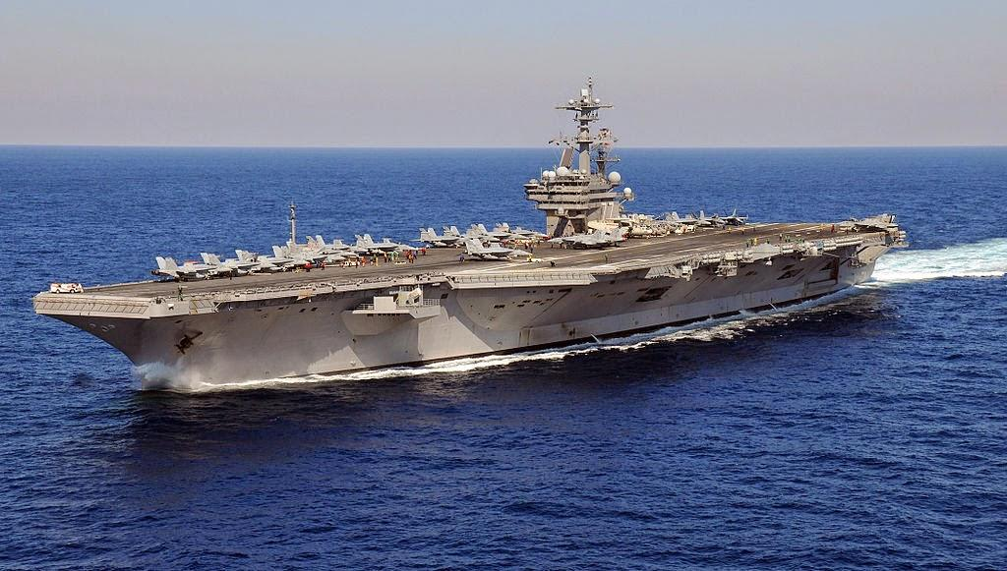
On any given day the U.S. Navy’s carrier fleet is busy on deployment, in training and in maintenance.
U.S. Navy 100,000 ton Super Carrier.

