Sinclair Inlet Chapter No. 80 National Sojourners, Inc

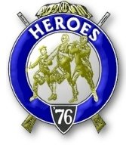

Bremerton, Washington
Our website address is: www.telebyte.com/masons/sojourn/index.htm

April 2012 Newsletter

Chapter Officers 2011-2012
President | Mr. Peter Dawson | 360-779-8219 | etypebubba@aol.com
1st Vice President | HMCM Joseph MacIntyre | 360-275-0589 | haggis@wavecable.com
2nd Vice President | None
Secretary/Treasurer | Mr. Charles Yankosky | 206-780-0563 | cyankosky@yahoo.com
Marshal | CPO Stephen Quance | 360-731-5552 | sdquance@yahoo.com
Chaplain | Mr. Richard Dexter | 360-692-6876 | rdexter@tscnet.com
Color Bearer

Hero Camp Officers 2011-2012
Commander | Col William Biscomb | 206-842-6417 | milfordbiscomb@comcast.net
Chief of Staff | Mr. Alex Jordan |  | jordan3614@hotmail.com
Adjutant | MMCM Henry Carman | 360-698-4776 | hankcarman@wavecable.com

Meeting Notice!
We will meet at VFW Post #239, 190 Dora Ave, Bremerton (see directions) on Friday 13 Apr. Social hour and dinner begins at 1800, meeting at 1900 hours. Ladies and guests are always welcome at the meeting and are urged to attend.
The associated Lewis and Clark Camp of the Hero's of '76 meets immediately following the Sojourner meeting and is open to all Hero's.
Don’t forget to wear your Medals!
Highlights of the Last Meeting
Friday, 9 March, was a windy, rainy and totally disagreeable night. As we didn’t have a quorum of members, we didn’t open in the large meeting room, but chatted in the VFW dining hall after finishing our steak dinners. Chapter Rep. Wendell Dutt had a cor-rection to the March newsletter. He informed us that the 2013 School Essay writing assignment has already been posted on the National website. The subject is: “What Does The American Creed Mean To You?” We need to get in touch with the Bremerton High School and South Kitsap JROTCs to find out whose names to put on this year’s awards. Fort Lewis Chapter #89 gives out 17 awards in May so we should be able to cover our area high schools. We said we would sup-port Franklin Lodge #5’s Military Appreciation night on 9 May. “Building The Flag” takes from half an hour to 45 minutes to perform. Pres. Peter Dawson will contact Worshipful Master Phill Rice to see exactly what Franklin would want us to do. Rep. Wendell reminded us that we need to have a nom-inating committee give us a list of names for next year’s officers so that we can vote on them at the May meeting. Also at the May meeting, we need to have a 3 Candle Ceremony for the brothers we lost this past year. Rep. Wendell spoke some more on the difficul-ties the Collingwood Library & Museum was having. They can’t pay their mortgage. Hank Carman mentioned that once when he was travelling in Virginia he dropped in at the National Sojourners headquarters. It was so out of the way that he said he never would have found it without GPS. The secretaries said that he was the first visitor they’d had all day. There being no further business to come
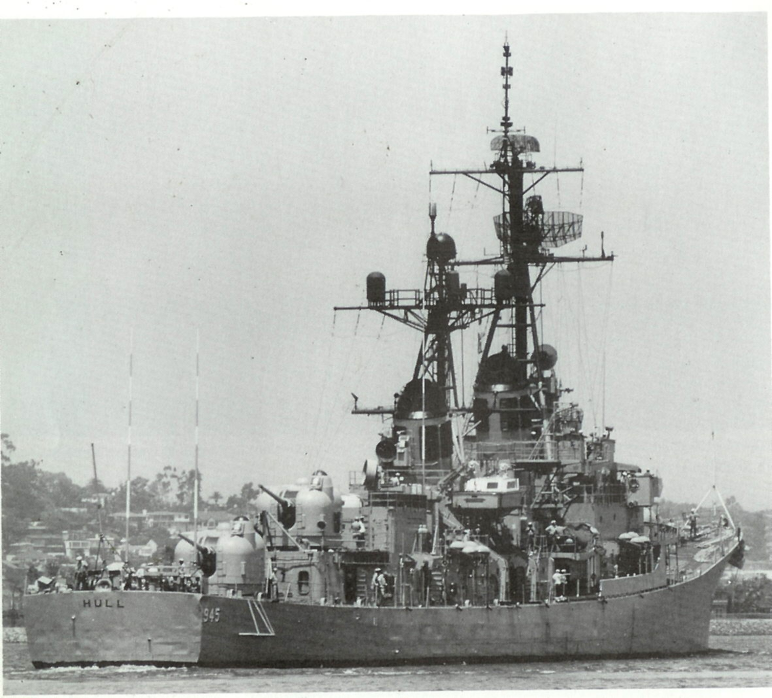
before us, we departed to get home and out of the rain as soon as possible.
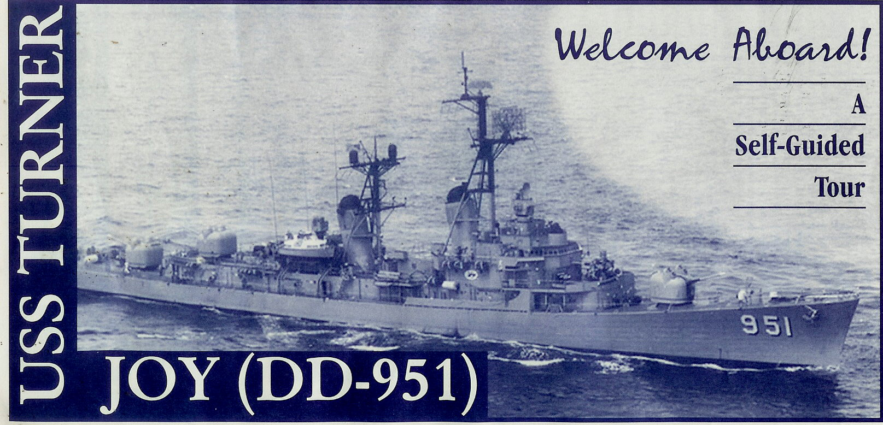
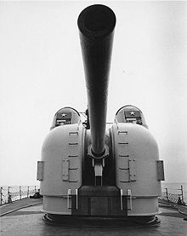
U.S.S. Adm. Charles Turner Joy – Bremerton, WA
One Saturday afternoon Secy. Charles was walking along the waterfront, saw the destroyer moored by the Manette Bridge, paid $12 and went aboard. The tour is self guided. You get a brochure at the gift shop showing the points of interest and go at your own pace. The lights are on and about 80% of the ship is open but you have to be prepared to go up and down narrow ladders to access the crews quarters and the engine room. Officers Country is easier to get to and you can see the Captain’s uniform and sword laid out on his bunk. A video exhibit recounts the ship’s bom-A stern view of the Hull showing that the Forrest Shermans were the first American warships to have more firepower aft than forward. The 5 inch, 54 caliber rapid fire guns could shoot 20 seventy pound shells over 5 miles every minute.

bardment of North Vietnamese shore batteries in 1967. Two destroyers were darting in and out at 30 knots. Numerous times shell geysers erupted where they had been seconds before, so if they hadn’t been going so fast they would have been casualties. Being from the Vietnam era, the ship has an MIA exhibit, showing an American bound in a tiny North Viet tiger cage with a bunk and netting, a pot for a toilet and not much else. Pushing a button to activate another display gives an audio recap of World War 2 in the Pacific starting with Pearl Harbor. The ship is still owned by the U.S. Navy and is on loan to Bremerton Historic Ships Assn. for as long as they can maintain it in decent condition. The antique Olympia CA6 almost sank at its moorings.
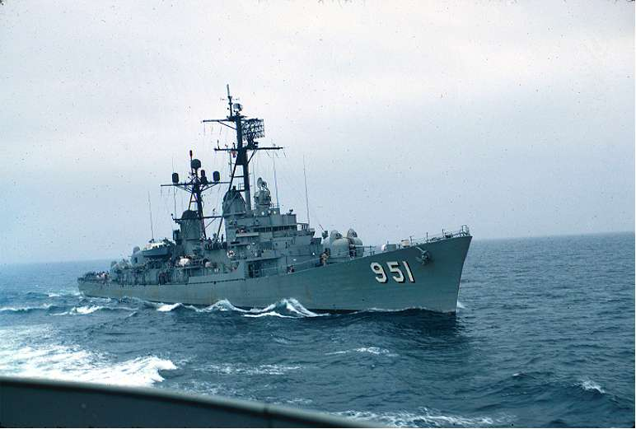
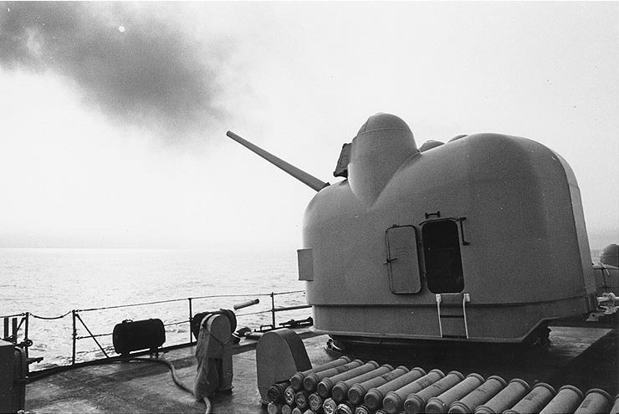
Turner Joy on deployment off Viet Nam

The 18 Forrest Shermans, built between 1953 and 1958, were the first new class of American destroyer built after WW2. No new destroyers were needed as an amply supply were left over from the war. The last of the class was the C. Turner Joy, built 1957-58 by the former Puget Sound Bridge & Dredging Co. of Seattle, WA.
Turner Joy was based out of San Diego in 1960 and made several Pacific tours. The ship’s place in the history books came from her participation in the Gulf of Tonkin Incident in 1964. On the night of 4 Aug., destroyers Maddox (DD-731) and Turner Joy came under attack from North Viet patrol craft while cruising about 28 miles off the North Vietnamese coast. Retaliatory carrier air strikes bombed North Vietnamese bases and oil tanks. Congress passed the Gulf of Tonkin Resolution which was to widen Amer-ican participation in the Vietnam war. A fatal accident happened aboard the ship in Oct. 1964. After firing 700 five inch rounds off Chu Lai, a shell got caught in the barrel of the aft 5 inch gun. While gunners were trying to get the shell unstuck, it exploded killing 3 men and injuring 3 others. Today a marker on the deck just outside Turret 53 lists the names of casualties. Turner Joy received 9 Battle Stars for her gunfire support during the war.
Because of her long tours of duty during the Vietnam War, the ship missed her regularly scheduled maintenance. The ship was unable to leave port and much of 1976 was spent trying to fix engine problems. The following 2 years saw the ship in port for recurring problems and overhauls. In 1982 the Navy retired the Forrest Shermans because their average age was 24 and it would cost too much to bring them up to date. The custodian on board the ship noted that the Forrest Sherman, after being laid up in the Philadel-phia reserve fleet for 30 years, has deteriorated to the point where it could only be scrapped.
Boom

Forrest Sherman Class (Eighteen ships): Forrest Sherman (931), John Paul Jones (932), Barry (933), Decatur (936), Davis (937), Jonas Ingram (938), Manley (940), Dupont (941), Bigelow (942), Blandy (943), Mullinnix (944), Hull (945), Edson (946), Somers (947), Morton (948), Parsons (949), Richard S. Edwards (950), C. Turner Joy (951).

The Navy figured that the service life of a destroyer was 20-some years. Therefore the World War 2 era destroyers would be ready for retirement by the 1960’s. To take this many ships out of service at one time would be unacceptable. Between 1959 and 1965 Congress authorized the Fleet Rehabilitation and Modernization (FRAM) program. FRAM I would extend the hull life of a modern destroyer by 8-10 years. FRAM II was to extend the life of older destroyers by 5 years. The program succeeded by extending the life of many destroyers when replace-ment was impossible. It failed by foisting new tech-nology Drone Anti-Sub Helicopters (DASH) on the fleet. Of the 746 DASHs delivered 70% crashed. It was left to foreign navies to develop the Light Multi Purpose Helicopter. Replacement came in the form of the Spruance class (DD-963 to DD-997) launched between 1973 and 1982 and Aegis guided missile Arleigh Burke class (DDG-51 & on) launched beginning in 1988.

