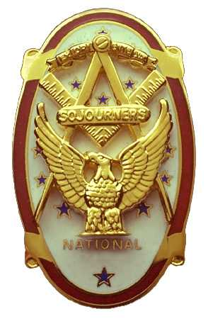
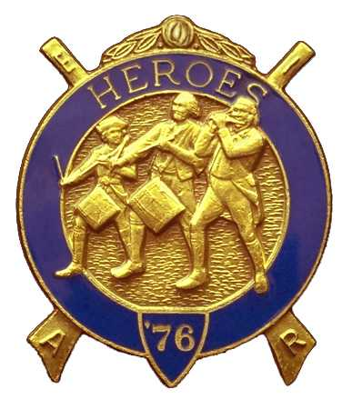
Olympic Chapter No.539
National Sojourners
And Marvin Glenn Shields Camp
Heroes of '76
Edwin C. Marion P.0. Box 364
Secretary/Treasurer Forks. WA 98331-0364 edwin028@centurytel.net http://www:telebyte.com/masons/sojourn/ ( 360) 374-6777
25 July 2012
Wednesday
Was worried when we got to the lake, The DOT was painting the strips around the lake, and there was no way we could get around them. Lots of lost time. Normally it takes about 18 to 20 minutes to get around the lake, but this time it was 30 to 45 minutes. But we made it before 1800 Hours.

Following dinner, WB Paul J. Carmean Gave the “Toast to the Flag.” Great job Paul, you get better each time. Following the Toast, our President WB Ron Chase, opened the Chapter According to the Orders of Ceremonies, page 3. Then he introduced our guest speaker for the evening. Kylie Finily, VWB Darel Maxfield's granddaughter, whom we donated money for her trip expenses for a school trip to Florida. As you can see, guest speakers come in all sizes and ages. Look around you, if you see someone who has a subject that we would like to hear about, get that person committed to speaking to us. Remember we will buy them and their companion dinner. Can't afford to pay them more than that.
Subject came up about uniforms and such. I will try to explain that for your information. When you order your uniform, you will pay a required $150.00 down payment. This will come from your pocket. When you receive your uniform, there will be a final bill with the uniform. Just give the bill to the secretary, and he will pay the rest of the charge, which will be around $250.00. You will be expected to try to pay back the $250.00, but at your time line. Maybe you will only give back $5 per time, but at least you will be trying.
This will also apply to your pay back for your MIP. At this time it is $250.00 ,but once we pay it, we hope that you can pay us at least the amount of the dues, which is $30 per year. This can be done by giving us $5 every once in a while. This will keep our funds up to where we can pay for brothers to come, while making it easy on you so that you don't have to give out a lot of money.
May I suggest that you get yourself some sort of container, place it on your dresser, and each day toss a penny, or more, in the container? National Sojourners will levy $3.65 for charity each year for each member. By doing this, you will have your $3.65 for your charity. Or, if you desire you can pay $36.50 one time and that gives you a life membership.
Hope this clears up some things for you. If you have questions on this, give the secretary a call.
The raffle was held with $40 going into our treasury.
There being nothing else to come before the meeting, the meeting was closed by our President Ron Chase, according to the Orders of Ceremonies, page 8.
______________________________________________________________________________

HOW GOES THE WAR
Nothing to report at this time. Nothing until November.
______________________________________________________________________________
NEWS OF OUR MEMBERSHIP.

Once again, nothing new on Gunny Riggs. He is still in Oak Harbor. If you know something, let me know so I can pass it on to everyone.

As far as I know our Secretary is now doing very well. He is able to get out and about. Attended National Sojourners meeting last night with no bad results.

If you know of a brother or sister that is ill, let me know so that I can inform all our brothers. . ______________________________________________________________________________

HERE IS THE LIST OF YOUR OFFICERS FOR 2012-2013

OLYMPIC CHAPTER MARVIN G. SHIELDS CAMP
President—---------------------Ronald Chase Commander----------------------Joe G Anticevich 360-379-4074 ron_chase2000@yahoo.com 360-453-4843 angeleslock@gmail.com
1st Vice President------Donald C. Williams Chief of Staff--------------------Ronald R. Chase
360-582-0628 williamsdc@wavecable.com 360-379-4074 ron_chase2000@yahoo.com

²nd Vice President---- -Robert Caruthers A/C Staff----------------------Donald C. Williams
360-461-8164 bobcaruthers@hotmail.com 360-582-0628 williamsdc@wavecable.com

3rd Vice Ptrsident--------Kirk A. (Al) Rose
360-809-3632 theroses@wavecablr.com

Chaplain--------------------Paul J. Carmean Chaplain--------------------------Paul J. Carmean
360-928-3358 pjcarmean@q.com 360-928-3358 pjcarmean@q.com

Secretary----------- Edwin C. “Ed” Marion Adjutant---------------- Edwin C. “Ed” Marion 360-374-6777 Edwin028@centurytel.net 360-374-6777 Edwin028@centurytel.net

Assistant Secretary--Dare E. Maxfield Sr Assistant Adjutant--------Darel E. Maxfield Sr. 360-374-9330 maynard@olynet.com 360-374-9330 maynard@olynet.com

Area Representative and Regional Representative
SMSGT Robert S. Colton
206-439-2320 rshgcolton1@netzero.net
Deputy Area Representative and Regional Representative
Lt Col Wendell A. Dutt
253-565-5264 wadutt@comcast.net

_______________________________________________________________________
NEXT MEETING
22 August 2012
Paradise Restaurant
Sequim, WA

Our meeting this month will be held on 22 August 2012.. Our meeting will start at 1900 Hours (7 PM) following dinner at 1800 hours (6 PM) for those that wish dinner, . We are still looking for speakers. If you or someone you know would have a subject they would like to speak on, just let me know.. .

DIRECTIONS TO THE MEETING PLACE. No matter from which direction you come, as you must come by Highway 101, east or west, when you see the road sign for Sequim Avenue, you take that exit. If you come from the east, turn right onto Sequim Avenue, if you come from the west, turn left onto Sequim Avenue. This will place you heading north along Sequim Avenue. You will stay on Sequim Avenue until you reach the restaurant, which will be approximately one mile. There will be one traffic light , which is at Main Street, this means you are about half way there.

Approximately ¾ miles along the way, you will come to Sequim High School on your left. It is a large brick building. There will be a chain-link fence around the practice field part of the High School. At the end of the fenced off area is a cross street, which forms a three way intersection, or a “T” bone intersection. The Paradise Restaurant is on the north west corner of the intersection. The parking lot is in the front, so just pull into the parking lot. Come into the restaurant, walk straight back to the private dinning room. This is where we have our meetings.

Now remember, YOU DON'T HAVE TO COME FOR THE DINNER, YOU DON'T EVEN HAVE TO BUY COFFEE. If you need a ride to and from the meeting, give me a call and I will arrange for someone to pick you up and take you home. Call me at 360-374-6777.

Our next meeting will be on 22 August 2012 at the Paradise Restaurant.

HAPPY BIRTHDAY
John Richardson (16)
Paul J. Carmean (21)
Ron Chase (24)
Robert Clubb (29)
We wish everyone of these brothers and sisters a very HAPPY BIRTHDAY and may you have many more of .them.
______________________________________________________________________________
BLUE LODGE

Meetings: Quilcene-Jefferson #107 will meet 6 August and 10 September 2012, dinner 6:30, lodge 7:30; Mt. Olympus #298 1 August and 5 September 2012, dinner 6:30 Lodge 7:30; Pt. Angeles #69 7 August and 11 September 2012, no dinner, lodge 7:30 ; Sequim #213, 9 August and 13 September2012, dinner 6:15 lodge 7:30.. Pt Townsend #6, 15 August and 12 September (Fill the Lodge Night) 2012, 6:30 Dinner, Lodge 7:30. Remember brothers attend your Blue Lodge at least once a year just so they can see you are still among the living.
______________________________________________________________________________

UNIFORMS

Here is the means by which you can get a heroes uniform if you don't have one, but you do want one. First of all, we have a couple of uniforms of past members. If one fits you, then you have it made. There is no charge for these uniforms. Now if you want a new one, you can order it, pay the $150.00 (They have raised the down payment to $150.00 from $125.00) down payment that is required when you order, (this will show us you are in the hunt and need help). then when your uniform arrives, turn the bill to the secretary for the remaining cost. The secretary will pay for the rest of the cost of the uniform. Talk with the adjutant about this. You may be in uniform before you know it.

Just notified by National that the Heroes Hat is now costing $25.00.

WISH LIST

- An enclosed trailer to haul all our equipment needed for our “Build the Flag” program. My truck has short bed which will not hold everything needed for our Hero Programs.
- An awards chairman as suggested by David MacNeill. David can't take the job as he has moved out of area, and is traveling most of time.
- We need more members in uniform. We have a working solution.
- Guest speakers are needed very badly. Subject is of their own choosing, but they must work for dinner only, can't afford to pay them more than that.
- More brothers and their ladies at our meetings
- A phone committee. Open not only to brothers, but to their ladies also.
- Sure could use someone to take over the responsibility for some of this equipment I have. Sometimes it gets more than an 84 year old can handle.
- Someone to take over the “Traveling Bar”.

