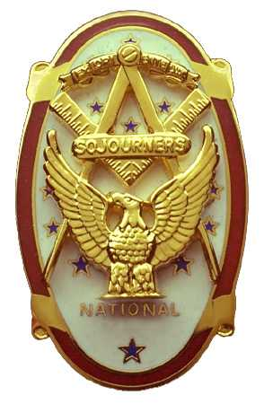
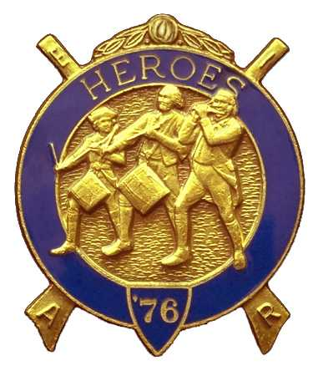
Olympic Chapter No.539
National Sojourners
And Marvin Glenn Shields Camp
Heroes of '76
Edwin C. Marion P.0. Box 364
Secretary/Treasurer Forks. WA 98331-0364 edwin028@centurytel.net http://www:telebyte.com/masons/sojourn/ ( 360) 374-6777
27 June 2012
Wednesday

Well we did it again. Seems there were not enough brothers present to open a meeting. There were only two brothers present. Our guest speaker for the evening was Cadet Seth Bell, the ROTC recipient. His parents came with him. The Chapter bought their dinner. So this was not a very profitable evening for us. Maybe better next time.

We are still looking for guest speakers. Look around, there may be a speaker standing next to you.
______________________________________________________________________________
This may be an odd news, but I have been thinking about it for a while. We, in Heroes, dress and conduct our selves as if we were fighting the Revolutionary War. So, why not give an account of the War? Here goes. I will start with the problems that lead to the start of the war.

1754-1763 French and Indian War 1754 June 19-July 11 The Albany Congress
1763 Oct 7 Proclamation of 1763 1764 April l5 The Sugar Act
September 1 The Currency Act
1765 March 22 The Stamp Act March 24 The Quartering Act of 1765 May 29 Patrick Henry's
“If this be treason, make the most of it.” speech. May 30 The Virginia Stamp Act
Resolution October 7-25 The Stamp Act Congress
1766 March 18 The Declaratory Act 1767 June 29 The Townshend Revenue Act
1768 August 1 Boston Non-Importation Agreement 1770 March 8 The Boston Massacre
1772 June 9 The Gaspee Affair 1773 May 10 The Tea Act December 16 Boston Tea Party
1774 March 31 Boston Port Act one of the Intolerable Acts May 20 Administration of Justice Act one of the Intolerable Acts May 20 Massachusetts Government Act one of the Intolerable Acts. June 2 Quartering Act of 1774 one of the Intolerable Acts June 22 Quebec Act of 1774
Sept 8-Oct 26 The First Continental Congress Meets in Philadelphia and issues Declaration and Resolves. October 10 Battle of Point Pleasant, Virginia (disputed as to whether it was a battle of the American Revolution or the culmination of Lord Dunmore's War.) October 20 Association (prohibition of trade with Great Britain) October 24 Galloway's Plan rejected.
1775 March 23 Patrick Henry's “Give me Liberty or Give me Death” speech. April 18 The rides of Paul Revere and William Dawes April 19 Minutemen and Red Coats Clash at Lexington and Concord “The shot heard around the World.” May 10 Ethan Allen and the Green Mountain Boys seize Fort Ticonderoga. May 10 The Second Continental Congress meets in Philadelphia. June 18 George Washington named Commander in Chief. June 17 Battle of Bunker Hill The British drive the Americans from Breed's Hill. July 3 Washington assumes command of the Continental Army

I will stop at this point as we are caught up to date. I will add the rest of it on the dates it happened.

NEWS OF OUR MEMBERSHIP.

Nothing new to report on Gunny Riggs. He is still in Oak Harbor.

Our secretary has been down for the count with 8 broken ribs in his back on the right side. Seems he fell at home while trying to feed the humming birds. This was on Thursday, and on Saturday he went to the hospital, and was admitted for pneumonia After 8 day stay in the hospital he is at recovering at home. At age 84, his ribs don't heal as quickly as when he was 25 years old.

If you know of a brother or sister that is ill, let me know so that I can inform all our brothers. . ______________________________________________________________________________

HERE IS THE LIST OF YOUR OFFICERS FOR 2012-2013

OLYMPIC CHAPTER MARVIN G. SHIELDS CAMP
President—---------------------Ronald Chase Commander----------------------Joe G Anticevich 360-379-4074 ron_chase2000@yahoo.com 360-453-4843 angeleslock@gmail.com
1st Vice President------Donald C. Williams Chief of Staff--------------------Ronald R. Chase
360-582-0628 williamsdc@wavecable.com 360-379-4074 ron_chase2000@yahoo.com

^{2nd} Vice President---- -Robert Caruthers A/C Staff----------------------Donald C. Williams
360-461-8164 bobcaruthers@hotmail.com 360-582-0628 williamsdc@wavecable.com

3rd Vice Ptrsident--------Kirk A. (Al) Rose
360-809-3632 theroses@wavecablr.com

Chaplain--------------------Paul J. Carmean Chaplain--------------------------Paul J. Carmean
360-928-3358 pjcarmean@q.com 360-928-3358 pjcarmean@q.com

Secretary----------- Edwin C. “Ed” Marion Adjutant---------------- Edwin C. “Ed” Marion 360-374-6777 Edwin028@centurytel.net 360-374-6777 Edwin028@centurytel.net

Assistant Secretary--Dare E. Maxfield Sr Assistant Adjutant--------Darel E. Maxfield Sr. 360-374-9330 maynard@olynet.com 360-374-9330 maynard@olynet.com

Area Representative and Regional Representative
SMSGT Robert S. Colton
206-439-2320 rshgcolton1@netzero.net
Deputy Area Representative and Regional Representative
Lt Col Wendell A. Dutt
253-565-5264 wadutt@comcast.net

_______________________________________________________________________
NEXT MEETING
22 July2012
Paradise Restaurant
Sequim, WA

Our meeting this month will be held on June 20 2012.. Our meeting will start at 1900 Hours (7 PM) following dinner at 1800 hours (6 PM) for those that wish dinner, . We are still looking for speakers. If you or someone you know would have a subject they would like to speak on, just let me know.. .

DIRECTIONS TO THE MEETING PLACE. No matter from which direction you come, as you must come by Highway 101, east or west, when you see the road sign for Sequim Avenue, you take that exit. If you come from the east, turn right onto Sequim Avenue, if you come from the west, turn left onto Sequim Avenue. This will place you heading north along Sequim Avenue. You will stay on Sequim Avenue until you reach the restaurant, which will be approximately one mile. There will be one traffic light , which is at Main Street, this means you are about half way there.

Approximately ¾ miles along the way, you will come to Sequim High School on your left. It is a large brick building. There will be a chain-link fence around the practice field part of the High School. At the end of the fenced off area is a cross street, which forms a three way intersection, or a “T” bone intersection. The Paradise Restaurant is on the north west corner of the intersection. The parking lot is in the front, so just pull into the parking lot. Come into the restaurant, walk straight back to the private dinning room. This is where we have our meetings.

Now remember, YOU DON'T HAVE TO COME FOR THE DINNER, YOU DON'T EVEN HAVE TO BUY COFFEE. If you need a ride to and from the meeting, give me a call and I will arrange for someone to pick you up and take you home. Call me at 360-374-6777.

Our next meeting will be on 25 July 2012 at the Paradise Restaurant.

HAPPY BIRTHDAY

None listed

We wish everyone of these brothers and sisters a very HAPPY BIRTHDAY and may you have many more of .them.
______________________________________________________________________________
BLUE LODGE

Meetings: Quilcene-Jefferson #107 will meet 2 July and (Fill the Lodge Night) 6 August 2012, dinner 6:30, lodge 7:30; Mt. Olympus #298 4 July and 1 August 2012, dinner 6:30 Lodge 7:30; Pt. Angeles #69 10 July and 7 August 2012, no dinner, lodge 7:30 ; Sequim #213 (Fill the Lodge Night) 12 July and 9 August 2012, dinner 6:15 lodge 7:30.. Pt Townsend #6 18 July and 15 August 2012, 6:30 Dinner, Lodge 7:30. Remember brothers attend your Blue Lodge at least once a year just so they can see you are still among the living.
________________________________________________________________________
UNIFORMS

Here is the means by which you can get a heroes uniform if you don't have one, but you do want one. First of all, we have a couple of uniforms of past members. If one fits you, then you have it made. There is no charge for these uniforms. Now if you want a new one, you can order it, pay the $150.00 (They have raised the down payment to $150.00 from $125.00) down payment that is required when you order, (this will show us you are in the hunt and need help). then when your uniform arrives, turn the bill to the secretary for the remaining cost. The secretary will pay for the rest of the cost of the uniform. Talk with the adjutant about this. You may be in uniform before you know it.

Just notified by National that the Heroes Hat is now costing $25.00.

WISH LIST

- An enclosed trailer to haul all our equipment needed for our “Build the Flag” program. My truck has short bed which will not hold everything needed for our Hero Programs.
- An awards chairman as suggested by David MacNeill. David can't take the job as he has moved out of area, and is traveling most of time.
- We need more members in uniform. We have a working solution.
- Guest speakers are needed very badly. Subject is of their own choosing, but they must work for dinner only, can't afford to pay them more than that.
- More brothers and their ladies at our meetings
- A phone committee. Open not only to brothers, but to their ladies also.
- Sure could use someone to take over the responsibility for some of this equipment I have. Sometimes it gets more than an 84 year old can handle.
- Someone to take over the “Traveling Bar”.

