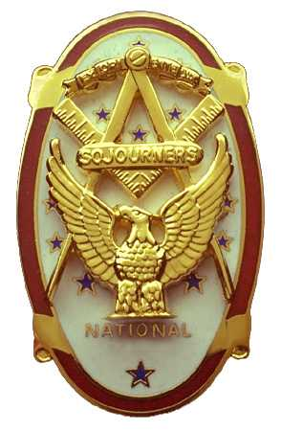
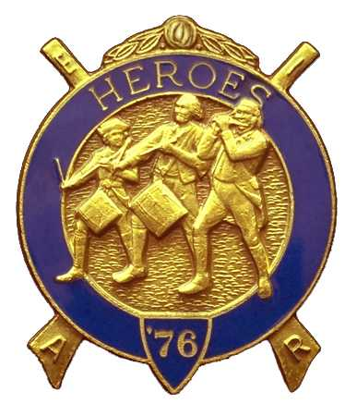
Olympic Chapter No.539
National Sojourners
And Marvin Glenn Shields Camp
Heroes of '76
Edwin C. Marion P.0. Box 364
Secretary/Treasurer Forks. WA 98331-0364 edwin028@centurytel.net http://www:telebyte.com/masons/sojourn/ (360) 374-6777
22 February 2012
Wednesday

Due to there not bring a quorum present, there was no official meeting. We just set around and talked. Nothing earth shaking, but it turned into nice evening anyway.
Here is a new idea that we will be trying for guest speakers. Each of us pick a month, then you can speak on a subject of your own choosing, or you can get a guest speaker to doing the speaking. If you bring in a guess speaker, the Chapter will pickup the speakers, and wifes, meal ticket. This is the best we can do at this time.
Our speaker at this March meeting will be speaking on the Declaration of Independence. Should be an interesting subject as it will cover little known facts about the Declaration of Independence

Our next meeting held on April 25th will be our anniversary meeting. This will be a catered dinner meeting. Price for dinner will be $25.00 per person, and will be Prime Rib, Prawns, Chicken or Fish with all the trimmings. Our guest speaker that night will be MWB Wayne Smith. Call me at 360-374-6777 to let me know if you are coming and how many dinners you want. Need to let the restaurant know how many to prepare for.
Cutoff day will be April 23. _______________________________________________________________________

NEWS OF OUR MEMBERSHIP

_______________________________________________________________________

HERE IS THE LIST OF YOUR OFFICERS FOR 2011-2012

OLYMPIC CHAPTER MARVIN G. SHIELDS CAMP

President------ Mr. Joe G. Anticevich Commander------------GySgt. C. Earl Riggs
360-452-4841 angeleslock@gmail.com 360-380-4944 jarhead1949@netzero.com

1st Vice Pre sident---------------GySgt C. Earl Riggs Chief of Staff------------Mr Joe G. Anticevich
360-380-4944 jarhead1949@netzero.com 360-452-4841 angeleslock@gmail.com

2nd Vice President--------- -----Ronald Chase A/C of Staff-------------------Ronald Chase
360-379-4074 ron_chase2000@yahoo.com 360-379-4074 ron_chase2000@yahoo.com

3rd Vice President—----Donald C. Williams
360-582-0628 williamsdc@wavecable.com

Chaplain----------SGT Fredrick W. Johnson Chaplain---------SGT Fredrick W.Johnson
360-385-3130 fjohnson-30@q.com 360-385-3130 fjohnson-30@q.com

Secretary-----LtCol Edwin C. “Ed” Marion Adjutant-----LtCol Edwin C. “Ed” Marion
360-374-6777 Edwin028@centurytel.net 360-374-6777 Edwin028@centurytel.net

Assistant Secretary-Darel E. Maxfield Sr Assistant Adjutant---Darel E. Maxfield Sr.
360-374-9330-------maynard@olynet.com 360-374-9330-------maynard@olynet.com

Area Representative and Regional Representative
SMSGT Robert S. Colton
206-439-2320 rshgcolton1@netzero.net
Deputy Area Representative and Regional Representative
LtCol Wendell A. Dutt
253-565-5264 wadutt@comcast.net

_______________________________________________________________________
NEXT MEETING
28 March 2012
Paradise Restaurant
Sequim, WA

Our meeting this month will be held on 28 March 2012.. Our meeting will start at 1900 Hours (7 PM) following dinner at 1800 hours (6 PM) for those that wish dinner, You order from the menu. There will be a guest speaker, speaking on the Declaration of Independence. We are still looking for speakers. If you or someone you know would have a subject they would like to on, just let me know.. .

DIRECTIONS TO THE MEETING PLACE. No matter from which direction you come, as you must come by Highway 101, east or west, when you see the road sign for Sequim Avenue, you take that exit. If you come from the east, turn right onto Sequim Avenue, if you come from the west, turn left onto Sequim Avenue. This will place you heading north along Sequim Avenue. You will stay on Sequim Avenue until you reach the restaurant, which will be approximately one mile. There will be one traffic light , which is at Main Street, this means you are about half way there.

Approximately ¾ miles along the way, you will come to Sequim High School on your left. It is a large brick building. There will be a chain-link fence around the practice field part of the High School. At the end of the fenced off area is a cross street, which forms a three way intersection, or a “T” bone intersection. The Paradise Restaurant is on the north west corner of the intersection. The parking lot is in the front, so just pull into the parking lot. Come into the restaurant, walk straight back to the private dinning room. This is where we have our meetings.

Now remember, YOU DON'T HAVE TO COME FOR THE DINNER, YOU DON'T EVEN HAVE TO BUY COFFEE. If you need a ride to and from the meeting, give me a call and I will arrange for someone to pick you up and take you home. Call me at 360-374-6777.

Our April meeting, which is our 9th Anniversary Night. will be on 25 April 2012 at the Paradise Restaurant.

HAPPY BIRTHDAY

We have no birthdays listed for March.

_______________________________________________________________________
BLUE LODGE

Meetings: Quilcene-Jefferson #107 will meet5 March 2013 and 2 April 2012, . dinner 6:30, lodge 7:30; Mt. Olympus #298 7 March 2012 (Fill the Lodge Night) and 4 April 2012 dinner 6:30 Lodge 7:30; Pt. Angeles #69 13 March 2012 and 10 April 2012, no dinner, lodge 7:30; Sequim #213 8 March 2012 and 12 April 2012, dinner 6:15 lodge 7:30.. Pt Townsend #6 14 March 2012 and 11 April 2013, 6:30 Dinner, Lodge 7:30. Remember brothers. attend your Blue Lodge at least once a year just so they can see you are still among the living.
________________________________________________________________________
UNIFORMS

Here is the means by which you can get a heroes uniform if you don't have one, but you do want one. First of all, we have a couple of uniforms of past members. If one fits you, then you have it made. There is no charge for these uniforms. Now if you want a new one, you can order it, pay the $150.00 (They have raised the down payment to $150.00 from $125.00) down payment that is required when you order, (this will show you are in the hunt and need help). then when your uniform arrives, turn the bill for the remaining cost, over to the secretary who will pay for the rest of the cost of the uniform. Talk with the adjutant about this. You may be in uniform before you know it.

WISH LIST

- An enclosed trailer to haul all our equipment needed for our “Build the Flag” program. My truck has short bed which will not hold everything needed for our Hero Programs.
- An awards chairman as suggested by David MacNeill. David can't take the job as he has moved out of area, and is travel most of time.
- We need more members in uniform. We are working on a solution.
- Guest speakers are needed very badly. Subject is of their choosing, but they must work for dinner only, can't afford pay them more than that.
- More brothers and their ladies at our meetings
- A phone committee. Open not only to brothers, but to their ladies also.
- Sure could use someone to take over the responsibility for some of this equipment I have. Sometimes it gets more than an 83 year old can handle.
- Someone to take over the “Traveling Bar

