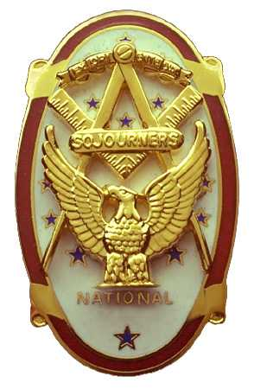
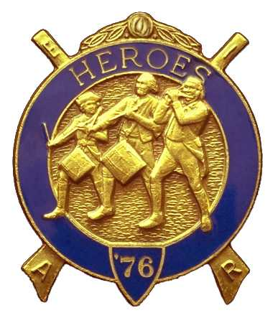
Olympic Chapter No.539
National Sojourners
And
Marvin Shields Camp of Heroes of ‘76
Edwin C. Marion P.O..Box 364
Secretary?Treasurer Forks, WA 98331-0364
edwin028@centurytel.net http://www:telebyte.com/masons/sojourn/ (360) 374-6777
================================================================================25 January 2012
Wednesday

Grip – N – Grin started at about 5:30 tonight. Seems Darel and I got there on time, and didn't have any thing to do, no shopping at Costco or anywhere else. We will stop at Costco Gas after the meeting and fill the tank before we head back to Forks. Gas at Costco is 20 cents a gallon cheaper than in Forks, and I haven't been able to wean my truck off of the pump. Lucky if I get 15 miles to the gallon.

First of all our meeting was held in the small dinning room, just off the main dinning area. Seems that the restaurant had a very large group that needed the use of the back dinning room. So, we said it was OK to move us into the small room. This was an experience. The small dinning room is open to viewing by the people in the main dinning room. In other words they could see everything we were doing. So, when WB Paul Carmean did the “Toast to the Flag”, all eyes in the main dinning room were on him. Then when he asked us to stand and join him in the Pledge, I looked out into the main dinning room and saw that there was about 10 or so men standing at attention, saluting, and repeating the Pledge along with us. This was great.

Beings that WB Joe Anticevich was not present, 1st Vice President WB Ron Chase took over the meeting and opened the chapter according to page 3 of the “Orders of Ceremonies.” For your first time, WB Ron, you did a bang-up job. Thanks for being here and ready to go.

Again we didn't have a guest speaker for our meeting. I have an idea how to solve this problem which I will put before the Chapter at our next meeting. We need guest speakers so if you have any thoughts on this, bring them to the meeting and let us know about them. This is a problem that we all should be involved in solving, not just one person.

It was suggested that we hold the next Heroes meeting at my Pool House here in Forks. This would be OK with me. There is a complete kitchen, bar and such. Due to the cost of fuel to heat the pool, I did away with the pool. I drained out the water, filled in the pool, and had it concreted over. This gave me a room that is 60 feet long by 32 feet wide. With the help of my son we now have it furnished, complete with shower, kitchen and all. Lots a rec toys to play with, and sleeping areas. Anyone out there interested in purchasing a used oil fired boiler and filter system for a swimming pool?!?

We topped off the evening with the drawing for the raffle bags. This put $50.00 from raffle ticket sales in our treasure, plus the $1.00 fine (For failure to wear name tag.), and $19.00 from sales of supplies, (Patches and such). All this helps keep us from having to pay dues to keep us going. Once again, Thanks a lot Sue Porter.

WB Ron Chase closed the meeting according to the Orders of Ceremonies, page 8. Thank you Ron.
_________________________________________________________________________________________

NEWS OF OUR MEMBERS.

Gunny is still on the mend. It will be a while before he is back on his feet again. Hang in there Gunny, you will be back and helping to run this organization again soon.

VWB Darel Maxfield has been taking care of his mother for over the past four years. His mother passed away the first of the month. VW Darel, I wish to express here, that you know that our hearts go out to you in your hour of need. God bless you for giving up so much of your life to take care of you mother like you have done. Not many of us could do what you have done.

Brothers, if you have any news about our membership, your self included, that we should pass on to the rest of the membership, give me a call or send me an e-mail. This would help me very much as I don't get around very much any more following my stroke. I use to attend a lot of lodge meetings, there-by picking up information about our different members, but not any more. As the song goes, “Don't Get Around More”.
_________________________________________________________________________________________

LIST OF OFFICERS FOR 2011-2012

OLYMPIC CHAPTER MARVIN G. SHIELDS CAMP

President------ ---------------Mr. Joe G. Anticevich Commander-------------------GySgt. C. Earl Riggs
360-452-4841 angeleslock@gmail.com 360-380-4944 jarhead1949@netzero.com

1st Vice President---------------GySgt C. Earl Riggs Chief of Staff--------------Mr Joe G. Anticevich
360-380-4944 jarhead1949@netzero.com 360-452-4841 angeleslock@gmail.com

2nd Vice President--------- -----Ronald Chase A/C of Staff--------------------Ronald Chase
360-379-4074 ron_chase2000@yahoo.com 360-379-4074 ron_chase2000@yahoo.com

3rd Vice President—----Donald C. Williams
360-582-0628 williamsdc@wavecable.com

Chaplain----------SGT Fredrick W. Johnson Chaplain---------SGT Fredrick W.Johnson
360-385-3130 fjohnson-30@q.com 360-385-3130 fjohnson-30@q.com

Secretary-----LtCol Edwin C. “Ed” Marion Adjutant-----LtCol Edwin C. “Ed” Marion
360-374-6777 Edwin028@centurytel.net 360-374-6777 Edwin028@centurytel.net

Assistant Secretary-Darel E. Maxfield Sr Assistant Adjutant---Darel E. Maxfield Sr.
360-374-9330-------maynard@olynet.com 360-374-9330-------maynard@olynet.com

Area Representative and Regional Representative
SMSGT Robert S. Colton
206-439-2320 rshgcolton1@netzero.net
Deputy Area Representative and Regional Representative
LtCol Wendell A. Dutt
253-565-5264 wadutt@comcast.net

NEXT MEETING
22 February 2012
Paradise Restaurant
Sequim, WA

Our meeting this month will be held on 22 February 2012. Our meeting will start at 1900 Hours (7 PM) following dinner at 1800 hours (6 PM) for those that wish dinner, You order from the menu. We have no guest speaker at this time, still looking for speakers, . Now, if you or someone you know would have a subject they would like to talk to us about, just let me know.. . Subject doesn't have to be something earth shaking, or about Masonry.

DIRECTIONS TO THE MEETING PLACE. No matter from which direction you come, as you must come by Highway 101, east or west, when you see the road sign for Sequim Avenue, you take that exit. If you come from the east, turn right onto Sequim Avenue, if you come from the west, turn left onto Sequim Avenue. This will place you heading north along Sequim Avenue. You will stay on Sequim Avenue until you reach the restaurant, which will be approximately one mile. There will be one traffic light , which is at Main Street, this means you are about half way there.

Approximately ¾ miles along the way, you will come to Sequim High School on your left. It is a large brick building. There will be a chain-link fence around the practice field part of the High School. At the end of the fenced off area is a cross street, which forms a three way intersection, or a “T” bone intersection. The Paradise Restaurant is on the north west corner of the intersection. The parking lot is in the front, so just pull into the parking lot. Come into the restaurant, walk straight back to the private dinning room. This is where we have our meetings.

Now remember, YOU DON'T HAVE TO COME FOR THE DINNER, YOU DON'T EVEN HAVE TO BUY COFFEE. If you need a ride to and from the meeting, give me a call and I will arrange for someone to pick you up and take you home. Call me at 360-374-6777.

Our next meeting will be on 28 March 2012 at the Paradise Restaurant.

HAPPY BIRTHDAY

NONE LISTED

ust encase there is someone we are overlooking. Happy Birthday Brothers and Sisters. Hope your day was, or will be, a great one. MANY HAPPY RETURNS to you. Now if I have missed anyone, may your day be a memorable one. And ladies please send me the month and day of your birth so I can post it for you. Don't send the year of birth.

BLUE LODGE

Meetings: Quilcene-Jefferson #107 will meet 6 February 2012 and 5 March 2012, dinner 6:30, lodge 7:30; Mt. Olympus #298 1 February 2012 (Fill the lodge night) and 7 March 2012, dinner 6:30 Lodge 7:30; Pt. Angeles #69 14 February and 13 Maech 2012 , no dinner, lodge 7:30, ; Sequim #213 12 February and 8 March 2012,, dinner 6:15 lodge 7:30.. Pt Townsend #6 8 February 1012 and 14 March, this is “Fill the Lodge Night” 6:30 Dinner, Lodge 7:30. Remember brothers. attend your Blue Lodge at least once a year just so they can see you are still among the living.
_________________________________________________________________________________________
UNIFORMS

Here is the means by which you ca n get a heroes uniform if you don't have one, but you do want one. First of all, we have a couple of uniforms of past members. If one fits you, then you have it made. There is no charge for these uniforms. Now if you want a new one, you can order it, pay the $150.00 down payment that is required when you order, (this will show us you are in the hunt and need help). then when your uniform arrives, turn the bill for the remaining cost, over to the secretary who will pay for the rest of the cost of the uniform. Talk with the adjutant about this. You may be in uniform before you know it.

WISH LIST

- An enclosed trailer to haul all our equipment needed for our “Build the Flag” program. My truck has short bed which will not hold everything needed for our Hero Programs.
- An awards chairman as suggested by David MacNeill. David can't take the job as he has moved out of area, and is travel most of time.
- We need more members in uniform. We are working on a solution.
- Guest speakers are needed very badly. Subject is of their choosing, but they must work for dinner only, can't afford pay them more than that.
- More brothers and their ladies at our meetings
- A phone committee. Open not only to brothers, but to their ladies also.
- Sure could use someone to take over the responsibility for some of this equipment I have. Sometimes it gets more than an 84 year old can handle.
- Someone to take over the “Traveling Bar”.

