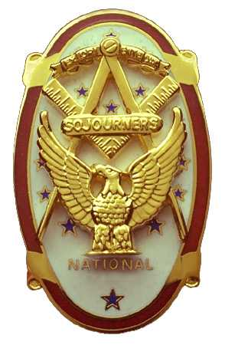
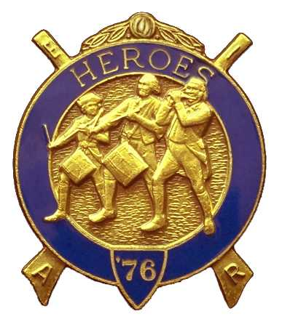
Olympic Chapter No.539
National Sojourners
And
Marvin Shields Camp of Heroes of ‘76
Edwin C. Marion P.O..Box 364
Secretary?Treasurer Forks, WA 98331-0364
edwin028@centurytel.net http://www:telebyte.com/masons/sojourn/ (360) 374-6777
================================================================================
14 December 2012
Wednesday

Grip-N-Grin part of our meeting started a bit early tonight. Seems Darel and myself had to make a stop at the Trophy Shop to pick up three new name tags for our three new members. So, we got to the restaurant a bit early. The Trophy Store closes at 5 PM, this made us early for Chapter meeting, and made us early for Grip-N-Grin. This way you get to see and talk with brothers and sisters that you like very much, but don't get to see very often.

After dinner, WB Paul Carmean did his thing with the “Toast to the Flag”. It is getting very hard to come up with the proper words to describe the OUTSTANDING job that Bro. Paul is doing with the Toast. You do a great job WB Paul, one of the best I have ever witnessed. THANKS A HECK OF A LOT.

Wasn't much new business for our meeting. Things seem to get quiet this time of the year following the holidays. There won't be a raffle this meeting as we will be holding our annual White Elephant Program. This is always fun for everyone.

Without cheating I once again drew ticket #1 again. I did it last year too. This means I will draw the first gift but must wait until the end to see if I want the gift I have or want one that someone else has. .Well I guess you know I got a type of candle my wife would like, but it didn't last too long. It was taken by one of the ladies, but in the end I got it back. Sorry about that Mrs. Chase. All I can say, that is part of the fun of a White Elephant Program.

Just wanted to remind everyone that had their MIP paid for by the Chapter. You can say that the money that bought your MIP was loaned to you by the Chapter. You will be expected to pay the money back to the Chapter at the same rate as you were paying the National Office for your Chapter dues, except you wont be sending the $30.00 per year to National, you will be sending sending it to the Chapter instead. This will pay the Chapter back in 6.7 years at $30.00 per year. After that you will pay nothing. Of course, you can pay more than $30.00 per year, paying back the money quicker. This is all on the honor system, you will never be billed for the money. If for some reason you can't pay the money back in the form of yearly dues, then that will be excepted by the Chapter and nothing will ever be said.

Once again I will explain about the $3.65 charity fund imposed by National. This is the organization's charity drive. One penny a day, or $3.65 per year. Each member is required by National to pay this, which is billed to the Chapter. Of course you can do what most of us have done, buy a life membership for $36.50. One time payment and you don't have to ever pay again.
================================================================================

NEWS OF OUR MEMBERS

We have had two weddings by our members. First one is Robert “Bob” Caruthers who married his long time girl friend Peggy Iotte. They are making their home in the Port Angeles area.

Fred Johnson married his lady friend Trish Pint in Port Townsend. They were married at their Church Service on a Sunday.

To the two new couples I would like use and old fashion saying. which is Congratulations to the men, and telling the ladies lots of luck.

As most of you know I have been having a lot of trouble with my legs, making it hard for me to walk. Well my doctor, Steve Kreible, sent me to a specialist . Dr. Kreible then promptly retired.. Well the specialist told me my problem was the way I walk. Now they are teaching me how to walk properly. Hope it works.

Talked to Sue Riggs, Gunny Riggs wife. He is still in the rehab center, but is improving each day. He can now talk, but his left side is giving him problems. He still has a way to go before they will let him come home. Good hunting Gunny, hurry and get better, we need you in Chapter.
==============================================================================

OLYMPIC CHAPTER MARVIN G. SHIELDS CAMP

President------ ---------------Mr. Joe G. Anticevich Commander-------------------GySgt. C. Earl Riggs
360-452-4841 angeleslock@gmail.com 360-380-4944 jarhead1949@netzero.com

1st Vice President---------------GySgt C. Earl Riggs Chief of Staff------------Mr Joe G. Anticevich
360-380-4944 jarhead1949@netzero.com 360-452-4841 angeleslock@gmail.com

2nd Vice President--------- -----Ronald Chase A/C of Staff-------------------Ronald Chase
360-379-4074 ron_chase2000@yahoo.com 360-379-4074 ron_chase2000@yahoo.com

3rd Vice President—----Donald C. Williams
360-582-0628 williamsdc@wavecable.com

Chaplain----------SGT Fredrick W. Johnson Chaplain---------SGT Fredrick W.Johnson
360-385-3130 fjohnson-30@q.com 360-385-3130 fjohnson-30@q.com

Secretary-----LtCol Edwin C. “Ed” Marion Adjutant-----LtCol Edwin C. “Ed” Marion
360-374-6777 Edwin028@centurytel.net 360-374-6777 Edwin028@centurytel.net

Assistant Secretary-Darel E. Maxfield Sr Assistant Adjutant---Darel E. Maxfield Sr.
360-374-9330-------maynard@olynet.com 360-374-9330-------maynard@olynet.com

Area Representative and Regional Representative
SMSGT Robert S. Colton
206-439-2320 rshgcolton1@netzero.net
Deputy Area Representative and Regional Representative
LtCol Wendell A. Dutt
253-565-5264 wadutt@comcast.net

NEXT MEETING
25 January 2012
Paradise Restaurant
Sequim, WA

Our meeting this month will be held on 25 January 2012. Our meeting will start at 1900 Hours (7 PM) following dinner at 1800 hours (6 PM) for those that wish dinner, You order from the menu. We have no guest speaker at this time, still looking for speakers, . Now, if you or someone you know would have a subject they would like to talk to us about, just let me know.. . Subject doesn't have to be something earth shaking.

DIRECTIONS TO THE MEETING PLACE. No matter from which direction you come, as you must come by Highway 101, east or west, when you see the road sign for Sequim Avenue, you take that exit. If you come from the east, turn right onto Sequim Avenue, if you come from the west, turn left onto Sequim Avenue. This will place you heading north along Sequim Avenue. You will stay on Sequim Avenue until you reach the restaurant, which will be approximately one mile. There will be one traffic light , which is at Main Street, this means you are about half way there.

Approximately ¾ miles along the way, you will come to Sequim High School on your left. It is a large brick building. There will be a chain-link fence around the practice field part of the High School. At the end of the fenced off area is a cross street, which forms a three way intersection, or a “T” bone intersection. The Paradise Restaurant is on the north west corner of the intersection. The parking lot is in the front, so just pull into the parking lot. Come into the restaurant, walk straight back to the private dinning room. This is where we have our meetings.

Now remember, YOU DON'T HAVE TO COME FOR THE DINNER, YOU DON'T EVEN HAVE TO BUY COFFEE. If you need a ride to and from the meeting, give me a call and I will arrange for someone to pick you up and take you home. Call me at 360-374-6777.

Our next meeting will be on 26 October 2011 at the Paradise Restaurant.

HAPPY BIRTHDAY

William Heckman 28
Happy Birthday Brothers and sister. Hope your day was, or will be, a great one. MANY HAPPY RETURNS to you. Now if I have missed anyone, may your day be a memorable one. And ladies please send me the month and day of your birth so I can post it for you. Don't send the year of birth.

BLUE LODGE

Meetings: Quilcene-Jefferson #107 will meet 2 January 2012 and 6 February 2012, dinner 6:30, lodge 7:30; Mt. Olympus #298 4 January 2012 and 1 February 2012, dinner 6:30 Lodge 7:30; Pt. Angeles #69 10 January 2012, this is “Fill the Lodge Night”, and 14 February, no dinner, lodge 7:30, ; Sequim #213 19 January 2012, and 12 February, dinner 6:15 lodge 7:30.. Pt Townsend #6 11 January 2012, and 8 February 1012, this is “F=ill the Lodge Night” 6:30 Dinner, Lodge 7:30. Remember brothers. attend your Blue Lodge at least once a year just so they can see you are still among the living.
================================================================================
UNIFORMS

Here is the means by which you ca n get a heroes uniform if you don't have one, but you do want one. First of all, we have a couple of uniforms of past members. If one fits you, then you have it made. There is no charge for these uniforms. Now if you want a new one, you can order it, pay the $150.00 down payment that is required when you order, (this will show you are in the hunt and need help). then when your uniform arrives, turn the bill for the remaining cost, over to the secretary who will pay for the rest of the cost of the uniform. Talk with the adjutant about this. You may be in uniform before you know it.

WISH LIST

- An enclosed trailer to haul all our equipment needed for our “Build the Flag” program. My truck has short bed which will not hold everything needed for our Hero Programs.
- An awards chairman as suggested by David MacNeill. David can't take the job as he has moved out of area, and is travel most of time.
- We need more members in uniform. We are working on a solution.
- Guest speakers are needed very badly. Subject is of their choosing, but they must work for dinner only, can't afford pay them more than that.
- More brothers and their ladies at our meetings
- A phone committee. Open not only to brothers, but to their ladies also.
- Sure could use someone to take over the responsibility for some of this equipment I have. Sometimes it gets more than an 84 year old can handle.
- Someone to take over the “Traveling Bar”.

