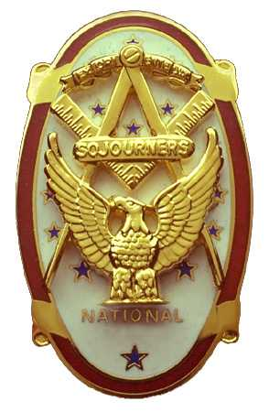
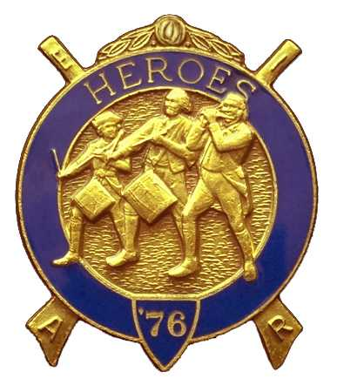
Olympic Chapter No.539
National Sojourners
And
Marvin Shields Camp of Heroes of ‘76
Edwin C. Marion P.O..Box 364
Secretary?Treasurer Forks, WA 98331-0364
edwin028@centurytel.net http://www:telebyte.com/masons/sojourn/ (360) 374-6777
16 November 2011
Wednesday

I AM BACK, AND IT IS GOOD TO BE HERE AGAIN. For those of you that didn't know, my wife and I, and 4 friends took a cruise. Nuff said on that.

Grip – N – Grin part of our meeting started at about 1730 Hours (5:30 PM civilian time.) It is always good to see our brothers and sisters again.

WB Paul Carmean gave us an excellent rendition of the Toast to the Flag, which was followed by the opening of the Chapter. WB Ron Chase, our 2nd VP, was called upon to open the Chapter as our President, Mr. Joe Anticevich was not able to make the meeting, and 1st VP Earl Riggs is recovering from a stroke. Thanks for a job well done Ron.

There was no guest speaker. On this subjects, brothers I need your help. I need you to look around and find some people that would make good speakers for our meetings. At my age, 84, I don't get out too much and thereby, I don't see people who would make good speakers. They must be able to speak to us for a free meal for them and their mate, this is all we can afford to pay for guest speakers. Help me on this brothers.

Our next meet will be a White Elephant Meeting. Everyone is request to bring a wrapped gift, maybe something around your house you want to get rid of, more or less a joke type gift.

The raffle was held and it raised $50.00 for the Chapter. Thanks so very much Sue, you help our finances so very much.

The new apron that is officially to be worn by Sojourners was shown. VWB Darel explained that he made an attempt to get it approved by Grand Lodge, but this didn't happen. Seems the apron didn't conform to the Washington State Masonic Code. What can I say about this. I think it is a great apron even if it doesn't conform to Grand Lodge. I have no regrets on purchasing for my personnel use.

This is a message to our brothers that the Chapter paid their MIP. We had hoped that you would continue paying your yearly dues until you have paid the $200.00 cost of the MIP, but just don't send the dues to National, send it to the chapter. As far as National is concerned, your dues is paid. It is just that your Chapter put out the cost. The reason it was done this way was to make it much easier on us as far as bookkeeping was concerned.

Also, it is now getting to the end of the year, and the mandatory charity dues is to be paid. This one is a penny a day, $3.65 per year. You can buy a life membership for $36.50, which most of us have done. Yet there is a few of us that don't have a life membership in this charity.
______________________________________________________________________
NEWS OF OUR MEMBERS

Gunny Riggs is still in rehab. Get well soon Gunny, we need you.

At this time I am awaiting for an appointment for my left hip. My Doctor tells me it is worn out and might have to be replaced. I have an appointment with a doctor in Silverdale who will be looking at it to see if I need a replacement.

This is all I have on this subject. If you know of ant news of our brothers or sisters, let me know.
______________________________________________________________________
HERE IS THE LIST OF YOUR OFFICERS FOR 2011-2012

OLYMPIC CHAPTER MARVIN G. SHIELDS CAMP

President------ ---------------Mr. Joe G. Anticevich Commander-------------------GySgt. C. Earl Riggs
360-452-4841 angeleslock@gmail.com 360-380-4944 jarhead1949@netzero.com

1st Vice President---------------GySgt C. Earl Riggs Chief of Staff------------Mr Joe G. Anticevich
360-380-4944 jarhead1949@netzero.com 360-452-4841 angeleslock@gmail.com

2nd Vice President--------- -----Ronald Chase A/C of Staff-------------------Ronald Chase
360-379-4074 ron_chase2000@yahoo.com 360-379-4074 ron_chase2000@yahoo.com

3rd Vice President—----Donald C. Williams
360-582-0628 williamsdc@wavecable.com

Chaplain----------SGT Fredrick W. Johnson Chaplain---------SGT Fredrick W.Johnson
360-385-3130 fjohnson-30@q.com 360-385-3130 fjohnson-30@q.com

Secretary-----LtCol Edwin C. “Ed” Marion Adjutant-----LtCol Edwin C. “Ed” Marion
360-374-6777 Edwin028@centurytel.net 360-374-6777 Edwin028@centurytel.net

Assistant Secretary-Darel E. Maxfield Sr Assistant Adjutant---Darel E. Maxfield Sr.
360-374-9330-------maynard@olynet.com 360-374-9330-------maynard@olynet.com

Area Representative and Regional Representative
SMSGT Robert S. Colton
206-439-2320 rshgcolton1@netzero.net
Deputy Area Representative and Regional Representative
LtCol Wendell A. Dutt
253-565-5264 wadutt@comcast.net

NEXT MEETING
14 December 2011
Paradise Restaurant
Sequim, WA

Our meeting this month will be held on 14 December 2011. Our meeting will start at 1900 Hours (7 PM) following dinner at 1800 hours (6 PM) for those that wish dinner, You order from the menu. We have no guest speaker at this time, still looking for speakers, but we will be having an “White Elephant” program. Just bring a small gift to exchange with someone, and join in the fun. Now, if you or someone you know would have a subject they would like to talk to us about, just let me know.. .

DIRECTIONS TO THE MEETING PLACE. No matter from which direction you come, as you must come by Highway 101, east or west, when you see the road sign for Sequim Avenue, you take that exit. If you come from the east, turn right onto Sequim Avenue, if you come from the west, turn left onto Sequim Avenue. This will place you heading north along Sequim Avenue. You will stay on Sequim Avenue until you reach the restaurant, which will be approximately one mile. There will be one traffic light , which is at Main Street, this means you are about half way there.

Approximately ¾ miles along the way, you will come to Sequim High School on your left. It is a large brick building. There will be a chain-link fence around the practice field part of the High School. At the end of the fenced off area is a cross street, which forms a three way intersection, or a “T” bone intersection. The Paradise Restaurant is on the north west corner of the intersection. The parking lot is in the front, so just pull into the parking lot. Come into the restaurant, walk straight back to the private dinning room. This is where we have our meetings.

Now remember, YOU DON'T HAVE TO COME FOR THE DINNER, YOU DON'T EVEN HAVE TO BUY COFFEE. If you need a ride to and from the meeting, give me a call and I will arrange for someone to pick you up and take you home. Call me at 360-374-6777.

HAPPY BIRTHDAY

Ed Marion 8
Graham Kent 25
Claudia Rose 30

Happy Birthday Brothers and sister. Hope your day was, or will be, a great one. MANY HAPPY RETURNS to you. Now if I have missed anyone, may your day be a memorable one. And ladies please send me the month and day of your birth so I can post it for you. Don't send the year of birth.

BLUE LODGE

Meetings: Quilcene-Jefferson #107 will meet 5 December 2011 and 9 January 2012, . dinner 6:30, lodge 7:30; Mt. Olympus #298 7 December 2011 and 4 January 2012, , dinner 6:30 Lodge 7:30; Pt. Angeles #69 13 December 2011 and 17 January 2012, no dinner, lodge 7:30, this is “Fill the Lodge Night”; Sequim #213 8 December 2011 and 19 January 2012, dinner 6:15 lodge 7:30.. Pt Townsend #6,, 14 December 2011, 11 January 2012, 6:30 Dinner, Lodge 7:30. Remember brothers. attend your Blue Lodge at least once a year just so they can see you are still among the living.
________________________________________________________________________
UNIFORMS

Here is the means by which you ca n get a heroes uniform if you don't have one, but you do want one. First of all, we have a couple of uniforms of past members. If one fits you, then you have it made. There is no charge for these uniforms. Now if you want a new one, you can order it, pay the $125.00 down payment that is required when you order, (this will show you are in the hunt and need help). then when your uniform arrives, turn the bill for the remaining cost, over to the secretary who will pay for the rest of the cost of the uniform. Talk with the adjutant about this. You may be in uniform before you know it.

WISH LIST

- An enclosed trailer to haul all our equipment needed for our “Build the Flag” program. My truck has short bed which will not hold everything needed for our Hero Programs.
- An awards chairman as suggested by David MacNeill. David can't take the job as he has moved out of area, and is travel most of time.
- We need more members in uniform. We are working on a solution.
- Guest speakers are needed very badly. Subject is of their choosing, but they must work for dinner only, can't afford pay them more than that.
- More brothers and their ladies at our meetings
- A phone committee. Open not only to brothers, but to their ladies also.
- Sure could use someone to take over the responsibility for some of this equipment I have. Sometimes it gets more than an 84 year old can handle.
- Someone to take over the “Traveling Bar”.

