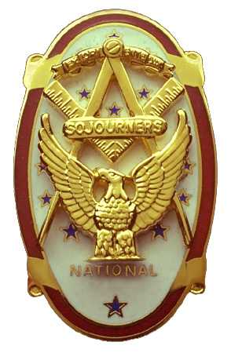
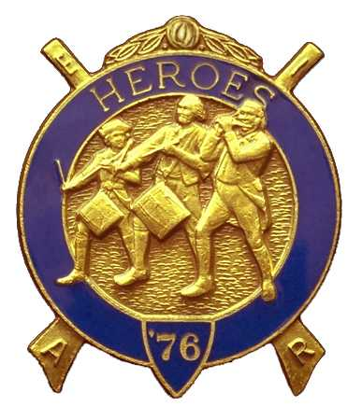
Olympic Chapter No.539
National Sojourners
And
Marvin Shields Camp of Heroes of ‘76
Edwin C. Marion P.O..Box 364
Secretary?Treasurer Forks, WA 98331-0364
edwin028@centurytel.net http://www:telebyte.com/masons/sojourn/ (360) 374-6777
24 August 2011
Wednesday

Grip-N-Grin started out good today. Sue Porter was present along with Lorrie, and said that she was feeling better. Here again it was good to see our brothers and sister friends. Following dinner WB (CPO) Paul Carmean was called on by our president WB (Mr.) Joe Anticevich to do the “Toast to the Flag”. and lead us in doing the pledge of allegiance. What can I say WB Paul, you did a very good job again? Now if we can get someone that can do “Old Glory Speaks” we would have it made. Try as I can, I can't seem to remember things like “Old Glory” anymore since my stroke. My mind just doesn't work that good anymore. ( I don't think it worked too good before.)

President WB (Mr) Joe Antiucevich opened our meeting according to Order of Ceremonies, page 3. There was no guest speaker. Here again, if you know of a good guest speaker, or someone who would make a good speaker, or have a subject they would like to speak on just let me know, and maybe I can get them as our guest speaker.

According to our books our treasury is solvent. We have $2986.74 in the bank. Our
JNROTC medal is $85.00
YLC is $250.00
Uniform fund is $590.00
leaving an operations fund of $1961.74
So, you can say we are more than keeping our heads above water.

As secretary I am announcing that we have applications for Pacific Beach. They needed to be in by the 2nd of September, or as soon as possible, as the Navy would like to have a head count of how many are going to be around for the Banquet on Saturday and breakfast on Sunday. Time is running short. The 23rd of September is just over 3 weeks away. If you plan to go, get your application in, and make your reservation with the resort. Don't miss out on the fun. Both our National President and National Commander are scheduled to be at the Encampment. This will be one of the first meetings that our chapter will not be busy doing so many jobs. Will be nice just to set back and see things being done by someone else.

Vicky Larson, on behalf of the Eastern Star, requested that our Flag Team do the “Build the Flag” on their Friends Night. This will be on October 24th, starting time of 2000 Hours, (8:00 PM). If you can make this in dress uniform, let us hear from you. If you don't have a uniform but would like one to become a part of the Flag Team, contact your secretary. Seems Ron Chase has expressed his desire for a uniform and become part of the Flag Team.. Call me Ron, I have uniform information sheets from the lady in Texas who makes the uniforms.

Bob Caruthers announced that their first Sunday Breakfast, at PA was a success so they will be doing their next one on September 4th .

By the time you read this the Outdoor Degree at Quilcene/Jefferson Lodge well be over. See you next year. Also, the Memorial Service for RWB Jerry Lingle will be over.

Our raffle was held and we netted $89.00. Thanks again Sue.

There being nothing else to come before the Chapter, President Joe closed the Chapter according to the Orders of Ceremonies, page 8.
________________________________________________________________________
NEWS OF OUR MEMBERSHIP

At this point and time, I don't have anything on the health and such of any of our members. _______________________________________________________________________
HERE IS THE LIST OF YOUR OFFICERS FOR 2011-2012

OLYMPIC CHAPTER MARVIN G. SHIELDS CAMP

President------ ---------------Mr. Joe G. Anticevich Commander-------------------GySgt. C. Earl Riggs
360-452-4841 angeleslock@gmail.com 360-380-4944 jarhead1949@netzero.com

1st Vice President---------------GySgt C. Earl Riggs Chief of Staff------------Mr Joe G. Anticevich
360-380-4944 jarhead1949@netzero.com 360-452-4841 angeleslock@gmail.com

2nd Vice President--------- -----Ronald Chase A/C of Staff-------------------Ronald Chase
360-379-4074 ron_chase2000@yahoo.com 360-379-4074 ron_chase2000@yahoo.com

3rd Vice President—----Donald C. Williams
360-582-0628 williamsdc@wavecable.com

Chaplain----------SGT Fredrick W. Johnson Chaplain---------SGT Fredrick W.Johnson
360-385-3130 fjohnson-30@q.com 360-385-3130 fjohnson-30@q.com

Secretary-----LtCol Edwin C. “Ed” Marion Adjutant-----LtCol Edwin C. “Ed” Marion
360-374-6777 Edwin028@centurytel.net 360-374-6777 Edwin028@centurytel.net

Assistant Secretary-Darel E. Maxfield Sr Assistant Adjutant---Darel E. Maxfield Sr.
360-374-9330-------maynard@olynet.com 360-374-9330-------maynard@olynet.com

Area Representative and Regional Representative
SMSGT Robert S. Colton
206-439-2320 rshgcolton1@netzero.net
Deputy Area Representative and Regional Representative
LtCol Wendell A. Dutt
253-565-5264 wadutt@comcast.net

NEXT MEETING
28 September 2011
Paradise Restaurant
Sequim, WA

Our meeting this month will be held on 28 September 2011. Our meeting will start at 1900 Hours (7 PM) following dinner at 1800 hours (6 PM) for those that wish dinner, You order from the menu. We have no guest speaker at this time, still looking for speakers. If you or someone you know would have a subject they would like to on, just let me know.. .

DIRECTIONS TO THE MEETING PLACE. No matter from which direction you come, as you must come by Highway 101, east or west, when you see the road sign for Sequim Avenue, you take that exit. If you come from the east, turn right onto Sequim Avenue, if you come from the west, turn left onto Sequim Avenue. This will place you heading north along Sequim Avenue. You will stay on Sequim Avenue until you reach the restaurant, which will be approximately one mile. There will be one traffic light , which is at Main Street, this means you are about half way there.

Approximately ¾ miles along the way, you will come to Sequim High School on your left. It is a large brick building. There will be a chain-link fence around the practice field part of the High School. At the end of the fenced off area is a cross street, which forms a three way intersection, or a “T” bone intersection. The Paradise Restaurant is on the north west corner of the intersection. The parking lot is in the front, so just pull into the parking lot. Come into the restaurant, walk straight back to the private dinning room. This is where we have our meetings.

Now remember, YOU DON'T HAVE TO COME FOR THE DINNER, YOU DON'T EVEN HAVE TO BUY COFFEE. If you need a ride to and from the meeting, give me a call and I will arrange for someone to pick you up and take you home. Call me at 360-374-6777.

Our next meeting will be on 26 October 2011 at the Paradise Restaurant.

HAPPY BIRTHDAY

Morris “Mike” Moug 6
Eric Anticevich 21
Donald Patrick 23
Fred Johnson 20

Happy Birthday Brothers. Hope your day was, or will be, a great one. MANY HAPPY RETURNS to you. Now if I have missed anyone, may your day be a memorable one. And ladies please send me the month and day of your birth so I can post it for you. Don't send the year of birth.

BLUE LODGE

Meetings: Quilcene-Jefferson #107 will meet 12 September 2011 and 3 October 2011, . dinner 6:30, lodge 7:30; Mt. Olympus #298 7 September 2011 and 5 October 2011, this will be “Fill the Lodge Night”, dinner 6:30 Lodge 7:30; Pt. Angeles #69 13 September 2011 and 11 October 2011, no dinner, lodge 7:30; Sequim #213 8 September 2011 and 13 October 2011, dinner 6:15 lodge 7:30.. Pt Townsend #6,, 14 September 2011 “Fill the Lodge Night” 6:30 Dinner, Lodge 7:30. Remember brothers. attend your Blue Lodge at least once a year just so they can see you are still among the living.
________________________________________________________________________
UNIFORMS

Here is the means by which you can get a heroes uniform if you don't have one, but you do want one. First of all, we have a couple of uniforms of past members. If one fits you, then you have it made. There is no charge for these uniforms. Now if you want a new one, you can order it, pay the $125.00 down payment that is required when you order, (this will show you are in the hunt and need help). then when your uniform arrives, turn the bill for the remaining cost, over to the secretary who will pay for the rest of the cost of the uniform. Talk with the adjutant about this. You may be in uniform before you know it.

WISH LIST

- An enclosed trailer to haul all our equipment needed for our “Build the Flag” program. My truck has short bed which will not hold everything needed for our Hero Programs.
- An awards chairman as suggested by David MacNeill. David can't take the job as he has moved out of area, and is travel most of time.
- We need more members in uniform. We are working on a solution.
- Guest speakers are needed very badly. Subject is of their choosing, but they must work for dinner only, can't afford pay them more than that.
- More brothers and their ladies at our meetings
- A phone committee. Open not only to brothers, but to their ladies also.
- Sure could use someone to take over the responsibility for some of this equipment I have. Sometimes it gets more than an 83 year old can handle.
- Someone to take over the “Traveling Bar

