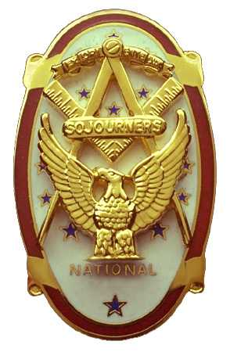
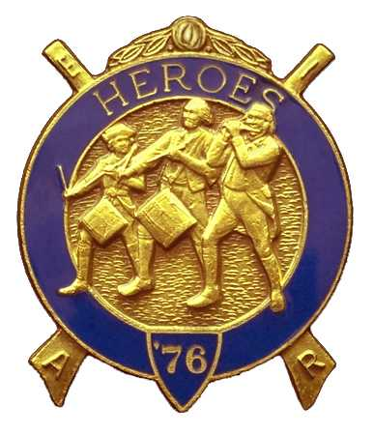
Olympic Chapter No.539
National Sojourners
And
Marvin Shields Camp of Heroes of ‘76
Edwin C. Marion P.O..Box 364
Secretary?Treasurer Forks, WA 98331-0364
edwin028@centurytel.net http://www:telebyte.com/masons/sojourn/ (360) 374-6777
27 July 2011
Wednesday

Prior to the official opening of Olympic Chapter, our new President Mr. Joe Anticevich called upon our Junior Past President CPO Paul J. Carmean to give the “Toast to the Flag”, Once again WB Paul did an outstanding job, WB CPO Paul you get better each time you do the “Toast”. Following WB CPO Paul's “Toast to the Flag” and the pledge, President Mr. Joe Anticevich opened chapter according to the Order of Ceremonies, page 3.

Following the chapter being opened, President WB Mr Joe Anticevich turned the floor over to MWB CDR Wayne I. Smith. Prior getting into the main part of his talk, MW CDR Wayne stated that he had a few presentations to make to the Chapter and to some of the membership.

First of all the chapter was presented with a Certificate of Appreciation as “3rd runners up Youth Emphasis Award. Surprise, surprise. Didn't even know we were in the running. We will take it. A Certificate of Appreciation was presented to Sue Porter for her work and effort with the raffle. Congratulations Sue, you deserve much more than that. You have the whole membership cheering you on. Propeller club pins were presented to WB CPO Paul Carmean, VWB Mr Darel Maxfield Sr, and WB LtC Ed Marion.

MWB Wayne then announced that the 2016 National Convention will be held in Seattle. He explained that this was going to take a lot of hard work on all our parts, and that we should do all that we called upon to do. What a great opportunity for our North West Area.

MW CDR Wayne then showed us a bumper sticker that spelled out COASTIE, with the A being a square and compass. Looks nice They are made for all services, plus there are the Masonic and past master ones. These will sell for $5.00 each. See the secretary who has them for the chapter. They will fit on the windows as well as your bumper.

As of this writing, we are still solvent. At present there is a total of $2974.64 in our account, of which JNROTC Medal fund is $85.00
YLC fund is $250.00
Uniform fund $590.00
leaving us with of Chapter operational fund of $2049.64.

Received an e-mail from our Junior Past National President that the “Eagle had Landed” was in perfect shape. For those not at our 25 May meeting, our National President was presented with a trophy, made by WB LtC Ed Marion, commemorating the visit to our Chapter

There being nothing else to come before the meeting, our President Mr. Joe Anticevich proceeded to close the meeting according to the Orders of Ceremonies page 8.
________________________________________________________________________
NEWS OF OUR MEMBERSHIP

SGT Bob Caurthers announced that he and his lady, Peggy, got married over the past weekend. In true fashion we say, Congratulations Bob, and good luck to you Peggy.

We understand that Sue Porter is back among the well people again, but Lorrie has moved to Aberdeen to go to school,. So, this leaves Sue in need of a ride to our meetings as she doesn't drive. If someone lives around were Sue lives, contact her see if she needs a ride to the meetings. Her number is .385 3228. She might have a ride now.
________________________________________________________________________
HERE IS THE LIST OF YOUR OFFICERS FOR 2011-2012

OLYMPIC CHAPTER MARVIN G. SHIELDS CAMP

President------ ---------------Mr. Joe G. Anticevich Commander-------------------GySgt. C. Earl Riggs
360-452-4841 angeleslock@gmail.com 360-380-4944 jarhead1949@netzero.com

1st Vice President---------------GySgt C. Earl Riggs Chief of Staff------------Mr Joe G. Anticevich
360-380-4944 jarhead1949@netzero.com 360-452-4841 angeleslock@gmail.com

2nd Vice President--------- -----Ronald Chase A/C of Staff-------------------Ronald Chase
360-379-4074 ron_chase2000@yahoo.com 360-379-4074 ron_chase2000@yahoo.com

3rd Vice President—----Donald C. Williams
360-582-0628 williamsdc@wavecable.com

Chaplain----------SGT Fredrick W. Johnson Chaplain---------SGT Fredrick W.Johnson
360-385-3130 fjohnson-30@q.com 360-385-3130 fjohnson-30@q.com

Secretary-----LtCol Edwin C. “Ed” Marion Adjutant-----LtCol Edwin C. “Ed” Marion
360-374-6777 Edwin028@centurytel.net 360-374-6777 Edwin028@centurytel.net

Area Representative and Regional Representative
SMSGT Robert S. Colton
206-439-2320 rshgcolton1@netzero.net
Deputy Area Representative and Regional Representative
LtCol Wendell A. Dutt
253-565-5264 wadutt@comcast.net

NEXT MEETING

24 August 2011
Paradise Restaurant
Sequim, WA

Our meeting this month will be held on 24 August 2011. Our meeting will start at 1900 Hours (7 PM) following dinner at 1800 hours (6 PM) for those that wish dinner, You order from the minu. We have no guest speaker at this time. If you or someone you know would have a subject they would like to speak on, just let me know.. .

DIRECTIONS TO THE MEETING PLACE. No matter from which direction you come, as you must come by Highway 101, east or west, when you see the road sign for Sequim Avenue, you take that exit. If you come from the east, turn right onto Sequim Avenue, if you come from the west, turn left onto Sequim Avenue. This will place you heading north along Sequim Avenue. You will stay on Sequim Avenue until you reach the restaurant, which will be approximately one mile. There will be one traffic light , which is at Main Street, this means you are about half way there.

Approximately ¾ miles along the way, you will come to Sequim High School on your left. It is a large brick building. There will be a chain-link fence around the practice field part of the High School. At the end of the fenced off area is a cross street, which forms a three way intersection, or a “T” bone intersection. The Paradise Restaurant is on the north west corner of the intersection. The parking lot is in the front, so just pull into the parking lot. Come into the restaurant, walk straight back to the private dinning room. This is where we have our meetings.

Now remember, YOU DON'T HAVE TO COME FOR THE DINNER, YOU DON'T EVEN HAVE TO BUY COFFEE. If you need a ride to and from the meeting, give me a call and I will arrange for someone to pick you up and take you home. Call me at 360-374-6777.

Our next meeting will be on 28 September at the Paradise Restaurant.

HAPPY BIRTHDAY
John Richardson 16
Paul J. Carmean 21
Ronald Chase 24
Robert Clubb 29

Happy Birthday. Hope your day was, or will be, a great one. MANY HAPPY RETURNS to you. Now if I have missed anyone, may your day be a memorable one. And ladies please send me the month and day of your birth so I can post it for you. Don't send the year of birth.

BLUE LODGE

Meetings: Quilcene-Jefferson #107 will meet and 1 August 2011 and 12 September 2011, . dinner 6:30, lodge 7:30; Mt. Olympus #298 3 August 2011 and 7 September 2011, dinner 6:30 Lodge 7:30; Pt. Angeles #69 is dark July and August 2011 and their next meeting will be 13 Sept., no dinner, lodge 7:30; Sequim #213, 11 August 2011 and 8 Sept. 2011, dinner 6:30 lodge 7:30.. Pt Townsend #6,, the lodge will go dark until 21 September 2011 6:30 Dinner, Lodge 7:30. Remember brothers. a ttend your Blue Lodge at least once a year just so they can see you are still among the living.
________________________________________________________________________
UNIFORMS

Here is the means by which you can get a heroes uniform if you don't have one, but you do want one. First of all, we have a couple of uniforms of past members. If one fits you, then you have it made. There is no charge for these uniforms. Now if you want a new one, you can order it, pay the $125.00 down payment that is required when you order, (this will show you are in the hunt and need help). then when your uniform arrives, turn the bill for the remaining cost, over to the secretary who will pay for the rest of the cost of the uniform. Talk with the adjutant about this. You may be in uniform before you know it.

WISH LIST

- An enclosed trailer to haul all our equipment needed for our “Build the Flag” program. My truck has short bed which will not hold everything needed for our Hero Programs.
- An awards chairman as suggested by David MacNeill. David can't take the job as he has moved out of area, and is travel most of time.
- We need more members in uniform. We are working on a solution.
- Guest speakers are needed very badly. Subject is of their choosing, but they must work for dinner only, can't afford pay them more than that.
- More brothers and their ladies at our meetings
- A phone committee. Open not only to brothers, but to their ladies also.
- Sure could use someone to take over the responsibility for some of this equipment I have. Sometimes it gets more than an 83 year old can handle.
- Someone to take over the “Traveling Bar.

