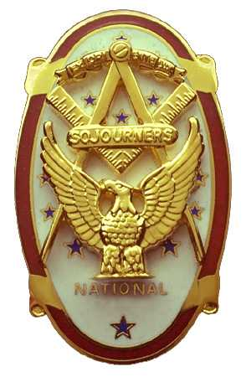
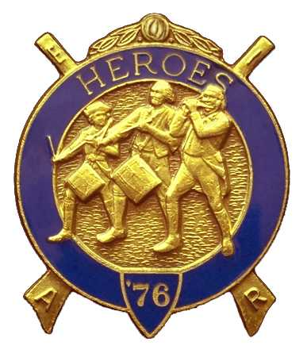
Olympic Chapter No.539
National Sojourners
And
Marvin Shields Camp of Heroes of ‘76
Edwin C. Marion P.O..Box 364
Secretary?Treasurer Forks, WA 98331-0364
edwin028@centurytel.net http://www:telebyte.com/masons/sojourn/ (360) 374-6777
22 June2011
Wednesday

Well, we are back to arriving at the restaurant first, not to be outdone by the National President, arriving first before we did. It was good to take part in our standard Grip – N – Grin with our brothers and sisters.

Surprise of all surprises! Dave and Kathy MacNeill were back among us again. Good to see them. Maybe they will be here for a while this time.

Due to the fact that some of our members had to catch a ferry, it was decided that we would do our raffle first. This worked out very well, at least everyone got to check out their own numbers, not having to rely upon someone checking for them. Once again, even though you weren't here, thanks so very much Sue!?!

Our new core of officers were in-charge of every thing tonight. President Joe Anticevich called on Junior Past President, WB Paul Carmean, if he would do the “Toast to the Flag”. As always, WB Paul did an outstanding job. WB Joe Anticevich opened the meeting according to the Order of Ceremonies, page 3

The Secretary Ed Marion was asked why there was no money set aside for the Youth Leadership Conference at this time. The Secretary explain a check for YLC, which cleaned out the YLC account, was sent to Major Campbell of Pt Angeles High School JNROTC to cover our Scholarship YLC., That we now had to place money aside for this next year. This being said, WB Paul Carmean made a motion that $250.00 to be allocated for YLC for 2012. Motion was seconded by WB Ron Chase. .Motion carried.

Once again our treasury is solvent. We now have $2835.14 in our bank account, of which $1841.14 is for Chapter operational funds. There is $250.00, just voted in see above, in our YLC scholarship fund, $58.00 in our JNROTC awards fund, and $590.00 in our uniform fund.

Even with Sue Porter being on the “not feeling up to par” list, she had her friend bring in the items for the raffle. She was able to raise $75.00 for our account. This money Sue raises with her raffle keeps us from charging dues. Thanks again Sue.

There being no other business to come before us, we closed the meeting according Orders of Ceremonies page 8.

NEWS OF OUR BROTHERS AND SISTERS

Seems Sue Porter is down with this cold going around. Get better soon Sue, we miss you.

With Gunny Riggs not being at our meeting means his wife isn't feeling up to par. Hope she is better soon so they may return to our meetings. Gunny is now 1st Vice President of our chapter and the Commander of Heroes.

Talked with Bill Heckman at York Rite. Seems why he ended up in the hospital was a problem with his ticker. They put in a pace maker and now things are beginning to run better.

At this same York Rite meeting, bumped into Louanne Yager, who is the Assistant Bingo Manager for Pt. Angeles Lodge.. At this time she is under-going chemo treatments. She is looking good. Hope she is improving.

________________________________________________________________________
HERE IS THE LIST OF YOUR OFFICERS FOR 2011-2012

OLYMPIC CHAPTER MARVIN G. SHIELDS CAMP

President------ ---------------Mr. Joe G. Anticevich Commander-------------------GySgt. C. Earl Riggs
360-452-4841 angeleslock@gmail.com 360-380-4944 jarhead1949@netzero.com

1st Vice President---------------GySgt C. Earl Riggs Chief of Staff------------Mr Joe G. Anticevich
360-380-4944 jarhead1949@netzero.com 360-452-4841 angeleslock@gmail.com

2nd Vice President--------- -----Ronald Chase A/C of Staff-------------------Ronald Chase
360-379-4074 ron_chase2000@yahoo.com 360-379-4074 ron_chase2000@yahoo.com

3rd Vice President—----Donald C. Williams
360-582-0628 williamsdc@wavecable.com

Chaplain----------SGT Fredrick W. Johnson Chaplain---------SGT Fredrick W.Johnson
360-385-3130 fjohnson-30@q.com 360-385-3130 fjohnson-30@q.com

Secretary-----LtCol Edwin C. “Ed” Marion Adjutant-----LtCol Edwin C. “Ed” Marion
360-374-6777 Edwin028@centurytel.net 360-374-6777 Edwin028@centurytel.net

Area Representative and Regional Representative
SMSGT Robert S. Colton
206-439-2320 rshgcolton1@netzero.net
Deputy Area Representative and Regional Representative
LtCol Wendell A. Dutt
253-565-5264 wadutt@comcast.net

NEXT MEETING

27 July 2011
Paradise Restaurant
Sequim, WA

Our meeting this month will be held on 27 July 2011. Our meeting will start at 1900 Hours (7 PM) following dinner at 1800 hours (6 PM), Our guest speaker will be MW Wayne Smith, who will be telling us what happened at the National Convention, as he represented our Chapter, and he has some of the awards for us... Ho[pe it good news that MW Wayne brings us.

If you know of someone that would be a good guest speaker, please let me know.. .

DIRECTIONS TO THE MEETING PLACE. No matter from which direction you come, as you must come by Highway 101, east or west, when you see the road sign for Sequim Avenue, you take that exit. If you come from the east, turn right onto Sequim Avenue, if you come from the west, turn left onto Sequim Avenue. This will place you heading north along Sequim Avenue. You will stay on Sequim Avenue until you reach the restaurant, which will be approximately one mile. There will be one traffic light , which is at Main Street, this means you are about half way there.

Approximately ¾ miles along the way, you will come to Sequim High School on your left. It is a large brick building. There will be a chain-link fence around the practice field part of the High School. At the end of the fenced off area is a cross street, which forms a three way intersection, or a “T” bone intersection. The Paradise Restaurant is on the north west corner of the intersection. The parking lot is in the front, so just pull into the parking lot. Come into the restaurant, walk straight back to the private dinning room. This is where we have our meetings.

Now remember, YOU DON'T HAVE TO COME FOR THE DINNER, YOU DON'T EVEN HAVE TO BUY COFFEE. If you need a ride to and from the meeting, give me a call and I will arrange for someone to pick you up and take you home. Call me at 360-374-6777.

Installation of Officers was held on 4 June, at 1200 Hours at Des Monies Temple. All officers installed/

Our next meeting will be on 24 August at the Paradise Restaurant.

HAPPY BIRTHDAY
July

Joe Illes 25
Now did I ever goof on the birthdays last month. Joe's birthday was this month, July, not June. I will now acknowledge our June brothers now which I left out;
John Jones 5
David Larson 5
Marion Windell 9

Again Joe, Happy Birthday. Hope your day was, or will be, a great one., Now for all the men who had their birthday in June, the ones I overlooked, MANY HAPPY RETURNS to you. Better late than never, I guess. Now if I have missed anyone else, may your day be a memorable one. And ladies please send me the month and day of your birth so I can post it for you. Don't send the year of birth.

BLUE LODGE

Meetings: Quilcene-Jefferson #107 will meet 11 July 2011 and 1 August 2011,. dinner 6:30, lodge 7:30; Mt. Olympus #298 6 July 2011 and 3 August 2011, dinner 6:30 Lodge 7:30; Pt. Angeles #69 is dark July and August 2011 and their next meeting will be 14Sept., 6{30 dinner, lodge 7:30; Sequim #213, 14 July2011 and 11 August 2011, dinner 6:30 lodge 7:30.. Pt Townsend #6, 15 June 2011, the lodge will go dark until 21 September 2011 6:30 Dinner, Lodge 7:30. Attend your Blue Lodge Brothers at least once a year just so they can see you are still among the living.
________________________________________________________________________
UNIFORMS

Here is the means by which you can get a heroes uniform if you don't have one, but you do want one. First of all, we have a couple of uniforms of past members. If one fits you, then you have it made. There is no charge for these uniforms. Now if you want a new one, you can order it, pay the $125.0 down payment that is required when you order, (this will show you are in the hunt and need help). then when your uniform arrives, turn the bill for the remaining cost, over to the secretary who will pay for the rest of the cost of the uniform. Talk with the adjutant about this. You may be in uniform before you know it.

WISH LIST

- An enclosed trailer to haul all our equipment needed for our “Build the Flag” program. My truck has short bed which will not hold everything needed for our Hero Programs.
- An awards chairman as suggested by David MacNeill. David can't take the job as he has moved out of area, and is travel most of time.
- We need more members in uniform. We are working on a solution.
- Guest speakers are needed very badly. Subject is of their choosing, but they must work for dinner only, can't afford pay them more than that.
- More brothers and their ladies at our meetings
- A phone committee. Open not only to brothers, but to their ladies also.
- Sure could use someone to take over the responsibility for some of this equipment I have. Sometimes it gets more than an 83 year old can handle.
- Someone to take over the “Traveling Bar.

