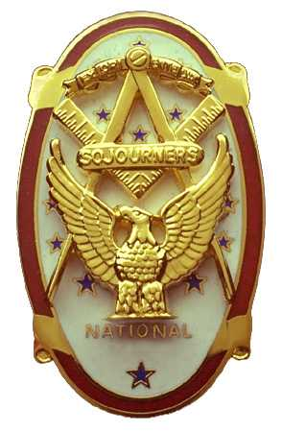
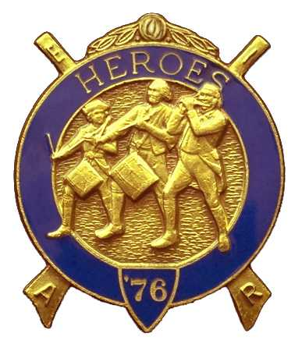
Olympic Chapter No.539
National Sojourners
And
Marvin Shields Camp of Heroes of ‘76
Edwin C. Marion P.O..Box 364
Secretary?Treasurer Forks, WA 98331-0364
edwin028@centurytel.net http://www:telebyte.com/masons/sojourn/ (360) 374-6777
25 May 2011
Wednesday

Of course we arrived at the Paradise Restaurant just after 1700 hours (5PM) to have every thing set up and in place prior to the arrival of our National President. Well, to our surprise, the National President, Lt Col Harry E. Sanders, Jr. and his wife Lyn, were already present. It seemed that they beat everyone else to the meeting. This made the Grip -N- Grin portion of our meeting very pleasant. We had a very nice and interesting informal meeting and introductions with the National President and his wife, I think it was good for everyone

Our President Paul Carmean opened our meeting by doing the “Toast to the Flag”. The President then proceed to open the meeting according to the Order of Ceremonies, page 3.
The meeting was turned over to National President Sanders who was our guest speaker for the evening.

President Sanders spoke on his “Propeller Club”, assisted by accompanying slide program. It was very interesting. And we were informed that the program had been extended for a few weeks, until the second week in June, We were informed that if we wanted to join the Propeller Club, we were to return the application, together with the appropriate amount of money to MW Wayne Smith at the installation of officers and we would be in business.

Our treasury is solvent. We have $3114.62 in the bank. Of which $58.00 is for JROTC Medal, and there is $590.00 in our uniform fund. We have an operations fund of $2466.52.

We had only the petition for membership of the National President. His petition was accompanied by the money for a MIP in our Chapter. His petition was approved. Thank you Sir.

The evening was closed out with the raffle. Because Sue was home not feeling well, Darel Maxfield conducted the raffle for her.

Meeting was closed by our President Paul Carmean according to page 8 of the order of ceremonies. This is Paul's last meeting as the President. Installation of new officers will be on June 4, 2011.

------------------------------------------------------------------------------------------------------------

NEWS OF OUR BROTHERS

Doug Pucket has moved to the big city of Reno Nevada. He had a job offer there that he couldn't pass up. Good luck Doug.

________________________________________________________________________
HERE IS THE LIST OF YOUR OFFICERS FOR 2011-2012

OLYMPIC CHAPTER MARVIN G. SHIELDS CAMP

President------ ---------------Mr. Joe G. Anticevich Commander-------------------GySgt. C. Earl Riggs
360-452-4841 angeleslock@gmail.com 360-380-4944 jarhead1949@netzero.com

1st Vice President---------------GySgt C. Earl Riggs Chief of Staff------------Mr Joe G. Anticevich
360-380-4944 jarhead1949@netzero.com 360-452-4841 angeleslock@gmail.com

2nd Vice President--------- -----Ronald Chase A/C of Staff-------------------Ronald Chase
360-379-4074 ron_chase2000@yahoo.com 360-379-4074 ron_chase2000@yahoo.com

3rd Vice President—----Donald C. Williams
360-582-0628 williamsdc@wavecable.com

Chaplain----------SGT Fredrick W. Johnson Chaplain---------SGT Fredrick W.Johnson
360-385-3130 fjohnson-30@q.com 360-385-3130 fjohnson-30@q.com

Secretary-----LtCol Edwin C. “Ed” Marion Adjutant-----LtCol Edwin C. “Ed” Marion
360-374-6777 Edwin028@centurytel.net 360-374-6777 Edwin028@centurytel.net

Area Representative and Regional Representative
SMSGT Robert S. Colton
206-439-2320 rshgcolton1@netzero.net
Deputy Area Representative and Regional Representative
LtCol Wendell A. Dutt
253-565-5264 wadutt@comcast.net

NEXT MEETING
22 June 2011
Paradise Restaurant
Sequim, WA

Our meeting this month will be held on 22 June 2011. Our meeting will start at 1900 Hours (7 PM) following dinner at 1800 hours (6 PM), Again we have no guest speaker.. If you know of someone that would be a good guest speaker, please let me know.. .

DIRECTIONS TO THE MEETING PLACE. No matter from which direction you come, as you must come by Highway 101, east or west, when you see the road sign for Sequim Avenue, you take that exit. If you come from the east, turn right onto Sequim Avenue, if you come from the west, turn left onto Sequim Avenue. This will place you heading north along Sequim Avenue. You will stay on Sequim Avenue until you reach the restaurant, which will be approximately one mile. There will be one traffic light , which is at Main Street, this means you are about half way there.

Approximately ¾ miles along the way, you will come to Sequim High School on your left. It is a large brick building. There will be a chain-link fence around the practice field part of the High School. At the end of the fenced off area is a cross street, which forms a three way intersection, or a “T” bone intersection. The Paradise Restaurant is on the north west corner of the intersection. The parking lot is in the front, so just pull into the parking lot. Come into the restaurant, walk straight back to the private dinning room. This is where we have our meetings.

Now remember, YOU DON'T HAVE TO COME FOR THE DINNER, YOU DON'T EVEN HAVE TO BUY COFFEE. If you need a ride to and from the meeting, give me a call and I will arrange for someone to pick you up and take you home. Call me at 360-374-6777.

Installation of Officers was held on 4 June, at 1200 Hours at Des Monies Temple. All officers installed/

Our next meeting will be on 22 June at the Paradise Restaurant.

HAPPY BIRTHDAY

Joe Illes 25

Happy Birthday Joe!?!. Hope your day was, or will be, a great one., If I have missed someone, may your day be a memorable one. And ladies please send me the month and day of your birth so I can post it for you. Don't send the year of birth.

BLUE LODGE

Meetings: Quilcene-Jefferson #107 will meet 4 July 2011 and 1 August 2011,. dinner 6:30, lodge 7:30; Mt. Olympus #298 6 July 2011 and 3 August 2011, dinner 6:30 Lodge 7:30; Pt. Angeles #69 is dark July and August 2011 and their next meeting will be 14Sept. 9 August 2011, 6{30 dinner, lodge 7:30; Sequim #213, 14 July2011 and 11 August 2011, dinner 6:30 lodge 7:30.. Pt Townsend #6, 15 June 2011, the lodge will go dark until 21 September 2011 6:30 Dinner, Lodge 7:30. Attend your Blue Lodge Brothers at least once a year just so they can see you are still among the living.
________________________________________________________________________
UNIFORMS

Here is the means by which you can get a heroes uniform if you don't have one, but you want one. First of all, we have a couple of uniforms of past members. If one fits you, then you have it made. There is no charge for these uniforms. Now if you want a new one, you can order it, pay the $125.00 down payment, (this will show you are in the hunt to help). then when your uniform arrives, turn the bill for the remaining cost, over to the secretary who will pay for the rest of the cost of the uniform. Talk with the adjutant about this. You may be in uniform before you know it.

WISH LIST

- An enclosed trailer to haul all our equipment needed for our “Build the Flag” program. My truck has short bed which will not hold everything needed for our Hero Programs.
- An awards chairman as suggested by David MacNeill. David can't take the job as he has moved out of area, and is travel most of time.
- We need more members in uniform. We are working on a solution.
- Guest speakers are needed very badly. Subject is of their choosing, but they must work for dinner only, can't afford pay them more than that.
- More brothers and their ladies at our meetings
- A phone committee. Open not only to brothers, but to their ladies also.
- Sure could use someone to take over the responsibility for some of this equipment I have. Sometimes it gets more than an 83 year old can handle.
- Someone to take over the “Traveling Bar.

