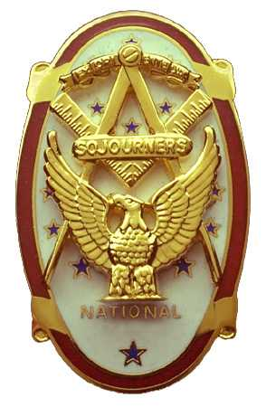
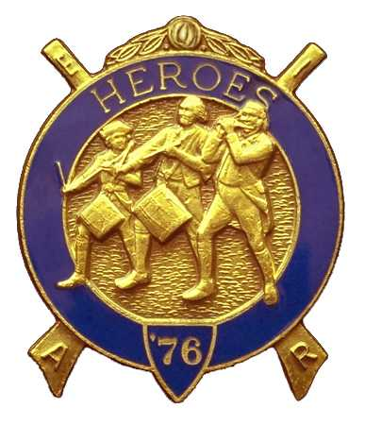
Olympic Chapter No.539
National Sojourners
And
Marvin Shields Camp of Heroes of ‘76
Edwin C. Marion P.O..Box 364
Secretary?Treasurer Forks, WA 98331-0364
edwin028@centurytel.net http://www:telebyte.com/masons/sojourn/ (360) 374-6777
27 April 2011

A few brothers showed up early, like 1730 hours, for our Grip – N – Grin part of our meeting. This is unscheduled, but is important to a few of us. We are “breaking bread with our brothers and sisters.” Good to see them.

Prior to the meeting opening, President Paul Carmean called upon himself to give the “Toast to the Flag.” Following the Toast, President Paul opened the meeting according to the ceremonies on page 3. Great job well done Paul.

We were supposed to have MWB Jimmy Reid as our guest speaker, as this was our 8th Anniversary, and MWB Jimmy was our guess speaker at each anniversary as he was supposed to be this time. But we didn't count on this crazy weather. We were lucky we have as many brothers as we have at the meeting. Darel Maxfield and myself have a 75 mile (150 miles round trip.) one way trip to get to the meetings, and we started out with rain and hail. By the time we got to Sappho, the rain had changed to snow, ON THE 27 APRIL!!!?? So, if we were having this kind of trouble, it was happening to everyone else. To the ones who made the trip, Thanks Brothers and Sisters for coming.

Our treasury is solvent. We have $2814.22 in the bank. Of which $50.00 is earmarked for YLC, $58.00 is for JROTC Medal, and there is $590.00 in our uniform fund. We have an operations fund of $2116.99.

Ballots for the election of officers for both the Chapter and Heroes Camp were passed out to our members present. Here is the results of the election.:

Chapter Heroes
Joe Anticevich, President Earl Riggs, Commander
Earl Riggs, 1sr Vice President Joe Anticevich, Chief of Staff
Ron Chase, 2nd Vice President Ron Chase, Assistant Chief of Staff
Donald Williams, 3rd Vice President Fred Johnson, Chaplain
Fred Johnson, Chaplain Ed Marion, Adjutant
Ed Marion, Secretary/Treasurer Darel Maxfield, Assist. Adjutant
Darel Maxfield, Assist. Secretary/Treasurer

These men will be installed on 4 June at the Des Moines Temple at 1200 hours. There will be a catered lunch, which in the past has been excellent and worth the $10.00 fee. Get your name in to your secretary, Ed Marion 360-374-6777, as lunch is by reservation only.

If you have an interest in becoming one of our officers, then start attending our meetings and let us know you want to be an officer. Officers are picked from the men who attend the meetings and express an interest in becoming an officer, From this interested group the nomination committee will make their selection who they think should be running for the position, .

Our next meeting will be 25 May and we can expect the National President, and his Lady Lynn, at the meeting. Preparations for his meeting are underway, and we hope we are covering everything. We would like to see more members and their wives present.

Sojourner of the year was announced by the “Sojourner of the Year Committee”. Our Sojourner of the year for 2010 was Ed Marion, our Secretary.

The evening was close out with the raffle by Sue Porter.

Meeting was closed by our President Paul Carmean according to -pager 8 of the order of ceremonies.
------------------------------------------------------------------------------------------------------------

NEWS OF OUR BROTHERS

Gunny Riggs and his wife were present tonight. She indicated thtat she was feeling better now. At least she looked better.

Darel Maxfield will be the new District Deputy for the new Grand Master. This will be Darels second time around. Seems he was District Deputy 4 years ago. I guess you might say he is making up for Mt. Olympus Lodge only having one District Deputy in 55 years. only having one. Good going Darel.

________________________________________________________________________
HERE IS THE LIST OF YOUR OFFICERS FOR 2010-2011

OLYMPIC CHAPTER MARVIN G. SHIELDS CAMP

President------ ---------------CPO Paul J. Car mean Commander------------Mr. Darel E. Maxfield Sr.
360-928-3358 pjcarmean@q.com 360-374-9330 maynard@olynet.com

1st Vice President---LCD Dr. John R. Richardson Chief of Staff--------------GYSGT C. Earl Riggs
360-385-3117 djohnone@cablespeed.com 360-380-4944 jarhead1949@netzero.com

2nd Vice President--------- Joe G. Anticevich A/C of Staff--------------Joe G. Anticevich
360-432-4843 acn@olypen.com 360-432-4843 ace@olypen.com

3rd Vice President—---------Douglas Puckett
100 Wild Orchid Lane

Chaplain----------SGT Fredrick W. Johnson Chaplain---------SGT Fredrick W.Johnson
360-385-3130 fjohnson-30@q.com 360-385-3130 fjohnson-30@q.com

Secretary-----LtCol Edwin C. “Ed” Marion Adjutant-----LtCol Edwin C. “Ed” Marion
360-374-6777 Edwin028@centurytel.net 360-374-6777 Edwin028@centurytel.net

Area Representative and Regional Representative
SMSGT Robert S. Colton
206-439-2320 rshgcolton1@netzero.net
Deputy Area Representative and Regional Representative
LtCol Wendell A. Dutt
253-565-5264 wadutt@comcast.net

NEXT MEETING
25 May 2011
Paradise Restaurant
Sequim, WA
NATIONAL PRESIDENTS MEETING

Our meeting this month will be held on 25 May 2011. At which time we will be welcoming our National President, LtCol. Harry E. Sanders, Jr. Our meeting will start at 1700 Hours (7 PM) following dinner at 1800 hours (6 PM),. .

DIRECTIONS TO THE MEETING PLACE. No matter from which direction you come, as you must come by Highway 101, east or west, when you see the road sign for Sequim Avenue, you take that exit. If you come from the east, turn right onto Sequim Avenue, if you come from the west, turn left onto Sequim Avenue. This will place you heading north along Sequim Avenue. You will stay on Sequim Avenue until you reach the restaurant, which will be approximately one mile. There will be one traffic light , which is at Main Street, this means you are about half way there.

Approximately ¾ miles along the way, you will come to Sequim High School on your left. It is a large brick building. There will be a chain-link fence around the practice field part of the High School. At the end of the fenced off area is a cross street, which forms a three way intersection, or a “T” bone intersection. The Paradise Restaurant is on the north west corner of the intersection. The parking lot is in the front, so just pull into the parking lot. Come into the restaurant, walk straight back to the private dinning room. This is where we have our meetings.

Now remember, YOU DON'T HAVE TO COME FOR THE DINNER, YOU DON'T EVEN HAVE TO BUY COFFEE. If you need a ride to and from the meeting, give me a call and I will arrange for someone to pick you up and take you home. Call me at 360-374-6777.

Installation of Officers will be held on 4 June, at 1200 Hours at Des Monies Temple.

Our next meeting will be on 22 June at the Paradise Restaurant.

HAPPY BIRTHDAY

Norm Bright 2
David MacNeill 5
Janet Marion 5
Robert Mitchell 12
Wayne Smith 17
Joe Anticevich 25.

Happy Birthday to all of you. Hope your day was, or will be, a great one., If I have missed someone, may your day be a memorable one. And ladies please send me the month and day of your birth so I can post it for you. Don't send the year of birth.

BLUE LODGE

Meetings: Quilcene-Jefferson #107 will meet 2 May 2011 and 6 June 2011. dinner 6:30, lodge 7:30; Mt. Olympus #298 4 May 2011 and 1 June 2011, dinner 6:30 Lodge 7:30; Pt. Angeles #69 on 10 May 2011 and 7 June 2011, no dinner, lodge 7:30; Sequim #213, 12 May 2011 and 9 June 2011, dinner 6:30 lodge 7:30.. Pt Townsend #6, 11 May 2011 and 8 June 2011 6:30 Dinner, Lodge 7:30. Attend your Blue Lodge Brothers at least once a year just so they can see you are still among the living.

WISH LIST

- An enclosed trailer to haul all our equipment needed for our “Build the Flag” program. My truck has short bed which will not hold everything needed for our Hero Programs.
- An awards chairman as suggested by David MacNeill. David can't take the job as he has moved out of area, and is travel most of time.
- We need more members in uniform. We are working on a solution.
- Guest speakers are needed very badly. Subject is of their choosing, but they must work for dinner only, can't afford pay them more than that.
- More brothers and their ladies at our meetings
- A phone committee. Open not only to brothers, but to their ladies also.
- Sure could use someone to take over the responsibility for some of this equipment I have. Sometimes it gets more than an 83 year old can handle.
- Someone to take over the “Traveling Bar.

