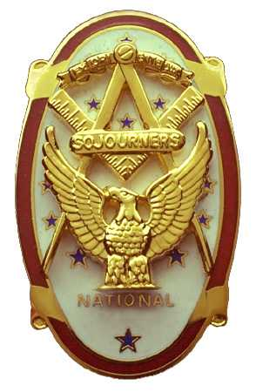
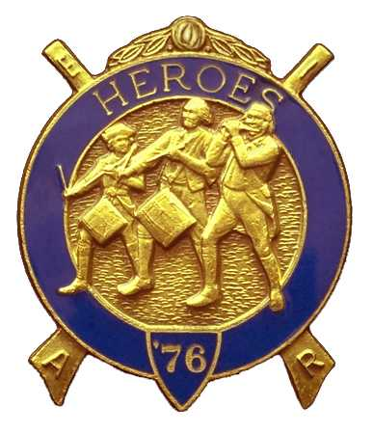
Olympic Chapter No.539
National Sojourners
And
Marvin Shields Camp of Heroes of ‘76
Edwin C. Marion P.O..Box 364
Secretary?Treasurer Forks, WA 98331-0364
edwin028@centurytel.net http://www:telebyte.com/masons/sojourn/ (360) 374-6777
23 March 2011

Our meeting got underway with our President giving his rendition of “Toast to the Flag”. What more can I say Bro. Paul, you get better every time you do the “Toast”. Just wish all of us could do as good when it comes to the rituals. Wouldn't that be great!?! But, alas it isn't going to happen.

Well it seems that our treasury is still solvent. We have $ 2814.79 in the bank, of which $ 2,116.79 is operational funds. We have $50.00 in our YLC fund at this time; there is $58.00 in our JNROTC fund; our uniform fund stands at $590.00.

We had no guest speaker for this meeting, but we will for our April meeting, which is our 8th Anniversary Meeting. At our first meeting, MWB Jimmy Reid was our guest speaker, and presented our Chapter Charter. Lots of water has run under the bridge between 23 April 2003 and 27 April 2011. It will be interesting to see what MWB Jimmy has to say after 8 years.

We have lost a few members since our First Anniversary, 3 of which were part of the Founding Members. Clarence Johnson, Founding President; “Bud” Porter, Past Commander of Heroes, and Chairman of the membership Committee; then Dr. S. Steve Seteroff our Founding Secretary, just to name a few. Of course we have grown in membership too. I was going to say, “Of course we were able to replace their loss with new Brothers”. But that would not be correct, I don't think we can ever replace these brothers, we can only add new members to take their place in the membership line, but not replacements for those brothers. Hope you follow my meaning.

Most the rest of the meeting was taken up with the discussion of our up and coming 8th Anniversary and the May visit by our National President.. Now, we plan to have a special dinner, as we always have, which will be Prime rib, prawns, chicken or salmon. The price is thee same, $25.00 per person. Please let me know if you are coming and what you want to eat. Need to give the restaurant a head start on dinner.

We will be holding elections of officers on the evening of 27th. If you want to be on the ballet for one of the officer positions, please come to the meeting and let us know.

Someone will be selected as Sojourner of the year for 2010.

The evening ended with Sue Porter doing her raffle. Thanks a lot Sue.
________________________________________________________________________

NEWS OF OUR BROTHERS

Have heard from Mike Moug in a round about way. Got a message from National asking for his correct address. I though the one we had was the correct one, but apparently it wasn't. So, I contacted Arnie Finley, Secretary of Jefferson-Quilcene Lodge No. 107, Mikes home lodge, to see if Arnie had a new address for Mike. Here is Mikes new address: Morris E. Moug, 7221 NE 182nd St, Kent, WA 98028. Will let you know if I get more on Mike.

Talked with Gunny Riggs. His wife is somewhat better. They hope they have her diabetes under control, and he should be making meetings again. See you at our April meeting Gunny!

________________________________________________________________________
HERE IS THE LIST OF YOUR OFFICERS FOR 2010-2011

OLYMPIC CHAPTER MARVIN G. SHIELDS CAMP

President------ ---------------CPO Paul J. Car mean Commander------------Mr. Darel E. Maxfield Sr.
360-928-3358 pjcarmean@q.com 360-374-9330 maynard@olynet.com

1st Vice President---LCD Dr. John R. Richardson Chief of Staff--------------GYSGT C. Earl Riggs
360-385-3117 djohnone@cablespeed.com 360-380-4944 jarhead1949@netzero.com

2nd Vice President--------- Joe G. Anticevich A/C of Staff--------------Joe G. Anticevich
360-432-4843 acn@olypen.com 360-432-4843 ace@olypen.com

3rd Vice President—---------Douglas Puckett
100 Wild Orchid Lane

Chaplain----------SGT Fredrick W. Johnson Chaplain---------SGT Fredrick W.Johnson
360-385-3130 fjohnson-30@q.com 360-385-3130 fjohnson-30@q.com

Secretary-----LtCol Edwin C. “Ed” Marion Adjutant-----LtCol Edwin C. “Ed” Marion
360-374-6777 Edwin028@centurytel.net 360-374-6777 Edwin028@centurytel.net

Area Representative and Regional Representative
SMSGT Robert S. Colton
206-439-2320 rshgcolton1@netzero.net
Deputy Area Representative and Regional Representative
LtCol Wendell A. Dutt
253-565-5264 wadutt@comcast.net

NEXT MEETING
25 May 2011
Pardise Restaurant
Sequim, WA
NATIONAL PRESIDENTS MEETING

Our meeting this month will be held on 25 May 2011. At which time we will be welcoming our National President, LTC Harry E. Sanders, Jr. Our meetings start at 1800 Hours (6 PM), our normal meeting time and day of the week..

DIRECTIONS TO THE MEETING PLACE. No matter from which direction you come, as you must come by Highway 101, east or west, when you see the road sign for Sequim Avenue, you take that exit. If you come from the east, turn right onto Sequim Avenue, if you come from the west, turn left onto Sequim Avenue. This will place you heading north along Sequim Avenue. You will stay on Sequim Avenue until you reach the restaurant, which will be approximately one mile. There will be one traffic light , which is at Main Street, this means you are about half way there.

Approximately ¾ miles along the way, you will come to Sequim High School on your left. It is a large brick building. There will be a chain-link fence around the practice field part of the High School. At the end of the fenced off area is a cross street, which forms a three way intersection, or a “T” bone intersection. The Paradise Restaurant is on the north west corner of the intersection. The parking lot is in the front, so just pull into the parking lot. Come into the restaurant, walk straight back to the private dinning room. This is where we have our meetings.

Now remember, YOU DON'T HAVE TO COME FOR THE DINNER, YOU DON'T EVEN HAVE TO BUY COFFEE. If you need a ride to and from the meeting, give me a call and I will arrange for someone to pick you up and take you home. Call me at 360-374-6777.

HAPPY BIRTHDAY

Darel E. Ma xfield Sr (4).
Ralph O'Dell (19)

Happy Birthday, If I have missed someone, may your day be a memorable one. And ladies please send me the month and day of your birth so I can post it for you. Don't send the year of birth.

BLUE LODGE

Meetings: Quilcene-Jefferson #107 will meet 4 April 2011., and 2 May 2011 dinner 6:30, lodge 7:30; Mt. Olympus #298 6 April 2011 and 4 May 2011, dinner 6:30 Lodge 7:30; Pt. Angeles #69 on 12 April 2011, and 10 May 2011, no dinner, lodge 7:30; Sequim #213, 14 April 2011, and 12 May 2011, dinner 6:30 lodge 7:30.. Pt Townsend #6, 13 April 2011, 11 May 2011 Lodge 7:30. Attend your Blue Lodge Brothers at least once a year just so they can see you are still among the living!

HEIP NEEDED

Brothers, please check this out and see if you can be of help to me on this. Following Pacific Beach, I realized that I need help, or I may have to pass this job on to someone else. I am 83 heading into 84, and I need to return to just being the Secretary, not the Quartermaster and Storekeeper. Some of you please step forward and take over some of these jobs that have nothing to do with being the Secretary.

WISH LIST

- An enclosed trailer to haul all our equipment needed for our “Build the Flag” program. My truck has short bed which will not hold everything needed for our Hero Programs.
- An awards chairman as suggested by David MacNeill. David can't take the job as he has moved out of area, and is travel most of time.
- We need more members in uniform. We are working on a solution.
- Guest speakers are needed very badly. Subject is of their choosing, but they must work for dinner only, can't afford pay them more than that.
- More brothers and their ladies at our meetings
- A phone committee. Open not only to brothers, but to their ladies also.
- Sure could use someone to take over the responsibility for some of this equipment I have. Sometimes it gets more than an 83 year old can handle.
- Someone to take over the “Traveling Bar”.

