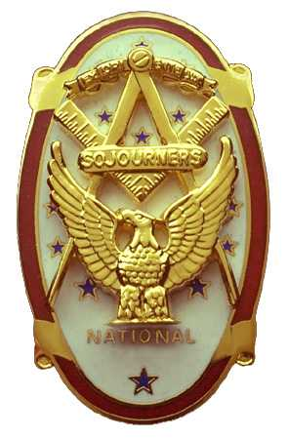
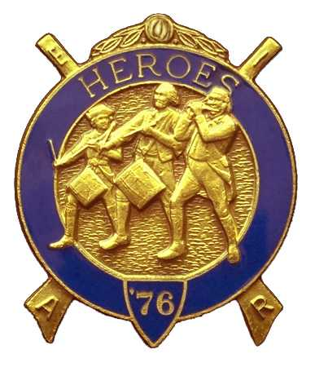
Olympic Chapter No.539
National Sojourners
And
Marvin Shields Camp of Heroes of ‘76
Edwin C. Marion P.O..Box 364
Secretary?Treasurer Forks, WA 98331-0364
edwin028@centurytel.net http://www:telebyte.com/masons/sojourn/ (360) 374-6777
26 January 2011
Meeting Minutes

Grip -n- Grin started tonight about 1730 hours. A few of us got to the meeting a bit early, so we had a lot of time to visit with a few of our friends, especially those we haven't seen in a while, such as Frank Benson, who had been traveling for a bit.

Our President, CPO Paul Carmean called upon himself to do the “Toast to the Flag”. And a darn good job Paul. I am sure “Bud” would agree with his replacement. Our President then opened the meeting according to the Orders of Ceremonies, page 3.

Once again we don't have a guest speaker. Sorry about that, but I just don't know too much about getting speakers. Now if someone feels like it, they can start looking around for speakers. All I ask is they notify me who, and the meeting date they will be speaking. I know that Steve Seteroff was so good at this he was able to book people a year in advance. Think about this brothers and ladies, if you can take over this job, feel free to do so. Just let me know who you have for a speaker , and when.

Our treasury is still solvent at this time. Our treasury stands at $2514.22. We have $1808.22 for operations, with $50.00 committed to YLC, $58.00 in our JNROTC fund, and a total of $626.00 in our uniform fund.

Two brothers, Steven Craig Lingle, retired U.S. Army First Sargent, and Mister John Patrick Baughman were given a vote of approval for membership, and presented themselves for induction into our ranks.

They were initiated by the President Paul Carmean, assisted by VWB Darel Maxfield as Chaplain and doing the history lecture. Br Joe Anticevich did the medal lecture. Nice to have some new blood in the organization. Welcome aboard Brothers.

We had a meeting of the members of the uniform committee, and it was decided that if you want the Chapter to help you purchase a Heroes Uniform,these are the rules you have to live with. Just like the MIP fund, the Chapter will put you on our loan system. As for the MIP you get the MIP paid for by the chapter, but you have years to pay the money back, why not say $30.00 a year, the price you would pay as your yearly dues. At this rate you would pay the chapter back in 7 years, and you payback money could be used by some other worthy brother.

Back to the uniform. It will require you to make the initial payment with you order, which requires $125.00 up front. When your order comes, you just give me the bill, and I will pay rest for it from the uniform fund. You will have your uniform.

Sue Porter had her raffle and took in a bit for our treasury. Sure don't know what we would do without the Porter raffle. Thanks a lot Sue!
________________________________________________________________________

NEWS OF OUR MEMBERSHIP

Haven't had any word from VWB Steve Seteroff's family. Just rumors. It is my understanding that the lodge in Alaska was in charge of his service, and that his ashes were scattered at sea as per his request. If anyone has any better information, please let me know so that I can keep the membership informed.

While we are on this type of subject, has anyone heard anymore about Mike Moug and Coralee? All I know is he was moved out of the assisted living home here in Sequim, to one in the Seattle area. Haven't heard any more. Let me know if you know something.

Gunny Riggs hasn't been to the meeting again, which means he or his wife is on the sick list again. Get better Gunny, we need you and your wife at the meetings.
________________________________________________________________________

HERE IS THE LIST OF YOUR OFFICERS FOR 2010-2011

OLYMPIC CHAPTER MARVIN G. SHIELDS CAMP

President------ ---------------CPO Paul J. Car mean Commander---------Mr. Darel E. Maxfield Sr.
360-928-3358 pjcarmean@q.com 360-374-9330 maynard@olynet.com

1st Vice President---LCD Dr. John R. Richardson Chief of Staff-------------GYSGT C. Earl Riggs
360-385-3117 djohnone@cablespeed.com 360-380-4944 jarhead1949@netzero.com

2nd Vice President--------- Joe G. Anticevich A/C of Staff-------------Joe G. Anticevich
360-432-4843 acn@olypen.com 360-432-4843 ace@olypen.com

3rd Vice President—---------Douglas Puckett
100 Wild Orchid Lane

Chaplain----------SGT Fredrick W. Johnson Chaplain-------SGT Fredrick W. Johnson
360-385-3130 fjohnson-30@q.com 360-385-3130 fjohnson-30@q.com

Secretary-----LtCol Edwin C. “Ed” Marion Adjutant—---LtCol Edwin C. “Ed” Marion
360-374-6777 Edwin028@centurytel.net 360-374-6777 Edwin028@centurytel.net

Area Representative and Regional Representative
SMSGT Robert S. Colton
206-439-2320 rshgcolton1@netzero.net
Deputy Area Representative and Regional Representative
LtCol Wendell A. Dutt
253-565-5264 wadutt@comcast.net

NEXT MEETING
23 February 2011
Pardise Restaurant
Sequim, WA

Our meeting this month will be held on 26 February 2011. Our meetings start at 1800 Hours (6 PM), our normal meeting time and day of the week..

DIRECTIONS TO THE MEETING PLACE. No matter from which direction you come, as you must come by Highway 101, east or west, when you see the road sign for Sequim Avenue, you take that exit. If you come from the east, turn right onto Sequim Avenue, if you come from the west, turn left onto Sequim Avenue. This will place you heading north along Sequim Avenue. You will stay on Sequim Avenue until you reach the restaurant, which will be approximately one mile. There will be one traffic light , which is at Main Street, this means you are about half way there.

Approximately ¾ miles along the way, you will come to Sequim High School on your left. It is a large brick building. There will be a chain-link fence around the practice field part of the High School. At the end of the fenced off area is a cross street, which forms a three way intersection, or a “T” bone intersection. The Paradise Restaurant is on the north west corner of the intersection. The parking lot is in the front, so just pull into the parking lot. Come into the restaurant, walk straight back to the private dinning room. This is where we have our meetings.

Now remember, YOU DON'T HAVE TO COME FOR THE DINNER, YOU DON'T EVEN HAVE TO BUY COFFEE. If you need a ride to and from the meeting, give me a call and I will arrange for someone to pick you up and take you home. Call me at 360-374-6777.

HAPPY BIRTHDAY

My Records Show None

Happy Birthday, If I have missed someone, may your day be a memorable one. We will assume that you are now down in Yuma relaxing in the sun for the winter. Hope to see you at Chapter soon? And ladies please send me the month and day of your birth so I can post it for you. Don't send the year of birth.

BLUE LODGE

Meetings: Quilcene-Jefferson #107 will meet 7 February 2011., and 7 March 2011 dinner 6:30, lodge 7:30; Mt. Olympus #298 2 February 2011 and 2 March 2011, and dinner 6:30 Lodge 7:30; Pt. Angeles #69 on 8 February 2011, and 8 March 2011, no dinner, lodge 7:30; Sequim #213, 10 February 2011, and 10 March 2011, dinner 6:30 lodge 7:30.. Pt Townsend #6, 9 February 2011, 9 March 2011 dinner 6:30 Lodge 7:30. Attend your Blue Lodge Brothers at least once a year just so they can see you are still among the living!

HEIP NEEDED

Brothers, please check this out and see if you can be of help to me on this. Following Pacific Beach, I realized that I need help, or I may have to pass this job on to someone else. I will be 83 in December, and I need to return to being just the Secretary, not the Quartermaster and Storekeeper. Some of you please step forward and take over some of these jobs that have nothing to do with being the Secretary.

WISH LIST

- An enclosed trailer to haul all our equipment needed for our “Build the Flag” program. My truck has short bed which will not hold everything needed for our Hero Programs.
- An awards chairman as suggested by David MacNeill. David can't take the job as he has moved out of area, and is travel most of time.
- We need more members in uniform. We are working on a solution.
- Guest speakers are needed very badly. Subject is of their choosing, but they must work for dinner only, can't afford pay them more than that.
- More brothers and their ladies at our meetings
- A phone committee. Open not only to brothers, but to their ladies also.
- Sure could use someone to take over the responsibility for some of this equipment I have. Sometimes it gets more than an 83 year old can handle.
- Someone to take over the “Traveling Bar”.

