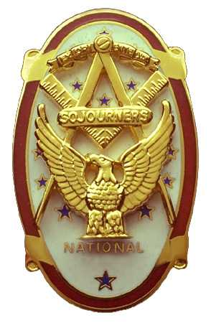
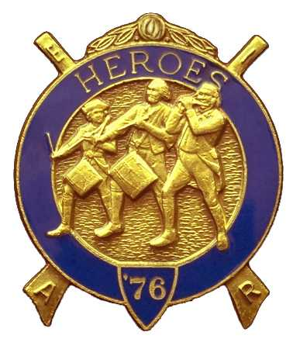
Olympic Chapter No.539
National Sojourners
And
Marvin Shields Camp of Heroes of ‘76
Edwin C. Marion P.O..Box 364
Secretary?Treasurer Forks, WA 98331-0364
edwin028@centurytel.net http://www:telebyte.com/masons/sojourn/ (360) 374-6777
15 December 2010
Meeting Minutes

The Grip -n- Grin portion of our meeting started at about 1730 (5:30) hours. Once again Sue Porter was the first one here. As members arrived they ordered dinner, which was a special Christmas Dinner, Prime Ribs and Prawns. The restruant is use to our ordering. They kind of know what we like to eat.

As we had no guest speaker, President CPO Paul Carmean did the “Toast to the Flag”, followed by Pledge of Allegence to the Flag. Following the Toast and Pledge, President Paul officially opened the meeting according to the Orders of Ceremonies, page 3. Once again a great job President Paul. Seems yoiu have worked yourself into the job of doing the Toast and Pledge to the Flag, replacing Bud., You will have a great time following in Bud's footsteps, but you have shown you can do it. I guess there must be something ingrained in you Chief Petty Officers that allows you to be good at this.. Now if we can get someone to take over “Old Glory Speaks”, we would have it made.

As this was our Christmas Party Time, the meeting moved right along, no messing around on any of the subjects. Seems everyone was back in their childhood mood wanting to get going on the gift exchange part of the meeting I will say that everyone seemed to be having a great time with this portion of our meeting, I know I did. And to you ladies who brought extra presents just in case they would be needed by someone, all I can say IS THANK YOU SO VERY MUCH.

Seems our treasury is still solvent. We have a total of $ 1588.22 in our operational funds. We also have $50.00 in our YLC fund at this time, (This fund will grow before it is needed in June.) There is $58.00 earmarked for the purchase of medals and such for the JNROTC at Port Angelkes High School. Our uniform fund stands at $450.00. We are looking for more donations to the uniform fund from any member who wants to help with the purechase of uniforms.

There was no raffle tonight as we were having our gift exchange instead, so President Paul closed the meeting according to the Orders of Cermonies, page 8. I must admit the gift portion was something else. Was fun just to watch

Just a reminder to the brothes that we bought MIP's for, we hope that you will make a dues payment of $30.00,. This will be your way of paying the lodge back for the cost of your MIP, mking your payment available to purchase MIP's for future brothers..

NEWS OF OUR MEMBERSHIP

At Mt. Olympus Lodge, we were informed
that WB Paul Carmean was down with this cold like inflamation that is going around.. He is our junior Past Master and now is our Chaplain, Hope you get to feeling better soon Paul. We need you at Chapter as well as Lodge..

It is our understanding that our 1st Vice President is visiting his brother in Texas following the death of his lady Doris. Sorry about that Dr. John. Hope we see you in chapter soon.

In December, I had a very plesent suprise I recieved from the Govener of Kentucky a Certificate making me a “Kentucky Colonel”. I was born, raise and educated in Kentucky. I graduated from University of Kentucky, at which time I was appointed as a Second Leiutenet of Infantry. Then I found myself on the front lines in Korea.

It is with a deep and heavy heart that I report that one of our founding brothers, Dr. Steve Seteroff has gone to that celestral home above. He passed away on Sunday, January 8th. From complications of his truck accident he had in November.I will keep you informed as I get more information.

MARVIN G. SHIELDS CAMP, HEROES OF '76

Camp Commander Darel Maxfield has called for a meeting of Marvin Shields Heroes of '76 Camp to at Bivourac at Fort Quilcene-Jefferson, located in Quilcene on January 15th 0930 hours. There will be a Heroes of '76 degree, we hope, on Saturday January 15th, starting at 1000 hours, (10:00 AM. Regular time.) Uniform of the Day will be Field Uniform or Dress Uniform, your choice. I know this is short notice, but it can't be helped. If you can do it, please be there to give us a hand.
________________________________________________________________________

HERE IS THE LIST OF YOUR OFFICERS FOR 2010-2011

OLYMPIC CHAPTER MARVIN G. SHIELDS CAMP

President------ ---------------CPO Paul J. Carmean Commander---------Mr. Darel E. Maxfield Sr.
360-928-3358 pjcarmean@q.com 360-374-9330 maynard@olynet.com

1st Vice President---LCD Dr. John R. Richardson Chief of Staff-------------GYSGT C. Earl Riggs
360-385-3117 djohnone@cablespeed.com 360-380-4944 jarhead1949@netzero.com

2nd Vice President--------- Joe G. Anticevich A/C of Staff-------------Joe G. Anticevich
360-432-4843 acn@olypen.com 360-432-4843 ace@olypen.com

3rd Vice President—---------Douglas Puckett
100 Wild Orchid Lane

Chaplain----------SGT Fredrick W. Johnson Chaplain-------SGT Fredrick W. Johnson
360-385-3130 fjohnson-30@q.com 360-385-3130 fjohnson-30@q.com

Secretary-----LtCol Edwin C. “Ed” Marion Adjutant—---LtCol Edwin C. “Ed” Marion
360-374-6777 Edwin028@centurytel.net 360-374-6777 Edwin028@centurytel.net

Area Representive and Regional Representive
SMSGT Robert S. Colton
206-439-2320 rshgcolton1@netzero.net
Deputy Area Representive and Regional Representive
LtCol Wendell A. Dutt
253-565-5264 wadutt@comcast.net

NEXT MEETING
26 January 2011
Pardise Restaurant
Sequim, WA

Our meeting this month will be held on 26 January 2011. Our meeting are at 1800 Hours (6 PM), our normal meeting time and day of the week..

DIRECTIONS TO THE MEETING PLACE. No matter from which direction you come, as you must come by Highway 101, east or west, when you see the road sign for Sequim Avenue, you take that exit. If you come from the east, turn right onto Sequim Avenue, if you come from the west, turn left onto Sequim Avenue. This will place you heading north along Sequim Avenue. You will stay on Sequim Avenue until you reach the restaurant, which will be approximatly one mile. There will be one traffic light , which is at Main Street, this means you are about half way there.

Approximatly ¾ miles along the way, you will come to Sequim High School on your left. It is a large brick building. There will be a chain-link fence around the practice field part of the High School. At the end of the fenced off area is a cross street, which forms a three way intersection, or a “T” bone intersection. The Paradise Restaurant is on the north west corner of the intersection. The parking lot is in the front, so just pull into the parking lot. Come into the restaurant, walk straight back to the private dinning room. This is where we have our meetings.

Now remember, YOU DON'T HAVE TO COME FOR THE DINNER, YOU DON'T EVEN HAVE TO BUY COFFEE. If you need a ride to and from the meeting, give me a call and I will arrange for someone to pick you up and take you home. Call me at 360-374-6777.

HAPPY BIRTHDAY

William Heckman 28

Happy Birthday, may your day be a memorable one. We will assume that you are now down in Yuma relaxing in the sun for the winter. Hope to see you at Chapter soon? And ladies please send me the month and day of your biurth so I can post it for you. Don't send the year of birth.

BLUE LODGE

Meetings: Quilcene-Jefferson #107 will meet 3 January 2011, 7 february 2011., dinner 6:30 lodge 7:30, December meeting will be Prinme Rib Night; Mt. Olympus #298 on 5 January 2011, and 2 February 2011, dinner 6:30 Lodge 7:30; Pt. Angeles #69 on 11 January and 8 February, no dinner, lodge 7:30; Sequim #213, 13 January and 10 February 2011, dinner 6:30 lodge 7:30.. Pt Townsend #6, 12 January and 9 February 2011, dinner 6:30 Lodge 7:30. Attend your Blue Lodge Brothers at least once a year just so they can see you are still among the living!

HEIP NEEDED

Brothers, please check this out and see if you can be of help to me on this. Following Pacific Beach, I realized that I need help, or I may have to pass this job on to someone else. I will be 83 in December, and I need to return to being just the Secretary, not the Quatermaster and Storekeepoer. Some of you please step forward and take over some of these jobs that have nothing to do with being the Secretary.

WISH LIST

- An enclosed trailer to haul all our equipment needed for our “Build the Flag” program. My truck has short bed which will not hold everything needed for our Hero Programs.
- An awards chairman as suggested by David MacNeill. David can't take the job as he has moved out of area, and is travel most of time.
- We need more members in uniform. We are working on a solution.
- Guest speakers are needed very badly. Subject is of their choosing, but they must work for dinner only, can't afford pay them more than that.
- More brothers and their ladies at our meetings
- A phone committee. Open not only to brothers, but to their ladies also.
- Sure could use someone to take over the responceablity for some of this equipment I have. Sometimes it gets more than an 83 year old can handle.
- Somone to take over the “Traveling Bar”.

