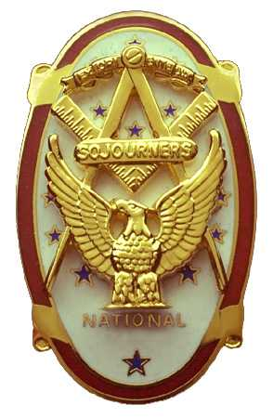
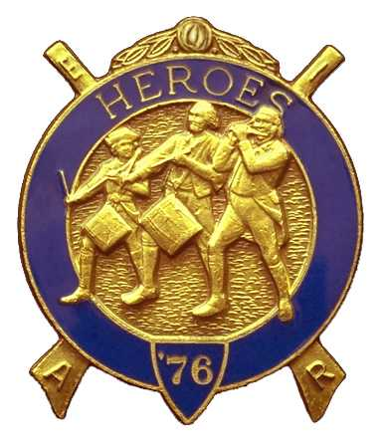
Olympic Chapter No.539
National Sojourners
And
Marvin Shields Camp of Heroes of ‘76
Edwin C. Marion P.O..Box 364
Secretary?Treasurer Forks, WA 98331-0364
edwin028@centurytel.net http://www:telebyte.com/masons/sojourn/ (360) 374-6777
17 November 2010 Meeting minutes.

The Grip-n-Grin portion of our meeting started tonight at 1730 Hour (5:30 PM for those who don't understand military time.)with 9 of us being present at that time. Most of us began to order our dinner at this time, as we could get a break on prices with the “Early Bird Special” still on until 1800 hours. People kept arriving after that until about 1815 hours, when we had 17 people at our dinner.

At about 1900 hours, prior to officially opening the meeting, President Paul Carmean did the “Toast to the Flag” followed with the Pledge Allegiance to the Flag. Following this, President Paul officially opened the meeting according to page 3, Orders of Ceremonies. There was no guest speaker so we moved right into the meeting proper. A check of officers showed that our 1st and 3rd VP were not present, but did have an excused absence, as did our chaplain.

Our treasury is still solvent. There is $2,315.22 in our bank account, of which $1717.22 is in our operational fund. We have $50.00 in our YLC Fund, $58.00 in our JNROTC fund. Our uniform fund has grown to $450.00. Contributions to the Uniform Fund , at this time, are kept anonymous until the rules governing this fund are worked out.

Plans were discussed about the visit of our National President on 25 May, 2011. We want to make this an Olympic Chapter celebration that will please everyone. At this point we will be having a “Dining Out” type meeting that night. Sorry, but that is about all we know for sure at this point. As we get more information, we will let you know. Just wanted to let you know this part of our plans so that you can start ordering your tickets in advance. We have room for 60 people the owner of the restaurant tells us. Being this will be the celebration of the attendance of our National President, we thought we should let you start making your reservations early. Contact me on line, Edwin028@centrytel.net or call me on 360-374-6777, but start getting those reservations in soon. 25 May will be here before you know it.

A letter was read from a young lady about a school project she will be having in the spring in the Florida Everglades. This project is costing $1500.00 per child. Joe Anticevich made a motion that we donate $200 to this project. It is costing $1500 per child. The motion was seconded by Don Williams. Motion passed.

Before the meeting was closed, Sue Porter held here raffle, and she raised another $50.00 for our treasury. Following the raffle, President Paul closed the meeting according to the Orders of Ceremonies, page 8.

NEWS OF OUR MEMBERSHIP

Now this will be something new, which we will continue in the future:

Our Past President and Past Commander Mike Moug and his wife Corralee has been transferred out of the assisted living facilities here in Sequim to a new one in Seattle. Don’t have the name of this new one yet, nor the address, but will put out the information as soon as we get it.

Understand that Steve Seteroff tried skiing with his pick up, but he lost the game. Came off with a few bruises. Sorry about that Steve, but you should know better that you can't use your vehicle for skiing. Anyway, glad you are basically OK.

Our Chaplain Fred Johnson had to go in the hospital to have his right artery cleaned out. Seems it was almost blocked. He was at lodge Monday night, and stated he felt much better now than he has in months.

Dave MacNeil is recovering nicely from total knee surgery and should be up and about shortly. Heal quickly Dave!!

Just got off the phone with “Gunny” Riggs. Seems he hasn't been to our meetings for the last three months. He and his wife always made the meetings. It seems his wife has been under the weather, so to speak, but she is now getting better. They hope to return to chapter meeting soon.
_______________________________________________________________________

HERE IS THE LIST OF YOUR OFFICERS FOR 2010-2011

OLYMPIC CHAPTER MARVIN G. SHIELDS CAMP

President------ ------CPO Paul J. Carmean Commander-----Mr. Darel E. Maxfield Sr.
360-928-3358 pjcarmean@q.com 360-374-9330 maynard@olynet.com

1st Vice President---LCD Dr. John R. Richardson Chief of Staff-------------GYSGT C. Earl Riggs
360-385-3117 djohnone@cablespeed.com 360-380-4944 jarhead1949@netzero.com

2nd Vice President--Joe G. Anticevich A/C of Staff-----Joe G. Anticevich
360-432-4843 acn@olypen.com 360-432-4843 ace@olypen.com

Chaplain-----SGT Fredrick W. Johnson Chaplain---SGT Fredrick W. Johnson
360-385-3130 fjohnson-30@q.com 360-385-3130 fjohnson-30@q.com

Secretary-----LtCol Edwin C. “Ed” Marion Adjutant—---LtCol Edwin C. “Ed” Marion
360-374-6777 Edwin028@centurytel.net 360-374-6777 Edwin028@centurytel.net

Area Representative and Regional Representative
SMSGT Robert S. Colton
206-439-2320 rsgecolton1@netzero.net
Deputy Area Representative and Regional Representative
LtCol Wendell A. Dutt
253-565-5264 wadutt@comcast.net

NEXT MEETING

EVENING MEETING
15 December 2010
Pardise Restaurant
Sequim, WA

Our meeting this month will be held on 15 December 2010.. Our meeting will be at 1800 Hours (6 PM), our normal meeting time and day of the week. Our December meeting will be on 15 December at which time we will be having our “White Elephant” Christmas gift program.. Our January meeting will be on 26 January 2011.

DIRECTIONS TO THE MEETING PLACE. No matter from which direction you come, as you must come by Highway 101, east or west, when you see the road sign for Sequim Avenue, you take that exit. If you come from the east, turn right onto Sequim Avenue, if you come from the west, turn left onto Sequim Avenue. This will place you heading north along Sequim Avenue. You will stay on Sequim Avenue until you reach the restaurant, which will be approximatly one mile. There will be one traffic light , which is at Main Street, this means you are about half way there.

Approximatly ¾ miles along the way, you will come to Sequim High School on your left. It is a large brick building. There will be a chain-link fence around the practice field part of the High School. At the end of the fenced off area is a cross street, which forms a three way intersection, or a “T” bone intersection. The Paradise Restaurant is on the north west corner of the intersection. The parking lot is in the front, so just pull into the parking lot. Come into the restaurant, walk straight back to the private dinning room. This is where we have our meetings.

Now remember, YOU DON'T HAVE TO COME FOR THE DINNER, YOU DON'T EVEN HAVE TO BUY COFFEE. If you need a ride to and from the meeting, give me a call and I will arrange for someone to pick you up and take you home. Call me at 360-374-6777.

HAPPY BIRTHDAY

Edwin C. Marion 8th
Graham Kent 25

Happy Birthday to you both, may your day be a memorable one. Hope to see you at Chapter soon? And ladies please send me the month and day of your biurth so I can post it for you. Don't send the year of birth.

BLUE LODGE

Meetings: Quilcene-Jefferson #107 will meet on 6 December and Jnuary 3., dinner 6:30 lodge 7:30, Prinme Rib Night; Mt. Olympus #298 on 1 December and 5 January, dinner 6:30 Lodge 7:30; Pt. Angeles #69 on 14 December and 11 January, dinner 6:30 lodge 7:30; Sequim #213, 9 December and 13 January, dinner 6:30 lodge 7:30.. Pt Townsend #6, 8 December and 12 January, dinner 6:30 Lodge 7:30. Attend your BlueLodge Brothers at least once a year just so they can see you are still among the living!

HEIP NEEDED

Brothers, please check this out and see if you can be of help to me on this. Following Pacific Beach, I realized that I need help, or I may have to pass this job on to someone else. I will be 83 in December, and I need to return to being just the Secretary, not the Quatermaster and Storekeepoer. Some of you please step forward and take over some of these jobs that have nothing to do with being the Secretary.

WISH LIST

- An enclosed trailer to haul all our equipment needed for our “Build the Flag” program. My truck has short bed which will not hold everything needed for our Hero Programs.
- An awards chairman as suggested by David MacNeill. David can't take the job as he has moved out of area, and is travel most of time.
- We need more members in uniform. We are working on a solution.
- Guest speakers are needed very badly. Subject is of their choosing, but they must work for dinner only, can't afford pay them more than that.
- More brothers and their wives at our meetings
- A phone committee. Open not only to brothers, but to their ladies too.
- A slide projector. I have one but I need two, I have two sets of slides. I will even pay you for a used slide projector. If you have one and want to get rid of it, just give me a call. I'll be there with the money in my hot little hand. THIS ONE WAS SOLVED, DAVE AND KATHY MAC NEILL DONATED ONE.
- Sure could use someone to take over the responceablity for some of this equipment I have. Sometimes it gets more than an 82 year old can handle.
- Somone to take over the “Traveling Bar”.

